ICS 103, Term 083

Computer Programming in C

HW# 3
Due date: Sunday, August 23, 2009

You are required to write a C program to do the following:

Ask the user to enter an input file name and read it.

Count the number of occurrences of each of the alphabetic characters in the input file i.e. ‘a’ to ‘z’ regardless whether the character is small letter or capital.

Write a function histogram that receives an input array and displays a histogram of ‘*’ according to each element count. If an array element count is 0, that element should not be displayed. Then, use this function to display a histogram of the counted alphabetic characters read from the file.

A sample execution of the program is shown below:

Input file: hw3.txt | Histogram Display:

You are required to write a C program to do the following:

Ask the user to enter input file name and read from it students ID’s along with their exam scores.

Ask the user to select the type of sorting required ( a for ascending sorting of scores and d for descending). Then, write the sorted IDs and scores in an output file with its name selected by the user. Assume that the default sorting will be descending.

Ask the user to enter a student ID and display the rank of the student in the class. This process is repeated until the user enters 0 for the ID.

A sample execution of the program is shown below:

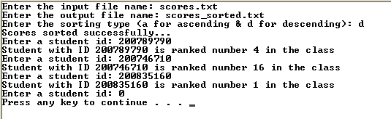

scores.txt: | scores_sorted.txt

You are required to write a C program to do the following:

Ask the user to enter an input file name and read it.

Ask the user to enter a string and read it. Assume that the string is of maximum 80 characters and that the string can include spaces.

Count the number of occurrences of the string in the input file and display its count. Note that any matching string with the same letters regardless of being lower or upper case should be counted. If the string is not found, a message is printed indicating that the string was not found in the file.

A sample execution of the program is shown below:

Input file: hw3.txt | Histogram Display:

The solution should be well organized and your program should be well documented. Submit a soft copy of your solution in a zip file. Your solution should be submitted in a word file that contains the following items:

Your name and ID

Homework number

Problem statement for each question

Your solution along with the code for each question

Discussion of what worked and what did not work in your programs. Include snapshots that demonstrate the working parts of your programs. If things did not work and you attempted to solve them, mention that and write about the difficulty that you have faced.

The soft copy should also contain the source code files (i.e. .c) for each question separately.

