ICS 103, Term 103

Computer Programming in C

HW# 1Solution
Due date: Monday, July 11, 2011

You are required to write a program to compute the area of a triangle. You are required to give the user the option to either enter the size of the three sides of the triangle or enter the size of two sides and the angle between them. The user should enter either 1 or 2 to select between the two choices. If the user enters any other value, an error message should be displayed that the user has entered the incorrect choice.

Write a function to display the menu for the user to choose between the two options.

In case option 1 is selected, compute the three angles of the triangle and the area of the triangle. Then display the angles between all the sides and the triangle area. In case option 2 is selected, compute the size of the third side and the remaining angles. Then display the size of the third side, the angles between all the sides and the triangle area. Assume that the sides of the triangles are real numbers. Display the angles and area of the triangle correct to two decimal places.

Sample executions of the program are given below:

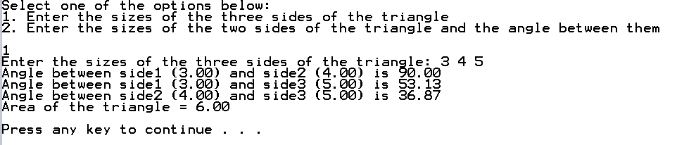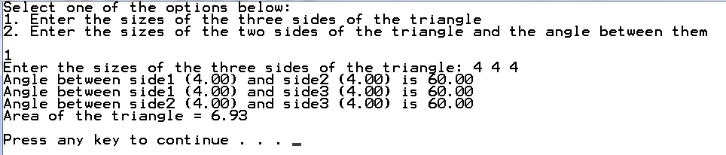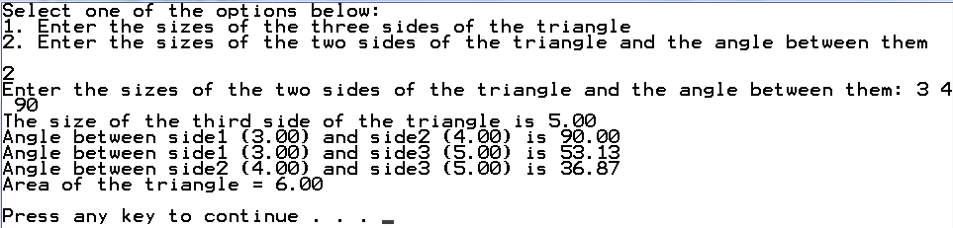
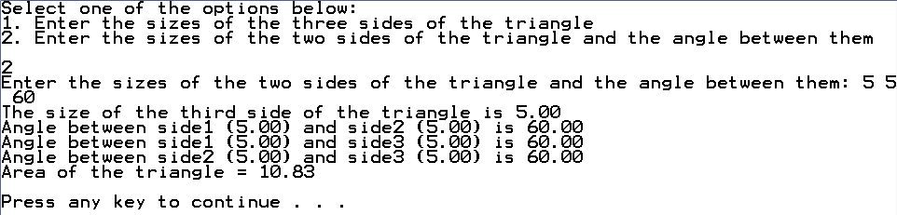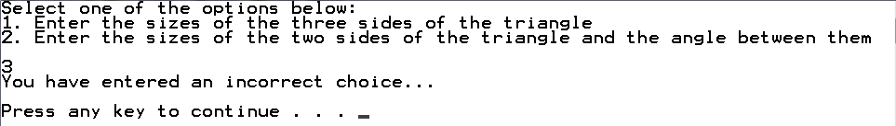

#include <stdio.h>
#include <stdlib.h>
#include <math.h>
#define PI 3.14159
void menu(void);

int main() {

double side1, side2, side3, angle12, angle23, angle13, area;
int choice;

menu();
scanf("%d", &choice);
if (choice == 1) {
printf("Enter the sizes of the three sides of the triangle: ");
scanf("%lf %lf %lf", &side1, &side2, &side3);
angle12 = acos((side1*side1 + side2*side2-side3*side3)/(2*side1*side2))*180/PI;
printf("Angle between side1 (%.2f) and side2 (%.2f) is %.2f\n",side1, side2, angle12);
angle13 = acos((side1*side1 + side3*side3-side2*side2)/(2*side1*side3))*180/PI;
printf("Angle between side1 (%.2f) and side3 (%.2f) is %.2f\n",side1, side3, angle13);
angle23 = 180 - angle12 - angle13;
printf("Angle between side2 (%.2f) and side3 (%.2f) is %.2f\n",side2, side3, angle23);
area = 0.5*side3*side2*sin(angle23*PI/180);
printf("Area of the triangle = %.2f \n\n", area);
} else if (choice == 2) {
printf("Enter the sizes of the two sides of the triangle and the angle between them: ");
scanf("%lf %lf %lf", &side1, &side2, &angle12);
side3 = sqrt(side1*side1+side2*side2-2*side1*side2*cos(angle12*PI/180));
printf("The size of the third side of the triangle is %.2f\n",side3);
printf("Angle between side1 (%.2f) and side2 (%.2f) is %.2f\n",side1, side2, angle12);
angle13 = acos((side1*side1 + side3*side3-side2*side2)/(2*side1*side3))*180/PI;
printf("Angle between side1 (%.2f) and side3 (%.2f) is %.2f\n",side1, side3, angle13);
angle23 = 180 - angle12 - angle13;
printf("Angle between side2 (%.2f) and side3 (%.2f) is %.2f\n",side2, side3, angle23);
area = 0.5*side3*side2*sin(angle23*PI/180);
printf("Area of the triangle = %.2f \n\n", area);
} else
printf("You have entered an incorrect choice...\n\n");

system("pause");
return 0;
}

void menu(void){

printf("Select one of the options below:\n");
printf("1. Enter the sizes of the three sides of the triangle\n");
printf("2. Enter the sizes of the two sides of the triangle and the angle between them\n\n");

}

