ICS 103, Term 093

Computer Programming in C

HW# 1 Solution
Due date: Monday, July 19, 2010

The equation of a line can be represented by y=a x + b, where a and b are real numbers. Write a C program that does the following:

Asks the user to enter the equations of two lines by entering the coefficients a and b and reads them. Then, prints the two entered line equations.

Prints whether the two lines intersect or not. If they intersect at one point, then print the point of intersection. If the two lines are equal, print that the two lines are equal.

Sample executions of the program are shown below:

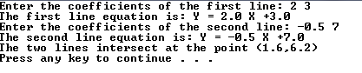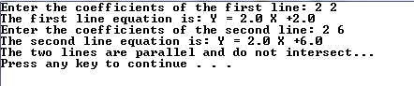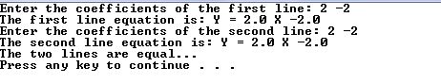

#include <stdio.h>
#include <stdlib.h>

int main (void){

double a1, b1, a2, b2, d1, d2, x, y;

printf("Enter the coefficients of the first line: ");
scanf("%lf%lf",&a1, &b1);
printf("The first line equation is: Y = %.1f X %+.1f \n",a1, b1);
printf("Enter the coefficients of the second line: ");
scanf("%lf%lf",&a2, &b2);
printf("The second line equation is: Y = %.1f X %+.1f \n",a2, b2);

d1=a1 - a2;
d2=b2 - b1;
if ((d1==0) && (d2==0)) printf("The two lines are equal...\n");
else if (d1==0) printf("The two lines are parallel and do not intersect...\n");
else {
x=d2/d1;
y=a1*x+b1;
printf("The two lines intersect at the point (%.1f,%.1f)\n", x, y);
}

system ("pause");
return 0;
}

Numbers represented in hexadecimal representation have the base 16 and the digits (0,1,2,3,4,5,6,7,8,9,A,B,C,D,E,F). Write a C program that asks the user to enter a decimal number and displays its hexadecimal representation. Assume that the decimal number is in the range 0-65535.

Sample executions of the program are shown below:

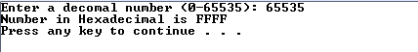

#include <stdio.h>
#include <stdlib.h>

char Hex(int d);

int main (void){

int num, d;
char d4, d3, d2, d1;
printf("Enter a decimal number (0-65535): ");
scanf("%d",&num);
d = num%16;
num = num/16;
d1 = Hex(d);
d = num%16;
num = num/16;
d2 = Hex(d);
d = num%16;
num = num/16;
d3 = Hex(d);
d = num%16;
num = num/16;
d4 = Hex(d);
printf("Number in Hexadecimal is %c%c%c%c \n", d4, d3, d2, d1);

system ("pause");
return 0;
}

char Hex(int d){
switch (d){
case 0: return '0';
case 1: return '1';
case 2: return '2';
case 3: return '3';
case 4: return '4';
case 5: return '5';
case 6: return '6';
case 7: return '7';
case 8: return '8';
case 9: return '9';
case 10: return 'A';
case 11: return 'B';
case 12: return 'C';
case 13: return 'D';
case 14: return 'E';
case 15: return 'F';
default: printf("Error...\n");
}
}

