ICS 103, Term 103

Computer Programming in C

HW# 1
Due date: Monday, July 11, 2011

You are required to write a program to compute the area of a triangle. You are required to give the user the option to either enter the size of the three sides of the triangle or enter the size of two sides and the angle between them. The user should enter either 1 or 2 to select between the two choices. If the user enters any other value, an error message should be displayed that the user has entered the incorrect choice.

Write a function to display the menu for the user to choose between the two options.

In case option 1 is selected, compute the three angles of the triangle and the area of the triangle. Then display the angles between all the sides and the triangle area. In case option 2 is selected, compute the size of the third side and the remaining angles. Then display the size of the third side, the angles between all the sides and the triangle area. Assume that the sides of the triangles are real numbers. Display the angles and area of the triangle correct to two decimal places.

Sample executions of the program are given below:

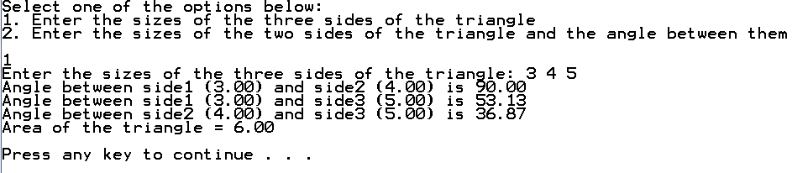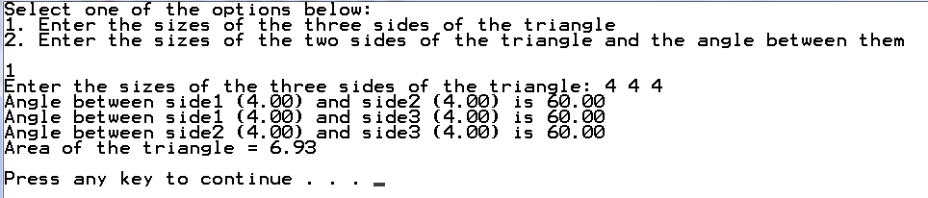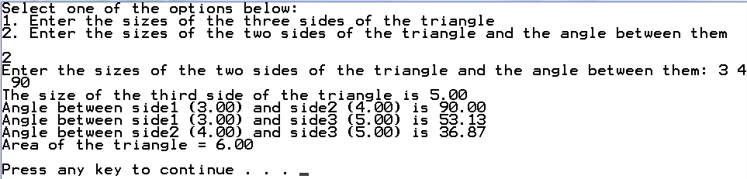
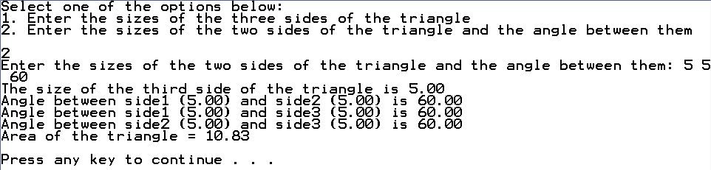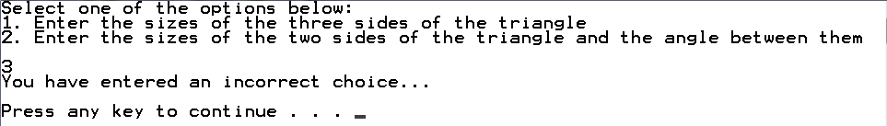

The solution should be well organized and your program should be well documented. Submit a soft copy of your solution in a zip file. Your solution should be submitted in a word file that contains the following items:

Your name and ID

Homework number

Problem statement

Your solution along with the code

Discussion of what worked and what did not work in your program. Include snapshots that demonstrate the working parts of your program. If things did not work and you attempted to solve them, mention that and write about the difficulty that you have faced.

The soft copy should also contain the source code file (i.e. .c) and the executable (i.e. .exe).

