ICS 103, Term 093

Computer Programming in C

HW# 1
Due date: Monday, July 19, 2010

The equation of a line can be represented by y=a x + b, where a and b are real numbers. Write a C program that does the following:

Asks the user to enter the equations of two lines by entering the coefficients a and b and reads them. Then, prints the two entered line equations.

Prints whether the two lines intersect or not. If they intersect at one point, then print the point of intersection. If the two lines are equal, print that the two lines are equal.

Sample executions of the program are shown below:

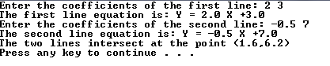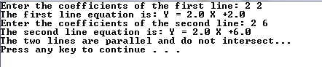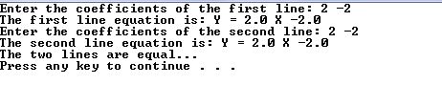

Numbers represented in hexadecimal representation have the base 16 and the digits (0,1,2,3,4,5,6,7,8,9,A,B,C,D,E,F). Write a C program that asks the user to enter a decimal number and displays its hexadecimal representation. Assume that the decimal number is in the range 0-65535.

Sample executions of the program are shown below:

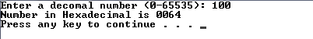

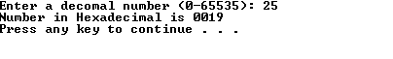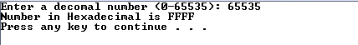

This homework is to be done by a group of two students. The solution should be well organized and your program should be well documented. Submit a soft copy of your solution in a zip file. Your solution should be submitted in a word file that contains the following items:

Your names and IDs

Homework number

Problem statement for each question

Your solution along with the code for each question

Discussion of what worked and what did not work in your programs. Include snapshots that demonstrate the working parts of your programs. If things did not work and you attempted to solve them, mention that and write about the difficulty that you have faced.

The soft copy should also contain the source code files (i.e. .c) for each question separately.

