Name: Id#

COE 405, Term 152

Design & Modeling of Digital Systems

Quiz# 5

Date: Sunday, April 24, 2016

It is required to design a circuit that counts the number of data transitions (i.e. 0→1and 1→0 data changes) through a stream of 128 bit data. The data is applied serially through an input X once the user presses a Start button, where the first bit is transmitted in the same cycle the Start button is asserted. Once the computation is finished the machine asserts a Done signal which remains asserted until the user presses the Start button again or resets the machine. Assume that the machine has Asynchronous Reset input. The ASMD chart for this machine is given below.

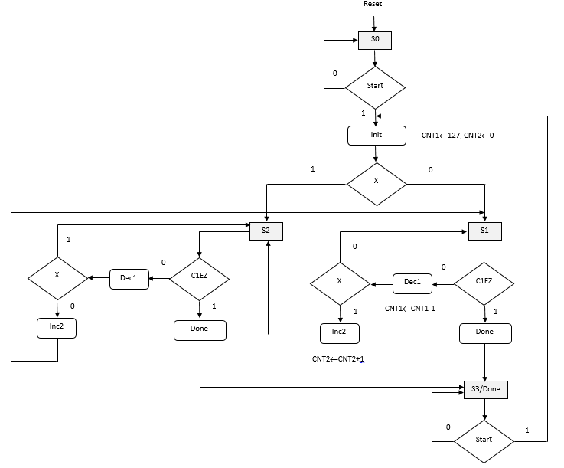

Write a behavioral Verilog module to model the data path unit for the given ASMD chart for circuit.

Write a behavioral Verilog module to model the control unit for the given ASMD chart for this circuit.

Write a Verilog module to model the overall circuit by connecting the data path and control unit modules.

