Name: KEY Id#

COE 405, Term 152

Design & Modeling of Digital Systems

Quiz# 4

Date: Sunday, April 14, 2016

It is required to design a circuit that receives two 4-bit signed numbers in 2's complement representation A=A₃A₂A₁A_{0,} B=B₃B₂B₁B₀ and produces a 6-bit output C= C₅C₄C₃C₂C₁C₀. The circuit implements the following functions based on the values of the three selection inputs: S1, S1 and S0.

S2 S1 S0 | Function
0 0 0 | C = A + B
0 0 1 | C = A - B
0 1 0 | C = A + 1
0 1 1 | C = A - 1
1 0 0 | C = 2*A+B
1 0 1 | C = 2*A-B
1 1 0 | C = 2*A+1
1 1 1 | C = 2*A-1

Show the block diagram design of your circuit using MSI components like Adder, Multiplexor, as needed. Use only one adder in your solution.

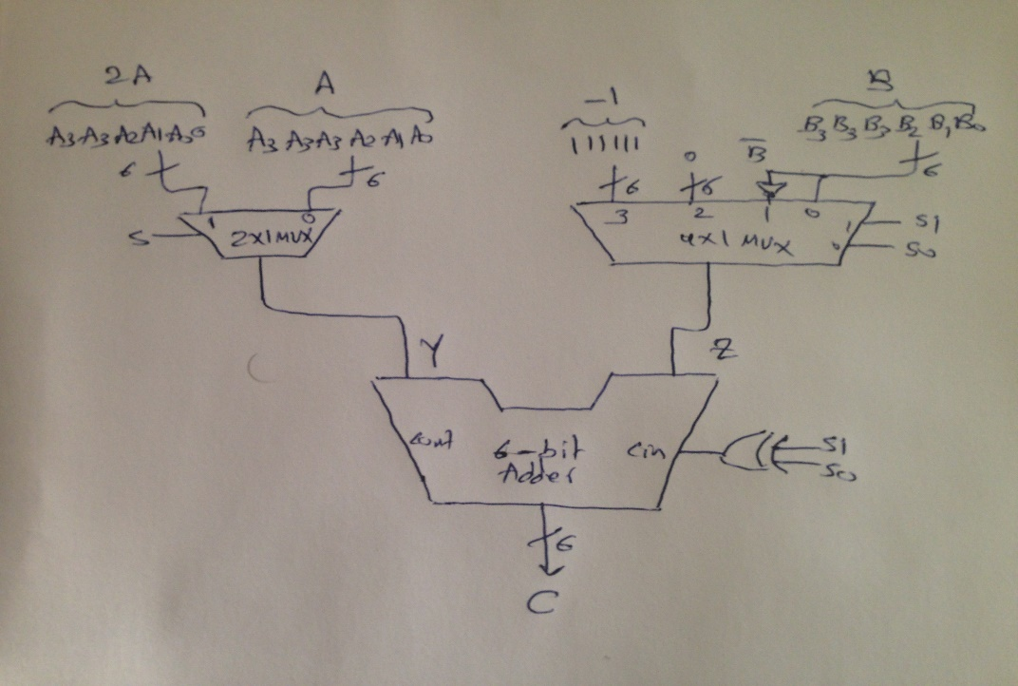

Model your design in Verilog by modeling each component separately i.e. adder, MUX, etc. and then instantiate these components to model your circuit.

module Mux2x1 (output [5:0] y, input [5:0] a, b, input s);

assign y = (s ? b : a);

endmodule

module Mux4x1(output reg [5:0] z, input [5:0] a, b, c, d, input s1, s0);

always@(s1, s0, a, b, c, d) begin
case ({s1, s0})
2'b00: z=a;
2'b01: z=b;
2'b10: z=c;
2'b11: z=d;
endcase
end

endmodule

module Adder (output [5:0] sum, input [5:0] a, b, input cin);

assign sum = a + b + cin;

endmodule

module Quiz4 (output [5:0] C, input [3:0] A, B, input [2:0] S);

wire [5:0] Y, Z;
assign cin = S[0]^S[1];
Mux2x1 M1 (Y, {A[3],A[3],A}, {A[3],A,1'b0}, S[2]);
Mux4x1 M2 (Z , {B[3],B[3],B}, ~{B[3],B[3],B}, 6'b000000 , 6'b111111, S[1],S[0]);
Adder M3 (C, Y, Z, cin);

endmodule

Write a Behavioral Verilog model to model the given circuit.

module Quiz4Behav (input [3:0] A, B, input s2, s1, s0, output reg[5:0]C);

wire [4:0] A5;
wire [5:0] A6, B6;
assign A5={ A[3], A};
assign A6={ A[3], A[3], A};
assign B6={ B[3], B[3], B};

always @* begin
case ({s2,s1,s0})
3'b000: C = A6 + B6;
3'b001: C = A6 – B6;
3'b010: C = A6 + 1;
3'b011: C = A6 - 1;
3'b100: C = 2*A5 + B6;
3'b101: C = 2*A5 – B6;
3'b110: C = 2*A5 + 1;
3'b111: C = 2*A5 – 1;
endcase
end
endmodule

