Name: KEY Id#

COE 405, Term 152

Design & Modeling of Digital Systems

Quiz# 2

Date: Sunday, Feb. 28, 2016

It is required to design a sequential circuit that has a single input X representing a signed 2's complement number and a single output Y. The circuit receives the number serially through the input X from the least significant bit (LSB) to the most significant bit (MSB), and computes the equation Y=X-3 and generates the output serially from the least significant bit to the most significant bit. The circuit has an additional asynchronous reset input R that resets the circuit into an initial state. The following are examples of input and output data:

Examples:
LSB
MSB
Output=3
Input=6
Input | X | 0 | 1 | 1 | 0 | 0
Output | Y | 1 | 1 | 0 | 0 | 0
MSB
LSB
Output=9
Input=12
Input | X | 0 | 0 | 1 | 1 | 0
Output | Y | 1 | 0 | 0 | 1 | 0

Draw a state diagram or show the state table of the circuit with minimum number of states assuming a Mealy model. You are not required to implement the circuit.

Present State | Next State, Y
 | X=0 | X=1
S0 (B=3) | S1, 1 | S2, 0
S1 (B=2) | S2, 0 | S2, 1
S2 (B=1) | S2, 1 | S3, 0
S3 (B=0) | S3, 0 | S3, 1

Consider the given FSM that has 4states, one input X and one output Z, represented by the following state table:

Present State | Next State, Z
 | X=0 |  | X=1
S0 | S1, 0 | S2, 0
S1 | S0, 0 | S3, 0
S2 | S2, 0 | S3, 1
S3 | S3, 0 | S2, 1

Determine the equivalent states.

S1 | (S2, S3)
S2
S3 |  |  | √
 | S0 | S1 | S2

Thus, the equivalent states are (S0, S1) and (S2, S3).

Reduce the state table into the minimum number of states and show the reduced state table.

Present State | Next State, Z
 | X=0 |  | X=1
S0 | S0, 0 | S2, 0
S2 | S2, 0 | S2, 1

Consider the sequential circuit given below having 5 inputs {A, B, C, D, E} and one output {Z}. Assume that the delay of a gate is related to the number of inputs i.e. the delay of a 2-input AND gate is 2 unit delays and the delay of a 2-input OR gate is 2 unit delays.

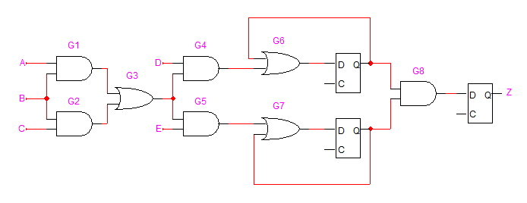

Determine the critical path of this circuit and the maximum propagation delay.

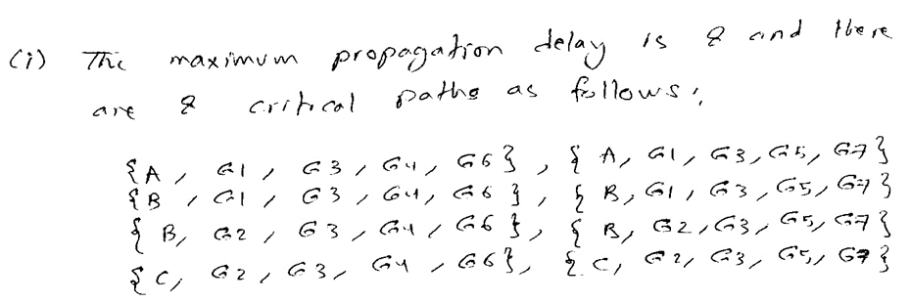

Using only the Retiming transformation, reduce the critical path of this circuit with the minimum number of flip-flops possible. Determine the maximum propagation delay after retiming.

