

COE 405


VHDL

By Dr.
Aiman El-Maleh

Rayan Jamal Mufti
985023
Burhan Ali
987528

Q.1.
(i)

The intity description of the four bit carry look ahead adder is as follow:

-----------------------------------------------------------------------------------
-- I N T I T Y D E S C R I P T I O N O F C L A
-----------------------------------------------------------------------------------
--
ENTITY CLA is
PORT ( A,B: in Bit_Vector (3 DOWNTO 0); -- A & B ==> four bit inputs each.
C0: in Bit; -- C0 ==> Carry in (C zero).
S: out Bit_Vector (3 DOWNTO 0); -- S ==> four bit output.
C4: out Bit); -- C4 ==> Carry out.
END CLA;
--

Q.1.
(ii)

------------------------------------------------------------------------------------
-- A R C H I T E C T U R E D E S C R I P T I O N OF C L A
------------------------------------------------------------------------------------
--
ARCHITECTURE Arch1 of CLA4 is
SIGNAL C1,C2,C3: Bit;
SIGNAL P,G: Bit_Vector (3 DOWNTO 0);
BEGIN
P(0) <= A(0)XOR B(0); -- The propagate function of A & B.
G(0) <= A(0)AND B(0); -- The generate function of A & B.
S(0) <= P(0)XOR C0 after 5 ns; -- The sum of A & B.
C1 <= G(0)OR -- The carry is generated after 2 gates only.
(P(0)AND C0) after 3 ns;
------------------------------------------------------------------------------------
P(1) <= A(1)XOR B(1); -- The propagate function of A & B.
G(1) <= A(1)AND B(1); -- The generate function of A & B.
S(1) <= P(1)XOR C1 after 5 ns; -- The sum of A & B.
C2 <= G(1)OR(P(1)AND G(0))OR -- The carry is generated after 2 gates only.
(P(1)AND P(0)AND C0) after 3 ns;
------------------------------------------------------------------------------------
P(2) <= A(2)XOR B(2); -- The propagate function of A & B.
G(2) <= A(2)AND B(2); -- The generate function of A & B.
S(2) <= P(2)XOR C2 after 5 ns; -- The sum of A & B.
C3 <= G(2)OR (P(2)AND G(1))OR
(P(2)AND P(1)AND G(0))OR -- The carry is generated after 2 gates only.
(P(2)AND P(1)AND P(0)AND C0) after 4 ns;
------------------------------------------------------------------------------------
P(3) <= A(3)XOR B(3); -- The propagate function of A & B.
G(3) <= A(3)AND B(3); -- The generate function of A & B.
S(3) <= P(3)XOR C3 after 5 ns; -- The sum of A & B.
C4 <= G(3)OR (P(3)AND G(2))OR
(P(3)AND P(2)AND G(1))OR -- The carry is generated after 2 gates only.
(P(3)AND P(2)AND P(1)AND G(0))OR
(P(3)AND P(2)AND P(1)AND P(0)AND C0) after 5 ns;
END Arch1;

Q.1.
(iii)

The simulation is working properly.
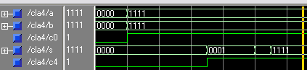
Example: A: 1111
B: 1111 +
C0: 1 +
-------
S: 1111
C4 1

>force A 1111 2ns
>force B 1111 2ns
>force C0 1 2ns
>run 15
- - - - - - - - - - - - - - - - - - - - - - - - - - - - - - - - - - - - - - - - - -
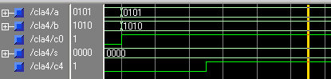
Example: A: 0101
B: 1010 +
C0: 1 +
-------
S: 0000
C4 1

>force A 0101 2ns
>force B 1010 2ns
>force C0 1 2ns
>run 15

- - - - - - - - - - - - - - - - - - - - - - - - - - - - - - - - - - - - - - - - - -
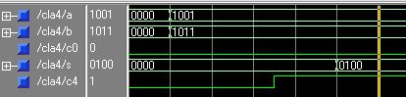
Example: A: 1001
B: 1011 +
C0: 0 +
-------
S: 0100
C4 1

>force A 1001 2ns
>force B 1011 2ns
>force C0 0
>run 15

- - - - - - - - - - - - - - - - - - - - - - - - - - - - - - - - - - - - - - - - - -
Q.2.
(i)

The Adder8 uses 2 instants of the four bits CLA. The carry goes out from CLA1 as C4 and connects to CLA2 C4 via an internal signal called “Inter_Carry”.

-----------------------------------------------------------------------------------
-- I N T I T Y D E S C R I P T I O N O F A d d e r 8
-----------------------------------------------------------------------------------
--
ENTITY Adder8 IS
PORT (
SIGNAL X,Y : IN bit_vector (7 DOWNTO 0); -- X & Y ==> eight bit inputs each.
SIGNAL Z0 : IN bit ; -- Carry in
SIGNAL P : OUT bit_vector (7 DOWNTO 0) ; -- P ==> eight bit inputs each.
SIGNAL R8 : OUT bit ) ; -- Carry out
END Adder8 ;
--

Q.2.
(ii)
--
------------------------------------------------------------------------------------
-- A R C H I T E C T U R E D E S C R I P T I O N O F A d d e r 8
------------------------------------------------------------------------------------
--
ARCHITECTURE Struct OF Adder8 IS
SIGNAL Inter_Carry : bit;
COMPONENT CLA4
PORT (
A,B: in Bit_Vector (3 downto 0);
C0: in Bit;
S: out Bit_Vector (3 downto 0);
C4: out Bit
);
END COMPONENT;
BEGIN
-- Instantiation:

CLA1: CLA4 PORT MAP ( X(3 DOWNTO 0) --X(3),X(2),X(1),X(0)
Y(3 DOWNTO 0), --Y(3),Y(2),Y(1),Y(0)
Z0,
P(3 DOWNTO 0), --P(3),(2),P(1),P(0)
Inter_Carry
);

CLA2: CLA4 PORT MAP ( X(7 DOWNTO 4), --X(7),X(6),X(5),X(4)
Y(7 DOWNTO 4), --Y(7),Y(6),Y(5),Y(4)
Inter_Carry,
P(7 DOWNTO 4), --P(7),P(6),P(5),P(4)
C8
);
END Struct;
Q.2.
(iii)

The simulation is working properly.
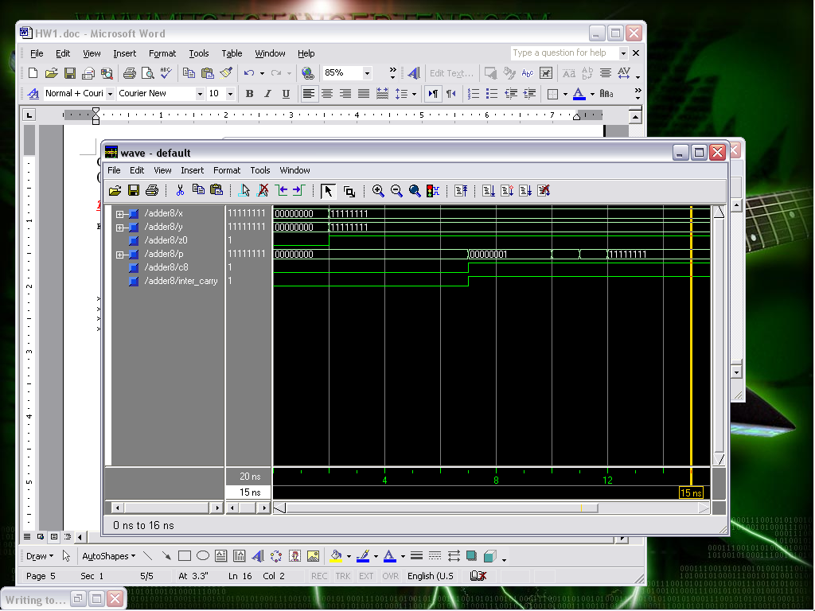
Example: X: 1111 1111
Y: 1111 1111 +
Z0: 1 +
------------
P: 1111 1111
C8 1

>force X 11111111 2ns
>force Y 11111111 2ns
>force Z0 1 2ns
>run 20

- - - - - - - - - - - - - - - - - - - - - - - - - - - - - - - - - - - - - - - - - -

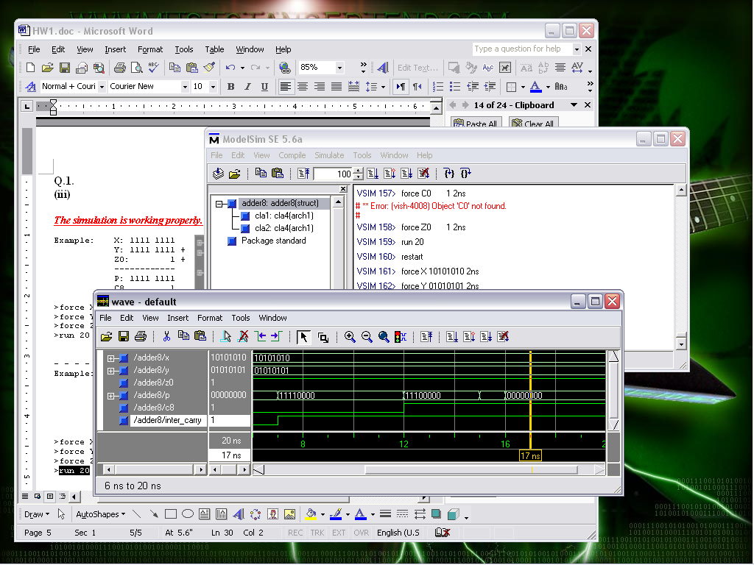
Example: X: 1010 1010
Y: 0101 0101 +
Z0: 1 +
------------
P: 0000 0000
C8 1

>force X 10101010 2ns
>force Y 01010101 2ns
>force Z0 1 2ns
>run 20

- - - - - - - - - - - - - - - - - - - - - - - - - - - - - - - - - - - - - - - - - -

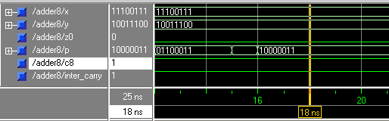
Example: X: 1110 0111
Y: 1001 1100 +
Z0: 0 +
------------
P: 1000 0011
C8 1

>force X 11100111 2ns
>force Y 10011100 2ns
>force Z0 1 2ns
>run 20

