Name: Id#

COE 301/ICS 233, Term 172

Computer Architecture & Assembly Language

Quiz# 6

Date: Tuesday, April 17, 2018

Q1. Consider the single-cycle datapath and control given below along with ALU design for the MIPS processor implementing a subset of the instruction set:

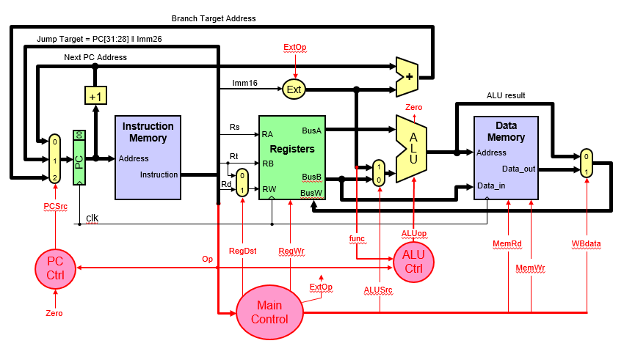

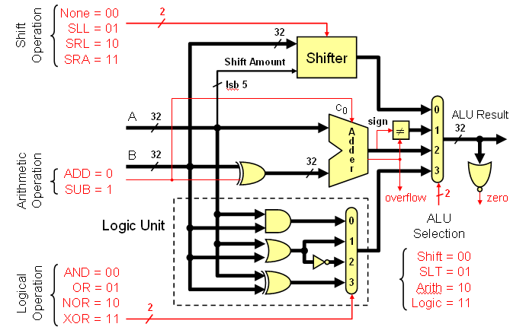

(5 points) Show the control signals generated for the execution of the following instructions by filling the table given below:

Op | RegDst | RegWrite | ExtOp | ALUSrc | MemRead | MemWrite | WBdata
R-type
xori
lw
bne
j

(4 points) Show the block diagram for designing the main control unit for this CPU and show the logic gates or equations for the control signals RegDst, RegWrite and ExtOp based on these instructions. Assume that the opcode of these instructions is a 6-bit opcode such that the opcode for R-type instructions is 0, the opcode for xori is 1, the opcode for lw is 2, and so on for the rest of the instructions.

(12 points) We wish to add the following instructions to the MIPS single-cycle datapath. Add any necessary datapath modifications and control signals needed for the implementation of these instructions. Show only the modified and added components to the datapath.

  - srl

  - lui

  - bgtz

  - jal

