***King Fahd University of Petroleum and Minerals***

***College of Computer Science and Engineering***

***Computer Engineering Department***

COE 301 COMPUTER ORGANIZATION

**ICS 233: COMPUTER ARCHITECTURE & ASSEMBLY LANGUAGE**

**Term 161 (Fall 2016-2017)**

**Major Exam 2**

**Saturday Dec. 10, 2016**

**Time: 150 minutes, Total Pages: 13**

**Name:______________________________ ID:__________________ Section: _______**

**Notes:**

* Do not open the exam book until instructed
* Answer all questions
* All steps must be shown
* Any assumptions made must be clearly stated

|  |  |  |
| --- | --- | --- |
| **Question** | **Max Points** | **Score** |
| **Q1** | **20** |  |
| **Q2** | **10** |  |
| **Q3** | **17** |  |
| **Q4** | **23** |  |
| **Total** | **70** |  |

Dr. Aiman El-Maleh

Dr. Marwan Abu Amara

# **[20 Points]**

# **(Q1)** Write MIPS programs with minimal used instructions. Use MIPS programming convention in saving and restoring registers in procedures.

## **[4 points]** Write a procedure **GetAscii** that receives a single hexadecimal digit in register $a0 and returns the ASCII code of that digit in register $v0.For example, if $a0=0x9 the procedure will return 0x39 in $v0 and if $a0=0xA, the procedure will return 0x41 in $a0. Assume the use of capital letters for the digits A to F.

## **[11 points]** Write a procedure **DispHex** that receives a number in register $a0 and displays the hexadecimal representation of that number. Only significant hexadecimal digits need to be displayed. For example, if $a0=0x1E, the procedure will display 1E. Your DisHex procedure should utilize the GetAscii procedure.

## **[5 points]** Write a MIPS program that asks the user to enter a decimal number and displays its hexadecimal content using the **DispHex** procedure. Two sample runs of the program are given below:

Enter a decimal number: 260

Your number in hexadecimal is: 0x104

Enter a decimal number: 0

Your number in hexadecimal is: 0x0

.data

Prompt: .asciiz "Enter a decimal number: "

MSG: .asciiz "Your number in hexadecimal is: 0x"

TTable: .ascii "0123456789ABCDEF"

.text

la $a0, Prompt

li $v0, 4

syscall

li $v0, 5

syscall

move $s0, $v0

la $a0, MSG

li $v0, 4

syscall

move $a0, $s0

jal DispHex

li $v0, 10

syscall

DispHex:

#save registers

addi $sp, $sp, -12

sw $s0, 0($sp)

sw $s1, 4($sp)

sw $s2, 8($sp)

li $s0, 8

move $s1, $a0

li $s2, 0

Next:

rol $s1, $s1, 4

andi $t0, $s1, 0xF

bne $s2, $0, Sig

beq $s0, 1, Sig

beq $t0, $0, Skip

li $s2, 1

Sig:

move $a0, $t0

addi $sp, $sp, -4

sw $ra, ($sp)

jal GetAscii

lw $ra ($sp)

addi $sp, $sp, 4

move $a0, $v0

li $v0, 11

syscall

Skip:

addi $s0, $s0, -1

bne $s0, $0, Next

# restore registers

lw $s0, 0($sp)

lw $s1, 4($sp)

lw $s2, 8($sp)

addi $sp, $sp, 12

jr $ra

**GetAscii**:

la $t0, TTable

add $t0, $t0, $a0

lb $v0, ($t0)

jr $ra

**[10 points]**

**(Q2)**

## **[4 Points]** Given that **Multiplicand=0111** and **Multiplier=1011** are signed 2’s complement numbers, show the **signed** multiplication of **Multiplicand** by **Multiplier**. The result of the multiplication should be an 8 bit **signed** number in HI and LO registers. Show the steps of your work.

|  |  |  |  |  |
| --- | --- | --- | --- | --- |
| **Iteration** | | **Multiplicand** | **Sign** | **Product =HI,LO** |
| 0 | Initialize | **0111** |  | **0000 1011** |
| 1 | LO[0] = 1 => ADD |  | **0** | **0111 1011** |
| Shift Product = (HI, LO) right 1 bit | **0111** |  | **0011 1101** |
| 2 | LO[0] = 1 => ADD |  | **1** | **1010 1101** |
| Shift Product = (HI, LO) right 1 bit | **0111** | *overflow* | **0~~1~~101 0110** |
| 3 | LO[0] = 0 => Do nothing |  | **0** | **0101 0110** |
| Shift Product = (HI, LO) right 1 bit | **0111** |  | **0010 1011** |
| 4 | LO[0] = 1 => SUB (ADD 2's compl) | **1001** | **1** | **1011 1011** |
| Shift Product = (HI, LO) right 1 bit |  |  | **1101 1101** |

## **[6 Points]** Given that **Dividend=0111** and **Divisor=1011** are signed 2’s complement numbers, show the **signed** division of **Dividend** by **Divisor**. The result of division should be stored in the Remainder and Quotient registers. Show the steps of your work, and show the final result.

## Since the Divisor is negative, we take its 2’s complement ⇒ Divisor = 0101

Sign of Quotient = negative, Sign of Remainder = positive

|  |  |  |  |  |  |
| --- | --- | --- | --- | --- | --- |
| **Iteration** | | **Remainder (HI)** | **Quotient (LO)** | **Divisor** | **Difference** |
| 0 | Initialize | **0000** | **0111** | **0101** |  |
| 1 | 1: SLL, Difference | **0000** | **1110** | **0101** | **1011** |
| 2: Diff < 0 => Do Nothing | **0000** | **1110** | **0101** |  |
| 2 | 1: SLL, Difference | **0001** | **1100** | **0101** | **1100** |
| 2: Diff < 0 => Do Nothing | **0001** | **1100** | **0101** |  |
| 3 | 1: SLL, Difference | **0011** | **1000** | **0101** | **1110** |
| 2: Diff < 0 => Do Nothing | **0011** | **1000** | **0101** |  |
| 4 | 1: SLL, Difference | **0111** | **0000** | **0101** | **0010** |
| 2: Rem = Diff, set lsb Quotient | **0010** | **0001** | **0101** |  |
| Final Result | | **0010** | **1111** |  |  |

**[17 points]**

**(Q3)**

1. **[2 Points]** Find the **decimal value** of the following single precision float:

[0, 1000 1000, 0000 0100 1100 0000 0000 000]

= + (1.0000010011000...0)2 * 2(136-127) = + (1.0000010011000...0)2* 29

= +1000001001.1 = **+521.5**

1. **[2 Points]** Find the **decimal value** of the following single precision float:

[1, 0000 0000, 0110 0000 0000 0000 0000 000]

= - (0.01100...0)2 * 2-126 = **-1.5 × 2-128**

1. **[3 Points]** Find the normalized single precision representation of –59.625.

59.625 = 111011.101 = 1.11011101 * 25

Exponent = 5 + 127 = 132

**[1, 1000 0100, 1101 1101 0000 0000 0000 000]**

1. **[4 Points]** Round the given single precision float with the given GRS bits using the following rounding modes showing the resulting normalized number:

**GRS**

**+1.111 1111 1111 1111 1111 1111 100 x 2-127**

Zero: [ **+1.111 1111 1111 1111 1111 1111 x 2-127** ]

+infinity: [ **+1.000 0000 0000 0000 0000 0000 x 2-126** ]

-infinity: [ **+1.111 1111 1111 1111 1111 1111 x 2-127** ]

Nearest Even: [ **+1.000 0000 0000 0000 0000 0000 x 2-126** ]

1. **[6 Points]** Find the normalized **difference** between **A** and **B** (i.e., A-B) by using rounding to **+infinity**. Perform the operation using **guard**, **round** and **sticky** bits.

**A = +1.000 0101 1100 1010 1000 0001 × 24**

**B = +1.011 1001 0101 0000 0010 1000 × 2-1**

**1.000 0101 1100 1010 1000 0001 000 x 24**

**- 1.011 1001 0101 0000 0010 1000 000 x 2-1**

**01.000 0101 1100 1010 1000 0001 000 x 24**

**- 00.000 0101 1100 1010 1000 0001 010 x 24 (align)**

**01.000 0101 1100 1010 1000 0001 000 x 24**

**+ 11.111 1010 0011 0101 0111 1110 110 x 24 (2’s complement)**

**00.111 1111 1111 1111 1111 1111 110 x 24**

**= + 0.111 1111 1111 1111 1111 1111 110 x 24**

**= + 1.111 1111 1111 1111 1111 1111 100 x 23 (normalize)**

**= + 10.000 0000 0000 0000 0000 0000 x 23 (round)**

**= + 1.000 0000 0000 0000 0000 0000 x 24 (renormalize)**

**[23 Points]**

# **(Q4)** Consider the single-cycle datapath and control given below along with ALU design for the MIPS processor implementing a subset of the instruction set:



## 

## Show the control signals generated for the execution of the following instructions by filling the table given below: **(5 points)**

|  |  |  |  |  |  |  |  |  |  |  |  |
| --- | --- | --- | --- | --- | --- | --- | --- | --- | --- | --- | --- |
| Op | RegDst | RegWrite | ExtOp | ALUSrc | ALUOp | Beq | Bne | J | MemRead | MemWrite | MemtoReg |
| R-type | 1 = Rd | 1 | x | 0=BusB | R-type | 0 | 0 | 0 | 0 | 0 | 0 |
| slti | 0 = Rt | 1 | 1=sign | 1=Imm | SLT | 0 | 0 | 0 | 0 | 0 | 0 |
| sw | x | 0 | 1=sign | 1=Imm | ADD | 0 | 0 | 0 | 0 | 1 | x |
| beq | x | 0 | x | 0=BusB | SUB | 1 | 0 | 0 | 0 | 0 | x |
| j | x | 0 | x | x | x | 0 | 0 | 1 | 0 | 0 | x |

## Excluding the ALUOp, Beq, Bne and J signals, show the design of the control unit for the control signals given in the table above based on the given instructions. Assume that the opcode of these instructions is a 6-bit opcode such that the opcode for R-type instructions is 0, the opcode for slti is 1, the opcode for sw is 2, and so on for the rest of the instructions. **(5 points)**

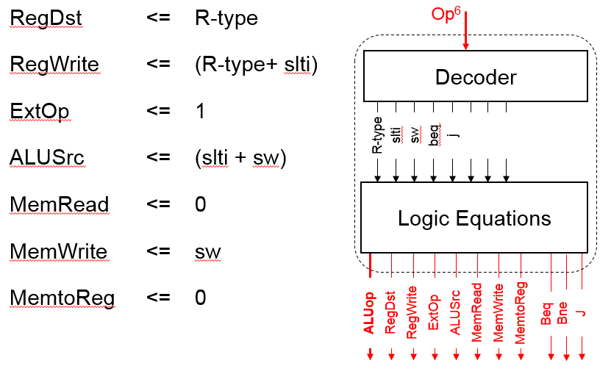

## Show the design of the Next PC block. **(4 points)**

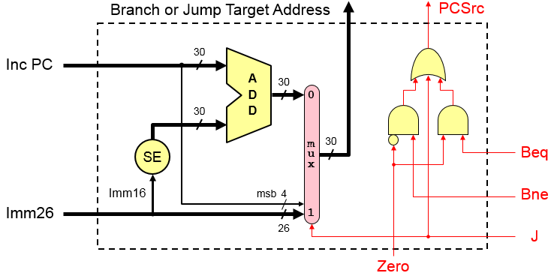

## We wish to add the following instructions to the MIPS single-cycle datapath. Add any necessary datapath modifications and control signals needed for the implementation of these instructions. Show only the **modified** and **added** components to the datapath.

* 1. sra **(3 points)**

|  |  |  |  |  |  |  |  |
| --- | --- | --- | --- | --- | --- | --- | --- |
| Instruction | Meaning | Format | | | | | |
| sra rd, rt, imm5 | rd= rt>>imm16 | Op6 = 0 | 0 | rt5 | rd5 | Imm5 | f6=3 |

For the sra instruction, examining the ALU one can see that the shift amont is coming through the A-input of the ALU and the operand to be shifted comes through the B input of the ALU. Thus, we need-to add a MUX on the A-input to select between the output of a register and the immediate values. This MUX needs to select only between the least significant 5 bits of BusA and bits 6 to 10 from Imm16. The modified part in the datapath is shown below:

**E**xt

A

L

U

ALUCtrl

BusA

BusB

ALUSrc

zero

Imm16

Imm32

**m**

**u**

**x**

0

1

0

**m**

**u**

**x**

0

1

0

Shifti

ExtOp

* 1. jr **(3 points)**

|  |  |  |  |  |  |  |  |
| --- | --- | --- | --- | --- | --- | --- | --- |
| Instruction | Meaning | Format | | | | | |
| jr rs | PC=rs | op6 = 0 | rs5 | 0 | 0 | 0 | 8 |

For this instruction, the changes required in the datapath to implement it is to load the PC from BusA, which is driven by the RS field. Thus, we need to add a MUX to select the target address to be loaded in the PC either from the output of the MUX choosing between the address from NextPC block and incremented PC or from BusA. The required changes are shown below:

PC

00

+1

30

**m**

**u**

**x**

0

1

0

jr

**m**

**u**

**x**

0

1

0

PCSrc

BusA

Address from NextPC

## Assume that the propagation delays for the major components used in the datapath are as follows:

* + - Instruction and data memories: 120 ps
    - ALU and adders: 30 ps
    - Register file access (read or write): 14 ps
    - Main control: 8 ps
    - ALU control: 7 ps

Ignore the delays in the multiplexers, PC access, extension logic, and wires. What is the cycle time for the single-cycle datapath given above? **(3 points)**

Cycle Time = IM + max(Main Control+ALU Control, Register Reading) + ALU + DM + Register Write

= 120 ps + 15 ps + 30 ps + 120 ps+ 14 ps = 299 ps

**Syscall Services:**

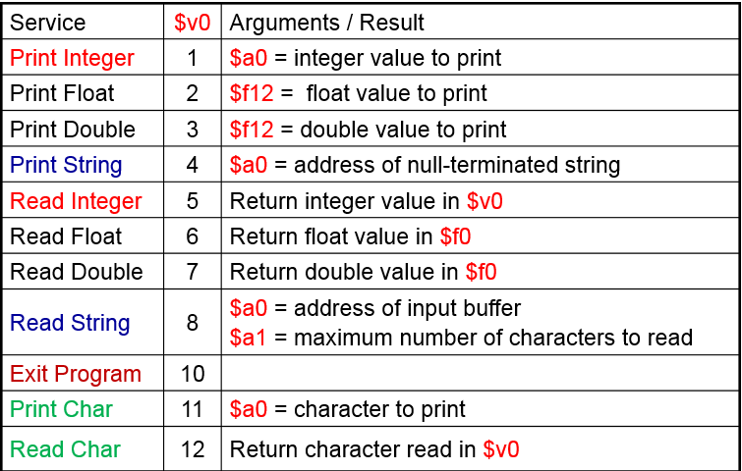

**MIPS Instructions:**

