King Fahd University of Petroleum and Minerals
College of Computer Science and Engineering
Computer Engineering Department

COE 301 COMPUTER ORGANIZATION
ICS 233: COMPUTER ARCHITECTURE & ASSEMBLY LANGUAGE
Term 171 (Fall 2017-2018)
Major Exam 1
Saturday Oct. 21, 2017

Time: 120 minutes, Total Pages: 10

Name:__KEY_________________________ ID:__________________ Section: _______

Notes:
- Do not open the exam book until instructed
- Answer all questions
- All steps must be shown
- Any assumptions made must be clearly stated
- No calculators are allowed to be used in the exam

Question | Max Points | Score
Q1 | 28
Q2 | 11
Q3 | 17
Total | 56

Dr. Aiman El-Maleh
Dr. Marwan Abu-Amara

[28 Points]

(Q1) Fill in the blank in each of the following questions:

Assuming 12-bit unsigned number representation, the binary number 1111 1111 0000 is equal to the decimal number 4080.

Assuming 16-bit signed 2`s complement representation, the hexadecimal number FEA0 is equal to the decimal number -352.

Two advantages of programming in assembly language are space and time efficiency and accessibility to system hardware.

Two advantages of programming in high-level language are programs are portable and program development and maintenance are faster.

The instruction set architecture of a processor consists of the instruction set, memory and programmer accessible registers.

With a 24-bit address bus and 32-bit data bus, the maximum memory size (assuming byte addressable memory) that can be accessed by a processor is 2²⁴=16 MB and the maximum number of bytes that can be read or written in a single cycle is 32/8=4.

The advantage of static RAM over dynamic RAM is that it is faster but the disadvantage is that it is less dense and more expensive.

Given a magnetic disk with the following properties:

- Time of one rotation is 8 ms
- Average seek = 8 ms, Sector = 512 bytes, Track = 200 sectors

The average time to access a block of 100 consecutive sectors is 8 ms + 0.5*8 ms + 100/200 * 8 ms = 16 ms.

Assuming variable Array is defined as shown below:

Array: .word 10
.half 11, 12
.byte 13, 14, 15, 16

The content of register $t1 (in hexadecimal) after executing the following sequence of instructions is 0x000c000b.

la $t0, Array
lw $t1, 4($t0)

The pseudo instruction bgt $s2, 10, Next is implemented by the following minimum MIPS instructions:

slti $at, $s2, 11
beq $at, $0, Next

The pseudo instruction li $t0, 0x12345678 is implemented by the following minimum MIPS instructions:

lui $t0, 0x1234

ori $t0, $t0, 0x5678

The pseudo instruction rol $s0, $s0, 4 ($s0 is rotated to the left by 4 bits and stored in $s0) is implemented by the following minimum MIPS instructions:

srl $at, $s0, 28

sll $s0, $s0, 4

or $s0, $s0, $at

Assuming that $a0 contains an Alphabetic character, the instruction andi $a0, $a0, 0xDF will make the character stored in $a0 always upper case. Note that the ASCII code of character ‘A’ is 0x41 while that of character ‘a’ is 0x61.

Assume that the instruction bne $t0, $t1, NEXT is at address 0x00400040 in the text segment, and the label NEXT is at address 0x00400028. Then, the value stored in the assembled instruction for the label NEXT is (0x00400028-0x00400044)/4=FFF9.
-

Assuming that variable Array is defined as shown below:

Array2: .half -2,-3, 4, 5

After executing the following sequence of instructions, the content of the two registers (in hexadecimal) is $t1=000000FF and $t2=FFFFFFFD.

la $t0, Array2
lbu $t1, 1($t0)
lh $t2, 2($t0)

Assuming the following data segment, and assuming that the first variable X is given the address 0x10010000, then the addresses for variables Y and Z will be 0x10010006 and 0x10010010.

.data

X: .byte 10, 11, 12, 13, 14

Y: .half 15, 16, 17, 18

Z: .word 19, 20

To multiply the signed content of register $t0 by 112 without using multiplication instructions, we use the following minimum MIPS instructions (HINT: 112=16*7):

sll $t1, $t0, 4

sll $t0, $t1, 3

sub $t0, $t0, $t1

[11 Points]

(Q2) Answer each of the following questions. Show how you obtained your answer:

(i) Given that TABLE is defined as: TABLE: .asciiz "Aiman El-Maleh"

Determine the content of register $t0 after executing the following code:

xor $t0, $t0, $t0
la $t1, TABLE
li $t2, 'a'
Next: lbu $t3, ($t1)
beq $t3, $zero, ENL
ori $t3, $t3, 0x20
addi $t1, $t1, 1
bne $t2, $t3, Next
addi $t0, $t0, 1
j Next
ENL:

The content of register $t0=3 as the program counts the number of characters equal to ‘A’ or ‘a’ in TABLE.

(ii) Determine the content of register $t1 after executing the following code:

li $t0, 0x1234
xor $t1, $t1, $t1
AGAIN: andi $t2, $t0, 0xf
add $t1, $t1, $t2
srl $t0, $t0, 4
bne $t0, $zero, AGAIN

The content of register $t1=0xA as the program computes the sum of the hexadecimal digits in register $t0.

(iii) Given that TABLE is defined as: TABLE: .word 90, 70, 80, 60, 100

Determine the content of register $v0 after executing the following code:

la $a0, TABLE
addi $a1, $a0, 16
lw $v0, 0($a0)
loop: addi $a0, $a0, 4
lw $t1, 0($a0)
bge $t1, $v0, skip
move $v0, $t1
skip: bne $a0, $a1, loop

The content of register $v0=0x3C=60 as the program computes the minimum of the numbers stored in TABLE.

[17 points]

(Q3) Write separate MIPS assembly code fragments with minimum instructions to implement each of the given requirements. You can use pseudo instructions in your solution.

[10 points] Write a MIPS code fragment that returns the maximum integer value found in a user-specified row number of a 32 × 32 matrix A of 32-bit signed integers. The program should read the desired row number from the user and check that it is in the range between 0 and 31. If not, the program should display the error message “Row number is out of range.” and terminate. Otherwise, the program should display the message “Maximum integer in the row is ” and the value of the maximum integer found in the specified row, and then terminate. Assume that matrix A is already stored in memory.

.data
prompt: .asciiz "Please enter a row number between 0 and 31: "
outofrange: .asciiz "Row number is out of range.\n"
outmsg: .asciiz "Maximum integer in the row is "

.text
.globl main
main:
la $a0,prompt # display prompt string
li $v0,4
syscall
li $v0,5 # read row number into $t0
syscall
move $t0,$v0
bltz $t0,error # check row boundary
addiu $t1,$t0,-31 # If $t0 > 31, then result of ($t0-31) > 0
bgtz $t1,error
la $t1,A # compute starting location of 1st element in desired row
sll $t2,$t0,5 # $t2 = i*32 (ixCOL+0)
sll $t2,$t2,2 # $t2 = i*32*4 (ixCOL+0)x(int size)
addu $t2,$t1,$t2 # $t2 = address of 1st element in desired row
li $t3,31 # max j = 31
lw $t4,0($t2) # read 1st element of desired row & set as maximum
loop:
addiu $t2,$t2,4 # increment index to point to next row element
lw $t5,0($t2) # read next element of desired row
ble $t5,$t4,next # next element ($t5) <= current max ($t4)?
move $t4,$t5 # No -> set max ($t4) = next element ($t5)
next:
addiu $t3,$t3,-1 # prepare for next row element
bgtz $t3,loop
la $a0,outmsg # display prompt string
li $v0,4
syscall
move $a0,$t4 # output $t4 = maximum in desired row
li $v0,1
syscall
j exit
error:
la $a0,outofrange
li $v0,4
syscall
exit:
li $v0,10 # exit
syscall

[7 points] Given two arrays A and B, write the smallest MIPS assembly fragment for the following computation. Assume that register $s0 will be used to store cnt and assume that the following registers have the mentioned values: register $s1 = number of elements, N, in each array, register $s2 = base address of the array A, and register $s3 = base address of the array B. Each array element is a 32-bit signed integer. Assume that N > 0. Insert comments to clarify the meaning of instructions and the use of registers.

int cnt = 0;
for (i=0; i != N; i++) {
if (((A[i] – B[i]) > 5) || ((B[i] – A[i]) > 5)) cnt = cnt + 1;
}

li $s0,0 # $s0 = cnt = 0
loop:
lw $t0,0($s2) # $t0 = A[i]
lw $t1,0($s3) # $t1 = B[i]
addiu $t2,$t0,5 # $t2 = A[i]+5
addiu $t3,$t1,5 # $t3 = B[i]+5
bgt $t0,$t3,incr # Check if (A[i]-B[i]>5)
ble $t1,$t2,done # Check if (B[i]-A[i]>5)
incr:
addiu $s0,$s0,1 # cnt++
done:
addiu $s2,$s2,4 # point to A[i+1]
addiu $s3,$s3,4 # point to B[i+1]
addiu $s1,$s1,-1 # decrement loop index
bne $s1,$0,loop

MIPS Instructions:

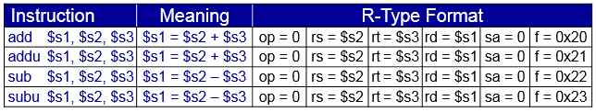
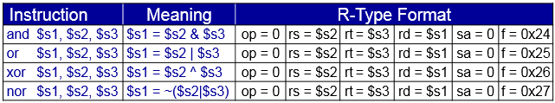
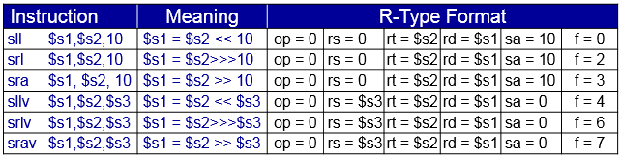
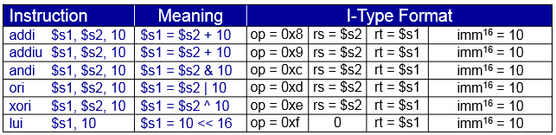
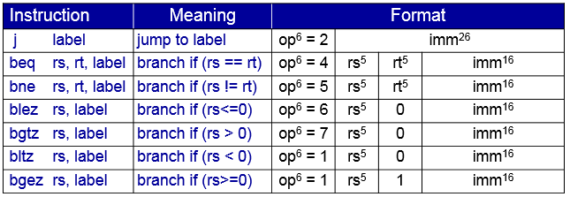
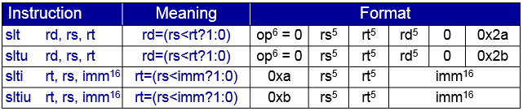
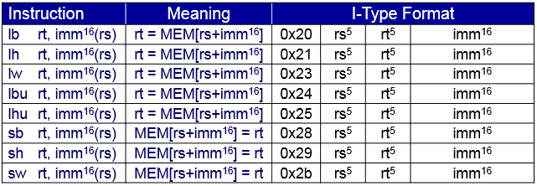

Syscall Services:

