King Fahd University of Petroleum and Minerals
College of Computer Science and Engineering
Computer Engineering Department

COE 301 COMPUTER ORGANIZATION
ICS 233: COMPUTER ARCHITECTURE & ASSEMBLY LANGUAGE
Term 171 (Fall 2017-2018)
Major Exam 1
Saturday Oct. 21, 2017

Time: 120 minutes, Total Pages: 10

Name:______________________________ ID:__________________ Section: _______

Notes:
- Do not open the exam book until instructed
- Answer all questions
- All steps must be shown
- Any assumptions made must be clearly stated
- No calculators are allowed to be used in the exam

Question | Max Points | Score
Q1 | 28
Q2 | 11
Q3 | 17
Total | 56

Dr. Aiman El-Maleh
Dr. Marwan Abu-Amara

[28 Points]

(Q1) Fill in the blank in each of the following questions:

Assuming 12-bit unsigned number representation, the binary number 1111 1111 0000 is equal to the decimal number _______________.

Assuming 16-bit signed 2`s complement representation, the hexadecimal number FEA0 is equal to the decimal number _______________.

Two advantages of programming in assembly language are___________________ _________________________________________________________________.

Two advantages of programming in high-level language are___________________ _________________________________________________________________.

The instruction set architecture of a processor consists of the instruction set, memory and ______________________________________________________.

With a 24-bit address bus and 32-bit data bus, the maximum memory size (assuming byte addressable memory) that can be accessed by a processor is ___________ and the maximum number of bytes that can be read or written in a single cycle is ____________.

The advantage of static RAM over dynamic RAM is that it is ________________ but the disadvantage is _______________________________________________.

Given a magnetic disk with the following properties:

- Time of one rotation is 8 ms
- Average seek = 8 ms, Sector = 512 bytes, Track = 200 sectors

The average time to access a block of 100 consecutive sectors is _______________________________________________ ms.

Assuming variable Array is defined as shown below:

Array: .word 10
.half 11, 12
.byte 13, 14, 15, 16

The content of register $t1 (in hexadecimal) after executing the following sequence of instructions is _____________.

la $t0, Array
lw $t1, 4($t0)

The pseudo instruction bgt $s2, 10, Next is implemented by the following minimum MIPS instructions:

______________________________________________________________________________________________________________________________________________________________________________________________________

The pseudo instruction li $t0, 0x12345678 is implemented by the following minimum MIPS instructions:

______________________________________________________________________________________________________________________________________________________________________________________________________

The pseudo instruction rol $s0, $s0, 4 ($s0 is rotated to the left by 4 bits and stored in $s0) is implemented by the following minimum MIPS instructions:

______________________________________________________________________________________________________________________________________________________________________________________________________

Assuming that $a0 contains an Alphabetic character, the instruction ____________________ will make the character stored in $a0 always upper case. Note that the ASCII code of character ‘A’ is 0x41 while that of character ‘a’ is 0x61.

Assume that the instruction bne $t0, $t1, NEXT is at address 0x00400040 in the text segment, and the label NEXT is at address 0x00400028. Then, the value stored in the assembled instruction for the label NEXT is __________________.

Assuming that variable Array is defined as shown below:

Array2: .half -2,-3, 4, 5

After executing the following sequence of instructions, the content of the two registers (in hexadecimal) is $t1=___________________, and $t2=____________________.

la $t0, Array2
lbu $t1, 1($t0)
lh $t2, 2($t0)

Assuming the following data segment, and assuming that the first variable X is given the address 0x10010000, then the addresses for variables Y and Z will be _____________ and _____________.

.data

X: .byte 10, 11, 12, 13, 14

Y: .half 15, 16, 17, 18

Z: .word 19, 20

To multiply the signed content of register $t0 by 112 without using multiplication instructions, we use the following minimum MIPS instructions (HINT: 112=16*7):

________________________________________________________________________________________________________________________________________________________________________________________________________________________________________________________________________

[11 Points]

(Q2) Answer each of the following questions. Show how you obtained your answer:

(i) Given that TABLE is defined as: TABLE: .asciiz "Aiman El-Maleh"

Determine the content of register $t0 after executing the following code:

xor $t0, $t0, $t0
la $t1, TABLE
li $t2, 'a'
Next: lbu $t3, ($t1)
beq $t3, $zero, ENL
ori $t3, $t3, 0x20
addi $t1, $t1, 1
bne $t2, $t3, Next
addi $t0, $t0, 1
j Next
ENL:

(ii) Determine the content of register $t1 after executing the following code:

li $t0, 0x1234
xor $t1, $t1, $t1
AGAIN: andi $t2, $t0, 0xf
add $t1, $t1, $t2
srl $t0, $t0, 4
bne $t0, $zero, AGAIN

(iii) Given that TABLE is defined as: TABLE: .word 90, 70, 80, 60, 100

Determine the content of register $v0 after executing the following code:

la $a0, TABLE
addi $a1, $a0, 16
lw $v0, 0($a0)
loop: addi $a0, $a0, 4
lw $t1, 0($a0)
bge $t1, $v0, skip
move $v0, $t1
skip: bne $a0, $a1, loop

[17 points]

(Q3) Write separate MIPS assembly code fragments with minimum instructions to implement each of the given requirements. You can use pseudo instructions in your solution.

[10 points] Write a MIPS code fragment that returns the maximum integer value found in a user-specified row number of a 32 × 32 matrix A of 32-bit signed integers. The program should read the desired row number from the user and check that it is in the range between 0 and 31. If not, the program should display the error message “Row number is out of range.” and terminate. Otherwise, the program should display the message “Maximum integer in the row is ” and the value of the maximum integer found in the specified row, and then terminate. Assume that matrix A is already stored in memory.

[7 points] Given two arrays A and B, write the smallest MIPS assembly fragment for the following computation. Assume that register $s0 will be used to store cnt and assume that the following registers have the mentioned values: register $s1 = number of elements, N, in each array, register $s2 = base address of the array A, and register $s3 = base address of the array B. Each array element is a 32-bit signed integer. Assume that N > 0. Insert comments to clarify the meaning of instructions and the use of registers.

int cnt = 0;
for (i=0; i != N; i++) {
if (((A[i] – B[i]) > 5) || ((B[i] – A[i]) > 5)) cnt = cnt + 1;
}

MIPS Instructions:

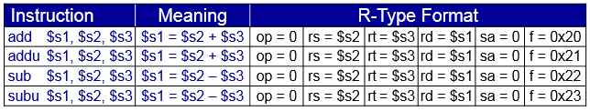
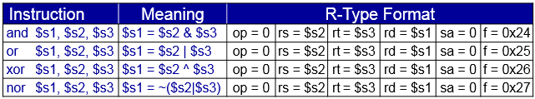
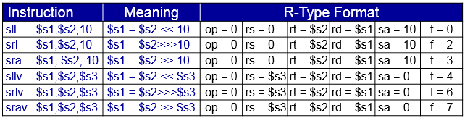
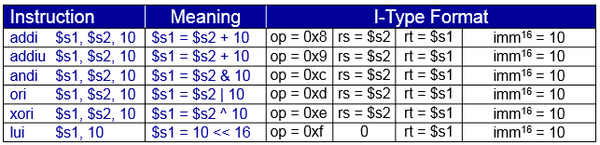
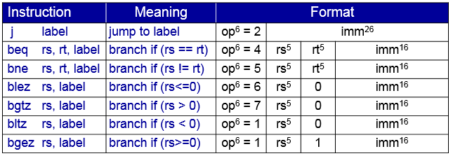
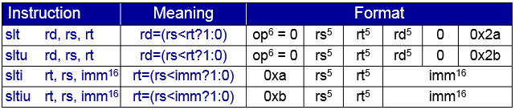
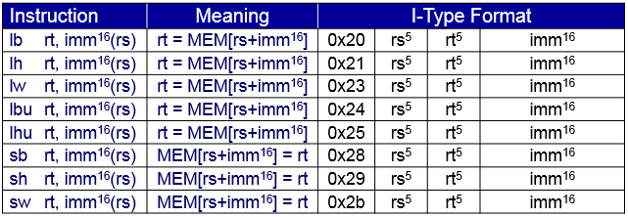

Syscall Services:

