COE 301 / ICS 233

Computer Organization

Final Exam – Spring 2017

Friday, May 19, 2017

7:30 – 10 AM

Computer Engineering Department

College of Computer Sciences & Engineering

King Fahd University of Petroleum & Minerals

Student Name: **SOLUTION**

Student ID:

|  |  |  |  |
| --- | --- | --- | --- |
| Q1 | / 14 | Q2 | / 16 |
| Q3 | / 15 | Q4 | / 18 |
| Q5 | / 10 | Q6 | / 20 |
| Q7 | / 10 |  |  |
| Total | / 103 | | |

Notes:

* This is a closed book and closed notes exam.
* Mobile phones and tablets are not allowed and should be switched off.
* Using unauthorized information on an exam is a severe violation of academic honesty. Detected cases will receive a failing grade.

**Question 1: True or False**

(14 pts) **Explain the reason why it is true or false for a full mark**.

**a)** (2 pts) A pipelined datapath must have separate instruction and data memories because the format of instructions is different from the format of data.

**False. It is because the instruction and data memories should be accessed in parallel during the same cycle. Otherwise, there will be a structural hazard.**

**b)** (2 pts)Allowing ALU instructions to write back their result in the 4th stage rather than the 5th stage, improves the performance of a MIPS 5-stage pipeline.

**False, it will cause a structural hazard. Pipeline performance depends on the rate of instruction completion, not on the latency of individual instructions.**

**c)** (2 pts) In the MIPS 5-stage pipeline, some but not all RAW data hazards can be eliminated by forwarding.

**True, the Load instruction has a delay that cannot be eliminated by forwarding.**

**d)** (2 pts) Name dependences such as Write-After-Read and Write-After-Write do not cause any hazard in the 5-stage pipeline and do not require special handling.

**True, because the register write-back is done in the last stage of the pipeline and is done in program order.**

**e)** (2 pts) A directly-mapped cache does not need to store tags because it is directly indexed. However, a fully-associative cache requires tags because it is not indexed.

**False. All caches require tags for block identification, whether the cache is directly-mapped or fully-associative.**

**f)** (2 pts) When comparing a set-associative with a directly-mapped cache with the same capacity (data size), the set-associative cache decreases the cache miss rate but increases the hit time.

**True. The set-associative cache reduces the cache miss rate because it provides more flexibility about block placement and less conflict misses. The hit time is increased because a multiplexer is used to select a block within the set.**

**g)** (2 pts) Each block in a write-through cache has a Modified bit to indicate whether the block is modified or not.

**False, the modified bit is used by Write-Back caches only to indicate that the block is modified.**

**Question 2: Single-Cycle / Multi-Cycle / Pipelined Performance**

(16 pts) Compare the performance of a **single-cycle** / **multi-cycle / pipelined** processor. The delay times are as follows:

Instruction memory access time = 500 ps Data memory access time = 500 ps

Instruction Decode and Register read = 300 ps Register write = 200 ps

ALU delay = 300 ps

Ignore the other delays in the multiplexers, wires, etc. Assume the following instruction mix: 35% ALU, 20% load, 10% store, 25% branch, and 10% jump.

1. (5 pts) Compute the delay for each instruction class for the **single-cycle** processor.

|  |  |  |  |  |  |  |
| --- | --- | --- | --- | --- | --- | --- |
| **Instruction**  **Class** | **Instruction**  **Memory** | **Decode and**  **Register Read** | **ALU** | **Data**  **Memory** | **Write**  **Back** | **Total**  **Delay** |
| **ALU** | **500** | **300** | **300** |  | **200** | **1300** |
| **Load** | **500** | **300** | **300** | **500** | **200** | **1800** |
| **Store** | **500** | **300** | **300** | **500** |  | **1600** |
| **Branch** | **500** | **300** | **300** |  |  | **1100** |
| **Jump** | **500** | **300** |  |  |  | **800** |

1. (2 pts) Compute the clock cycle for the **single-cycle** processor.

**Clock cycle = longest delay = 1800 ps**

1. (2 pts) Compute the clock cycle for the **multi-cycle** processor.

**Clock cycle for multi-cycle = max(500, 300, 200) = 500 ps**

1. (3 pts) Compute the average CPI for the **multi-cycle** processor.

**Average CPI = 0.35×4 + 0.2×5 + 0.1×4 + 0.25×3 + 0.1×2 = 3.75**

1. (2 pts) What is the speedup factor of the **multi-cycle** over the **single-cycle** processor?

**Speedup = 1800 × 1 / (500 × 3.75) = 1800 / 1875 = 0.96 (Multi-cycle is slower)**

1. (2 pts) What is the speedup factor of the **pipelined** over the **single-cycle** processor?

**Speedup = 1800 / 500 = 3.6 (Pipelined processor is faster)**

**Question 3: Performance of a MIPS program**

(15 pts) The following code fragment processes two single-precision floating-point arrays *A* and *B*, and modifies the array *B*. Each array consists of **500** single-precision floats. The addresses of *A* and *B* are stored in **$a0** and **$a1** respectively. Note that there is an outer loop and an inner loop in the MIPS assembly language code.

**li $a2, 500 # $a2 = 500**

**move $t0, $a0 # $t0 = address of array A**

**move $t4, $zero # $t4 = 0**

**mtc1 $zero, $f4 # $f4 = 0 (move to coprocessor 1)**

**outer: # outer loop**

**lwc1 $f0, ($t0) # load single-precision float**

**add.s $f4, $f4, $f0**

**move $t1, $a1 # $t1 = address of Array B**

**move $t5, $zero # $t5 = 0**

**inner: # inner loop**

**lwc1 $f1, ($t1) # load single-precision float**

**mul.s $f2, $f1, $f0**

**div.s $f3, $f2, $f4**

**swc1 $f3, ($t1) # store single-precision float**

**addi $t1, $t1, 4**

**addi $t5, $t5, 1**

**bne $t5, $a2, inner # end of inner loop**

**addi $t0, $t0, 4**

**addi $t4, $t4, 1**

**bne $t4, $a2, outer # end of outer loop**

The above code is executed on a processor with a **2 GHz** clock that requires the following number of cycles for each instruction:

|  |  |
| --- | --- |
| **Instruction** | **Cycles** |
| **li, move, mtc1, addi** | **3** |
| **lwc1, swc1** | **5** |
| **add.s, mul.s** | **10** |
| **div.s** | **20** |
| **bne** | **4** |

**a)** (3 pts) Count the total number of instructions executed by the above code fragment, including those executed outside the outer loop.

**b)** (6 pts) How many cycles does it take to execute the above code?

**c)** (2 pts) What is the execution time in nanoseconds?

**d)** (2 pts) What is the average CPI for the above code?

**e)** (2 pts) What is the MIPS rate for the above code?

**Solution:**

**a)** **Total Instructions = 4 (outside outer loop) +**

**7 (outer loop) × 500 +**

**7 (inner loop) × 500 × 500 = 1,753,504**

**b) Clock Cycles = 4 × 3 cycle (li, move, mtc1 outside outer loop) +**

**[1 × 5 (lwc1) + 10 (add.s) + 4 × 3 (move, addi) + 4 (bne) cycles] × 500 iterations +**

**[2 × 5 (lwc1, swc1) + 10 (mul.s) + 20 (div.s) + 2 × 3 (addi) + 4 (bne)] × 500 × 500**

**= 12 + 31 × 500 + 50 × 500 × 500 = 12,515,512 cycles**

**c) Clock cycle = 1 / 2 GHz = 0.5 ns**

**CPU Execution Time = 12,515,512 cycles × 0.5 ns = 6,257,756 ns**

**d) Average CPI = 12,515,512 cycles / 1,753,504 instructions = 7.137**

**e) MIPS Rate =** **1,753,504 / (6,257,756 × 10-9 × 106) = 280.02 MIPS**

**Question 4: MIPS 5-Stage Pipeline**

(18 pts) The following is a 5-stage pipeline for the MIPS processor that implements a subset of the MIPS instruction set, and that supports **forwarding** and **pipeline stall**.



Consider the following MIPS code that is being executed on the above 5-stage pipeline:

**I1: lw $t1, 8($t0)**

**I2: addi $t2, $t1, 2**

**I3: or $t3, $t1, $t2**

**I4: lw $t4, -4($t3)**

**I5: sub $t5, $t3, $t4**

**a)** (8 pts)Complete the following table showing the timing of the above code on the 5-stage pipeline MIPS processor (IF, ID, EX, MEM, WB). Draw an arrow showing forwarding between the stage that provides the data and the stage that receives the data. Show all stall cycles by placing an X in the box to represent a stall cycle.

|  |  |  |  |  |  |  |  |  |  |  |  |  |  |  |  |
| --- | --- | --- | --- | --- | --- | --- | --- | --- | --- | --- | --- | --- | --- | --- | --- |
|  | **1** | **2** | **3** | **4** | **5** | **6** | **7** | **8** | **9** | **10** | **11** | **12** | **13** | **14** | **15** |
| **I1: LW** | **IF** | **ID** | **EX** | **MEM** | **WB** |  |  |  |  |  |  |  |  |  |  |
| **I2: ADDI** |  | **IF** | **X** | **ID** | **EX** | **-** | **WB** |  |  |  |  |  |  |  |  |
| **I3: OR** |  |  |  | **IF** | **ID** | **EX** | **-** | **WB** |  |  |  |  |  |  |  |
| **I4: LW** |  |  |  |  | **IF** | **ID** | **EX** | **MEM** | **WB** |  |  |  |  |  |  |
| **I5: SUB** |  |  |  |  |  | **IF** | **X** | **ID** | **EX** | **-** | **WB** |  |  |  |  |

**b)** (10 pts) Complete the following table pertaining to the control signals needed for the execution of the following MIPS code on the 5-stage pipeline MIPS processor **during the first 9 clock cycles**. Use **?** for any control signal that is **unknown** during a given clock cycle and **X** for a **don't care**. Assume that instruction **I1:LW** is being fetched during **clock cycle** **1**. The control signals needed in the first clock cycle are shown as an example.

**I1: lw $t1, 8($t0)**

**I2: addi $t2, $t1, 2**

**I3: or $t3, $t1, $t2**

**I4: lw $t4, -4($t3)**

**I5: sub $t5, $t3, $t4**

|  |  |  |  |  |  |  |  |  |  |  |  |  |  |  |  |  |
| --- | --- | --- | --- | --- | --- | --- | --- | --- | --- | --- | --- | --- | --- | --- | --- | --- |
|  | **IF** | | **ID** | | | | | **EX** | | | | **MEM** | | | | **WB** |
| **Clock**  **Cycle** | **Disable PC (1=disable)** | **Disable IR (1=disable)** | **RegDst (0=Rt, 1=Rd)** | **ExtOp(0=zero,1=sign)** | **ForwardA** | **ForwardB** | **Stall** | **EX.RegWr** | **ALUSrc (0=B, 1=Imm)** | **ALUOp (add, sub, …)** | **EX.MemRd** | **MEM.RegWr** | **MEM.MemRd** | **MEM.MemWr** | **MEM.WBdata (0=ALU,1=MEM)** | **WB.RegWr** |
| **1** | 0 | 0 | ? | ? | ? | ? | ? | ? | ? | ? | ? | ? | ? | ? | ? | ? |
| **2** | 0 | 0 | 0 | 1 | 0 | 0 | 0 | ? | ? | ? | ? | ? | ? | ? | ? | ? |
| **3** | 1 | 1 | 0 | 1 | 1 | 0 | 1 | 1 | 1 | add | 1 | ? | ? | ? | ? | ? |
| **4** | 0 | 0 | 0 | 1 | 2 | 0 | 0 | 0 | 0 | 0 | 0 | 1 | 1 | 0 | 1 | ? |
| **5** | 0 | 0 | 1 | X | 3 | 1 | 0 | 1 | 1 | add | 0 | 0 | 0 | 0 | 0 | 1 |
| **6** | 0 | 0 | 0 | 1 | 1 | 0 | 0 | 1 | 0 | or | 0 | 1 | 0 | 0 | 0 | 0 |
| **7** | 1 | 1 | 1 | X | 2 | 1 | 1 | 1 | 1 | add | 1 | 1 | 0 | 0 | 0 | 1 |
| **8** | 0 | 0 | 1 | X | 3 | 2 | 0 | 0 | 0 | 0 | 0 | 1 | 1 | 0 | 1 | 1 |
| **9** | ? | ? | ? | ? | ? | ? | ? | 1 | 0 | sub | 0 | 0 | 0 | 0 | 0 | 1 |

**Question 5: MIPS 4-Stage Pipeline**

(10 pts) Given that the **load** and **store** instructions use **register-indirect addressing**, and always have a **zero offset**, there is NO need for the ALU to compute the memory address. The **load** and **store** instructions will have the following format, where **Rs** is the register that contains the memory address.

**LW Rt, (Rs) # No immediate constant used**

**SW Rt, (Rs) # No immediate constant used**

Accordingly, the MIPS pipeline can be modified to have only 4 stages: IF, ID, EX/MEM, and WB, as shown below. The modified pipeline MIPS processor eliminates the load delay and the RAW data hazard due to a load instruction.

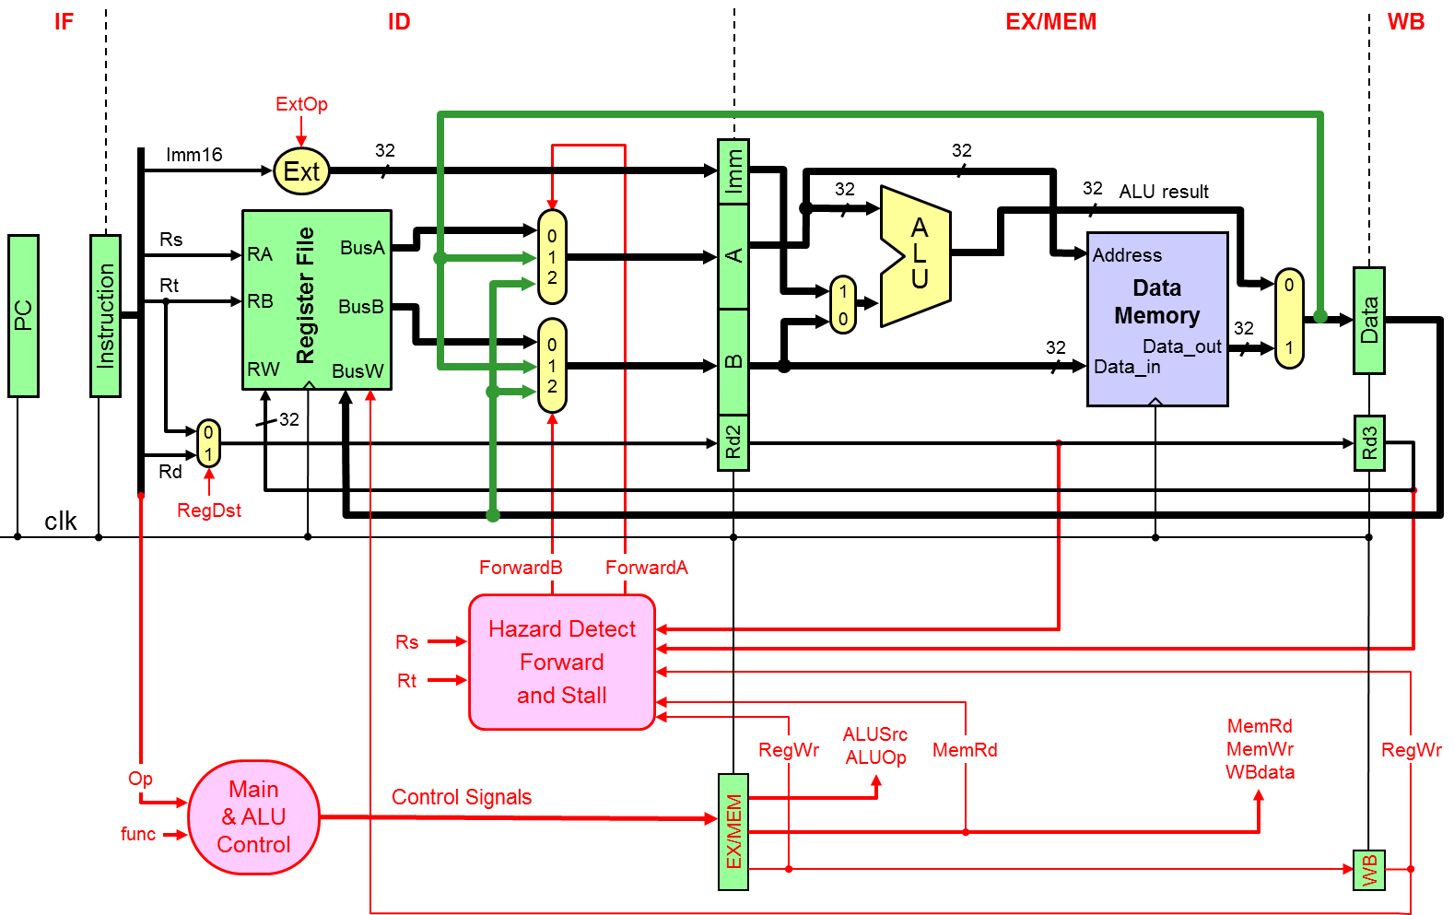

**a)** (4 pts) Provide the **control signals values** needed for executing the **LW** instruction.

**b)** (6 pts) Write the **if-statement** that will be used for generating the **ForwardA** signal.

**Solution a) Control signals for LW**

|  |  |  |  |  |  |  |  |  |
| --- | --- | --- | --- | --- | --- | --- | --- | --- |
|  | **RegDst** | **ExtOp** | **ALUSrc** | **ALUop** | **MemRd** | **MemWr** | **WBdata** | **RegWr** |
| **LW** | **0=Rt** | **X** | **X** | **X** | **1** | **0** | **1** | **1** |

**Solution b) ForwardA signal**

**if (Rs != 0 and Rs == Rd2 and EX/MEM.RegWr == 1) ForwardA = 1;**

**else if (Rs != 0 and Rs == Rd3 and WB.RegWr == 1) ForwardA = 2;**

**else ForwardA = 0;**

**Question 6: Cache Memory**

(20 pts) Consider a **2-way set-associative cache** with **2048 blocks**, where each block has a size of **64 bytes**.

**a)** (4 pts) Compute the number of sets and the cache data size (do NOT include the valid, modified, and tag bits).

**Number of Sets = 2048 blocks / 2 blocks per set = 1024 sets**

**Cache data size = 2048 × 64 bytes = 128 KiB = 131,072 Bytes**

**b)** (3 pts) If the memory address consists of 32 bits, find the number of tag bits, index bits, and block offset bits.

**Block offset bits = 6 bits**

**Index bits = 10 bits (for the 1024 sets)**

**Tab bits = 32 – 10 – 6 = 16 bits**

**c)** (3 pts) Given that the cache is a write-back cache, compute the total number of bits required to store the valid, modified, and tag bits in the cache.

**Total Valid bits = 2048 bits**

**Total Modified bits = 2048 bits**

**Total Tag bits = 2048 × 16 bits = 32,768 bits**

**Total Valid + Modified + Tag Bits = 36,864 bits**

**d)** (10 pts) Starting with an **empty cache**, show the **tag**, **index**, and **way** (block 0 or 1) for each address and indicate whether a hit or a miss. The replacement policy is FIFO.

|  |  |  |  |  |
| --- | --- | --- | --- | --- |
| **Address** | **Tag** | **Index** | **Way** | **Hit / Miss** |
| **0x001F3A70** | **0x001F** | **0x0E9** | **0** | **Miss** |
| **0x002E3A74** | **0x002E** | **0x0E9** | **1** | **Miss** |
| **0x001F3A80** | **0x001F** | **0x0EA** | **0** | **Miss** |
| **0x001F3A78** | **0x001F** | **0x0E9** | **0** | **Hit** |
| **0x002E3A78** | **0x002E** | **0x0E9** | **1** | **Hit** |
| **0x007F3A80** | **0x007F** | **0x0EA** | **1** | **Miss** |
| **0x001F3A84** | **0x001F** | **0x0EA** | **0** | **Hit** |
| **0x001F3A74** | **0x001F** | **0x0E9** | **0** | **Hit** |

**Question 7: Cache Performance**

(10 pts) A processor runs at 3.0 GHz and has a CPI=1.5 for a perfect cache (i.e. without including the stall cycles due to cache misses). Assume that load and store instructions are 25% of the instructions. The processor has an I-cache with a 5% miss rate and a D-cache with 4% miss rate. The hit time is 1 clock cycle for both caches. Assume that the time required to transfer a block of data from the main memory to the cache, i.e. miss penalty, is 40 ns.

1. (5 pts) Compute the number of stall cycles per instruction.

**Combined misses per instruction = 5% + 25% × 4% = 0.06**

**Miss Penalty = 40 ns × 3 GHz = 120 cycles**

**Memory stall cycles per instruction = 0.06 × 120 = 7.2 cycles**

1. (2 pts) Compute the overall CPI.

**Overall CPI = 1.5 + 7.2 = 8.7 cycles**

1. (3 pts) Compute the average memory access time (AMAT) in ns.

**Combined Miss Rate = Combined misses per instruction / 1.25 access per instruction**

**Combined Miss Rate = 0.06 / 1.25 = 0.048 misses per access**

**AMAT = 1 + 0.048 × 120 cycles = 6.76 cycles = 6.76 cycles / 3 GHz = 2.253 ns**