COE 301 / ICS 233
Computer Organization

Exam 2 – Spring 2017

Saturday, April 29, 2017
6:30 PM – 8:30 PM

Computer Engineering Department
College of Computer Sciences & Engineering
King Fahd University of Petroleum & Minerals

Student Name: SOLUTION

Student ID:

Section:

Q1 | / 15 | Q2 | / 15
Q3 | / 15 | Q4 | / 25
Q5 | / 15 | Q6 | / 20
Total | / 105

Important Reminder on Academic Honesty
Using unauthorized information or notes on an exam, peeking at others work, or altering graded exams to claim more credit are severe violations of academic honesty. Detected cases will receive a failing grade in the course.
Question 1: Writing a Recursive Function in MIPS

(15 pts) Write a MIPS assembly-language function sum that receives two arguments: list[] and length, passed in $a0 and $a1, respectively, computes recursively and returns the sum of the array elements in $f0. list[] is the address of an array of single-precision floats. The result of the function is a single-precision float.

float sum (float list[], int length) {
if (length == 0) return 0;
else return (list[0] + sum(&list[1], length-1));
}

SOLUTION:

sum:
bne $a1, $zero, else # if (length != 0) else:
sub.s $f0, $f0, $f0 # $f0 = $f0 - $f0 = 0
jr $ra # return to caller
else:
addiu $sp, $sp, -8 # allocate stack frame = 8 bytes
lwc1 $f0, 0($a0) # load $f0 = list[0]
sw $ra, 0($sp) # save return address
swc1 $f0, 4($sp) # save $f0 = list[0]
addiu $a0, $a0, 4 # $a0 = &list[1]
addiu $a1, $a1, -1 # $a1 = length–1
jal sum # recursive call
lw $ra, 0($sp) # restore return address
lwc1 $f1, 4($sp) # restore $f1 = list[0]
add.s $f0, $f1, $f0 # $f0 = list[0] + sum(,)
addiu $sp, $sp, 8 # free stack frame
jr $ra # return to caller

Question 2: Greatest Common Divisor
(15 pts) The greatest common divisor of two integers a and b can be computed as follows:
gcd(a, 0) = a
gcd(a, b) = gcd(b, a % b) where % is the remainder operator
For example,
gcd(30, 18) = gcd(18, 30%18) =
gcd(18, 12) = gcd(12, 18%12) =
gcd(12, 6) = gcd(6, 12%6) = gcd(6, 0) = 6
Write a MIPS assembly-language function that receives two integer arguments in $a0 and $a1, computes and returns the greatest common divisor in $v0. Hint: use integer division and remainder in your computation, and write a loop to repeatedly compute the gcd.

SOLUTION:

gcd:
bne $a1, $zero, loop # if (b != 0) branch to loop
move $v0, $a0 # $v0 = a
jr $ra # return to caller
loop:
div $a0, $a1 # divide a/b; HI = remainder = a%b
move $a0, $a1 # $a0 = b
mfhi $a1 # $a1 = a % b (remainder)
bne $a1, $zero, loop # loop if (remainder != 0)
move $v0, $a0 # $v0 = a
jr $ra # return to caller

Question 3: Sequential Signed Integer Multiplication

(15 pts) Given that the Multiplicand = 10100101 and the Multiplier = 10101101 are signed 2’s complement numbers, show the signed multiplication of the Multiplicand by the Multiplier. The result of the multiplication should be a 16-bit signed number in HI and LO registers. Show the steps of your work for a full mark.

Iteration |  | Multiplicand | Sign | Product = HI, LO
0 | Initialize | 10100101 |  | 00000000, 10101101
1 | LO[0]=1 ADD | 10100101 | 1 | 10100101, 10101101
 | Shift right arithmetic |  |  | 11010010, 11010110
2 | LO[0]=0 Do Nothing | 10100101 |  | 11010010, 11010110
 | Shift right arithmetic |  |  | 11101001, 01101011
3 | LO[0]=1 ADD | 10100101 | 1 | 10001110, 01101011
 | Shift right arithmetic |  |  | 11000111, 00110101
4 | LO[0]=1 ADD | 10100101 | 1 | 01101100, 00110101
 | Shift right arithmetic |  |  | 10110110, 00011010
5 | LO[0]=0 Do Nothing | 10100101 |  | 10110110, 00011010
 | Shift right arithmetic |  |  | 11011011, 00001101
6 | LO[0]=1 ADD | 10100101 | 1 | 10000000, 00001101
 | Shift right arithmetic |  |  | 11000000, 00000110
7 | LO[0]=0 Do Nothing | 10100101 |  | 11000000, 00000110
 | Shift right arithmetic |  |  | 11100000, 00000011
8 | LO[0]=1 SUBTRACT | 01011011 | 0 | 00111011, 00000011
 | Shift right arithmetic |  |  | 00011101, 10000001

Check: Multiplicand = 10100101 = -91
Multiplier = 10101101 = -83
Product = -91 × -83 = 7,553 = 00011101 10000001

Question 4: Floating-Point Numbers and Arithmetic
- (4 pts) Find the decimal value of the following single-precision float:

S | Exponent | Fraction
1 | 1000 1110 | 000 0100 1100 0000 0110 0000

Decimal Value = -1.000 0100 1100 0000 0110 0000×2¹⁵
Decimal Value = -1000 0100 1100 0000.0110 0000
Decimal Value = -1000 0100 1100 0000.0110 0000 = -33984.375

- (4 pts) Find the decimal value of the following single-precision float:

S | Exponent | Fraction
0 | 0000 0000 | 010 1100 0001 0000 0000 0000

Decimal Value = 0.010 1100 0001 0000 0000 0000×2⁻¹²⁶
Decimal Value = 0.010 1100 0001 0000 0000 0000×2⁻¹²⁶
Decimal Value = 10 1100 0001.0000 0000 0000×2⁻¹³⁷
Decimal Value = 705×2⁻¹³⁷ = 4.0465015×10⁻³⁹

- (4 pts) Find the IEEE 754 single-precision representation of –126.2, rounded to the nearest even.

126.2 = 1111110.0011 0011 0011 0011 0011 ...
Normalize: 126.2 = 1.111 1100 0110 0110 0110 0110 0110 ... ×2⁺⁶
Round: 126.2 = 1.111 1100 0110 0110 0110 0110 ×2⁺⁶ (R=0, S=1)
IEEE Representation:
S | Exponent | Fraction
1 | 1000 0101 | 111 1100 0110 0110 0110 0110

- (4 bits) Normalize and Round the given single-precision number with given GRS (Guard, Round, and Sticky) bits using the following four rounding modes. Show the final normalized number and its exponent:
GRS
-0.111 1111 1111 1111 1111 1111 110 × 2⁻¹²

Round towards Zero: -1.111 1111 1111 1111 1111 1111 × 2⁻¹³ (Always Truncate)
Round towards +Infinity: -1.111 1111 1111 1111 1111 1111 × 2⁻¹³ (Negative Truncate)
Round towards -Infinity: -1.000 0000 0000 0000 0000 0000 × 2⁻¹² (RS=10 Inc + Renormalize)
Round towards Nearest Even: -1.000 0000 0000 0000 0000 0000 × 2⁻¹² (Inc + Renormalize)

- (9 pts) Given that A and B are single-precision floats, compute the difference A–B. Use rounding to nearest even. Perform the operation using guard, round and sticky bits.

A = +1.010 1001 1111 1010 0000 1101 × 2⁺³
B = +1.001 1111 1010 0000 1110 0100 × 2⁻¹

A–B =
1.010 1001 1111 1010 0000 1101 × 2⁺³
– 1.001 1111 1010 0000 1110 0100 × 2⁻¹

1.010 1001 1111 1010 0000 1101 × 2⁺³
– 0.000 1001 1111 1010 0000 1110 010 × 2⁺³ (Right-shift)

1.010 1001 1111 1010 0000 1101 × 2⁺³
+ 1.111 0110 0000 0101 1111 0001 110 × 2⁺³ (2's complement)

+ 1.001 1111 1111 1111 1111 1110 110 × 2⁺³ (positive result)
GRS

Result is already normalized, GRS bits = 110
Therefore, Increment Fraction

+ 1.001 1111 1111 1111 1111 1111 × 2⁺³ (Final result)

Question 5: Register File

(15 pts) Draw a register file having 7 registers only (R1 to R7) with two register read ports (Ra and Rb) and one register write port (Rw). R0 should be hardwired to zero and cannot be written. The register file should have two output data busses (BusA and BusB) and one input data bus (BusW). A control signal (RegWrite) should be used to enable the writing of the register file at the edge of the Clock signal.

WE
WE

BusA

BusB

"0"

"0"

R1

R2

R7

.
.
.
BusW
Decoder
RW
3

Clock
RegWrite

.
.
.
R0 is not used
32

32
32
Tri-state
buffers
WE
32
32
32
32
WE
WE
RA
Decoder
3
RB
Decoder
3

Question 6: Single-Cycle Datapath and Control

(20 pts) Consider the single-cycle datapath and control given below that implements a subset of the MIPS instruction set:

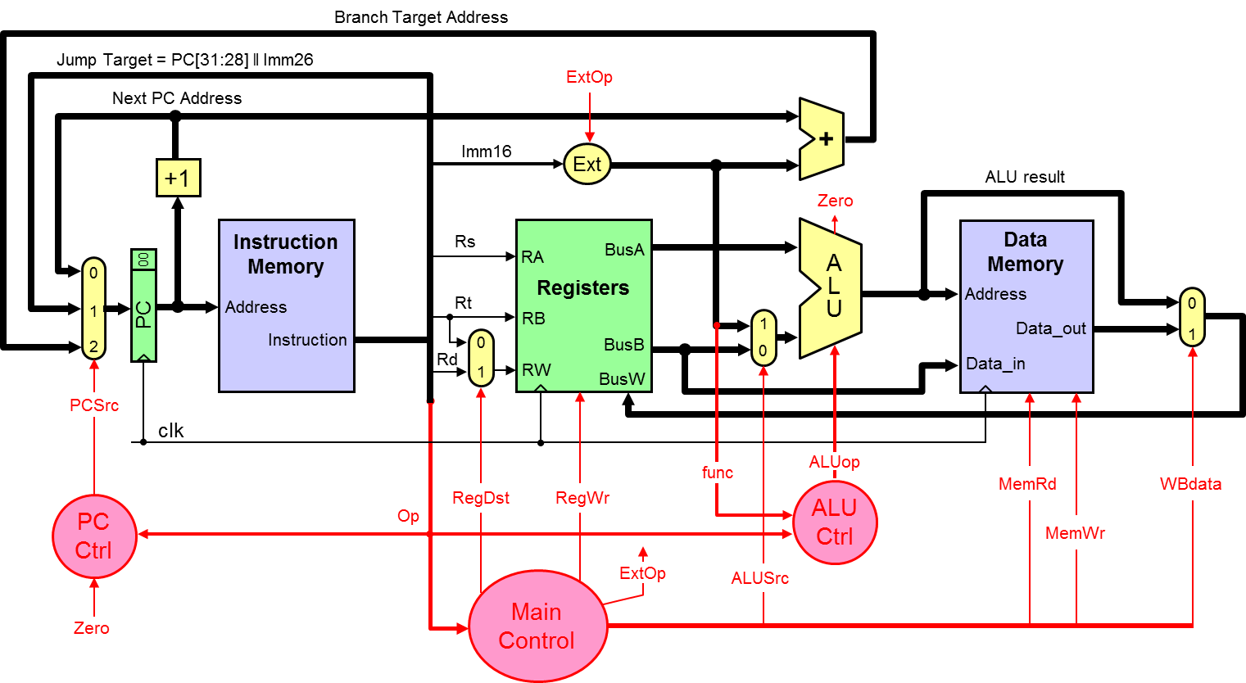

The PC control logic can be described as follows:

if (Op == J) PCSrc = 1;
else if ((Op == BEQ && Zero) || (Op == BNE && ~Zero)) PCSrc = 2;
else PCSrc = 0;

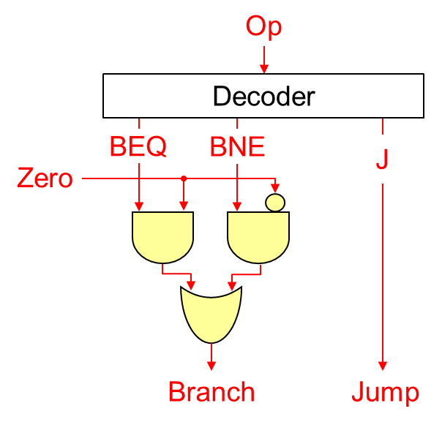
Branch, Jump = 00 PCSrc = 0
Branch, Jump = 01 PCSrc = 1
Branch, Jump = 10 PCSrc = 2

We wish to add the following instructions to the MIPS single-cycle datapath:

Instruction | Meaning | Format
jalr Rd, Rs | Rd = PC+4; PC = Rs | Op = 0 | Rs | 0 | Rd | 0 | f = 9
movz Rd, Rs, Rt | if (Rt==0) Rd = Rs | Op = 0 | Rs | Rt | Rd | 0 | f = 10
lwr Rd, Rs, Rt | Rd = MEM[Rs+Rt] | Op = 0 | Rs | Rt | Rd | 0 | f = 48

a) (10 pts) Redraw the single-cycle datapath. Show and describe any necessary modifications to the datapath and control signals needed for the implementation of the above three instructions.

b) (10 pts) Draw a table showing the values of ALL control signals needed for the implementation of the above three instructions. Describe any changes in the main control and PC control needed for the implementation of the above three instructions.

Solution a: The modified single-cycle datapath is shown below.

For JALR, a larger multiplexer is added at the PC input. The Jump Register Address is taken from BusA and fed back to input 3 of the PCSrc multiplexer. The PC Ctrl also depends on the function. Similarly, a larger multiplexer is needed for Write Back (WBdata). The Next PC address is connected to input 2 of the WBdata multiplexer.

For MOVZ, the value of register Rt (on BusB) is detected whether it is zero (Bzero). A 32-input NOR gate is used to generate the Bzero signal (whether BusB is zero). The Zero flag of the ALU cannot be used because it indicates whether the ALU result is zero. The RegWr signal now depends also on the function code and the Bzero signal.

For LWR, no change in the datapath is required. Only changes in the control signals.

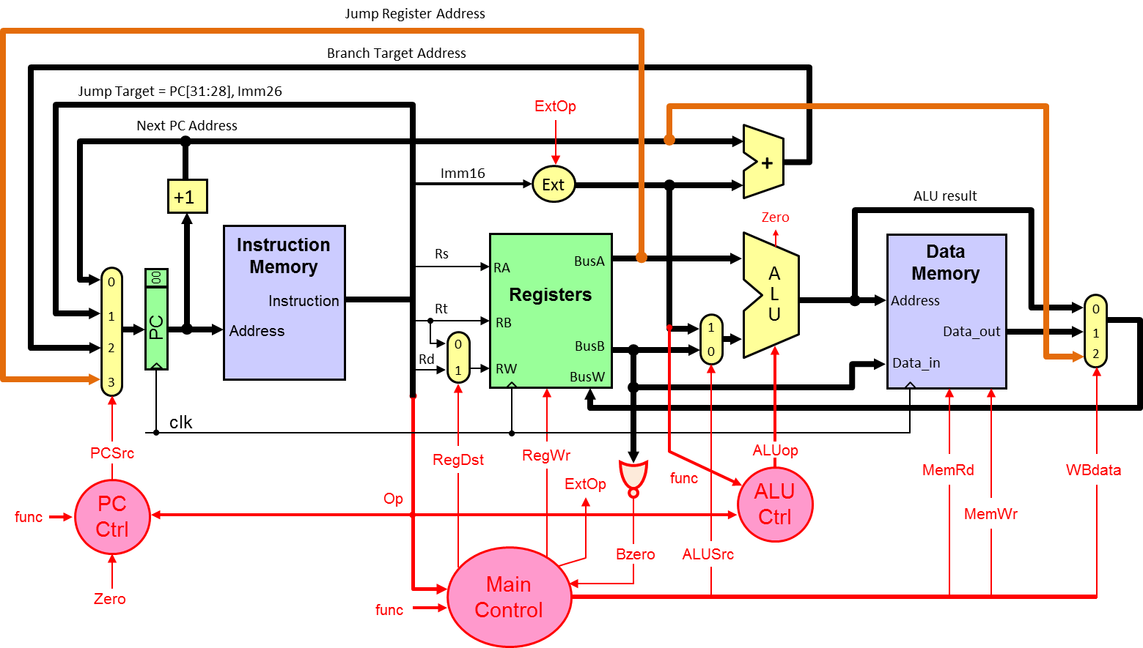
Solution b: Control Signals

Op | f | PCSrc | RegDst | RegWr | ExtOp | ALUSrc | ALUop | MemRd | MemWr | WBdata
0 | JALR=9 | BusA=3 | Rd=1 | 1 | X | X | X | 0 | 0 | RA=2
0 | MOVZ=10 | NextPC=0 | Rd=1 | Bzero | X | X | MoveA | 0 | 0 | ALU=0
0 | LWR=48 | NextPC=0 | Rd=1 | 1 | X | BusB=0 | ADD | 1 | 0 | DM=1

The Main control now depends on the Opcode, function code, and the Bzero signal. The PC control also depends on the function code. For JALR, PCSrc = 3 (BusA) and WBdata = 2 (return address). For MOVZ, RegWr = Bzero (enabled if Bzero is 1), ALUop = MoveA (ALU result = BusA), and WBdata = 0 (ALU result). Finally, LWR is similar to LW except that the memory address is computed as Reg(Rs) + Reg(Rt). This is why ALUSrc = BusB, ALUop is ADD, MemRd = 1, and WBdata = 1 (Data memory).

