COE 301 / ICS 233

Computer Organization

Exam 2 – Spring 2017

Saturday, April 29, 2017

6:30 PM – 8:30 PM

Computer Engineering Department

College of Computer Sciences & Engineering

King Fahd University of Petroleum & Minerals

Student Name:

Student ID:

Section:

|  |  |  |  |
| --- | --- | --- | --- |
| Q1 | / 15 | Q2 | / 15 |
| Q3 | / 15 | Q4 | / 25 |
| Q5 | / 15 | Q6 | / 20 |
| Total | / 105 | | |

Important Reminder on Academic Honesty

Using unauthorized information or notes on an exam, peeking at others work, or altering graded exams to claim more credit are severe violations of academic honesty. Detected cases will receive a failing grade in the course.

**Question 1: Writing a Recursive Function in MIPS**

## (15 pts) Write a MIPS assembly-language function **sum** that receives two arguments: **list[]** and **length**, passed in **$a0** and **$a1**, respectively, computes **recursively** and returns the sum of the array elements in **$f0**. **list[]** is the **address** of an array of single-precision floats. The result of the function is a single-precision float.

**float sum (float list[], int length) {**

**if (length == 0) return 0;**

**else return (list[0] + sum(&list[1], length-1));**

**}**

**Question 2: Greatest Common Divisor**

(15 pts) The greatest common divisor of two integers **a** and **b** can be computed as follows:

**gcd(a, 0) = a**

**gcd(a, b) = gcd(b, a % b) where % is the remainder operator**

For example,

**gcd(30, 18) = gcd(18, 30%18) =**

**gcd(18, 12) = gcd(12, 18%12) =**

**gcd(12, 6) = gcd(6, 12%6) = gcd(6, 0) = 6**

Write a MIPS assembly-language function that receives two integer arguments in **$a0** and **$a1**, computes and returns the greatest common divisor in **$v0**. Hint: use integer division and remainder in your computation, and write a loop to repeatedly compute the **gcd**.

**Question 3: Sequential Signed Integer Multiplication**

## (15 pts) Given that the **Multiplicand** = **10100101** and the **Multiplier** = **10101101** are signed 2’s complement numbers, show the **signed** multiplication of the **Multiplicand** by the **Multiplier**. The result of the multiplication should be a **16-bit** **signed** number in **HI** and **LO** registers. Show the steps of your work for a full mark.

|  |  |  |  |  |
| --- | --- | --- | --- | --- |
| **Iteration** | | **Multiplicand** | **Sign** | **Product = HI, LO** |
| 0 | Initialize |  |  |  |
| 1 |  |  |  |  |
|  |  |  |  |
| 2 |  |  |  |  |
|  |  |  |  |
| 3 |  |  |  |  |
|  |  |  |  |
| 4 |  |  |  |  |
|  |  |  |  |
| 5 |  |  |  |  |
|  |  |  |  |
| 6 |  |  |  |  |
|  |  |  |  |
| 7 |  |  |  |  |
|  |  |  |  |
| 8 |  |  |  |  |
|  |  |  |  |

**Question 4: Floating-Point Numbers and Arithmetic**

1. (4 pts) Find the **decimal value** of the following single-precision float:

|  |  |  |
| --- | --- | --- |
| **S** | **Exponent** | **Fraction** |
| **1** | **1000 1110** | **000 0100 1100 0000 0110 0000** |

1. (4 pts) Find the **decimal value** of the following single-precision float:

|  |  |  |
| --- | --- | --- |
| **S** | **Exponent** | **Fraction** |
| **0** | **0000 0000** | **010 1100 0001 0000 0000 0000** |

1. (4 pts) Find the IEEE 754 single-precision representation of **–126.2**, rounded to the nearest even.
2. (4 bits) **Normalize and Round** the given single-precision number with given GRS (Guard, Round, and Sticky) bits using the following four rounding modes. Show the final **normalized** number and its exponent:

**GRS**

**-0.111 1111 1111 1111 1111 1111 110 × 2-12**

Round towards Zero:

Round towards +Infinity:

Round towards -Infinity:

Round towards Nearest Even:

1. (9 pts) Given that **A** and **B** are single-precision floats, compute the difference **A–B**. Use rounding to **nearest even**. Perform the operation using **guard**, **round** and **sticky** bits.

**A = +1.010 1001 1111 1010 0000 1101 × 10+3**

**B = +1.001 1111 1010 0000 1110 0100 × 10-1**

**Question 5: Register File**

# (15 pts) Draw a register file having 7 registers only (R1 to R7) with two register read ports (Ra and Rb) and one register write port (Rw). R0 should be hardwired to zero and cannot be written. The register file should have two output data busses (BusA and BusB) and one input data bus (BusW). A control signal (RegWrite) should be used to enable the writing of the register file at the edge of the Clock signal.

**Question 6: Single-Cycle Datapath and Control**

# (20 pts) Consider the single-cycle datapath and control given below that implements a subset of the MIPS instruction set:

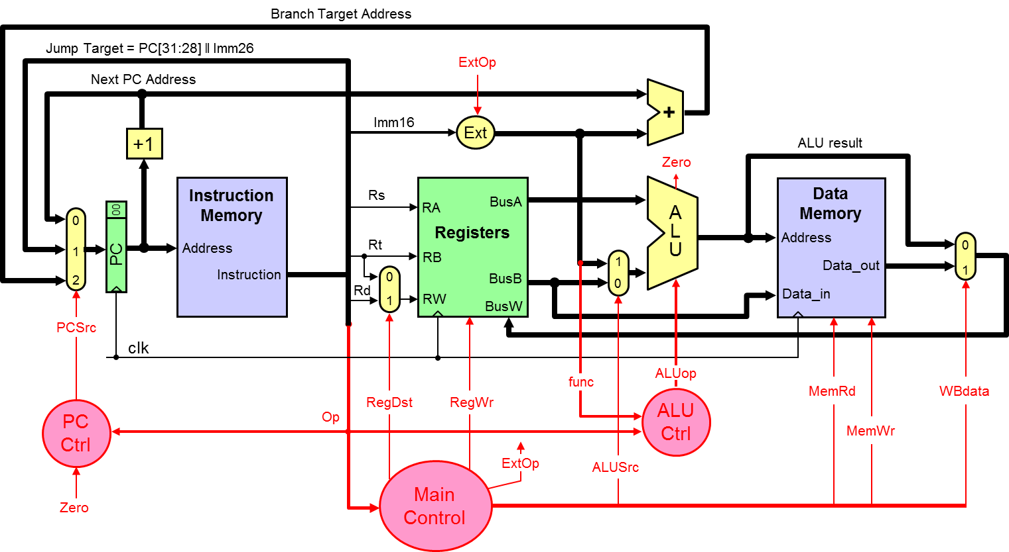

## The PC control logic can be described as follows:

**if (Op == J) PCSrc = 1;**

**else if ((Op == BEQ && Zero) ||** **(Op == BNE && ~Zero)) PCSrc = 2;**

**else PCSrc = 0;**

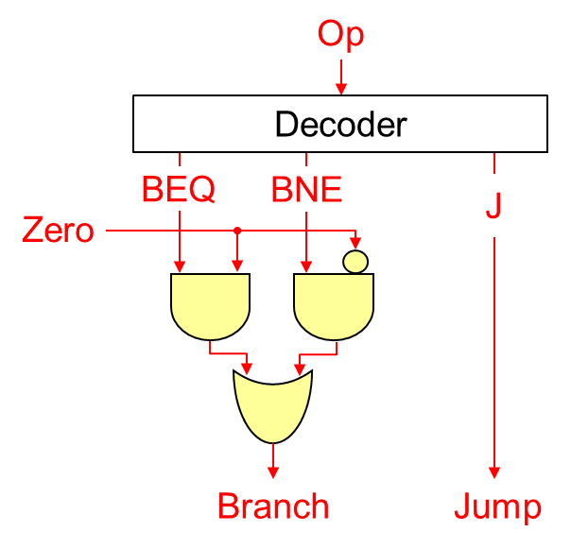

Branch, Jump = 00 🡺 PCSrc = 0

Branch, Jump = 01 🡺 PCSrc = 1

Branch, Jump = 10 🡺 PCSrc = 2

## We wish to add the following instructions to the MIPS single-cycle datapath:

|  |  |  |  |  |  |  |  |
| --- | --- | --- | --- | --- | --- | --- | --- |
| **Instruction** | **Meaning** | **Format** | | | | | |
| **jalr Rd, Rs** | **Rd = PC+4; PC = Rs** | **Op = 0** | **Rs** | **0** | **Rd** | **0** | **f = 9** |
| **movz Rd, Rs, Rt** | **if (Rt==0) Rd = Rs** | **Op = 0** | **Rs** | **Rt** | **Rd** | **0** | **f = 10** |
| **lwr Rd, Rs, Rt** | **Rd = MEM[Rs+Rt]** | **Op = 0** | **Rs** | **Rt** | **Rd** | **0** | **f = 48** |

## **a)** (10 pts) **Redraw** the single-cycle datapath. Show and describe any necessary modifications to the datapath and control signals needed for the implementation of the above three instructions.

## **b)** (10 pts) Draw a table showing the values of **ALL control signals** needed for the implementation of the above three instructions. Describe any changes in the main control and PC control needed for the implementation of the above three instructions.

**Additional Page if needed**

