Lecture 1-01

1. INTRODUCTION TO POLYMERIC MATERIALS

1.1. Introduction, Polymer Structure and Terminology

Readings: Chapter 1-3 in Textbook: Principles of Polymer Systems, F. Rodriguez, Taylor and Francis. and
Chapter 1 in Ref. 1: Polymer Science & Engineering, J. Fried, Prentice Hall.

Learning objectives:

- Define polymer.
- Be familiar with polymer structure and terminology.
- Be familiar with general properties of polymers.
- Explain the difference between thermoplastic, thermosetting and elastomeric polymers.

Greek word Poly = many; Mer = unit ⇒ Polymer = many units

The term polymer denotes a molecule made up by the repetition of some simpler unit, the monomer. The repeating structure is usually based on a carbon backbone.

Polymers are found in nature as proteins, cellulose, silk or synthesized like polyethylene, polystyrene and nylon. Some natural polymers can also be produced synthetically such as natural rubber (polyisoprene).

There are polymers that contain only carbon and hydrogen (for example, polypropylene, polybutylene, polystyrene, and polymethylpentene).

Even though the basic makeup of many polymers is carbon and hydrogen, other elements can also be involved. Oxygen, chlorine, fluorine, nitrogen, silicon, phosphorous, and sulfur are other elements that are found in the molecular makeup of polymers. Polyvinyl chloride (PVC) contains chlorine. Nylon contains nitrogen and oxygen. Teflon contains fluorine. Polyesters and polycarbonates contain oxygen. Vulcanized rubber and thiokol contain sulfur.

e.g., monomer monomer
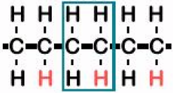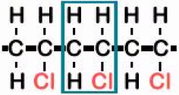
Polyethylene (PE) Poly(vinyl chloride) (PVC)
[Fig. 14.2, Materials Science & Engineering: an introduction, W. D. Callister, 6e, Wiley, 2003]

There are also some polymers that, instead of having carbon backbones, have silicon or phosphorous backbones. These are considered inorganic polymers. One of the most famous silicon-based polymers is Silly PuttyTM.

Single polymer molecules typically have molecular weights between 10,000 and 1,000,000 g/mol, that can be more than 2,000 repeating units depending on the polymer structure!

e.g.,
typical molecular weight ∼ 300,000 ∼ 21,000 C atoms/mol
typical chain length ∼ 2700 nm, typical diameter ∼ 0.3 nm

Notation

The repeating structure results in large chainlike molecules. In notation, the repeating unit or monomer is included with the number of repeating units per polymer chain, n.

e.g., Poly(vinyl chloride) (PVC)

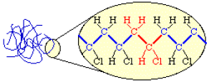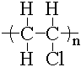
Polymer Chains
Chemical Structure
Notation

[Materials by Design, Dept. of Mat. Sci. Eng., Cornell Univ., http://www.mse.cornell.edu/courses/engri111/, 2/2/2007]

Nomenclature

Monomer-based naming: Monomer name comes after the word “poly”

poly________

e.g., ethylene ⇒ polyethylene

If monomer name contains more than one word: Monomer name is written in parenthesis

poly(_____ ____)

e.g., acrylic acid ⇒ poly(acrylic acid)

Physical Properties of Polymers
- Composed of very large molecules
- Low modulus of elasticity (low stiffness)
- Low tensile and compressive strengths
- Can be crystalline or semi-crystalline structure
- Deformation is very sensitive to temperature
- Low thermal and electrical conductivity(good insulator)
- Creep at room temperatures
- Low temperatures make plastics brittle
- Plastic deformation

Advantages of Polymers (over metals or ceramics)
- Low density (specific gravity = 1.0 – 1.4) (7.85 for steel)
- Corrosion resistance
- Easy to manufacture, easy to make complex shapes (low temperature to shape)
- Electrical insulation
- Low thermal conductivity
- Low finishing cost (no painting)
- Toughness, ductility
- Optics ( can be transparent) (preferred to glass because of light weight and toughness) (aircraft windows are plastics)

Disadvantages of Polymers (relative to metals or ceramics)
- Low use temperature
- Time-temperature dependence of properties.
- Low stiffness (Modulus, E ≈ E of a metal/100)
- Low strength (strength might be improved using composite structures)
- Fatigue sensitivity
- May swell with water
- Toxicity, flammability
- Solvent sensitivity (may be soluble or properties may change)
- U.V. light sensitivity (can break covalent bonds for some polymers)

Homopolymers: made up from only 1 type of monomer.

Copolymers: made up of 2 or more types of chemically distinct monomers.

Copolymer

Made up of 2 or more types of chemically distinct monomers. It may be composed of two bifunctional units and may alternate to give a well-defined recurring unit or the two different monomers may be joined in a random fashion in which no recurring unit can be defined. Synthetic rubbers are often copolymers, e.g., SBR – styrene butadiene rubber (used in automobile tires) is a random copolymer.

Alternating copolymer:

A copolymerization involving monomers A and B that results in -A-B-A-B-A-.


Random copolymer:

A copolymerization where the sequence of A's and B's is random,
-A-A-B-A-B-B-A-B-A-B-B-B-A-.


Block copolymer:

Built from first one polymer, and then another, as in
-A-A-A-A-A-A-A-A-A-A-A-B-B-B-B-B-B-B-B-B-B-B-.


Graft copolymer:

Where a polymer of 'B' was grafted onto a polymer of 'A'.

-A-A-A-A-A-A-A-A-A-A-
|
B
|
B
|
B
|


Molecular Structure

In each polymer molecule, the atoms are bound together by covalent bonds. However, the separate molecules, or segments of the same molecule, are attracted to each other by weak “intermolecular forces”, also termed “secondary” or “Van der Waals” forces.

In general, covalent bonds govern the thermal and chemical stability of polymers. On the other hand, secondary forces determine most of the physical properties we associate with specific compounds. Melting, dissolving, vaporizing, adsorption, diffusion, deformation, and flow involve the making and breaking of intermolecular bonds so that molecules can move past one another or away from each other.

Individual chains of polymers can also be chemically linked by covalent bonds (crosslinked) during polymerization or by subsequent chemical or thermal treatment during fabrication. Once formed, these crosslinked networks resist heat softening, creep, and solvent attack, but cannot be thermally processed.

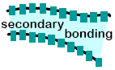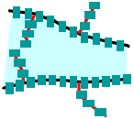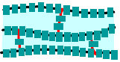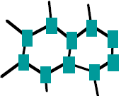
Linear Branched Cross-Linked Network
(more rigid)
[Fig. 14.7, Materials Science & Engineering: an introduction, W. D. Callister, 6e, Wiley, 2003]
Increase in Strength (in General)

e.g.,
Linear Polymers: Polyethylene, poly(vinyl chloride) (PVC), polystyrene, polymethyl methacrylate (plexiglass), nylon, fluorocarbons (teflon).
Branched Polymers: Many elastomers or rubbers.
Cross-linked Polymers: Thermosetting polymers, many elastomers or rubbers are also cross-linked (vulcanized).
Network Polymers: Epoxies, phenol-formaldehydes.

Tacticity (Stereoisomerism)

Atactic: An atactic polymer has chemical groups attached to the polymer chain randomly on either side of the carbon chain.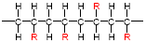
Isotactic: An isotactic polymer has the chemical groups attached to the same side of the carbon chain. 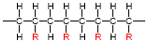
Syndiotactic: Syndiotactic polymers have the groups alternately on opposite sides of the chain. 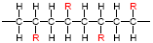
Classification of Polymers

Plastics – Greek word plastikos (Thermoplastics, Thermosets), Elastomers

The polymer chains can be free to slide past one another (thermoplastic) or they can be connected to each other with crosslinks (thermoset). Thermoplastics (including thermoplastic elastomers) can be reformed and recycled, while thermosets (including crosslinked elastomers) are not reworkable.

Thermoplastics

Polymers that flow when heated; thus, easily reshaped and recycled. This property is due to presence of long chains with limited or no crosslinks. In a thermoplastic material the very long chain-like molecules are held together by relatively weak Van der Waals forces. When the material is heated the intermolecular forces are weakened so that it becomes soft and flexible and eventually, at high temperatures, it is a viscous melt (it flows). When the material is allowed to cool it solidifies again.

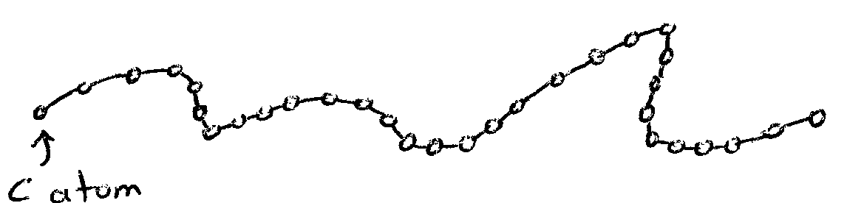
linear

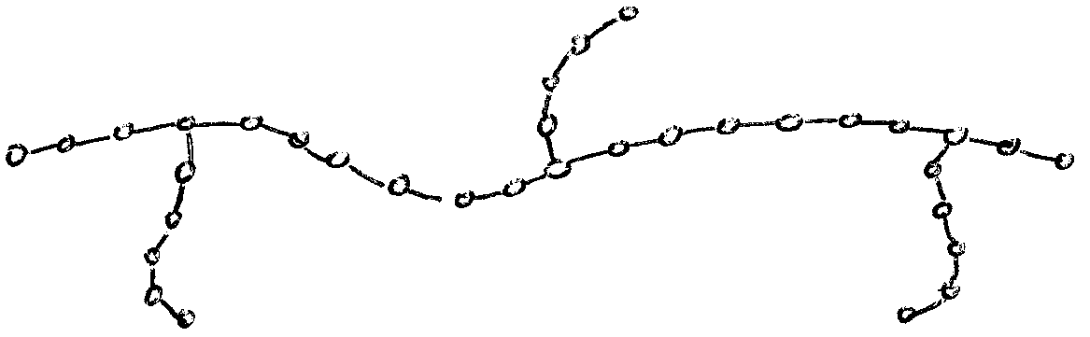
branched

e.g., polyethylene (PE), polypropylene (PP), poly(vinyl chloride) (PVC), polystyrene (PS), poly(ethylene terephthalate) (PET), nylon (polyamide), unvulcanized natural rubber (polyisoprene)

Thermosets

Decompose when heated; thus, can not be reformed or recycled. Presence of extensive crosslinks between long chains induce decomposition upon heating and renders thermosetting polymers brittle.

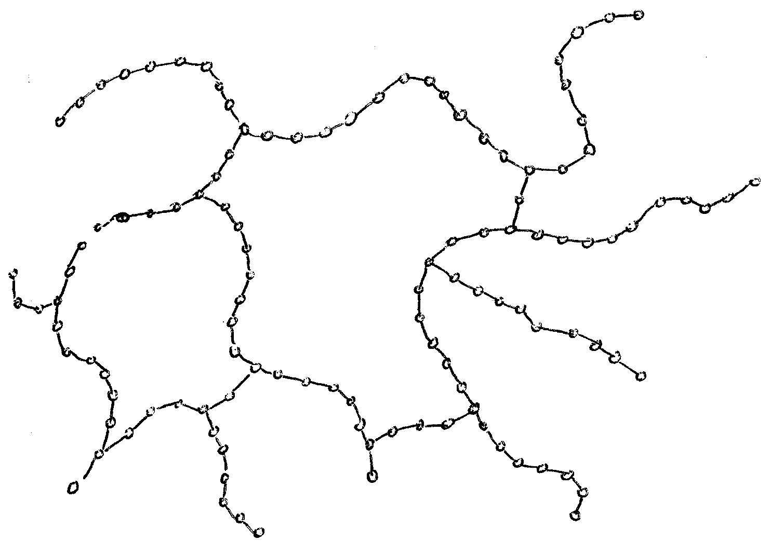
crosslinked

A thermosetting polymer is produced by a chemical reaction which has two stages. The first stage results in the formation of long chain-like molecules similar to those present in thermoplastics, but still capable of further reaction. The second stage of the reaction (crosslinking of chains) takes place during moulding, usually under the application of heat and pressure. During the second stage, the long molecular chains have been interlinked by strong covalent bonds so that the material cannot be softened again by the application of heat. If excess heat is applied to these materials they will char and degrade.

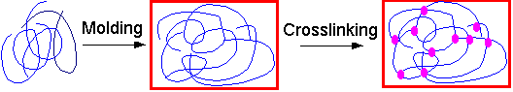
[Materials by Design, Dept. of Mat. Sci. Eng., Cornell Univ., http://www.mse.cornell.edu/courses/engri111/, 2/2/2007]

e.g., epoxy, unsaturated polyesters, phenol-formaldehyde resins, vulcanized rubber

Elastomers

The polymer chains in elastomers are above their glass transition at room temperature, making them rubbery. Can undergo extensive elastic deformation.
[Materials by Design, Dept. of Mat. Sci. Eng., Cornell Univ., http://www.mse.cornell.edu/courses/engri111/, 2/2/2007]

Elastomeric polymer chains can be crosslinked, or connected by covalent bonds. Crosslinking in elastomers is called vulcanization, and is achieved by irreversible chemical reaction, usually requiring high temperatures.

Unvulcanized natural rubber (polyisoprene) is a thermoplastic and in hot weather becomes soft and sticky and in cold weather hard and brittle. It is poorly resistant to wear. Sulfur compounds are added to form chains that bond adjacent polymer backbone chains and crosslinks them. The vulcanized rubber is a thermosetting polymer.

Crosslinking makes elastomers reversibly stretchable for small deformations. When stretched, the polymer chains become elongated and ordered along the deformation direction. This is entropically unfavorable. When no longer stretched, the chains randomize again. The crosslinks guide the elastomer back to its original shape.

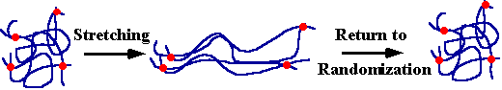
[Materials by Design, Dept. of Mat. Sci. Eng., Cornell Univ., http://www.mse.cornell.edu/courses/engri111/, 2/2/2007]

e.g., natural rubber (polyisoprene), polybutadiene (used in shoe soles and golf balls), polyisobutylene (used in automobile tires), butyl rubber (pond and landfill linings), styrene butadiene rubber – SBR (used in automobile tires) and silicone

Other Classification Schemes

1) Based on Source:

- Natural: Asphalt, lignin, shellac, tar, biopolymers such as DNA, protein, carboyhydrates, cellulose, silk.
- Synthetic: Produced from coal, natural gas or petroleum,
e.g., polyethylene, polystyrene, nylon

2) Based on Thermal Processing Behavior:

- Thermoplastics: can be heat-softened (melted) to process into a desired form, e.g. polyethylene, polystyrene, poly(vinyl chloride), poly(ethylene terephthalate), nylon (polyamide).
- Thermoset: cannot be heat-softened (melted), e.g. epoxies, phenolics, unsaturated polyesters, crosslinked elastomers such as vulcanized rubber

3) Based on Polymerization Mechanism:

- Addition (Chain-Growth)
i) Free-radical
ii) Ionic (anionic, cationic)
iii) Catalyzed (controlled radical polymerization)
- Condensation (Step-Growth)

4) Based on Structure:

- Linear
- Branched
- Crosslinked

5) Based on Crystal Structure:

- Crystalline
- Amorphous

6) Based on Mechanical Behavior:

- Plastic (T_{g} > RT)
- Elastomers (T_{g} < RT)
- Fiber

7) Based on Polymerization Processes:

- Bulk
- Solution
- Precipitation
- Suspension
- Emulsion
Major Feedstocks for Polymers

Ethane, propane, naphtha, atmospheric gas oil, crude oil.

Most Commonly Used Monomers

Ethylene, Propylene, Styrene, Terephthalic Acid, Acrylonitrile, Vinyl Acetate,
Adipic Acid, Bisphenol A

Industrially Important Polymers

A big portion of the world plastics consumption consists of the following polymers. They are all thermoplastics.

Polymer | Chemical Notation | Application
Polyethylene (PE) | 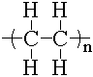 | HDPE* (High Density Polyethylene): milk and juice containers, grocery bags, toys, pipe, liquid detergent bottles, drums, sheet/film, …etc  LDPE* (Low Density Polyethylene): bread bags, frozen food bags, grocery bags, flexible tubing, squeeze bottles, toys, houseware, coatings, packaging films, …etc
Polypropylene (PP) | 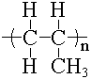 | carpet fibers, ropes, liquid containers, (cups/buckets/tanks), pipes, bicycle racks, automobile and appliance parts, oil funnels, furniture, film packaging, landscape borders, …etc
Polystyrene  (PS) | 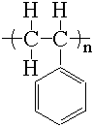 | packaging foams, egg cartons, lighting panels, rulers, houseware, coffee cups, knives, spoons and forks, cafeteria trays, meat trays, fast-food sandwich containers, …etc
Poly(vinyl chloride)  (PVC) |  | shampoo bottles, hoses, pipes, valves, electrical wire insulation, flooring, playground equipment toys, raincoats, film and sheet
Poly(ethylene terephthalate) (PET or PETE) | 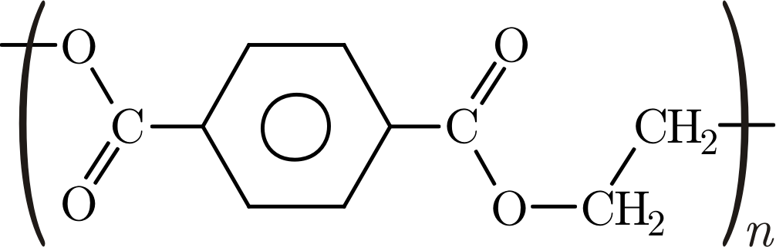 | bottles, beverage and food packaging, synthetic fibers, dishwashing liquid containers, laser toner cartridges, picnic tables, hiking boots, lumber, mailbox posts, fencing, furniture, …etc

* HDPE (High Density Polyethylene): Linear structure, better mechanical properties but more difficult to process than LDPE.
LDPE (Low Density Polyethylene): Branched structure, easier to process than HDPE.
Self Test

1. Which one of the following is an advantage of polymers over metals or ceramics?

a) higher use temperature
b) higher strength
c) lower specific gravity
d) higher stiffness

2. What is the typical molecular weight range for polymers?

a) between 1 and 100
b) between 100 and 1000
c) between 1,000 and 10,000
d) between 10,000 and 1,000,000

3. Which one of the following is not a recyclable polymer?

a) polystyrene
b) polyethylene
c) polypropylene
d) poly(vinylchloride)
e) epoxy

