Electronic Supplementary Material

Nanomolar amperometric sensing of hydrogen peroxide using a graphite pencil electrode modified with palladium nanoparticles
Md. Abdul Aziz, ª Abdel-Nasser Kawde ^{a, b,*}
ª Chemistry Department, King Fahd University of Petroleum and Minerals, Dhahran, 31261, Kingdom of Saudi Arabia
^{b} Chemistry Department, Faculty of Science, Assiut University, Assiut 71516, Egypt.
*Corresponding author, E-mail: akawde@kfupm.edu.sa, Tel.: +966 3 860 2145, Fax: +966 3 860 4277

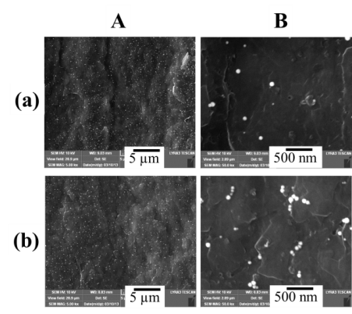
Figure S-1
FE-SEM images at two magnification levels, 5 µm (A) and 500 nm (B), of the PdNP-modified GPEs prepared by immersing the bare GPE in a PdNPs solution at 50 °C (a) or 90 °C (b) for 15 min.

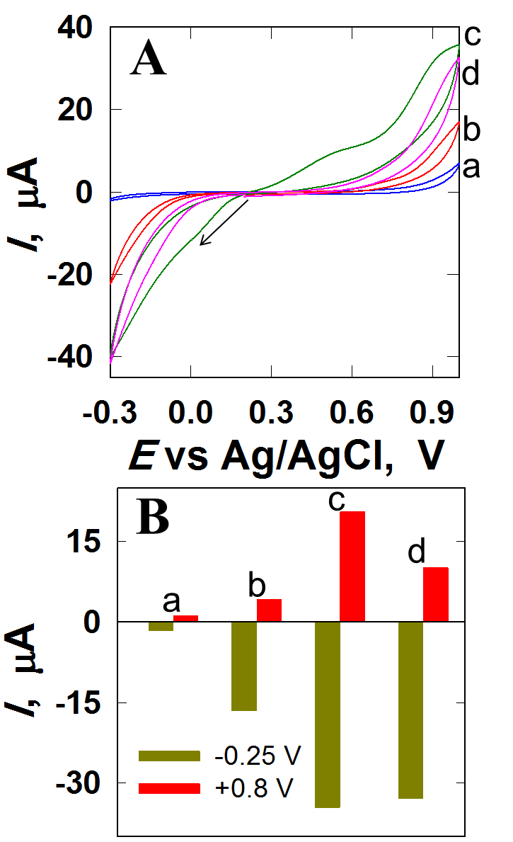

Figure S-2
(A) Cyclic voltammograms collected in PBS (0.1 M, pH 7) containing 1 mM H₂O₂, in the presence of the PdNP-modified GPE prepared by immersing the bare GPE in a PdNP solution at RT (a); 50 °C (b), 75 °C (c), and 90 °C (d) for 15 min. The scan rate was 100 mV·s⁻¹. Cyclic voltammograms were recorded after purging with argon for 20 min. (B) The corresponding histograms for the electroreduction (at –0.25 V) or electrooxidation (at + 0.8 V) in the presence of H₂O₂.

