EXAMPLE OF MIXTURE PROPORTIONING –
ABSOLUTE VOLUME METHOD

Problem: To proportion a trial mixture that will meet the following conditions and specifications.

Conditions and Specifications: Concrete is required for a pavement that will be exposed to moisture in a severe freeze-thaw environment. A specified compressive strength, f'_{c}, of 35 MPa is required at 28 days. Air entrainment is required. Slump should be between 25 mm and 75 mm. A nominal maximum size aggregate of 25 mm is required. No statistical data on previous mixes are available. The materials available are as follows:
Cement: Type I with relative density of 3.0.
Coarse aggregate: Well graded, 25-mm nominal maximum-size rounded gravel with ovendry relative density of 2.68, absorption of 0.5% and ovendry rodded bulk density of 1600Kg/m³. The laboratory sample for trial batching has a moisture content of 2%.
Fine aggregate: Natural sand with ovendry relative density of 2.64 and absorption of 0.7%. The laboratory sample moisture content is 6%. The fineness modulus is 2.80.
Air-Entraining Admixtures: Wood-resin type
Water reducer: reduces water demand by 10% when used at a dosage rate of 3 g per Kg of cement. Assume that density is that of water.

SOLUTION:

Strength. The minimum design compressive strength for concrete exposed to freeze-thaw condition is given as 31 MPa. (Table 9-1).

Table 9-1. Maximum Water-Cementitious Material Ratios and Minimum Design Strengths for Various Exposure Conditions

Exposure Condition | Maximum water-cementitious material ratio by mass for concrete | Minimum design compressive strength, f' c , MPa (psi)
Concrete protected from exposure to freezing and thawing, application of deicing chemicals, or aggressive substances. | Select water-cementitious material ratio on basis of strength, workabilty, and finishing needs | Select strength based on structural requirements
Concrete intended to have low permeability when exposed to water | 0.50 | 28 (4000)
Concrete exposed to freezing and thawing in a moist condition or deicers | 0.45 | 31 (4500)
For corrosion protection for reinforced concrete exposed to chlorides from deicing salts, salt water, brackish water, seawater, or spray from these sources | 0.40 | 35 (5000)
Thus, we see here that the required design strength is 35 MPa. Since no statistical data is given , as per table 9-11,
The required compressive strength for proportioning f'_{cr} is given by: f'_{c} + 8.5
i.e. f'_{cr} = 35 + 8.5 = 43.5 MPa.

Table 9-11. (Metric). Required Average Compressive Strength When Data are Not Available to Establish a Standard deviation

Specified compressive strength, f'c , Mpa | Required average compressive strength, f' cr, Mpa
Less than 21 | f' c + 7.0
21 to 35 | f' c + 8.5
Over 35 | 1.10 f' c + 5.0

w/c ratio: According to Table 9-1, the maximum w/c ratio for concrete exposed to freeze-thaw condition is 0.45. However , the recommended w/c ratio on basis of compressive strength as per Fig 9-2 or table 9-3 is :
[{(45-43.5)(0.34-0.30)/(45-40)}+0.30=0.31].
Therefore w/c ratio = 0.31 (lower value governs)

Table 9-3 (Metric). Relationship Between Water to Cementitious Material Ratio and Compressive Strength of Concrete

Compressive Strength at 28 days, Mpa | Water-cementitious materials ratio by mass
Compressive Strength at 28 days, Mpa | Non-air-entrained concrete | Air-entrained concrete
45 | 0.38 | 0.30
40 | 0.42 | 0.34
35 | 0.47 | 0.39
30 | 0.54 | 0.45
25 | 0.61 | 0.52
20 | 0.69 | 0.60
15 | 0.79 | 0.70

Air Content: According to Table 9-5, for severe conditions, a target air content of 6.0% is recommended for aggregate of size 25-mm.Therefore, we can design the mix for 5%-8% air and use 8% for batch proportions. The trail batch air content must be within ±0.5 % of the maximum allowable air content.

Table 9-5 (Metric). Approximate Mixing Water and Target Air Content Requirements for Different Slumps and Nominal Maximum Sizes of Aggregate

Slump, mm | Water, Kilograms per cubic meter of concrete, for indicated sizes of aggregate
Slump, mm | 9.5 mm | 12.5 mm | 19 mm | 25 mm | 37.5 mm | 50 mm | 75 mm | 150 mm
 | Non-air-entrained concrete
25 to 50 | 207 | 199 | 190 | 179 | 166 | 154 | 130 | 113
75 to 100 | 228 | 216 | 205 | 193 | 181 | 169 | 145 | 124
150 to 175 | 243 | 228 | 216 | 202 | 190 | 178 | 160 | -
Appropriate amount of entrapped air in non-air-entrained concrete, percent | 3.0 | 2.5 | 2.0 | 1.5 | 1.0 | 0.5 | 0.3 | 0.2
 | Air-entrained concrete
25 to 50 | 181 | 175 | 168 | 160 | 150 | 142 | 122 | 107
75 to 100 | 202 | 193 | 184 | 175 | 165 | 157 | 133 | 119
150 to 175 | 216 | 205 | 197 | 184 | 174 | 166 | 154 | -
Recommended average total air content, percent, for level of exposure:
Mild exposure | 4.5 | 4.0 | 3.5 | 3.0 | 2.5 | 2.0 | 1.5 | 1.0
Moderate exposure | 6.0 | 5.5 | 5.0 | 4.5 | 4.5 | 4.0 | 3.5 | 3.0
Severe exposure | 7.5 | 7.0 | 6.0 | 6.0 | 5.5 | 5.0 | 4.5 | 4.0

Slump: The slump is specified at 25-mm to 75-mm. However, for proportioning purpose, we shall use 75mm ±20mm.
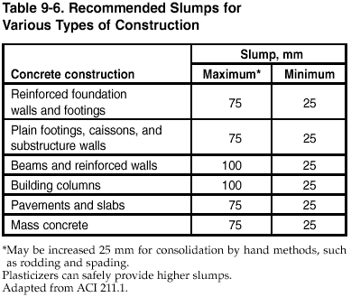

Water content: In accordance with Table 9-5 or Fig 9-5, the required water content for a 75-mm slump, air-entrained concrete with 25-mm aggregate size is about 175 Kg/m3. However, the rounded gravel would need only 150 Kg/m³. (175 – 25). Also, the water reducers would also result in reduction of 10%. Thus the final water content would be:
150 – (10% of 150) = 135 Kg/m³.

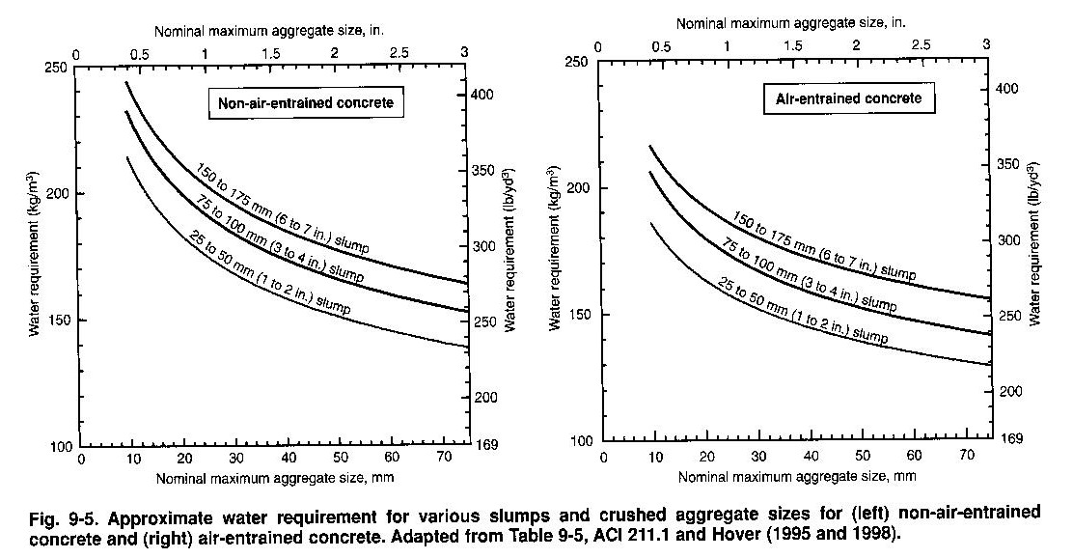

Cement Content: On basis of w/c ratio of 0.31 and water content of 135 Kg/m³,
The cement content required will be:
135/0.31 = 435 Kg/m³.
This is greater than the 335 Kg/m³ required for frost resistance (Table 9-7).

Table 9-7. Minimum Requirements of Cementing Materials for Concrete Used in Flatwork

Nominal maximum size of aggregate, mm (in.) | Cementing materials, Kg/m³ (lb/yd³)*
37.5 (11/2) | 280 (470)
25 (1) | 310 (520)
19 (3/4) | 320 (540)
12.5 (1/2) | 350 (590)
9.5 (3/8) | 360 (610)
*cementing materials quantities may need to be greater for severe exposure. For example, for deicer exposures, concrete should contain at least 335 Kg/m³ (564 lb/yd³) of cementing materials.

Coarse aggregate content: The bulk volume of CA (of 25-mm size) recommended when using sand with fineness 2.80 is 0.67. (Table 9-4 or Fig 9-3).
Therefore the ovendry mass of CA for a cubic meter of concrete will be density times the volume.
i.e. 1600 * 0.67 = 1072 Kg.

Table 9-4. Bulk Volume of Coarse Aggregate Per Unit Volume of Concrete

Nominal maximum size of aggregate, mm (in.) | Bulk volume of dry-rodded coarse aggregate per unit volume of concrete for different fineness moduli of fine aggregate
Nominal maximum size of aggregate, mm (in.) | 2.40 | 2.60 | 2.80 | 3.00
9.5 (3/8) | 0.5 | 0.48 | 0.46 | 0.44
12.5 (1/2) | 0.59 | 0.57 | 0.55 | 0.53
19 (3/4) | 0.66 | 0.64 | 0.62 | 0.6
25 (1) | 0.71 | 0.69 | 0.67 | 0.65
37.5 (11/2) | 0.75 | 0.73 | 0.71 | 0.69
50 (2) | 0.78 | 0.76 | 0.74 | 0.72
75 (3) | 0.82 | 0.8 | 0.78 | 0.76
150 (6) | 0.87 | 0.85 | 0.83 | 0.81

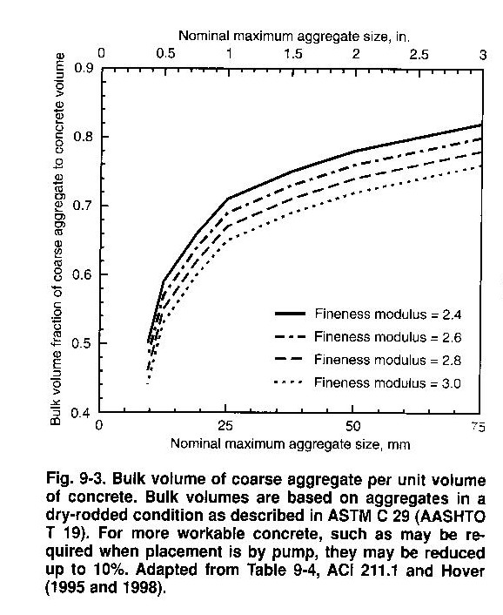

Admixture Content: For an 8% air content, the air entraining admixture manufacturer recommends a dosage of 0.5 g per Kg of cement. Hence, the amount of air-entraining admixture per cubic meter of concrete is:
0.5 * 435 = 218 g or 0.218 Kg.
The amount of water reducer per cubic meter of concrete is: 3 * 435 = 1305 g or 1.305 Kg.

Fine Aggregate content:
At this point, we have calculated the amount required of all the ingredients except fine aggregate.
By the Absolute volume method, FA content can be obtained by subtracting the absolute volumes of the known ingredients from 1 cubic meter.

Absolute volume is calculated by dividing the mass of ingredient by the product of its relative density and the density of water:

Water = = 0.135 m³.
Cement = = 0.145 m³.
Air = = 0.080 m³.
Coarse aggregate = = 0.400 m³.
---------------
Total Volume of known ingredients = 0.760 m³.
Hence, absolute volume of FA is: 1 – 0.760 = 0.24m³.
The mass of dry FA is: 0.24*2.64*1000 = 634 Kg.

Thus, the proportions before trial mixing per cubic meter of concrete are:
Water 135 Kg
Cement 435 Kg
Coarse aggregate (dry) 1072 Kg
Fine aggregate (dry) 634 Kg
--------------
Total mass 2276 Kg

Air entraining admixture 0.218 Kg
Water reducer 1.305 Kg

Slump 75 mm (±20 mm for trial batch)
Air content 8% (±0.5% for trial batch)

Estimated concrete density (using SSD aggregate) =
135 + 435 + (1072*1.005)+(634*1.007)
= 2286 Kg/m³.

Note: (0.5% absorption / 100) + 1 = 1.005
(0.7% absorption / 100) + 1 = 1.007

Correction for moisture:
Test indicates that for this example, CA moisture content is 2 % and FA moisture content is 6 %.
Now the trial batch aggregate proportions become:
CA = 1072*1.02 = 1093 Kg.
FA = 634*1.06 = 672 Kg.
Note that water absorbed by the aggregate does not become part of mixing water and hence must be excluded from water adjustment.
Surface moisture contributed by CA = 2 % - 0.5 % = 1.5 %. = 0.015
FA= 6 % - 0.7 % = 5.3 %. = 0.053
Thus, the estimated requirement for added water becomes:
135 – (1072*0.015)-(634*.053) = 85 Kg.

Now the revised proportions of batch taking moisture into consideration are:
Water (to be added) 85 Kg
Cement 435 Kg
Coarse aggregate (2% MC, wet) 1093 Kg
Fine aggregate (6% MC, wet) 672 Kg
--------------
Total mass 2285 Kg

Air entraining admixture 0.218 Kg
Water reducer 1.305 Kg

Trial Batch: Let us start by scaling down the weights to produce 0.1 m3 of concrete.
i.e. we are obtaining the quantity per 0.1m³ of concrete

Water (to be added) 85 * 0.1 = 8.5 Kg.
Cement 435 * 0.1 = 43.5 Kg.
Coarse aggregate (2% MC, wet) 1093 * 0.1 = 109.3 Kg.
Fine aggregate (6% MC, wet) 672 * 0.1 = 67.2 Kg.
--------------
Total mass 228.5 Kg

Air entraining admixture 218 g * 0.1 = 21.8 g
Water reducer 1305 g * 0.1 = 130.5 g
The above concrete, when mixed, had a measured slump of 100 mm, air content of 9 % and density of 2274 Kg/m³.The trial batch uses only 8 Kg of water to be added unlike 8.5 Kg.
Thus, we have
Water (to be added) 8.0 Kg.
Cement 43.5 Kg.
Coarse aggregate (2% MC, wet) 109.3 Kg.
Fine aggregate (6% MC, wet) 67.2 Kg.
--------------
Total mass 228.0 Kg
The yield of the trial batch is: = 0.10026 m³.
The mixing water is sum of water added, free water on CA and FA.
Water added = 8.0 Kg
Free water on CA = x 0.015 = 1.61 Kg.
Free water on FA = x 0.053 = 3.36 Kg.
Total water 12.97 Kg
The mixing water required for a cubic meter of the same slump concrete as the trial batch is: = 129 Kg.

Batch Adjustments. The obtained trial batch has some unacceptable results.
Neither a slump of 100 mm nor an air content of 9% is accepted. The yield is also slightly on a higher side. So we need some adjustments to get the slump as 75-mm and air content to be 8 %.
The adjustment is done by increasing the mixing water content by 3Kg/m³ for each 1 % by which the air content is decreased from that of the trial batch and also reducing the water content by 2 Kg/m³ for each 10 mm reduction in slump.

The new adjusted mixing water = (3 kg water * 1 % point difference of air) – (2 Kg water * 25/10 for slump change) + 129 = 127 Kg of water.

Cement content = Water content / (w/c ratio) = 127 / 0.31 = 410 Kg.

Since the workability was satisfactory, there shouldn’t be any changes made for aggregates.

Thus, the new adjusted batch weights are:

Water = = 0.127 m³.
Cement = = 0.137 m³.
Air = = 0.080 m³.
Coarse aggregate = = 0.400 m³.
---------------
Total Volume of known ingredients = 0.744 m³.

Hence, absolute volume of FA is : 1 – 0.744 = 0.256m³.

The mass of dry FA is : 0.256*2.64*1000 = 676 Kg.

Air entraining admixture: 0.4 * 410 = 164 g
Water reducer: 3.0 * 410 = 1230 g

The final adjusted batch weights per cubic meter of concrete are:
Water 127 Kg
Cement 410 Kg
Coarse aggregate (dry) 1072 Kg
Fine aggregate (dry) 676 Kg
--------------
Total mass 2285 Kg

Air entraining admixture 0.164 Kg
Water reducer 1.230 Kg
Estimated concrete density (using SSD aggregate) =
127 + 410 + (1072*1.005) + (676*1.007)
= 2295 Kg/m³.

After checking these adjusted proportions in a trial batch, it was found that the concrete had the desired slump, air content, and yield.

