KFUPM QUIZ (1) MATH 301-163 Name:_______________________________S.ID:______________________Sec.( ) Ser.# ( )
Q1) Let $f\left(x,y,z\right)=x^{3}z^{2}+y^{3}z+z−1$. Find the directional derivative at $P\left(1,1,−1\right)$ in the direction of $u=2i+3j+6k$. Is this direction makes a maximum directional derivative? Why?
Q2) Evaluate $\int_{C}{\left(2x+y\right)dx+xe^{y}dy}$ where C is the given curve between
(2,5)$\left(−1,2\right)∧\left(2,5\right).$
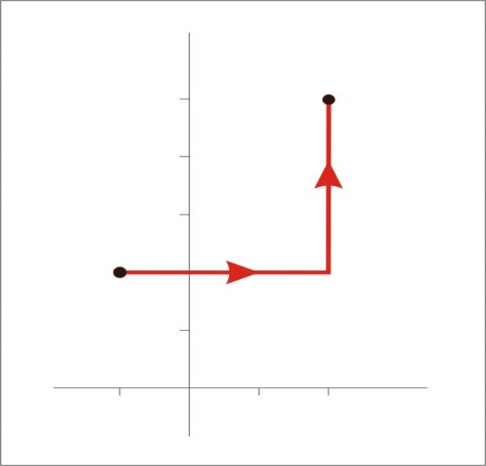

(−1,2)

