KFUPM MATH201 Quiz#1 Sec. 10
Name Sr.#
Q1.
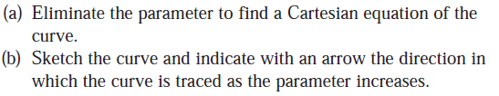
$$y=4+cost,x=2sint,0≤t≤3π/2$$

Q2

Q2.Find the length of the curve $x=4e^{t/2},y=−t+e^{t},−1≤t≤1$

