KFUPM MATH101 Quiz#1 Sec. 4
Name Sr.#
Q1) Find the following limit
a)
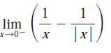

b)
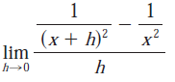

c)
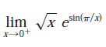

Q2
