Department of Mathematics and Statistics KFUPM
Quiz 1: ch1-3 Time: 40 mins
Student’s Name: ________________________________ ID: ____________________________

Q.No.1:-Answer the following questions.
(a)
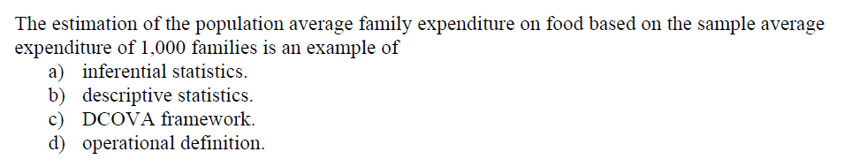
(b)
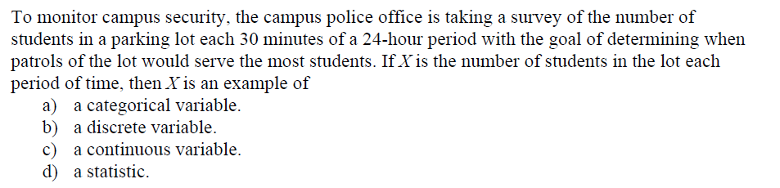
(c)
(d)
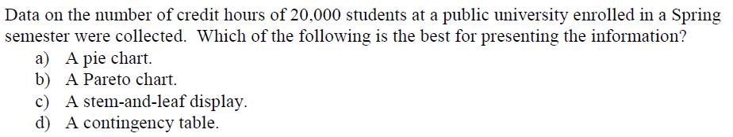
(e)
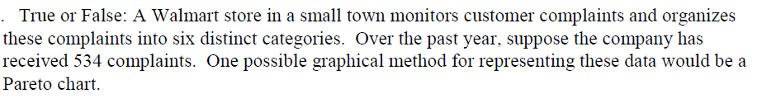
(f)
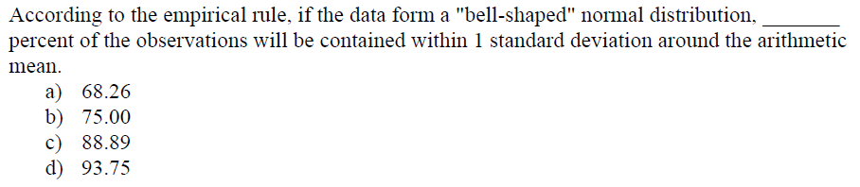

Q.No.2:-
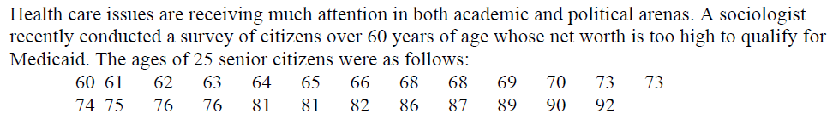
(a)

(b)

(c)

(d)

