Q1 Let $C$ be the parametric curve$x=2cost,y=1+sint,0≤t≤π.$
- Sketch the graph of $C.$

$$t$$ | $$x$$ | $$y$$
$$0$$ | $$2$$ | $$1$$
$$π/2$$ | $$0$$ | $$2$$
$$π$$ | $$−2$$ | $$1$$
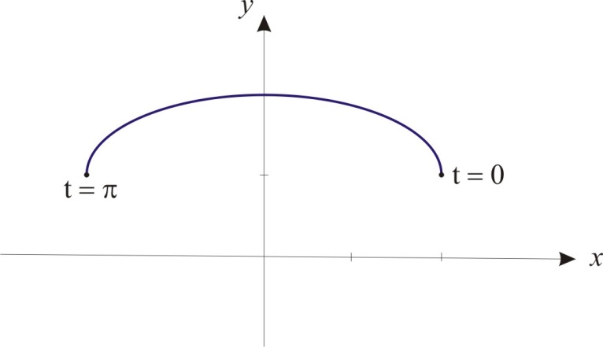
- Find the slope of the tangent line to C at the point $P\left(\sqrt{3},\frac{3}{2}\right).$
$$\frac{dy}{dx}=\frac{{dy}/{dt}}{{dx}/{dt}}=\frac{−cost}{2sint}$$
At $P\left(\sqrt{3},\frac{3}{2}\right),$we have $t=\frac{π}{6}.$ The required slope is
$$m={\left.\frac{dy}{dx}\right|}_{t=π/6}=\frac{−cos\left(π/6\right)}{2sin\left(π/6\right)}=\frac{−\sqrt{3}}{2}$$
- Find the area of the region bounded by $C$ and the line $y=1.$
$$Area=\int_{−2}^{2}{ydx}−\int_{−2}^{2}{dx}=$$
$$−4−2\int_{π}^{0}{}$$
$$−4−2{\left(−cost+\frac{1}{2}\left(t−\frac{1}{2}sin2t\right)\right)}_{π}^{0}=−4−2\left(−1−1−\frac{π}{2}\right)=π$$

Q2 (a) Graph the set of points whose polar coordinates satisfy the following conditions:
$$−2≤r≤3,0≤θ≤π/{3.}$$

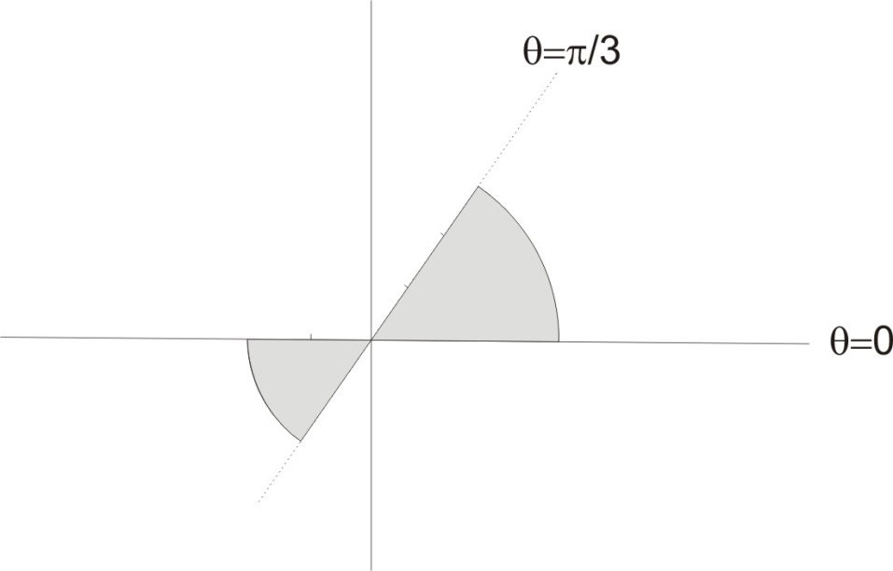

(b) Find a Cartesian equation for the polar curve$r=tanθsecθ.$

$$r=tanθsecθ=\frac{sinθ}{cosθ}\frac{1}{cosθ}$$
We have
$$r\cos^{2}θ=sinθ$$
or
$$r^{2}\cos^{2}θ=rsinθ.$$
The Cartesian equation for the curve is $y=x^{2}$

