Math 102 Major Quiz 2

Name: ID# Section# Serial#

Question# | Answer
1
2
3
4
5
6
Total

Instructions:
- Place your answer “letter” in the above table, including the solution
- Place letter “N” if you solved but found no answer
- Leave your answer blank if you did not solve the question

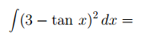
Question 1:

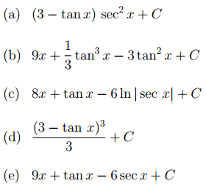

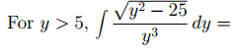
Question 2:

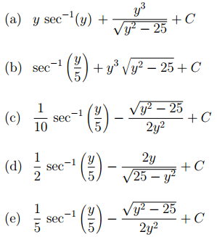

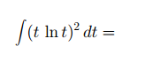
Question 3:
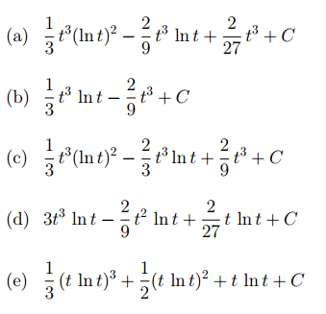

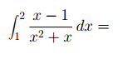
Question 4:

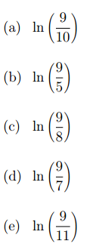

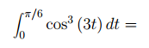
Question 5:
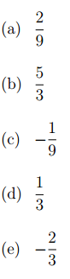

Question 6:
