Math 102 Major Quiz 3

Name: ID# Section# Serial#

Question# | Answer
1
2
3
4
5
6
Total

Instructions:
- Place your answer “letter” in the above table, including your complete solution
- Place letter “N” if you solved the question completely, but found no answer
- Leave your answer blank if you did not complete your answer

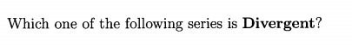
Question 1:

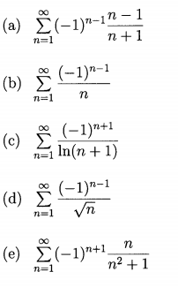

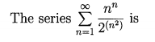
Question 2:
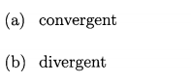

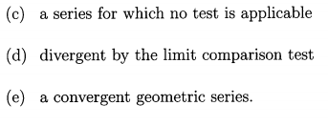

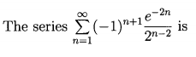
Question 3:
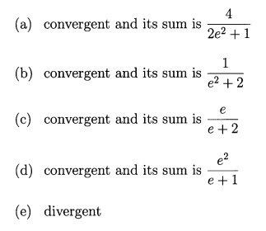

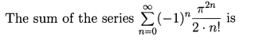
Question 4:
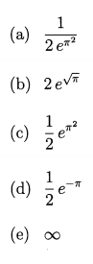

.
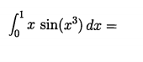
Question 5:
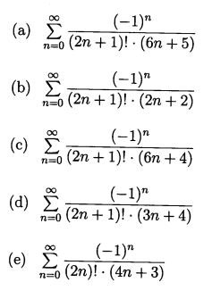

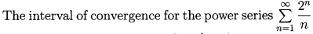
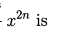
Question 6:
