Department of Mathematics and Statistics KFUPM
MATH 560 FINAL Time: 2 and Half hours Name: -------------------------------------------------ID: --------------------------------------
PART I:
Q1. Circle the correct option. (30 points)
1. An efficient design is one which:
- Is ecologically valid
- Does not involve many participants
- Does not cost much money
- Can detect genuine differences between conditions
2. A crossed design is one in which:
- There is an interaction between the factors.
- One level of one factor is combined with only one level of another factor.
- There is no interaction between the factors.
- Every condition is combined with every other condition.
3. A nested design is one in which:
- There are more than two independent variables.
- Participants are tested together
- There is more than one dependent variable.
- Certain levels of one variable only occur in certain levels of an independent variable
4. A two–way design is one which has two:
- Levels of the independent variable.
- Dependent variables
- Orders for the conditions
- Independent variables
5. A design which contains blocks is one:
- Where participants are measured on a number of occasions before and after an intervention.
- Where every condition is repeated a set number of times
- Where the researchers are prevented from allocating participants randomly.
- In which people with similar characteristics are grouped together.
6. The purpose of the Tukey tests for making unplanned or post hoc multiple pairwise comparison among the treatment means is to:
- Overcome the problem of heterogeneity of covariance.
- Make the tests more powerful.
- Control the individual Type I error rate.
- Control the familywise Type I error rate
7. Tukey multiple comparison test assumes that the data from the different groups come from populations where:
- the observations have a non-normal distribution.
- the observations have a normal distribution.
- the standard deviation is the same for each group
- Both b and c.
8. The __________ model contains some fixed and some random effects.
- Non-linear
- Fixed-effect
- Random effect
- Mixed-effect
- A simple experimental design with two levels of an independent variable cannot

- detect a curvilinear relationship between variables
- detect a monotonic relationship
- reveal a positive relationship
- show a negative relationship outcome

- In a factorial design, a main effect is the __________.
- the effect of each independent variable on the dependent variable
- the combined effect of the independent variables on the dependent variable
- interaction effect of the independent variables and their effect on the dependent variable
- interaction of the independent variables

- In a factorial design, a(an) ___________ between independent variables indicates that the effect of one independent variable is different at different levels of the other independent variable.
- interaction
- main effect
- factorial effect
- moderation

- What statistical procedure is used to assess the statistical significance of the main effects and the interaction(s) in a factorial design?
- analysis of variance
- t-test
- correlation
- analysis of covariance

- How would an interaction be indicated in a line graph?
- as intersecting lines
- as parallel lines
- as overlapping lines
- as diagonal lines

- If a study has two or more independent variables, it is called a factorial design.
- True
- False
- Not Sure
- None

- A main effect is the effect of one independent variable averaged over the other independent variables.

- True
- False
- Not Sure
- None

- If the effects of two treatment combinations are confounded, that is, if they cannot be separated in a fractional factorial design, one effect is said to be the ________ of the other.
- Alias
- confounded
- Partial confounded
- None

17. We can use ANOVA to test the equality of two or more means.
- False
- True
- None

18. What is meant by a replication of an experiment?
- Blocking
- A complete performance of the experiment. That is, every treatment possibility is applied.
- Experimental error

19. Does the picture below suggest that we have a significant result for differences between treatments?
- True. . it's obvious one of the means must be different
- False. . the means all seem to fall within the spread of the data. . it would be difficult to tell them apart.
- None
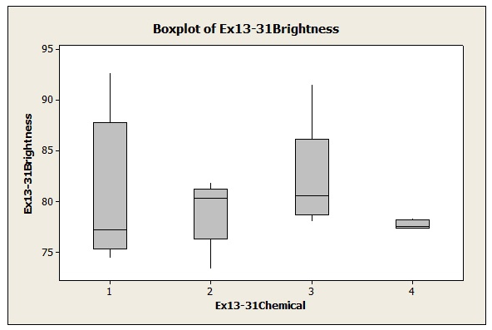

20. In a completely randomized experiment all of the runs are made in random order.
- False
- True
- None

21. Why randomize the application of treatments in the first place?
- Sometimes factor that are unknown can play a role, and randomization breaks any dependence between these factors, so their effect is negligible.
- Randomization reduces bias by equalizing other factors that have not been explicitly accounted for in the experimental design.
- Both A and B.
22. In a fixed effect experiments, the treatments are chosen at random.
- True
- False
- Not sure

23. The basic ANOVA identity is given as:
- Total MS=MST+MSE
- Total SS=SST+SSE
- None

24. Which is the correct value for the expected value of the mean square of the error?
- σ²
- σ

25. If the F-statistic in a single-factor ANOVA is significant this indicates that all of the means being compared are different.
- True
- False
- Information not sufficient

26. According to the data given below, what is the value of the F statistic?
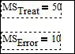 | - 10/50  - 50/10=5  - 5X10=50

27. In the picture below, does it seem that the results of the should be significant or not? That is, does it seem that at least one of the treatment means is different from the others?
- No. . it doesn't seem so
- Yes. . it seems so. .
- Information not sufficient
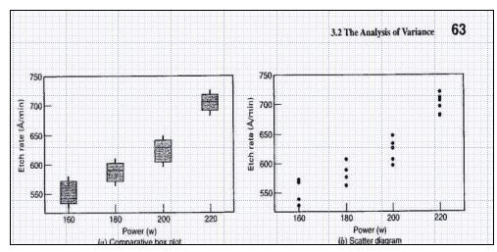

28. In the single-factor ANOVA model, the mean of treatment i is the sum of the grand mean and the ith treatment effect. Is the picture below correct?
- the sum of the error mean and the ith treatment effect
- the sum of the grand mean and the ith treatment effect
- the sum of the grand mean and the error mean

29. In the picture below, what exactly is the factor and what are the treatment levels and the response?
- The etch rate is the factor and the levels of etch rate are the response
- The power is the factor and the settings of power are the treatment levels and the etch rate is the response.
- The power is the treatment and the settings of power are the factors and the etch rate is the experimental error.

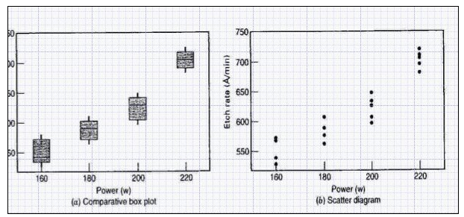
30. In the picture below, we see one replicate of the experiment is highlighted.
- True. . one power setting. . several measurements
- False. . only 1 power setting is used instead of all
- None
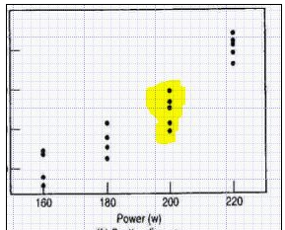

Name -----------------------------------------------ID: --------------------------------------

PART II: (5*4=20 points)

Q2. Consider the three-stage nested design used to investigate alloy hardness. Assuming that alloy chemistry and heats are fixed factors and ingots are random. We used the following experimental data to carry out analysis and got the following results. Fill the entries that are missing in the analysis table.

 | Alloy Chemistry
 | 1 |  |  |  |  |  |  |  |  | 2
Heats | 1 |  |  | 2 |  |  | 3 |  |  | 1 |  |  | 2 |  |  | 3
Ingots | 1 | 2 |  | 1 | 2 |  | 1 | 2 |  | 1 | 2 |  | 1 | 2 |  | 1 | 2
 | 40 | 27 |  | 95 | 69 |  | 65 | 78 |  | 22 | 23 |  | 83 | 75 |  | 61 | 35
 | 63 | 30 |  | 67 | 47 |  | 54 | 45 |  | 10 | 39 |  | 62 | 64 |  | 77 | 42

Minitab Output

ANOVA: Hardness versus Alloy, Heat, Ingot

Factor Type Levels Values
Alloy fixed 2 1 2
Heat(Alloy) fixed 3 1 2 3
Ingot(Alloy Heat) random 2 1 2

Analysis of Variance for Hardness

Source DF SS MS F P
Alloy 315.4 0.392
Heat(Alloy) 6453.8 0.055
Ingot(Alloy Heat) 2226.3 2.08 0.132
Error
Total 11137.0

Q3.Write the model for a two factor factorial experiment under RCBD and derive its least square estimates.

Q4. Confound a 2⁴ factorial deign into 4 blocks using AD and BC as confounding effects. Also work out the generalized interaction.

Q5. For a 2⁴ factorial experiment, provide a resolution IV design with the defining relation I=ABCD.

Name: -------------------------------------------------ID: --------------------------------------

PART III: (30 points)

Q6. A manufacturing engineer is studying the dimensional variability of a particular component that is produced on three machines. Each machine has two spindles, and four components are randomly selected from each spindle. The results follow. Analyze the data, assuming that machines and spindles are fixed factors.

 | Machine 1 |  |  | Machine 2 |  |  | Machine 3
Spindle | 1 | 2 |  | 1 | 2 |  | 1 | 2
 | 12 | 8 |  | 14 | 12 |  | 14 | 16
 | 9 | 9 |  | 15 | 10 |  | 10 | 15
 | 11 | 10 |  | 13 | 11 |  | 12 | 15
 | 12 | 8 |  | 14 | 13 |  | 11 | 14

Q7. Steel in normalized by heating above the critical temperature, soaking, and then air cooling. This process increases the strength of the steel, refines the grain, and homogenizes the structure. An experiment is performed to determine the effect of temperature and heat treatment time on the strength of normalized steel. Two temperatures and three times are selected. The experiment is performed by heating the oven to a randomly selected temperature and inserting three specimens. After 10 minutes one specimen is removed, after 20 minutes the second specimen is removed, and after 30 minutes the final specimen is removed. Then the temperature is changed to the other level and the process is repeated. Four shifts are required to collect the data, which are shown below. Analyze the data and draw conclusions, assume both factors are fixed.

 |  | Temperature (F)
Shift | Time(minutes) | 1500 | 1600
1 | 10 | 63 | 89
 | 20 | 54 | 91
 | 30 | 61 | 62
2 | 10 | 50 | 80
 | 20 | 52 | 72
 | 30 | 59 | 69
3 | 10 | 48 | 73
 | 20 | 74 | 81
 | 30 | 71 | 69
4 | 10 | 54 | 88
 | 20 | 48 | 92
 | 30 | 59 | 64

Q8. Four different formulations of an industrial glue are being tested. The tensile strength of the glue when it is applied to join parts is also related to the application thickness. Five observations on strength (y) in pounds and thickness (x) in 0.01 inches are obtained for each formulation. The data are shown in the following table. Analyze these data and draw appropriate conclusions.

 |  |  | Glue | Formulation
1 | 1 | 2 | 2 | 3 | 3 | 4 | 4
y | x | y | x | y | x | y | x
46.5 | 13 | 48.7 | 12 | 46.3 | 15 | 44.7 | 16
45.9 | 14 | 49.0 | 10 | 47.1 | 14 | 43.0 | 15
49.8 | 12 | 50.1 | 11 | 48.9 | 11 | 51.0 | 10
46.1 | 12 | 48.5 | 12 | 48.2 | 11 | 48.1 | 12
44.3 | 14 | 45.2 | 14 | 50.3 | 10 | 48.6 | 11

From the analysis performed in Minitab, glue formulation does not have a statistically significant effect on strength. As expected, glue thickness does affect strength.

Q9. The brake horsepower developed by an automobile engine on a dynamometer is thought to be a function of the engine speed in revolutions per minute (rpm), the road octane number of the fuel, and the engine compression. An experiment is run in the laboratory and the data that follow are collected.

Brake Horsepower | rpm | Road Octane Number | Compression
225 | 2000 | 90 | 100
212 | 1800 | 94 | 95
229 | 2400 | 88 | 110
222 | 1900 | 91 | 96
219 | 1600 | 86 | 100
278 | 2500 | 96 | 110
246 | 3000 | 94 | 98
237 | 3200 | 90 | 100
233 | 2800 | 88 | 105
224 | 3400 | 86 | 97
223 | 1800 | 90 | 100
230 | 2500 | 89 | 104

Fit a multiple linear regression model to the data. Test for significance of regression. What conclusions can you draw? Analyze the residuals from the regression model

