Department of Mathematics and Statistics KFUPM
MATH 560 Major 1 Time: 2 hours Name: -------------------------------------------------ID: --------------------------------------
PART I:
Q1. Circle the correct option. (20 points)
1. We can use ANOVA to test the equality of two or more means.
- False
- True
- None

2. What is meant by a replication of an experiment?
- Blocking
- A complete performance of the experiment. That is, every treatment possibility is applied.
- Experimental error

3. Does the picture below suggest that we have a significant result for differences between treatments?
- True. . it's obvious one of the means must be different
- False. . the means all seem to fall within the spread of the data. . it would be difficult to tell them apart.
- None
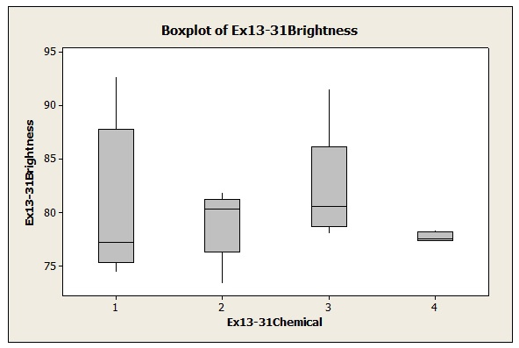

4. In a completely randomized experiment all of the runs are made in random order.
- False
- True
- None

5. Why randomize the application of treatments in the first place?
- Sometimes factor that are unknown can play a role, and randomization breaks any dependence between these factors, so their effect is negligible.
- Randomization reduces bias by equalizing other factors that have not been explicitly accounted for in the experimental design.
- Both A and B.
6. In a fixed effect experiments, the treatments are chosen at random.
- True
- False
- Not sure

7. The basic ANOVA identity is given as:
- Total MS=MST+MSE
- Total SS=SST+SSE
- None

8. Which is the correct value for the expected value of the mean square of the error?
- σ²
- σ

9. If the F-statistic in a single-factor ANOVA is significant this indicates that all of the means being compared are different.
- True
- False
- Information not sufficient

10. According to the data given below, what is the value of the F statistic?
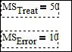 | - 10/50  - 50/10=5  - 5X10=50

11. In the picture below, does it seem that the results of the treatments should be significant or not? That is, does it seem that at least one of the treatment means is different from the others?
- No. . it doesn't seem so
- Yes. . it seems so. .
- Information not sufficient
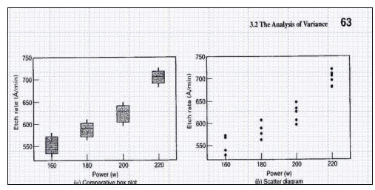

12. In the single-factor ANOVA model, the mean of treatment i is the sum of the grand mean and the ith treatment effect. Is the picture below correct?
- the sum of the error mean and the ith treatment effect
- the sum of the grand mean and the ith treatment effect
- the sum of the grand mean and the error mean

13. In the picture below, what exactly is the factor and what are the treatment levels and the response?
- The etch rate is the factor and the levels of etch rate are the response
- The power is the factor and the settings of power are the treatment levels and the etch rate is the response.
- The power is the treatment and the settings of power are the factors and the etch rate is the experimental error.

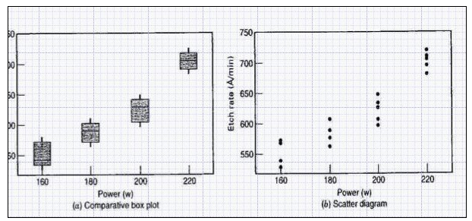
14. In the picture below, we see one replicate of the experiment is highlighted.
- True. . one power setting. . several measurements
- False. . only 1 power setting is used instead of all
- None
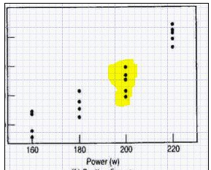

15. In the picture below, we see one full replicate of the experiment highlighted
- False. . this picture doesn't show one full replicate
- True. . all the power setting are applied
- None
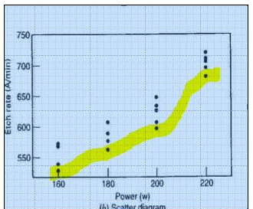

16. In the table below, if we increase n, what happens to the number of dots in a scatter diagram at every treatment level? Do the dots increase in number vertically or horizontally?
- It goes down vertically
- The dots increase in number. . more appear at every level vertically
- Nothing happens. . there is no connection between scatter points and n
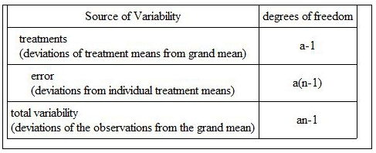

17. If I increase a in the table below, what will happen to the number of dots in a scatter diagram? Will the increase come from adding dots vertically at every level or horizontally WITH new levels?
- It will go down
- It will go up as we add levels. . horizontally
- It will go up as we add levels. . vertically
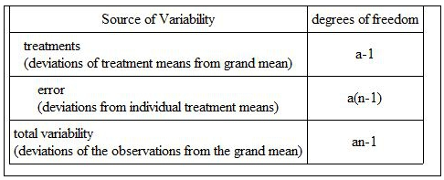

18. Which picture, the left or right, shows the correct groupings in terms of the definition of a replicate of an experiment?
- Right
- Left
- None

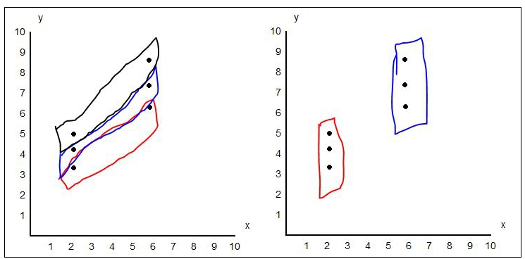
19. If in the table below, we increase n, will the degrees of freedom for error increase or decrease? Is the total variability in the data affected? Are the degrees of freedom for treatments affected?
- Freedom degrees for error increase, treatment degrees go down, total variability stays the same
- Freedom degrees for error increase, treatment degrees are constant, total variability increases.
- None

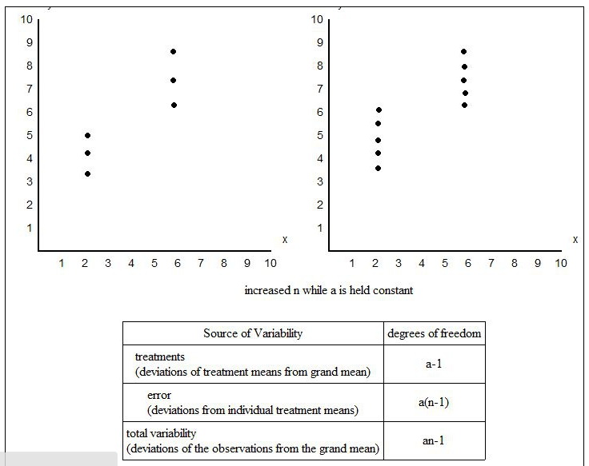
20. If we have 3 factors, all at two levels, experiment, what does this mean and we run 10 replicates, what's the result?
- 60 runs
- 80 runs
- 270 runs

Name: -------------------------------------------------ID: --------------------------------------

PART II: (20 points)
Q2. For a Latin square design, do the following:
- Write its ANOVA model.

- Give the assumptions about its error term.

- Provide the partitioning of total sum of square into different components.

- Derive expected value of MSE and comment on it. (Show necessary steps only once for similar terms).

Name: -------------------------------------------------ID: --------------------------------------

PART III: (30 points)

Q3. A mechanical engineer is studying the thrust force developed by a drill press. He suspects that the drilling speed and the feed rate of the material are the most important factors. He selects four feed rates and uses a high and low drill speed chosen to represent the extreme operating conditions. He obtains the following results. Analyze the data assuming normality and draw conclusions. Use α = 0.05.
(Provide ANOVA table, specify hypotheses and comment on your results.)

(A) |  | Feed | Rate (B)
Drill Speed | 0.015 | 0.030 | 0.045 | 0.060
125 | 2.70 | 2.45 | 2.60 | 2.75
 | 2.78 | 2.49 | 2.72 | 2.86
200 | 2.83 | 2.85 | 2.86 | 2.94
 | 2.86 | 2.80 | 2.87 | 2.88

Q4. The effect of three different lubricating oils on fuel economy in diesel truck engines is being studied. Fuel economy is measured using brake-specific fuel consumption after the engine has been running for 15 minutes. Five different truck engines are available for the study, and the experimenters conduct the following randomized complete block design.

 | Truck
Oil | 1 | 2 | 3 | 4 | 5
1 | 0.500 | 0.634 | 0.487 | 0.329 | 0.512
2 | 0.535 | 0.675 | 0.520 | 0.435 | 0.540
3 | 0.513 | 0.595 | 0.488 | 0.400 | 0.510

Analyze the data from this experiment, assuming non-normality at 5% level of significance. (Provide ANOVA table, specify hypotheses and comment on your results.)

Q5. The C. F. Eye Care company manufactures lenses for transplantation into the eye following cataract surgery. An engineering group has conducted an experiment involving two factors to determine their effect on the lens polishing process. The results of this experiment are summarized in the following ANOVA display:

Source | DF | SS | MS | F | P-value
Factor A | --- | --- | 0.0833 | 0.05 | 0.952
Factor B | --- | 96.333 | 96.3333 | 57.80 | <0.001
Interaction | 2 | 122.167 | 6.0833 | 3.65 | ---
Error | 6 | 10.000 | ---
Total | 11 | 118.667
Complete the missing places in the above table.

