KFUPM QUIZ (1a) MATH 301-151 Name:_______________________________S.ID:______________________Sec.( ) Ser.# ( )
Q1) If $r'\left(t\right)=costi+6tj+3t^{2}k∧r\left(0\right)=i−2j+k,findr\left(t\right)$.
Q2) Let $f\left(x,y,z\right)=x^{3}z^{2}+y^{3}z+z−1$.
a) Find $\left(∇f\right).$
b) Find the directional derivative at $P\left(1,1,−1\right)$ in the direction of
$u=2i+3j+6k$. Is this direction makes a maximum rate of change?
Q3) Evaluate $\int_{C}{\left(2x+y\right)dx+xydy}$ where C is the given curve between
(2,5)$\left(−1,2\right)∧\left(2,5\right).$
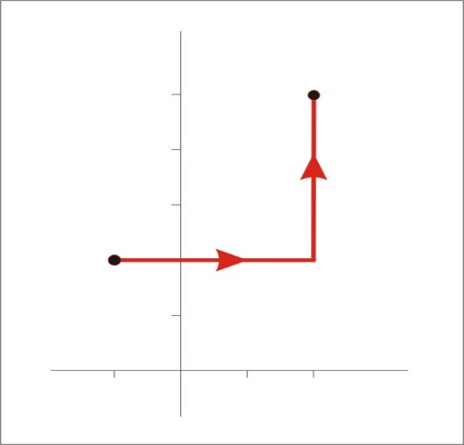

(−1,2)

