KING FAHD UNIVERSITY OF PETROLEUM & MINERALS

DEPARTMENT OF MATHEMATICS & STATISTICS

DHAHRAN, SAUDI ARABIA

STAT 212: BUSINESS STATISTICS II

Major Exam III

Name: ID#: Serial:

Please circle your section #:
Question No | Full Points | Points Obtained
1 | 30
2 | 6
3 | 4
Total | 40
Al-Sawi | 1 (07:00 -07:50 AM)
Malik | 2 (08:00 -8:50 AM)

- (30 pts.)
A personnel officer in a governmental agency administered four newly developed aptitude tests to each of 25 applicants for entry-level clerical positions in the agency. For purpose of the study, all 25 applicants were accepted for positions irrespective of their test scores. After a probationary period, each applicant was rated for proficiency on the job. The scores on the four tests (X1, X2, X3, X4) and the job proficiency score (Y) for the 25 employees were as follows:
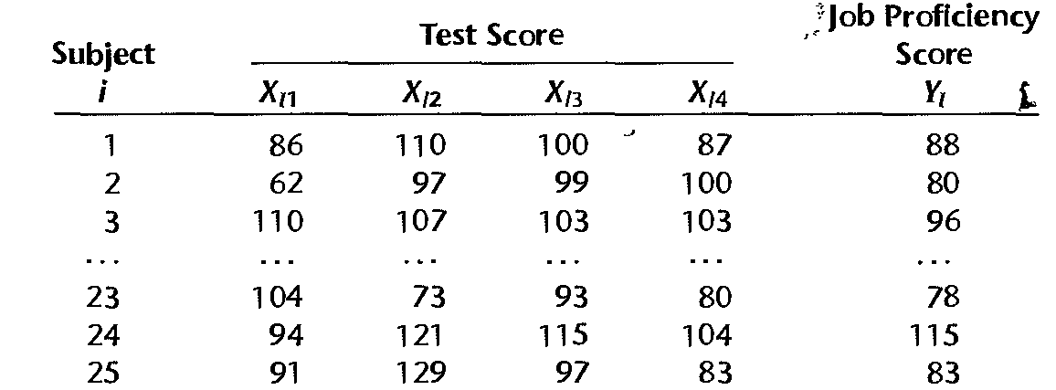

Correlations: Y, X1, X2, X3, X4

Y X1 X2 X3
X1 0.869
0.000

X2 0.327 0.514
0.111 0.009

X3 0.397 0.497 0.102
0.050 0.011 0.627

X4 0.782 0.897 0.181 0.519
0.000 0.000 0.387 0.008

Cell Contents: Pearson correlation
P-Value

Regression Analysis: Y versus X1, X2, X3, X4
The regression equation is
Y = 101 + 0.841 X1 - 0.192 X2 - 0.0457 X3 - 0.585 X4

Predictor Coef SE Coef T P VIF
Constant 100.88 30.03 3.36 0.003
X1 0.8406 0.2134 3.94 0.001 15.173
X2 -0.19182 0.09142 -2.10 0.049 3.042
X3 -0.04574 0.07258 -0.63 0.536 1.392
X4 -0.5853 0.4054 -1.44 0.164 11.384

S = 5.21205 R-Sq = 80.1% R-Sq(adj) = ???%

Analysis of Variance
Source DF SS MS F P
Regression 4 2192.13 548.03 20.17 0.000
Residual Error 20 543.31 27.17
Total 24 2735.44

Best Subsets Regression: Y versus X1, X2, X3, X4
Response is Y
Mallows X X X X
Vars R-Sq R-Sq(adj) Cp S 1 2 3 4
1 75.6 74.5 3.6 5.3888 X
1 61.2 59.5 18.1 6.7967 X
2 77.6 75.5 3.6 5.2822 X X
2 75.7 73.5 5.4 5.4911 X X
3 79.7 76.8 3.4 5.1367 X X X
3 78.1 74.9 5.1 5.3450 X X X
4 80.1 76.2 5.0 5.2121 X X X X

- (6 pts) Based on the scatter plot matrix and the correlation matrix of the X variables:
- (3 pts) Can we conclude that there is no relationship between Y and X2? Explain.

- (3 pts) Can we conclude that there is a NONLINEAR relationship between Y and X3? If yes, suggest a suitable transformation. Explain.

- (18 pts) Based on the output “Regression Analysis: Y versus X1, X2, X3, X4”, answer the following questions:
- (2 pts) Which test is the most important test in explaining the job proficiency score? Explain.

- (2 pts) Interpret the coefficient for test 1.

- (3 pts) Predict mean job proficiency score for the first employee.

- (3 pts) Compute and interpret the adjusted R².

- (3 pts) Write hypothesis for testing the overall significance of the regression model, then write your conclusion?

- (3 pts) At 5% level of significance, which test/tests affect the job proficiency score? Explain.

- (3 pts) Is there reason to suspect the existence of collinearity? If yes, which variable should be removed from the model? Explain.

- (2pts each =6pts ) Based on the output “Best Subsets Regression: Y versus X1, X2, X3, X4”, What are the best models based on
- Adjusted R-square criterion?

- Mallows Cp criterion?

- Standard error?

- (3+ 3 =6 pts.)
Suppose want to estimate the annual income for COE’s in KSA (y in $1000) using the numerical variables X₁ (experience) and X₂ (starting salary) and the categorical variable X₃ (Gender: 0=Females, 1=Males) using the following model :
$y=$ $β_{0}+β_{1}x_{1}+β_{2}x_{2}+β_{3}x_{1}^{2}+β_{4}x_{2}^{2}+β_{5}x_{1}x_{2}+β_{6}x_{3}+ε$

Assume and the estimated regression equation is:
$y=$ $\text{69}\text{.}7+\text{11}\text{.}3x_{1}+7\text{.}\text{61}x_{2}−1\text{.}\text{15}x_{1}^{2}−0\text{.}\text{51}x_{2}^{2}−0\text{.}\text{13}x_{1}x_{2}+2 x_{3}$

- Interpret the coefficient of $x_{1}^{2}$?

- Interpret the coefficient of x₃?

- (2+2=4 pts)
What can you conclude from the following residual plots?

