Q1. a) Find the divergence of $F\left(x,y,z\right)=x^{2}sin\left(xyz\right)i+y^{2}cos\left(xz^{3}\right)j+xye^{2yz}k$at $P\left(1,2,0\right)$

b) If $a$ is a constant vector and $r=xi+yj+zk.$ Verify the identity: curl$\left(a×r\right)=2a$

Q2. Evaluate $\int_{C}{2xdx−\left(2x^{2}+y^{2}\right)dy,}$ where C is the piecewise-smooth curve given below.
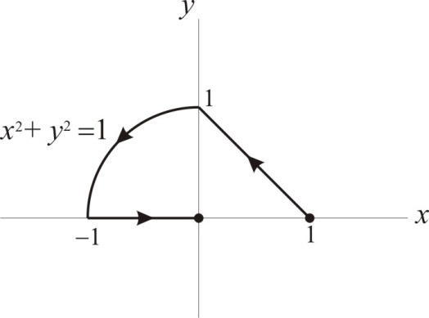
Curve C for Problem Q2

