Q1 Find the average value of
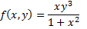
over the rectangle
Q2 Find the volume of the solid in the first octant bounded by the surface and the coordinate planes.

