- Find the limit if exists or show that the limit does not exist
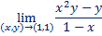

- Find if
- Let Find at

- Show that the limit does not exist
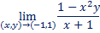

- Find if
- Let Find at

