Department of Mathematics and Statistics
Semester 132
STAT310 Midterm Exam Thursday, April 17, 2014
Name: ID #:
- The director of admissions of a small college selected 120 students at random from the new freshman class in a study to determine whether a student's grade point average (GPA) at the end of the freshman year (Y) can be predicted from the ACT test score (X). The results of the study follow.
provided: ∑y=, ∑x=, ∑x² =, ∑y² =, ∑xy=
- Fill the missing values “?” below?
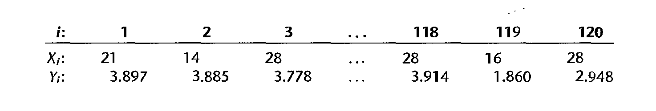
β₁
β₀
The regression equation is:

?

Predictor Coef SE Coef T P
Constant ?________ 0.3209 ________ 0.000
x ?________ 0.01277 ________ 0.003

S = ?________ R-Sq = ?________

Analysis of Variance

Source DF SS MS F P
Regression ?___ ?_______ _______ 9.24 0.003

Residual Error ____ 45.8176 ________
Lack of Fit 34 14.6600 0.4312 1.15 0.298
Pure Error 83 31.1042 0.3747
Total ____ ________

Predicted Values for New Observations

Obs Fit SE Fit 95% CI 95% PI
1 3.2012 0.0706 (3.0614, 3.3410) (1.9594, 4.4431)

Unusual Observations

Obs | SRES1 | TRES1 | HI1 | COOK1 | DFIT1
2 | 2.027999 | 2.055526 | 0.056665 | 0.123525 | 0.503787
9 | -4.43288 | -4.83496 | 0.016012 | 0.159886 | -0.61677
101 | -2.00435 | -2.03071 | 0.008365 | 0.016945 | -0.18651
102 | -2.00137 | -2.02758 | 0.027336 | 0.056286 | -0.33991
105 | -0.21259 | -0.21172 | 0.008554 | 0.000195 | -0.01967
115 | -2.97678 | -3.08213 | 0.024878 | 0.113038 | -0.4923

- Does the estimated regression function appear to fit the data well?

- Do outliers and/or leverage points exist? If yes, are the outliers and leverage points valid?

- What is the point estimate of the change in the mean response when the entrance test score increases by one point?

- Test whether or not a linear association exists between student’s ACT score (X) and GPA at the end of the freshman year (Y). Use a level of significance of 0.01. (State the alternatives, decision rule, and conclusion.)

- Obtain a 99% confidence interval for β₁. Interpret your confidence interval.

- Find the 90% joint confidence intervals for β₀ and β₁ and interpret.

- Obtain a 95% interval estimate of the mean freshman GPA for students whose ACT test score is 28. Interpret your confidence interval.
Interval:
Interpretation:

- Ahmad obtained a score of 28 on the entrance test. Predict his freshman GPA using a 95% prediction interval. Interpret your prediction interval.

Interval:

Interpretation:

- Compute R-sq and interpret its value? What can we conclude about the model?

- Lack of fit test outputs provided and assume the model assumptions are satisfied:

  - Can you perform a lack of fit test for this data set? Explain

  - Assume yes, perform the test and write your conclusion.

- Verify that your fitted regression line goes through the point $\left(\overline{X},\overline{Y}\right)$.
Part 2:
Consider the data sets in Blackboard. Use Minitab to solve the parts below. Save all Minitab output used in a word file called “yourLastName-ID”, and email it to me in blackboard or to mailto:alsawies@kfupm.edu.sabefore the end of the exam session.

- (Production time318) In a manufacturing study, the production times for 111 recent production runs were obtained. The table below lists for each run the production time in hours (7) and the production lot size (X).
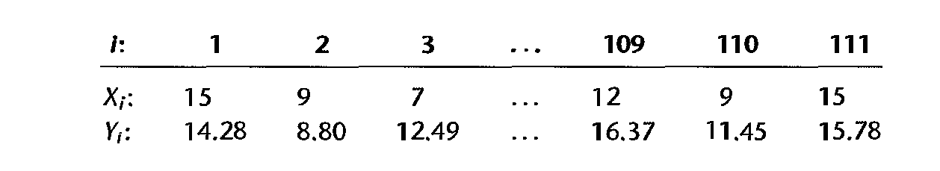
- Based on the scatter plot of the data: Does a linear relation appear adequate here? Would a transformation on X or Y be more appropriate here? Why?

- obtain the estimated linear regression function and
  - Comment on the assumptions.

  - Do outliers and/or leverage points exist? If yes, are the outliers and leverage points valid?

- Use the transformation X' = $\sqrt{X}$
  - Repeat part 2.

  - Estimate y when X=4

- (Sales growth317) A marketing researcher studied annual sales of a product that had been introduced 10 years ago. The data are as follows, where X is the year (coded) and Y is sales in thousands
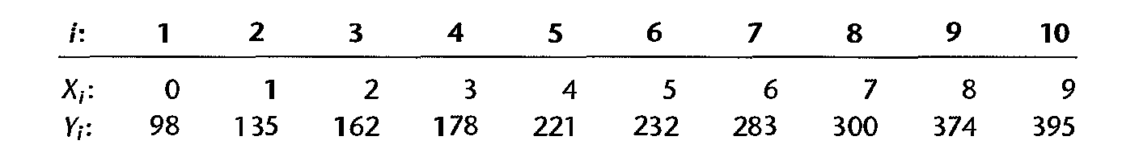
- Prepare a scatter plot of the data. Does a linear relation appear adequate here?

- obtain the estimated linear regression function and

  - Comment on the assumptions.

  - Do outliers and/or leverage points exist? If yes, are the outliers and leverage points valid?

- Researcher A suggests the transformation X' = $X^{2}$ and researcher B suggests the transformation Y' = $\sqrt{Y}$ . Which one will you choose and why?

