- Consider the matrix
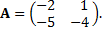
- Find the eigenvalues and eigenvectors of
- What are the eigenvalues and eigenvectors of
Solution:
- Solving the characteristic equation

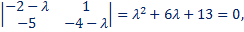

Gives eigenvalues of:
The corresponding eigenvectors are obtained by solving the system with augmented matrix
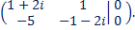
We have. Putting gives the eigenvector corresponding to
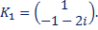

Complex conjugate of is an eigenvector corresponding to :

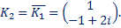

- If is an eigenvalue of with corresponding eigenvector K, then is an eigenvalue of with the same corresponding eigenvector K. Thus, eigenvalues of are
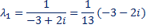
and
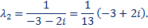
with corresponding eigenvectors

- Consider the matrix
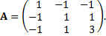
- Explain why matrix A is diagonalizable.
- Eigenvalues of A are and Find an orthogonal matrix P that diagonalizes A.
Solution:
- is diagonalizable, since is a symmetric matrix.
- For , we have
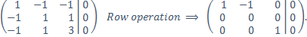
A corresponding eigenvector is 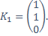
For, we have
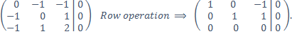
A corresponding eigenvector is 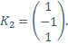
For, we have
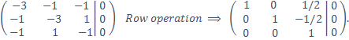
A corresponding eigenvector is 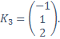
An orthogonal matrix that diagonalizes A is 

