- Let V be the set of all vectors on the plane
- Show that V is a subspace of
- Find a basis for V.
Solution:
- Since is on the plane, the set V is nonempty.

- If are in V, then

and.
We have
and

So, is in V.

- For any scalar

We have
So, is also in V.
From (i) and (ii) we conclude that V is a subspace of

- If is in V, then

So, the set spans V. Since the vector is not a scalar

multiplication of then B is linearly independent. Thus, B is a basis for V.

- Consider the linear system , where
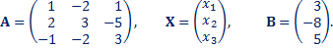
- Find rank(A) and rank(A|B)
- Solve the system.
Solution:
- 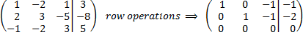

We have
rankrank

- From the reduced row-echelon form of the augmented matrix of the system, we obtain the solution (for any real number )

