King Fahd University of Petroleum & Minerals
Department of Mathematics & Statistics
STAT-201-Term131
Quiz #1
St. ID: St. Name: Serial#: Section:
Q1. The following data represent the annual income (in thousands of SR) of a simple random sample of 21 accountants in Saudi Arabia:
101 104 112 121 121 117 125 132 137 139 141 128 135 144
145 145 148 151 154 157 161

- Construct a frequency distribution using the end points: 100,110, … then draw the histogram and comment.

- What is the percentage of the employees with annual income between 120 and 130 thousands SR?

- What do we mean by the cumulative frequency of [120 ,130)?

- Construct a stem and leaf plot for the data.

Q2. Fill in the blank. One advantage of the __________ is that the actual data values are retained in the graphical summarization of the data
  - stem – and leaf plot
  - pie chart
  - histogram
  - bar chart

Q3: The manager of a store conducted a customer survey to determine why customers shopped at the store. The results are shown in the figure. What proportion of customers responded that merchandise was the reason they shopped at the store?
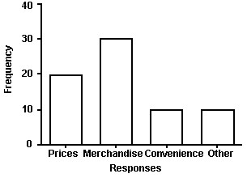

- 30
- 2/7
- 3/7
- ½

