- Show that the following line integral is independent of path and evaluate the integral.
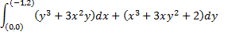

- Let be the circle Use Green’s Theorem to evaluate
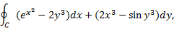

- Let S be the portion of the plane within the cylinder. Evaluate the surface integral
