- Set up the integral to find the volume of the solid in the first octant bounded by the coordinate planes, the plane and the cylinder Do not evaluate the integral.

- Convert the integral to an equivalent integral in cylindrical coordinates (do not evaluate the integral):
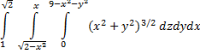

- Let D be the solid bounded above by the cone and below by the sphere Evaluate
