- Find the volume of the solid enclosed by the surface and the planes

- Evaluate
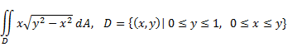

- Evaluate the integral by reversing the order of integration.
