KING FAHD UNIVERSITY OF PETROLEUM & MINERALS

DEPARTMENT OF MATHEMATICS AND STATISTICS
Term 122

STAT 212: BUSINESS STATISITICS II

Second Major Exam Sunday April 21, 2013

Please check/circle your instructor’s name

□ Al-Sabah □ Saleh .

Name: ID #: Section#

☺Important Note:
Show all your work including formulas, intermediate steps and final answer.
You may assume α = 0.05 for testing if not otherwise stated.

Question No | Full Marks | Marks Obtained
1 | 15
2 | 5
3 | 20
4 | 10
Total | 50

Q1: A shipping company believes that the variation in the cost of shipments can be explained by the differences in the weight of the packages being shipped. In order to investigate whether this relationship is useful, a random sample of 20 customer shipments was selected and the weight (in kg) and the cost (in dollars) for each shipment were recorded. The following results were obtained:

Weights | 8 | 6 | 5 | 7 | 12 | 9 | 17 | 13 | 8 | 18
Weights | 17 | 17 | 10 | 20 | 9 | 5 | 13 | 6 | 6 | 12
Cost | 11 | 8 | 11 | 11 | 17 | 11 | 27 | 16 | 9 | 25
Cost | 21 | 24 | 16 | 24 | 21 | 10 | 21 | 16 | 11 | 20
You may need the following information’s
$\sum{x}=218,\sum{y}=330,\sum{{\left(x−\overline{x}\right)}^{2}=437.8},\sum{{\left(y−\overline{y}\right)}^{2}=691},\sum{\left(x−\overline{x}\right)\left(y−\overline{y}\right)=482}∧MSE=8.907644$
- (5 points) Compute the linear regression model, interpret the slope.

- (2 point) Predict the cost of a package if the weight of that package 13 kg.

- (2 points) What is the percentage of the total variation in the shipping cost that can be explained by the regression model?

- (6 points) Construct a 95% confidence interval for the regression coefficient. Based on this confidence interval; do you think that there is a relation between the two variables? Explain

Q2: A recent study by the U.S. Department of Agriculture attempted to develop a regression model to explain variation in farm income. At one stage of development, the estimate of the model took the following form:
$\hat{y}=−23200+4.2x_{1}+2345x_{2}+4670x_{3}$

Where: $x_{1}$= Number of acres farmed

$x_{2}=\left\{\begin{matrix}1 & iflandisrow−irrigated \\ 0 & ifnot\end{matrix}\right.$

$x_{3}=\left\{\begin{matrix}1 & iflandissprinkler−irrigated \\ 0 & ifnot\end{matrix}\right.$

- (4 points) Interpret the regression coefficients.

- (1 point) Predict the average farm income for a 1000 –acre farm that uses sprinklers.

Q3: An investment company wants to develop a regression model using appropriate independent variables
These variables are as follows:
Y: Stock price
X1: Annual 3-year growth rate in sales as a percentage.
X2: Total sales in millions of dollars for last four quarters.
X3: Earnings per share annual growth rate as a percentage.
X4: Profits for last four quarters.
X5: Stock price 1 year earlier.
X6: Price earnings (P/E) ratio over last four quarters.

In addition to these variables, there are three mutually exclusive markets where the stock can be traded:
- Over the Counter (OTC)
- New York Stock Exchange (NYSE)
- NASDAQ

- (2 points) Define appropriate variables to indicate the markets where the stock can be traded.

Consider the Minitab output below

Regression Analysis: Y versus X1, X2, X3, X4, X5, X6, X7, X8

Predictor Coef SE Coef T P
Constant 17.447 6.021 2.90 0.005
X1 -0.01157 0.03774 -0.31 0.760
X2 -0.001622 0.002884 -0.56 0.575
X3 0.01743 0.01820 0.96 0.341
X4 0.11872 0.03492 3.40 0.001
X5 0.12446 0.04810 2.59 0.011
X6 0.15571 0.04643 3.35 0.001
X7 -0.614 5.040 -0.12 0.903
X8 -3.024 5.861 -0.52 0.607
S = 17.4220 R-Sq = 30.6% R-Sq(adj) = 24.5%
Analysis of Variance

Source DF SS MS F P
Regression 8 12186.1 1523.3 5.02 0.000
Residual Error 91 27620.9 303.5
Total 99 39807.0

Answer the questions:
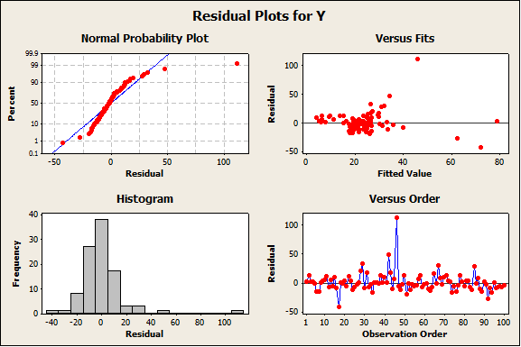
- (4 points) What can you say about the assumptions of regression model, using the MINITAB graph for the residuals? Explain.

- (2 points) Predict the stock price if, X1= 135, X2=500, X3=99, X4=20, X5=10, X6=14 and the company stock is traded in the NASDAQ.

- (3 points) How much of the total variation in the stock price is explained by the variation in the explanatory variables

- (6 points) Would you conclude that the model is significant at 10% level of significance? Explain.
(Clearly write the hypothesis, the decision rule, your decision and the conclusion)

- (3 points) At 10% level of significant, which of the predictors can be concluded to be significant in explaining the variation in the stock? Explain?

Q4: (10 points) In reference to question 3, adding the interaction terms to the model, the following Minitab results are given:

Predictor Coef SE Coef T P
Constant 22.00 12.94 1.70 0.093
X1 -0.1878 0.1601 -1.17 0.244
X2 0.020081 0.009614 2.09 0.040
X3 0.16647 0.04394 3.79 0.000
X4 0.11489 0.03522 3.26 0.002
X5 0.07713 0.04915 1.57 0.120
X6 0.22427 0.05050 4.44 0.000
X7 -9.98 14.21 -0.70 0.484
X8 -1.20 16.25 -0.07 0.942
X1*X7 0.1987 0.1670 1.19 0.237
X1*X8 0.1358 0.1802 0.75 0.453
X2*X7 -0.01868 0.01032 -1.81 0.074
X2*X8 -0.023406 0.009843 -2.38 0.020
X3*X7 -0.17059 0.04843 -3.52 0.001
X3*X8 -0.18723 0.06823 -2.74 0.007

Analysis of Variance

Source DF SS MS F P
Regression 14 16540.3 1181.4 4.32 0.000
Residual Error 85 23266.7 273.7
Total 99 39807.0

At 5% level of significance, determine whether the interactions collectively make a significant contribution to the model.
(Clearly write the hypothesis, the decision rule, your decision and the conclusion)

