KING FAHD UNIVERSITY OF PETROLEUM & MINERALS
DEPART OF MATHEMATICS & STATISTICS

STAT319: PROBABILITY & STATISTICS FOR ENGINEERS & SCIENTISTS

Fall 2010 (Term 101)
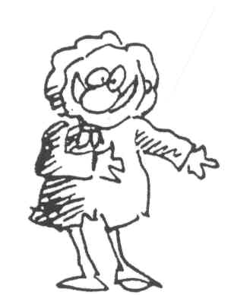

Instructor: Musawar Amin Malik
Office: 5-306 Phone: 2396
Email: mmalik@kfupm.edu.sa
Office Hours: SM: 11:00 am – 01:00 pm
U: 03:00 pm – 04:00 pm
and by appointment.

Course Objectives: Introduce the basic concepts of probability and statistics to engineering students. Emphasis will be given on the understanding of the nature of randomness of real world phenomena, the formulation of statistical methods by using intuitive arguments and thereby making meaningful decisions.

Text: Miller & Freund's Probability and Statistics for Engineers by Johnson, R. A. (2005) 7th Ed.
Software Package: The Student Edition of STATISTICA with a Lab Manual.

Students are required to carry a Scientific calculator with stat functions to every lecture, lab and in the exam with them. Usually once a chapter is finished, you expect a quiz/class test.

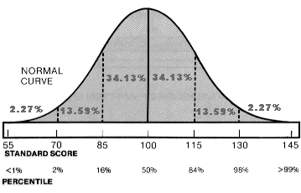

Assessment:
Activity | Weight
Classwork | 15%
Lab | 15%
First Major Exam (Chapters 1 to 3) , Week 6 Time and Location TBA | 15%
Second Major Exam (Chapters 4 to 6) , Week 11 Time and Location: TBA | 15%
Final Exam (Comprehensive) , 7:00 pm , January 22, 2011 Location: TBA | 40%

Important Note: You need to achieve at least 50% in order to pass the course.

Homework: Will be assigned later.

Syllabus
Week 1  25/9/ – 29/9 | Ch 1. Introduction  Ch 2. Treatment Of Data  2.1 Pareto Diagrams And Dot Diagrams  2.2 Frequency Distributions
Week 2  2/10 – 6/10 | Ch 2. Treatment Of Data  2.3 Graphs Of Frequency Distributions  2.4 Stem-And-Leaf Displays  2.5 Descriptive Measures  2.7 The Calculation Of Mean And Variance
Week 3  9/10 – 13/10 | Ch 2. Treatment Of Data  2.6 Quartiles And Percentiles  Ch 3. Probability  3.1 - 3.2 Sample Space And Events And Counting  3.3 Probability
Week 4  16/10 – 20/10 | 3.4 The Axioms Of Probability  3.5 Some Elementary Theorems  3.6 Conditional Probability
Week 5  23/10 – 27/10 | 3.7 Bayes' Theorem  3.8 Mathematical Expectation
Week 6  30/10 – 3/11 | Major Exam #1  Ch 4. Probability Distributions  4.1 Random Variables  4.2 - 4.3 The Binomial And Hypergeometric Distributions
Week7  6/11 – 10/11 | 4.4 The Mean And The Variance Of A Probability Distribution  4.7 – 4.8 The Poisson And Geometric Distributions.
 | Eid Al-Adha Vacation
Week 8  22/11 – 24/11 | Ch 5. Probability Densities  5.1 Continuous Random Variables  5.2 The Normal Distribution
Week 9  27/11 – 1/12 | 5.3 The Normal Approximation To The Binomial  5.4 – 5.9 Other Probability Distributions
Week 10  4/12 – 8/12 | Ch 6. Sampling Distributions  6.1 Populations And Samples  6.2 – 6.3 Sampling Distribution Of The Mean
Week 11  11/12 – 15/12 | Major Exam #2  Ch 7. Inferences Concerning Means  7.1 – 7.2 Point And Interval Estimation  7.3 Tests of Hypotheses
Week 12  18/12 – 22/12 | 7.4 - 7.5 Hypotheses Concerning One Mean  7.6 Relation Between Tests And Confidence Intervals
Week 13  25/12 – 29/12 | 7.8 Inference Concerning Two Means  Ch 9. Inferences Concerning Proportions  9.1 -9.2 Estimation And Hypotheses Concerning One Proportion
Week 14  1/1 – 5/1 | Ch 11. Curve Fitting  11.1 The Method Of Least Square  11.2 Inference Based On Least Square Estimators
Week 15  8/1 – 15/1 | 11.6 Correlation

