ICS 102 Lab #04: Selection Statements
Objectives:
- Learn to use relational and equality operators
- Learn to use boolean operators ! (not), && (logical AND), and || (logical OR)
- Learn to use if and switch statements:
- Two-way selection (if-else statement)
- One-way selection (if-statement)
- Multi-way selection with else option (if - else if – else)
- Multi-way selection with no else option (if – else if – else if)
- Nested if statements
- switch statement with default option
- switch statement with no default option

In Java, conditions are boolean expressions that evaluate to either true or false. The following relational and equality operators are used to form simple conditions:

Operator | Meaning
== | equals
!= | Not equal
> | Greater than
>= | Greater or equal
< | less
<= | Less or equal

Examples:

x >= y
2*a*b != k * m
Math.pow(b, 2) – 4*a*c > 0

The boolean operators && (and) and | | (or) are used to form complex conditions:

x > = y && y <= z
grade < 0.0 || grade > 100.0
ch1 >= 'a' && ch1 <= 'z' || ch1 >= 'A' && ch1 <= 'Z'

Operator Precedence
In Java, mathematical and boolean expressions are evaluated according to the following precedence and associativity rules:

 |  | Operators | Order of Evaluation of operands with same precedence  (Associativity)
Higher Priority  Low Priority | 1 | (expression) and method calls | Left to right
 | 2 | var++ var-- | Right to left
 | 3 | ! , unary +, unary – , ++var, --var, (type) | Right to left
 | 4 | *, /, % | Left to right
 | 5 | Binary +, binary - , String concatenation + | Left to right
 | 6 | <, <=, >=, > | Left to right
 | 7 | ==, != | Left to right
 | 8 | && | Left to right
 | 9 | | | | Left to right
 | 10 | = , *= , /=, %= , +=, -= | Right to left

Note: Parentheses are also used to group sub-expressions to force a different precedence; such parenthetical expressions can be nested and are evaluated from inner to outer.

Truth Tables
Let P and Q be boolean expressions

Truth table for the ! operator:
P | ! P
true | false
false | true

Truth table for the && operator:
P | Q | P && Q
true | true | true
true | false | false
false | true | false
false | false | false

Truth table for the | | operator:
P | Q | P | | Q
true | true | true
true | false | true
false | true | true
false | false | false

Two-way selection (if-else statement)

An if-else statement is used to execute a statement or a compound-statement when a condition is true; and another statement or compound-statement when that condition is false.

Single statements | Compound statements
if(condition)  statement1;  else  statement2; | if(condition)  compound_statement1  else  compound_statement2
Execute statement1 if condition is true else execute statement2 | Execute compound_statement1 if condition is true else execute compound_statement2  Note:  - It is a syntax error to put a semicolon after the closing brace of compound_statement1  - A compound statement may contain  zero or more statements
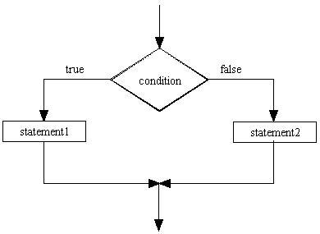 | 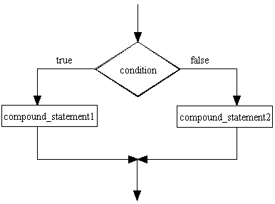
Example: Finding max of two numbers  if(x >= y)  max = x;  else  max = y; | Example:  char currencyType = scanner.nextLine().charAt(0);  if(currencyType = = 's' || currencyType = = 'S'){  System.out.println("Enter positive amount ");  amount = scanner.nextDouble();  riyalBalance = riyalBalance + amount;  }  else  System.out.println("Wrong currency type");

One-way selection (if-statement)

Used to execute a statement or a compound_statement when a condition is true.

Single statements | Compound statements
if(condition)  statement1; | if(condition)  compound_statement1
Execute statement1 if condition is true | Execute compound_statement1 if condition is true
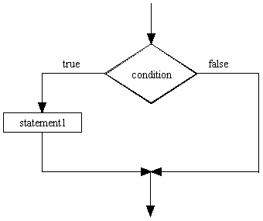 | 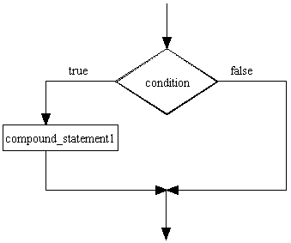
System.out.println(“Enter a number: ”);  double num = scanner.nextDouble( );  if (num > 0)  System.out.printf(“The square root is %f”,  Math.sqrt(num)); | System.out.println(“Enter a number: ”);  double num = scanner.nextDouble( );  if (num > 0) {  System.out.printf(“The square root is %f”,  Math.sqrt(num));  System.out.printf(“The natural logarithm is %f”,  Math.log(num));  }
Example: Finding max of three numbers  max = num1;  if(num2 > max)  max = num2;  if(num3 > max)  max = num3; | Example:  char currencyType = scanner.nextLine().charAt(0);  if(currencyType = = 's' || currencyType = = 'S'){  System.out.println("Enter positive amount ");  amount = scanner.nextDouble( );  riyalBalance = riyalBalance + amount;  }

Multi-way selection with an else option (if- else if - else statement)

Used to execute the first statement or the first compound_statement whose corresponding condition is true. The statement in the else part is executed if each condition is false.

Single statements | Compound statements
if(condition1)  statement1;  else if(condition2)  statement2;  else if(condition3)  statement3;  .  .  .  else if(conditionM)  statementM;  else  statementN; | if(condition1)  compound_statement1  else if(condition2)  compound_statement2  else if(condition3)  compound_statement3  .  .  .  else if(conditionM)  compound_statementM  else  compound_StatementN
Note: There may be one or more else if branches | Note:  - There may be one or more else if branches.  - It is a syntax error to put a semicolon  after the closing brace of a compound statement in an if branch.
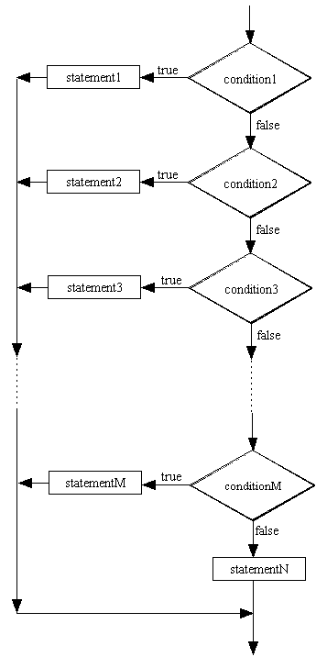 | 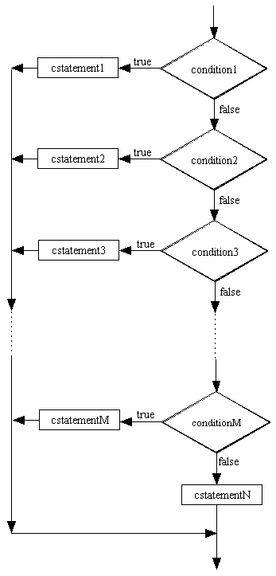

boolean validGrade = true;
double grade;
System.out.println("Enter grade");
grade = scanner.nextDouble();
if(grade < 0.0 || grade > 100.0)
validGrade = false;
else if(grade >= 85.0)
letterGrade = 'A';
else if(grade >= 75.0)
letterGrade = 'B';
else if(grade >= 65.0)
letterGrade = 'C';
else if(grade >= 45.0)
letterGrade = 'D';
else
letterGrade = 'F';

if(validGrade)
System.out.printf("The letter grade is %c", letterGrade);
else
System.out.println("Error: Invalid grade");

Multi-way selection without an else option (if - else if - else if statement)

Used to execute the first statement or compound_statement whose corresponding condition is true. No if-branch is executed if each condition is false.

Single statements | Compound statements
if(condition1)  statement1;  else if(condition2)  statement2;  else if(condition3)  statement3;  .  .  .  else if(conditionM)  statementM;  else if(conditionN)  statementN; | if(condition1)  compound_statement1  else if(condition2)  compound_statement2  else if(condition3)  compound_statement3  .  .  .  else if(conditionM)  compound_statementM  else if(conditionN)  compound_StatementN
Note: There may be one or more else if branches | Note:  - There may be one or more else if branches.  - It is a syntax error to put a semicolon  after the closing brace of a compound statement in an if branch (except the last branch).
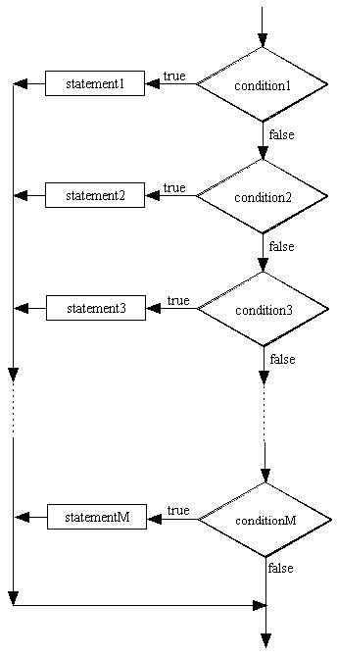 | 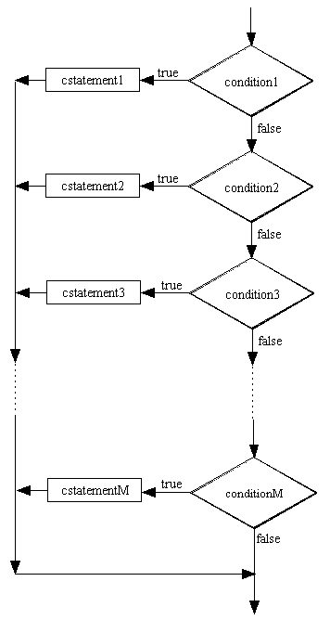
Example:

if(octaneNumber < 91)
System.out.println("Do not use this gasoline");
else if(octaneNumber < 95)
System.out.println("You may use this gasoline");

Nested if statements

The compound statement in an if-branch or an else-branch of an if-statement may contain one or more of any type of if-statement discussed in the previous pages.

Example:
if(grade < 0.0 || grade > 100.0)
System.out.println("Error: Invalid grade");
else{
if(grade >= 85.0)
letterGrade = 'A';
else if(grade >= 75.0)
letterGrade = 'B';
else if(grade >= 65.0)
letterGrade = 'C';
else if(grade >= 45.0)
letterGrade = 'D';
else
letterGrade = 'F';

System.out.printf("The letter grade is %c", letterGrade);
}

Nested if structures can be complicated:

if(condition1){  statement1;  if(condition2)  statement2;  else  statement3;  statement4;  }  else{  if(condition3)  compound_statementA  else if(condition4)  compound_statementB  else  compound_StatementC  compound_StatementD  } | 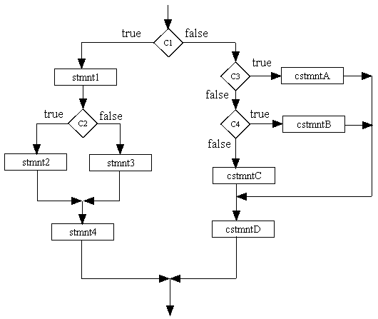

Note: In a nested if statement, the last else is associated with the closest unpaired if, unless braces are used to alter the default pairing:

Example:
if(hours < 9)
if(distance > 500)
System.out.println("Type 01");
else
System.out.println("Type 02");

is equivalent to:

if(hours < 9){
if(distance > 500)
System.out.println("Type 01");
else
System.out.println("Type 02");
}

Switch statement

The if- else if - else statement is used in programming situations where one set of statements must be selected from many possible alternatives. The switch statement provides an alternative to this statement for cases that compare the value of a char, byte, short, int, or String expression to a specific char, byte, short, int, or String constant. [Note: Using String in switch expression is supported in Java 7 and above]

The general form of the switch statement is:

switch(expression){ // char, byte, short, int, or String expression
case constant1: statementList1;
break;
case constant2: statementList2;
break;
.
.
.
case constantM: statementListM;
break;
default: statementListN;
}

Note:
- The case constants must be distinct char, byte, short, int, or String constants; otherwise there is a syntax error.
- A statementList may contain zero or more semi-colon separated statements. It is not necessary for statementList to be a compound-statement.
- The default label together with its statementList may be missing.
- The default label need not be the last label.
- The break statement following a statementList may be missing.
- The switch expression is evaluated and then the statementList of the case value that equals to the expression is executed. If there is a break statement, control passes to the statement after the switch; otherwise, the following statementLists are executed until a break statement is encountered, control then passes to the statement after the switch statement.
- If switch expression is not equal to any case value, the statementList for the default label is executed, and if the default label is the last one or if its statement list is followed by a break statement, control passes to the statement after the switch statement.
- If switch expression is not equal to any case value and there is no default label, control passes to the statement after the switch without executing any switch statementList.

switch example01: display the name of a digit:
int digit;
System.out.println("Enter an integer digit: ");
digit = scanner.nextDouble();
switch(digit){
case 0: System.out.println("zero");
break;
case 1: System.out.println("one");
break;
case 2: System.out.println("two");
break;
case 3: System.out.println("three");
break;
case 4: System.out.println("four");
break;
case 5: System.out.println("five");
break;
case 6: System.out.println("six");
break;
case 7: System.out.println("seven");
break;
case 8: System.out.println("eight");
break;
case 9: System.out.println("nine");
break;
default: System.out.println("Error: Invalid digit");
}

switch example02: classify a character

char c1;
System.out.println("Enter an English alphabet: ");
c1 = scanner.nextLine().charAt(0);
if(c1 >= 'a' && c1 <= 'z' || c1 >= 'A' && c1 <= 'Z'){
switch(c1){
case 'a':
case 'A':
case 'e':
case 'E':
case 'i':
case 'I':
case 'o':
case 'O':
case 'u':
case 'U': System.out.println("You entered a vowel");
break;
default: System.out.println("You entered a consonant");
}
}else
System.out.println("You entered a non-English alphabet");

switch example03: Determine month number from month string:

// Note: Strings in switch condition are supported in Java 7 and above
String month;
int monthNumber;
System.out.println(“Enter a month name:”);
month = scanner.next( );
switch (month.toLowerCase()) {
case "january": monthNumber = 1;
break;
case "february": monthNumber = 2;
break;
case "march": monthNumber = 3;
break;
case "april": monthNumber = 4;
break;
case "may": monthNumber = 5;
break;
case "june": monthNumber = 6;
break;
case "july": monthNumber = 7;
break;
case "august": monthNumber = 8;
break;
case "september": monthNumber = 9;
break;
case "october": monthNumber = 10;
break;
case "november": monthNumber = 11;
break;
case "december": monthNumber = 12;
break;
default: monthNumber = 0;
break; // optional
}

if(monthNumber != 0)
System.out.printf(“The month number for %s is %d%n”,
month, monthNumber);
else
System.out.println(“Error: Invalid month name”);

Task 01: Write a Java program that prompts and reads two integer numbers. It then checks the numbers and prints one of the following messages accordingly:
You have entered two even numbers.
You have entered two odd numbers.
You have entered one even number and one odd number.

Hint: Use the modulus operator (%) for checking the numbers.

Task 02: Write a Java program that reads a character from a text file input.txt. It then writes to a text file output.txt one of the following messages accordingly:
The character x is lowercase
The character x is uppercase
The character x is character digit

where x is the character read from input.txt

If the input file does not exist, write the following message on the output file:
Error: The input file input.txt does not exist
and then terminate your program.

Hint:
- Use some of the Character class methods introduced in ICS-102 Lab04.
- Use File I/O methods introduced in ICS-102 Lab05.
- Use the exists( ) method of the class File introduced in ICS-102 Lab05.

Task 03: Convert the program-fragment below to a complete Java program that uses if-else if -else statement instead of the switch statement:

System.out.println(“Enter the student letter grade (A, B, C, D, or F) : “);
grade = scanner.nextLine().charAt(0);
switch (grade) {
case ‘A’:
case ‘a’:
case ‘B’:
case ‘b’: System.out.println(“Good standing”);
break;
case ‘C’:
case ‘c’ System.out.println(“O.K.”);
break;
case ‘D’:
case ‘d’:
case ‘F’:
case ‘f’: System.out.println(“Poor, student is on probation”);
break;
default: System.out.println(“Invalid letter grade”);
}

Task 04: Write a Java program that displays the following menu:
1. Find area and perimeter of a square
2. Find area and perimeter of a rectangle
3. Find area and perimeter of a circle
The program then reads the menu choice and behaves as in the following table:

Menu choice | Program behavior
Input other than 1, 2, 3 | The program displays the following error message :  Error: Wrong menu choice
1 | The program prompts for and reads the length of a square. It then computes and displays the area and the perimeter of the square.
2 | The program prompts for and reads the length and the width of a rectangle. It then computes and displays the area and the perimeter of the rectangle.
3 | The program prompts for and reads the radius of a circle. It then computes and displays the area and the circumference of the circle. [ $Area=πr^{2}$ , $Circumference=2πr]$

Note:
- Assume that the values read by the program for options 1, 2, and 3 are in centimeters. For these options, your program must display appropriate units in the output.
- You can solve the problem by using if- or switch-statement.

Task05: Write a Java program that prompts for and reads two strings str1 and str2. The program then displays one of the following messages accordingly:
str1 and str2 are equal
str1 is greater than str2
str1 is less than str2

where str1 and str2 are the strings read. Your comparison must be case-sensitive.

Hint: Use the String comparison methods introduced in ICS-102 Lab04.

