King Fahd University of Petroleum & Minerals
Serial # 0

- 1 points for not writing your serial number

Electrical Engineering Department
EE315: Probabilistic Methods in Electrical Engineering (112)
Quiz 7: Random Processes-Temporal Characteristics
Name: KEY

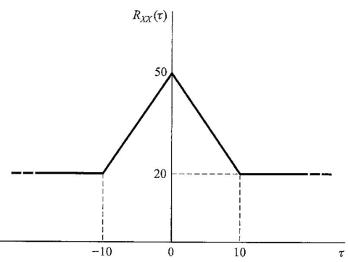
For a stationary ergodic random process having the autocorrelation function shown in the Figure , find:

a) $E\left[X\left(t\right)\right]=\sqrt{R_{XX}\left(τ\underset{→}{approches}∞\right)}=\sqrt{20}$

b) $E\left[X^{2}\left(t\right)\right]$=$R_{XX}\left(0\right)=50$

c) $σ_{X}^{2}=50-20=30$

Statistically independent zero mean random processes $X\left(t\right)$ and $Y\left(t\right)$ have auto correlation function $R_{XX}\left(τ\right)=e^{-\left|τ\right|}$ and $R_{YY}\left(τ\right)=cos⁡(2πτ)$.

Find the autocorrelation function of $W\left(t\right)=X\left(t\right)+2Y\left(t\right)+1$

$$E\left[\left\{X\left(t\right)+2Y\left(t\right)+1\right\}\left\{X\left(t+τ\right)+2Y\left(t+τ\right)+1\right\}\right]=R_{XX}\left(τ\right)+2R_{XY}\left(τ\right)+\overline{X}+4R_{YY}\left(τ\right)+2R_{YX}\left(τ\right)+2\overline{Y}+\overline{X}+2\overline{Y}+1=R_{XX}\left(τ\right)+4R_{YY}\left(τ\right)+1$$

$=e^{-\left|τ\right|}+4 cos⁡(2πτ)$+1

Note that the means are zeros and because of independence the cross correlation is 0

Good Luck, Dr. Ali Muqaibel

