King Fahd University of Petroleum & Minerals
Serial # 0

- 1 points for not writing your serial number

Electrical Engineering Department
EE315: Probabilistic Methods in Electrical Engineering (112)
Quiz 5: Multi Random Variables

Name: Key

The joint pdf of a bivariate r.v. (X,Y) is given

$$f_{XY}\left(x,y\right)=\left\{\begin{matrix}kxy & o<x<1, 0<y<1 \\ 0 & othewise\end{matrix}\right.$$

Where k is a constant.

- Find the value of $k$.

- Are X and Y independent? Show your steps.

- Find $(X+Y<1)$ ?

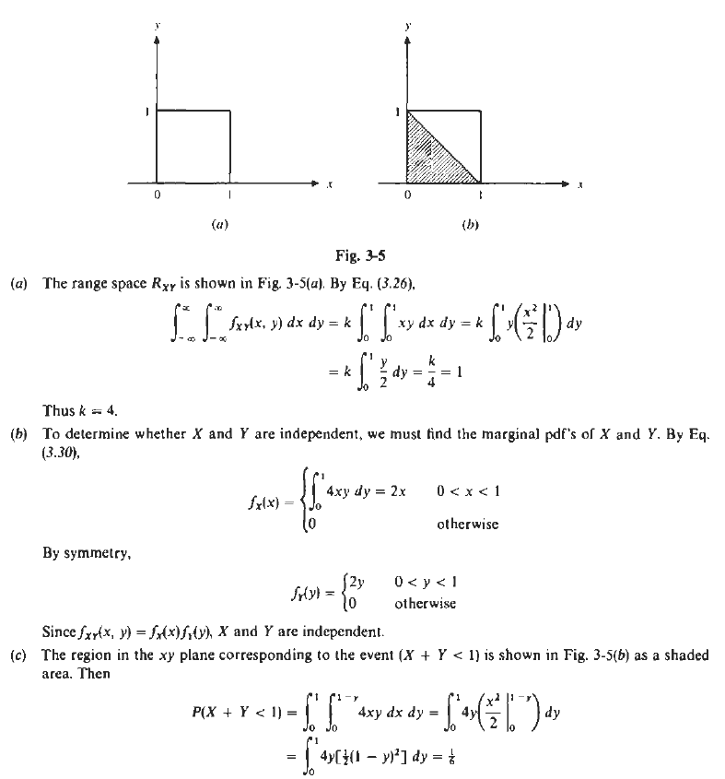

Good Luck, Dr. Ali Muqaibel

