Serial #
…0…

-1 points for not writing your serial #

King Fahd University of Petroleum & Minerals
Electrical Engineering Department
EE207: Signals & Systems (121)
Quiz 2: Continuous-Time Linear Time-Invariant Systems
Dr. Ali Hussein Muqaibel
Name: Key Ver.1

Consider an integrator LTI system which has the impulse response $h\left(t\right)=5u(t)$

- Using the convolution integral, find the system response, $y(t)$, to the input , (5 points) $x\left(t\right)=(1+e^{-2t})u(t)$

$y\left(t\right)=x\left(t\right)*h\left(t\right)=\int_{-∞}^{+∞}{h\left(t-τ\right)x\left(τ\right)dτ=\int_{-∞}^{+∞}{\left(1+e^{-2τ}\right)u\left(τ\right)5u\left(t-τ\right)dτ}}$

$$=\left\{\begin{matrix}\int_{0}^{t}{\left(1+e^{-2τ}\right)\left(5\right)dτ} & t>0 \\ 0 & t<0\end{matrix}\right.=\left\{\begin{matrix}5\left(t-\frac{e^{-2t}}{2}+\frac{1}{2}\right) & t>0 \\ 0 & t<0\end{matrix}=\left(5t-\frac{{5e}^{-2t}}{2}+\frac{5}{2}\right)\right.u(t)$$

- Is this system BIBO stable or not? Justify your answer. (2 points)

The system is NOT BIBO stable because the following test integral is not bounded
$$\int_{-∞}^{+∞}{\left|h\left(t\right)\right|dt=5\int_{0}^{∞}{dt\overset{→}{}∞}}$$

- Consider the interconnections of the LTI systems given in the figure below, where h(t) is the impulse response of the integrator. Find the impulse response of the total system. Simplify your answer. (3 points)

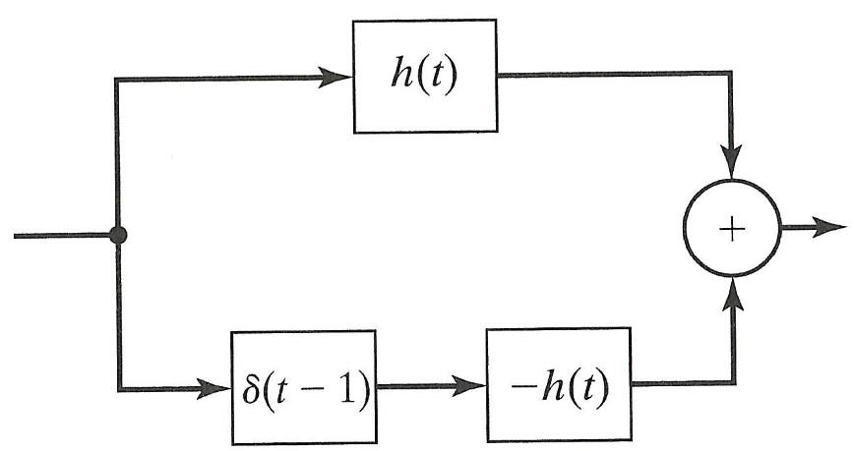

Total response $h\left(t\right)+[-h\left(t\right)*δ(t-1)$
$$=h\left(t\right)-[h\left(t\right)*δ\left(t-1\right)]$$
$$=h\left(t\right)-h\left(t-1\right)$$
For the given example
$$5[u\left(t\right)-u\left(t-1\right)]$$

All questions in this quiz are similar to the questions in the last HW assignment
Good luck, Dr. Ali Muqaibel

