King Fahd University of Petroleum & Minerals
___________________________________________________

_________________________________________________________________________________________
National IT Plan
for the Kingdom of Saudi Arabia
_____________________________________________

IT Plan Task Force
King Fahd University of Petroleum & Minerals
Ramadhan 1422
__________________________________________________________________________________________
Dhahran-31261, Saudi Arabia, Tel: (966-3) 860-1575, Fax: (966-3) 860-3001, Email: it.plan@kfupm.edu.sa
Foreword

In modern times, strategic planning is an important element for all directed efforts for economic development and social advances. Through its successive five-year national plans, the Kingdom of Saudi Arabia has a distinguished track record of achievements over the past three decades. Today, as the Kingdom crosses the threshold into the information age, a guiding framework in the form of a National IT plan is needed that will enable the Kingdom –Allah willing- to be at the forefront in the development and exploitation of Information Technology (IT) for the benefit of its people and humanity at large.

We at King Fahd University of Petroleum & Minerals are deeply honored for being asked to conduct a study to define a framework for Information Technology transfer. KFUPM was the first to recognize the role of Information Technology and was the first educational institution to establish an Information Technology Center.

I would like to express my deep gratitude to the Custodian of the two Holy Mosques, King Fahd bin Abdulaziz, and to HRH Prince Abdullah bin Abdulaziz, Crown Prince, and to HRH Prince Sultan bin Abdulaziz, Second Deputy Premier for their continuous support to the University and for enabling it to be a key contributor in the development of the Kingdom. I would also like to express my appreciation to H.E. the Minister of Higher Education Dr. Khalid Al-Angari for his constant support and confidence in KFUPM’s expertise. Finally, I would like to thank the team members of the project for the great effort made in completing this immense project.

Dr. Abdulaziz A. Al-Dukhayyil
Rector, King Fahd University of Petroleum & Minerals

Preface

In response to the letter from H.E. the Minister of Higher Education (dated 17/4/1422H), based on the directive of HRH Crown Prince Abdullah bin Abdulaziz (dated 6/4/1422H), H.E. the Rector of KFUPM formed a team of University faculty to undertake a study concerning the issues and challenges involved in achieving best possible ways and means for IT transfer.

This comprehensive study is based on analyses, audits, surveys, visits, consultations, intensive library/internet research, and meetings with leading IT industrialists and experts. IT plans of other countries have also been studied. Following this extensive study, and keeping in perspective the national and regional socio-economical, cultural and religious environment, the team concluded that the Kingdom of Saudi Arabia has all the necessary resources (both Human and Capital) to be a regional leader in IT. Based on this study, the project team has formulated a National IT plan for the Kingdom of Saudi Arabia.

Considering the current local, regional and international environment, this plan addresses major success factors. It contains five major strategic thrusts, which are: (1) IT Industry, (2) eBusiness, (3) Infrastructure, (4) eLearning and (5) Human Resources. Key areas for each strategic thrust, and their major initiatives and recommendations are proposed. Management aspects of the plan are also included. The strategic thrusts and their initiatives are all directed to achieving the vision of this plan, which aims at positioning the Kingdom of Saudi Arabia at the forefront in the development and exploitation of Information Technology (IT), and the adoption of IT as the basis and the drive for the development of industry, commerce, education, public sector, and the society-at-large in accordance with Islamic values.

I would like to express my thanks to H.E. the Rector for his enduring support to the project team and his personal involvement in helping us overcome the challenges and obstacles throughout the project. I also would like to express my deep gratitude to the project team members for their diligent efforts and professional commitment throughout the study project and the consequent development of this plan.

Dr. Abdullah H. Al-Abdul-Gader
Advisor to the Rector
Project Leader
______________
Table of Contents

Foreword A
Preface B
Executive Summary 1
The Vision Statement 6
The Mission Statement 6
1. Introduction 7
2. IT Global Trends and Saudi Scenario 9
3. Structure of the Plan 14
Strategic Thrusts 14
Management of the Plan 17
4. IT Industry 20
4.1 Road Map of the IT Industry Plan 22
4.2 Key Areas for IT Industry 23
KA-1.1 IT Entrepreneurship 23
KA-1.2 IT Industry Development 25
KA-1.3 Financing and Venture Capital 27
KA-1.4 Research, Development and Innovation 28
4.3 Management of IT Industry 30
5. eBusiness 33
5.1 Road Map of the eBusiness Plan 37
5.2 Key Areas for eBusiness 38
KA-2.1 Internet Access 38
KA-2.2 eBusiness Facilities 39
KA-2.3 eBusiness Awareness and Promotion 41
KA-2.4 eBusiness Legal Framework 42
KA-2.5 eBusiness Skills 43
KA-2.6 eBusiness Organization and Management 43
5.3 Management of eBusiness 43
6. IT Infrastructure 47
6.1 Road Map of the IT Infrastructure Plan 50
6.2 Key Areas for IT Infrastructure 51
KA-3.1 Access 51
KA-3.2 Tariffs 57
KA-3.3 Security 60
6.3 Management of IT Infrastructure 64
7. eLearning 67
7.1 Roadmap of the eLearning Plan 70
7.2 Key Areas and Initiatives for eLearning 71
KA-4.1 eLearning Organization and Management 71
KA-4.2 Digital Content 73
KA-4.3 Content Delivery 74
KA-4.4 eLearning Infrastructure 76
KA-4.5 Assessment and Quality Assurance 77
KA-4.6 Training & Awareness 79
7.3 Management of eLearning 80
8. IT Human Resources Development 83
8.1 Road Map of the IT Human Resources Plan 85
8.2 Key Areas for IT Human Resources Development 86
KA-5.1 Education 86
KA-5.2 Training 89
KA-5.3 HRD Supportive Environment 92
8.3 Management of IT Human Resources Development 94
9. Concluding Remarks 97
Glossary 99

___________
List of Figures

Figure 1: Council of Ministers, ITC and related stakeholders. 18
Figure 2: Sales of IT Hardware, Software, and Support services in the Arab Middle East (in Millions) 21
Figure 3: Gantt chart of Key Areas and Initiatives for IT Industry 32
Figure 4: eBusiness/Society Interaction 34
Figure 5: Gantt chart of Key Areas and Initiatives for eBusiness. 46
Figure 6: Internet dimensions of the Kingdom, Indonesia, Malaysia and Singapore, 2001 50
Figure 7: Growth of Teledensity in Saudi Arabia (source: STC, US Census Bureau) 53
Figure 8: Mobile subscribers per 100 inhabitants in the region 53
Figure 9: Internet dial-up access prices in other countries 58
Figure 10: Gantt chart of Key Areas and Initiatives for IT Infrastructure 66
Figure 11: Gantt chart of Key Areas and Initiatives for eLearning 82
Figure 12: Gantt chart of Key Areas and Initiatives for Human Resources 96

___________
List of Tables

Table 1: Steering and Implementation bodies in various countries. 17
Table 2. Key Areas and Initiatives for IT Industry 31
Table 3: Grouping of Countries by eReadiness Ranking 36
Table 4: Strategic Analysis of Saudi Arabian eBusiness Environment 37
Table 5: Key Areas and Initiatives of eBusiness 45
Table 6. Telecom and Internet indicators in OECD countries 50
Table 7. Secure servers in some of the countries 61
Table 8: Key Areas and Initiatives for IT Infrastructure 65
Table 9: Key Areas and Initiatives for eLearning. 81
Table 10: Key Areas and Initiatives for Human Resources 95

Executive Summary

The dawn of the knowledge-based economy has heralded IT (information Technology) as a key driving force behind economy, making it the primary source of wealth creation. Indeed the remarkable pace of IT, its growth, and innovations, has spawned an entire spectrum of opportunities for the development of both public and private sectors.

In light of the immense benefits that IT will bring to the Kingdom, His Royal Highness Crown Prince Abdullah bin Abdulaziz, Crown Prince and Deputy Premier of Council of Ministers issued a directive KH/6570 on 06/04/1422 Hijri. Based on this honorable directive, His Excellency, the Minister of Higher Education dispatched a letter to King Fahd University of Petroleum & Minerals (KFUPM) to undertake a study concerning the issues and challenges involved in achieving best possible ways and means for IT transfer.

This document presents a compilation of this study and its analysis, in the form of a National IT plan. Based on intensive library/Internet research, audits, surveys, analyses and meetings with leading IT industrialists and experts, the plan maintains its relevance to the Kingdom by taking into consideration the national and regional socio-economical, cultural and religious environment. The vision that has propelled this effort is as follows.

“To envision the Kingdom of Saudi Arabia at the forefront in the development and exploitation of Information Technology (IT), and the adoption of IT as the basis and the drive for the development of industry, commerce, education, public sector, and the society-at-large in accordance with Islamic values.”

It is anticipated that the plan will propel Saudi Arabia to a state similar to other countries, which are at the forefront in the development and exploitation of IT.

In order to develop the plan based on the above vision, guiding principles have been derived and adopted. These principles include factors such as abiding with Islamic principles, improving quality of life, diversification of economy, social uplift and increased level of literacy, and the establishment of a Kingdom wide information society. Further, the plan is in harmony and synchronization with the 7th Development Plan, and other Kingdom-wide IT projects.

In line with the developed guiding principles, five “strategic thrusts” are identified: (1) IT Industry, (2) eBusiness (eCommerce and eGovernment), (3) IT Infrastructure, (4) eLearning, and (5) IT Human Resources Development.

IT Industry: IT industry spans a wide range of products (both hardware and software) and services, and is one of the largest and fastest growing industrial sectors in the world. The vision of this strategic thrust is “to establish an environment where a vibrant IT industry will be an integral factor of wealth creation primarily through innovation and entrepreneurship, meeting local, regional and global market demands”.

To accomplish this vision, emphasis has been laid on IT entrepreneurship via the development and promotion of youth focused programs such as the proposed YIPES – ‘Young IT Professionals and Entrepreneurs’, and the setting up of IT incubators. The plan also calls for the enactment of intellectual property laws to protect the rights of owners against piracy and infringement. Further, it is proposed that the IT Industry be recognized as an industrial sector, at par with other strategic industrial sectors, the access of Small and Medium Enterprises (SMEs) to potential local & international markets be facilitated, and quality certification programs for IT products be developed. Initiatives for financing and venture capital via the Industrial Development Fund (IDF), and outsourcing of major government software projects to the Saudi private sector are suggested. Finally, the development of an IT focused R&D strategy for the Kingdom, and the establishment of IT technology parks are emphasized.

eBusiness: The vision of this strategic thrust is “to enable, facilitate, and promote the efficient and effective use of the Internet in the society for good governance, the betterment of the society, and economic development of the Kingdom of Saudi Arabia while maintaining local traditions and Islamic values.”

To accomplish the above vision, in addition to a reliable infrastructure, this plan advocates the establishment and improvement of eBusiness facilities such as upgrading the Government Information Infrastructure (GII), establishment of a certification authority & Public-Key Infrastructure (PKI) encryption system, the establishment of epayment gateways, and of reliable postal addresses for residences/businesses. Further, the plan calls for the setting up of eGovernment portals in all ministries, the translation of all government forms and relevant documents into electronic format, and the development of a nation-wide directory of government portals, websites, and email addresses.

In order to promote eBusiness awareness public seminars, training workshops, symposia and conferences on eBusiness and eGovernment need to be organized.

As for the eBusiness legal framework, legislative measures to ensure privacy and security need to be enacted. For the organization and management, the plan calls for the establishment of an eGovernment unit (or a consultant) in all major government organizations.

IT Infrastructure: The vision of this strategic thrust is “to provide fast, easy, secure and affordable access to facilitate a modern internationally linked e-enabled infrastructure.”

To realize the above vision, three key areas are identified: Access, Tariffs, and Security. In order to facilitate access, the plan calls for opening competition in the telecommunication sector and issuing of licenses for different wireless services to enhance connectivity. Other initiatives include the establishment of community and edutainment centers, as well as the deployment of a very high-speed network to link research institutions, universities, and IT parks.

To enhance internet usage, the proposed initiatives for tariffs include introduction of competition in all telecommunication markets, reductions in data line and Internet access tariffs, consolidation of ISP’s to maximize return on investment, and the introduction of special Internet access rates for academic institutions.

To promote a healthy environment for eCommerce and eGovernment, the plan calls for the formulation of a national level security policy, a mechanism to counter cyber-crime and the establishment of a national body/team to respond to security threats and breaches.

eLearning: The vision for eLearning is “to integrate IT into the Saudi educational system thereby bringing the Kingdom to the forefront of educational technology.”

To accomplish this vision, eLearning initiatives include the establishment of an organization and management authority at the national level (a National Education Board – NEB), which will be responsible for defining and adopting a comprehensive set of eLearning policies and regulations.

Other areas that require attention include the development of digital content for both K-12 and higher education, and the establishment of a national digital library of e-Reference material. Proposals for development of mechanisms for content delivery include the establishment of national education portals, improvement in ratio of Internet connected PCs in all public schools, and a scheme to support acquisition of educational technology. As regards eLearning infrastructure, it is imperative to connect all public schools and higher education institutions to the Internet with sufficient bandwidth.

The need for an assessment and quality assurance model for eLearning and a mechanism for applying this model is proposed. Carefully selected eLearning pilot projects need to be introduced. Training and awareness programs for instructors and administrators to improve their IT skills, and launching of eLearning awareness campaigns are emphasized.

IT Human Resource Development: The vision for IT human resources development (HRD) is “to have self-sufficiency of a well-trained, competent, qualified, and self-reliant workforce through dynamic education and training programs, which will produce quality IT graduates of international caliber.”

To realize the above vision, the approach is to focus on education, training and the development of a HRD supportive environment. As for education, it is proposed that computers and IT related programs be introduced at all levels of education. It is also recommended that the capacity of the existing post-secondary institutions be increased by providing resources, funding, and other support.

For the key area, ‘Training’, the establishment of edutainment centers, IT community centers, deployment of training programs for government employees, and coordination of training programs through certification with internationally reputed companies is proposed.

Review of all policies and regulations that affect the IT workforce to create a more conducive legal environment for the IT industry is urged. Regulations to ease hiring of IT professionals from abroad, granting of special facilities to these IT employees such as mobility, ease in changing jobs, ease of regulations in granting visas, etc., is advocated. This can facilitate solving the current shortage of IT workforce. It is also suggested that a national database on IT workforce be built and maintained, and research studies and projects in this area be funded.

This structured plan defines strategic thrusts, key areas for each strategic thrust, and initiatives for each key area. Because of the interdisciplinary nature of the initiatives and the large number of stakeholders that will be responsible for their execution, it is proposed that an authoritative body – Information Technology Commission (ITC) be established. The Commission reports to the Council of Ministers and will be responsible for implementing, promoting, and managing the IT national plan so that a dynamic and sustainable IT growth in all walks of Saudi society is assured. Yet all initiatives proposed in this plan will be executed by the existing ministries and other established bodies.

Finally, the Kingdom has a strong track record for establishing world-class industrial bases, when needed as a strategic decision, as demonstrated by the petrochemical industries. The Kingdom has the ability to do the same in the case of IT sector.

Contributors

Members of the team, who contributed to the plan in terms of serving on steering committee, individual groups, and those who served as consultants, administrative staffs are as below.

Steering Committee and Project Leaders: Dr. Abdullah Al-Abdul-Gader (Project leader, Professor, Department of Accounting and Management Information Systems), Dr. Jarallah Al-Ghamdi (Project deputy leader, Assistant Professor & Dean of College of Computer Sciences and Engineering), Dr. Saud Al-Semari (Assistant Professor, Electrical Engineering Department), Dr. Mahmood M. Nagadi (Associate Professor. Physics Department), Dr. Mohammad Al-Homoud (Associate Professor, Architectural Engineering Department), and Dr. Sadiq Sait Mohammad (Professor, Computer Engineering Department).

Team Members: Abdulaziz Almulhem, Abdul Malik Khan, Alaaeddin Amin, Hazem Selmi, Husni AlMohtaseb, Iftikhar Nadeem, Junaid Khan, Khalid Bubshait, Moataz Ahmed, Mohammad Faheemuddin, Mohammad Shafique, Mohammed Moizuddin, Mostafa Abd-El-Barr, Mustafa Faisal Ahmad, Nizar Mabroukeh, Salman Khan, Mohammad Shahed Akhtar, Syed Sanaullah, and Talal Maghrabi.

Acknowledgments: Thanks to Allah for his blessing and guidance that enabled completion of this challenging task. Thanks are also due to H.E. The Rector of KFUPM, Dr. Abdulaziz Al-Dukhayyil, for his tremendous support. The project team also acknowledges the following for their excellent efforts and contributions: Administrative services of KFUPM, KFUPM Press, Khaled H. Alangari (for conducting survey on status of IT in public sector), Adel Abdou (for assistance in art work), Abdulaziz Barnawi, and Yahya I. Mahmood, Seyed Mohamed Buhari (for help in conducting surveys), Suhaib Khan (for his excellent input on the draft), Ma’an Kousa, Dawoud Redwan, Hazem Selmi (for assistance in Arabic Translation) and Iftikhar Sheikh, Syed Omar, and Syed Abdulwaheed Shah (for secretarial assistance). Finally, we would like to thank the many individuals, and public & private organizations who helped in providing information and suggestions.

______________________
The Vision Statement

We envision the Kingdom of Saudi Arabia at the forefront in the development and exploitation of Information Technology (IT), and the adoption of IT as the basis and the drive for the development of industry, commerce, education, public sector, and the society-at-large in accordance with Islamic values.
_______________________
The Mission Statement

A plan to harness, embed, and exploit Information Technology (IT) for a thriving industry, economic growth, enhanced quality of education, and the betterment of the society in the Kingdom of Saudi Arabia.

1. Introduction

The Information Technology (IT) revolution, all over the world, has evolved into the main driving force behind economy. Recent technological innovations and their dropping costs are now offering tremendous opportunities for development and growth to both public and private sectors.

Several developing countries have realized the importance of IT and the importance of planning for IT. Currently, in most of these countries, IT is being deployed to modernize the education system by upgrading existing networks and providing Internet access to all schools, for the development of government systems, and for the betterment of society. Further, long-term projects to promote eCommerce and improve eBusiness infrastructure, digital inclusion projects aimed at connecting remote areas, establishment of community access centers and software development parks are being planned.

In light of the immense benefits that IT will bring to the Kingdom, His Royal Highness Crown Prince Abdullah bin Abdulaziz, Deputy Chairman of Council of Ministers issued a directive KH/6570 on 06/04/1422 Hijri. Based on this honorable directive, His Excellency, the Minister of Higher Education dispatched an official letter # KH/319 dated 17/04/1422 Hijri to King Fahd University of Petroleum & Minerals (KFUPM) to put forth an IT plan for the Kingdom of Saudi Arabia. In response, a Project Committee led by Dr. Abdullah Al-Abdulgader, Dr. Jarallah Al-Ghamdi, Dr. Saud Al-Semari, Dr. Mahmood Nagadi, Dr. Mohammad Al-Homoud, and Dr. Sadiq Sait Mohammad was formed.

The Steering Committee attracted diverse talents involving over 25 faculty members to serve in different groups. Project members were divided into 5 groups, one for each identified major area for IT planning. A computer FTP (File Transfer Protocol) site was set up where the groups uploaded all literature searched, presentations made, and the draft reports, for the benefit of the entire team. The group leaders held frequent meetings with their members. Several meetings were held by the steering committee, and the group leaders were invited to report their progress and accomplishments.

The plan has been prepared based upon all primary and secondary sources of information available to the project team. The primary sources included various published reports, data books, and Internet websites. The team particularly benefited from the documents related to national plans of other countries that included but are not limited to Australia, Korea, Malaysia, Japan, Egypt, India, Jordan, New Zealand, Pakistan, Philippines, United States, and the United Kingdom. On the domestic front, discussions were held with focus groups within the Kingdom representing banking, trading, manufacturing, government, and IT industry sectors.

In finalizing this plan the steering committee also sought the services of a local consultant to study the current status of IT in the government sector.

This document presents a national plan for Saudi Arabia to set pace and compete with the rest of the world in the areas pertaining to IT. If implemented within the suggested timeframe, this plan will avoid losses due to missed opportunities and the exorbitant costs that will be later incurred to catch up with the developed world. Major areas, where government’s attention and support are required to catch-up and compete with the regional and global situation are emphasized. It is anticipated that this plan will propel Saudi Arabia to a state similar to countries, which are at the forefront in the development and exploitation of IT.
It is anticipated that this plan will propel Saudi Arabia to a state similar to other countries, which are at the forefront in the development and exploitation of IT.

The following section discusses the IT global trends and the Saudi scenario. The rest of the document is devoted to discussing the plan’s strategic thrusts, key areas for each strategic thrust, and initiatives for each identified key area.

2. IT Global Trends and Saudi Scenario

E-mail and Instant Messaging is making the way people communicate more effective and efficient. eCommerce is changing the way people shop and do business, and eLearning is revolutionizing the way people learn and teach. Wireless Internet is growing as a part of people’s daily lives (anywhere and anytime).

The number of Internet users around the world is constantly growing. The Computer Industry ‘Almanac’ has reported that by the year 2002, 490 million people around the world will have Internet access, that is 79.4 per 1,000 people worldwide, and 118 people per 1,000 by year-end 2005.

Similar numbers have been predicted from Nielsen/Netrating. The first quarter 2001 Global Internet Trends report from Nielsen/Netrating measured Internet use in 27 countries around the world and found 420 million people have Internet access. The same agency also indicated that more and more people are beginning to have access from homes, as well as from their workplace. A study also showed that over 40% of people who use the net are English speaking.

Regionally speaking, according to a survey released in August 2001 the number of Internet users in the Arab world now stands at 3.54 Million. The survey also indicated that Internet penetration was the highest and fastest in the United Arab Emirates. The number of Internet subscribers in Saudi Arabia is 275,000 and the number of users is 687,500.

In addition to Internet being used extensively throughout the world, the IT industry also has made great strides. In the US, as per recent statistics, IT based industries, despite producing less than 10 percent of the total economic output, on an average, contributed almost one third of the total real economic growth between 1995 and 1999. During the same period, output from communication services grew at annual average of 7%, that of computer and communication hardware at an annual average of 9%, and prepackaged software and computer services at an annual average of 17%.
In Saudi Arabia, the IT Industry is behind other developed countries and its contribution to the local economy is minimal. With proper planning and support the situation is bound to improve and transform the Kingdom of Saudi Arabia into one of the major players in the knowledge-based economy.

In Saudi Arabia, the IT Industry is behind other developed countries and its contribution to the local economy is minimal. With proper planning and support the situation is bound to improve and transform the Kingdom of Saudi Arabia into one of the major players in the knowledge-based economy.

Empowering individuals and organizations for the utilization of IT requires the availability of required hardware, software, communication infrastructure, human capital, as well as a conducive environment. The extent of presence of such an environment and the availability of necessary technologies measures how e-ready an organization or a country at large is for IT, and is termed as eReadiness. In a recent study by McConnell International, two key aspects of eReadiness were examined: Innovation and Impact. In both these areas, Saudi Arabia fell behind other neighboring countries such as UAE and Egypt. In terms of eReadiness, Saudi Arabia falls into a category where “… substantial improvement is needed in the conditions necessary to support eCommerce and eGovernment”.
In terms of eReadiness, Saudi Arabia falls into a category where “… substantial improvement is needed in the conditions necessary to support eCommerce and eGovernment”.

eCommerce is the fastest growing sector of the Internet economy and comprises Business-to-Customer (B2C), Business-to-Business (B2B), and Business-to-Government (B2G).

eGovernment trends include distribution and processing of online forms, online payment of fees, eSignature (less paper work), online government procurement (B2G eCommerce), Government to citizens (G2C) contact, Government to Government (G2G) interaction, dissemination of government information and reports through the web and email, and integration of other government services. Challenges of eGovernment include security and privacy issues, cultural issues, and handling of the issue of access equality and avoiding the digital divide.

The strength of the Saudi eBusiness market lies in the Kingdom being the center of the Islamic World with the largest economy in the Arab world (615 Billion SR) with virtually no direct taxes. The favorable Gross Domestic Product (GDP) per capita is coupled with high disposable personal income. The rapid growth of Saudi population estimated at 3.4% per year, supported by a high youth population, is an expanding consumer base and, therefore is driving the growth in the private sector and eBusiness.
The strength of the Saudi eBusiness market lies in the Kingdom being the center of the Islamic World with the largest economy (168 Billion USD) in the Arab world with virtually no direct taxes.

Investment in IT infrastructure will not only aid the development of industry and commerce, but will also provide opportunities in areas such as education and training.

Infrastructure is one of the major factors that affect IT and its growth. It comprises issues like easy and affordable access, regulations, security aspects, and the human resources required. Investment in IT infrastructure will not only aid the development of industry and commerce, but will also provide opportunities in areas such as education and training.

Indicators in Information and Communication Technology (ICT) sector show explosive growth in fixed and mobile telecommunication, and Internet access. A recent study has shown that extension of existing and new telecom networks to rural and lesser economic zones will be one of the necessary conditions to participate in the information society. Globally, information technology including telecommunications has penetrated every market in the developed world; emerging economies view information technology infrastructure as a means to support eCommerce and eGovernance. Global computer penetration per capita in developed countries, in the area of small office/home office (SOHO) is very high and significant in relation to population numbers.

The sizable Saudi population compared to other Arabian Gulf Countries and the presence of large IT companies based in Saudi Arabia will give Saudi IT industry and eBusiness an advantage and a competitive edge in the region. With more openness towards direct foreign investment, it is inevitable that large foreign investors would setup bases bringing and utilizing latest technology to conduct their businesses. Local companies are expected to draw inspiration and follow suit. However, the present infrastructure situation is inadequate to attract and support foreign companies and investments. A weak infrastructure can be a major handicap to IT industry and eBusiness growth.
The present infrastructure situation is inadequate to attract and support foreign companies and investments.

A required feature of the infrastructure is access by a variety of standard and economically affordable devices. The access networks that link residential and enterprise users with public networks are the principal bottlenecks that obstruct potentially promising new services, such as voice/video/data integration, richer multimedia, and more flexible forms of distributed software execution. Convergence of technologies is facilitated with introduction of broadband and Very Small Aperture Terminal (VSAT) access methods to transmit various types of communication signals on the same media. It is important to understand that global trend of lowering the barriers to Internet access while maintaining filtering of forbidden content is helpful to everyone in the Kingdom in the context of gaining easier and affordable access to information. Every individual should have the right to access information - regardless of disability, economic situation, or geographic location. Without this realization there will be no consistent progress in the effort to provide global access.
It is important to understand that global trend of lowering the barriers to Internet access while maintaining filtering of forbidden content is helpful to everyone in the Kingdom in the context of gaining easier and affordable access to information.

A growing difference in the levels of market liberalization in the supply of Internet access service is leading to one form of "digital divide" on the global scale. Granting monopoly in Internet access service to a national incumbent operator or charging high license fees for the Internet access service are examples of barriers to market entry. The supply of Internet access service is free from regulatory burden in the majority of developed countries as Internet use in business activities substantially contributes to economic growth in general. The gap in economic development will widen between those countries where end users enjoy the benefits of the Internet, and those countries where the users do not.
Currently, the number of Saudi schools that have computer laboratories is lower than desired, and even a lesser number of schools are connected to the Internet.

Adequate IT infrastructure will not only open opportunities for IT-industry and eBusiness but will also enable the Saudi Arabian educational system to meet the challenges of the information age.

eLearning, or electronic learning, is the delivery of courses through electronic means, usually over the Web, but it could also include anything from CD-ROM to satellite transmission. The definition of eLearning is broad: it includes online learning, Web-based training, and computer-based training. It provides good control over the learning process, in terms of uniformity of content delivered to all, customizable content and quick access to updates. Though in its early phase, eLearning holds extraordinary potential. Cost effective learning anytime, anywhere, and for anyone, is made possible. Several countries or consortium of countries, have established a growing eLearning environment at various levels or have formulated plans for enhancing conventional education systems through eLearning.

The US is leading the world in eLearning both for K-12 and for higher education. Analysts put Europe about a year behind the United States. Internet connection and availability of enough computers is vital for schools and universities. The global trend is to connect schools with high-speed lines (E1, 2 MB/Sec) and Universities with Internet2 connections at an affordable rate.
The challenge for nations is to produce a strong skilled workforce, the challenge for employers is to attract and retain them.

Currently, the number of Saudi schools that have computer laboratories is lower than desired, and even a lesser number of schools are connected to the Internet. The cost of Internet connections to schools and universities in Saudi Arabia is prohibitive. Also the electronic content for courses is lacking both in school education as well as in higher education. Adopting an eLearning strategy will not only enhance the academic environment but would also produce a highly skilled, technically well-trained national workforce.
There is a great need to develop human resources via training, certification, and updating current curricula in order to have a strong and self-reliant IT industry, and bolster, eBusiness, eLearning, and infrastructure.
Presently there is a severe dearth of skilled manpower for IT related professions through out the world. The shortage in the IT workforce, a vital component for the information era, poses serious challenges for all nations, developed and developing. Only effective planning can help to meet the global challenge. While the challenge for nations is to produce a strong skilled workforce, the challenge for employers is to attract and retain them.

Several nations through their national plans, or specialized projects, are executing steps towards educating and training their national human resources in all areas of IT. The Swedish experience is an example of retraining government employees. Although the Swedish program was basically aimed at unemployed work force, it can be used in Saudi Arabia not only for that purpose but also for retraining government and private sector employees. Updating the current educational and training systems in IT departments and university curricula will also contribute to catching up with the current need.

There is a great need to develop Saudi human resources via educational training initiatives in order to have a strong and self-reliant IT industry, and bolster eBusiness, eLearning, and infrastructure.

At present, there are less than 20 major computer-training companies and most of the training is concentrated on basic computer/secretarial skills. There is a need for supporting advanced training. As per a recent study of the status on IT in the public sector, it was found that most government employees lack computer skills, and this has become a major obstacle in the use of IT in government organizations.

On a positive note, the Government of Saudi Arabia has been providing every possible avenue for Saudi females to pursue higher education. According to recent statistics published by the Ministry of Higher Education (1999-2000 Gregorian, 1419-1420 Hijri), the number of females is comparable to the number of males in areas of medicine, education, physics and economics. Saudi females graduating with a Bachelor degree in the above and other related fields can contribute to a number of areas in the IT profession. Keeping in mind Islamic and local values, females can be easily provided with conducive and acceptable IT work environment, and can also telecommute from home. This is possible given the successful experience in employing Saudi women in other professions such as banking, education, and medicine. Further, a number of Saudi businesswomen run successful businesses from their homes. eLearning, an important component of IT, can play a role in training Saudi females to contribute to a large number of IT related activities.
In exploring the global and regional IT trends and the status of Saudi IT, in a brief manner, many challenges and obstacles can be identified. Fortunately, the strengths and opportunities are much more. Saudi Arabia has the leadership, economy of scale, and young talent, which are requisites to be a leading country in IT.

In exploring the global and regional IT trends and the status of Saudi IT, in a brief manner, many challenges and obstacles can be identified. Fortunately, the strengths and opportunities are much more. Saudi Arabia has the leadership, economy of scale, and young talent, which are requisites to be a leading country in IT.

We envision the Kingdom of Saudi Arabia at the forefront in the development and exploitation of Information Technology (IT). When charged with developing the national IT plan, it was received as an honor. We made it our mission to outline a plan to harness, embed, and exploit Information Technology (IT) for a thriving industry, economic growth, enhanced quality of education, and the betterment of the society in the Kingdom of Saudi Arabia.

3. Structure of the Plan

Having discussed the tremendous potential IT provides, and based on the review of global trends and current status of IT in the Kingdom, the basis for the directive of HRH the Crown Prince to develop a national IT plan is evident. Based on this directive, the project team has formulated the following as a vision for IT in Saudi Arabia:

“To envision the Kingdom of Saudi Arabia at the forefront in the development and exploitation of Information Technology (IT), and the adoption of IT as the basis and the drive for the development of industry, commerce, education, governance, and the society-at-large in accordance with Islamic values.”

In order to develop the plan based on the above vision, guiding principles have been derived and adopted. These principles dictate that the plan should:

- be in compliance with Islamic values and teachings, which form the basis of all our analysis and guide our recommendations. In no way the recommendations are meant to ignore, invalidate, or contradict Islamic and Saudi norms.
- contribute to an improved quality of life, increased level of literacy, and social uplift.
- contribute to diversification of economy, job creation, and wealth creation.
- help in the establishment of a Kingdom-wide Information society.
- ensure that maximum benefits are achieved from IT in areas such as the government sector, the academic sector, and the private sector.
- call for a proactive role from the private sector, with the government playing the role of a facilitator, whenever applicable.
- explore the innovative and entrepreneurial potential of young Saudi citizens.
- be in harmony and synchronization with the 7th Development Plan, and other Kingdom wide IT projects such as Watani.
- facilitate and encourage foreign multinational companies to invest in the Kingdom’s economy.
- recognize the importance of a number of critical areas such as support from higher governmental authorities, flexibility in legal policies and regulations and the need for new legislative measures for the information society.

In line with the above guiding principles, and in light of the vision statement, five “strategic thrusts” have been identified and discussed in the following sections.

Strategic Thrusts

The plan derives inspiration from the immense benefits of IT, and our vision. The motivation for such a plan stems from the fact that IT in the Kingdom must benefit the economy, the society, and other public and private organizations. In line with this, several strategic thrusts can be identified; however, only major and significant ones have been considered for this plan. The five strategic thrusts are:
- IT Industry
- eBusiness (eCommerce and eGovernment)
- IT Infrastructure
- eLearning, and
- IT Human Resources Development

Information economy is probably the most recognizable and talked about manifestation of the digital revolution. In the US, the growth in all industrial sectors due to IT was 30%. The engine of this information economy is the IT industry. The Kingdom’s seventh development plan emphasizes the strategic importance of IT. But it fell short of making IT Industry a strategic choice for growth. The Kingdom has a strong track record for establishing a world-class industrial base, when needed as a strategic decision, as demonstrated by the petrochemical industries. The Kingdom has the ability to do the same in the case of IT.

Economic growth, wealth creation, job creation, and quality of life, have always been primary motivators. The next strategic thrust that will contribute in this direction, and also involve the private sector is eBusiness (electronic business). eBusiness is about enabling organizations to cohesively bring together their processes and Internet technologies for effectiveness, efficiency and better relationships between partners. These partners could be business organizations, customers, suppliers, government departments or citizens. Since the Internet is immensely changing the way we interact, it is also creating enormous opportunities for socio-economic development of a nation. The term eBusiness has been used here to represent both eGovernment and eCommerce.
The Kingdom has a strong track record for establishing a world-class industrial base, when needed as a strategic decision, as demonstrated by the petrochemical industries. The Kingdom has the ability to do the same in the case of IT.

IT infrastructure forms one of the core areas of this plan as it provides a platform which facilitates telecommunications and Internet technologies for economic growth and productivity, job creation, technological leadership, effective governance, eCommerce, eLearning, and health care. To address this strategic thrust, it is required to assess the Kingdom’s current IT Infrastructure, which includes telecommunications, Internet access, and other related infrastructures.
In order to have a strong IT industrial base and to support eBusiness, key requirements are reasonable infrastructure and skilled human resources.

Ease of communication offered by the Internet together with strides made in multimedia technologies can be utilized to empower education at all levels via eLearning, since it is education that will be the biggest investment and have the largest impact on the society.

In order to have a strong IT industrial base and to support eBusiness, key requirements are reasonable infrastructure and skilled human resources. For this reason, human resources development must be given immediate and serious consideration. There are many areas of concern that need to be addressed at the levels of education and training, in order to develop an indigenous work force for the information society. This work force will help reap the potential of IT and is most required for a strong IT industry, in eBusiness, in eLearning, and for the establishment of infrastructure.
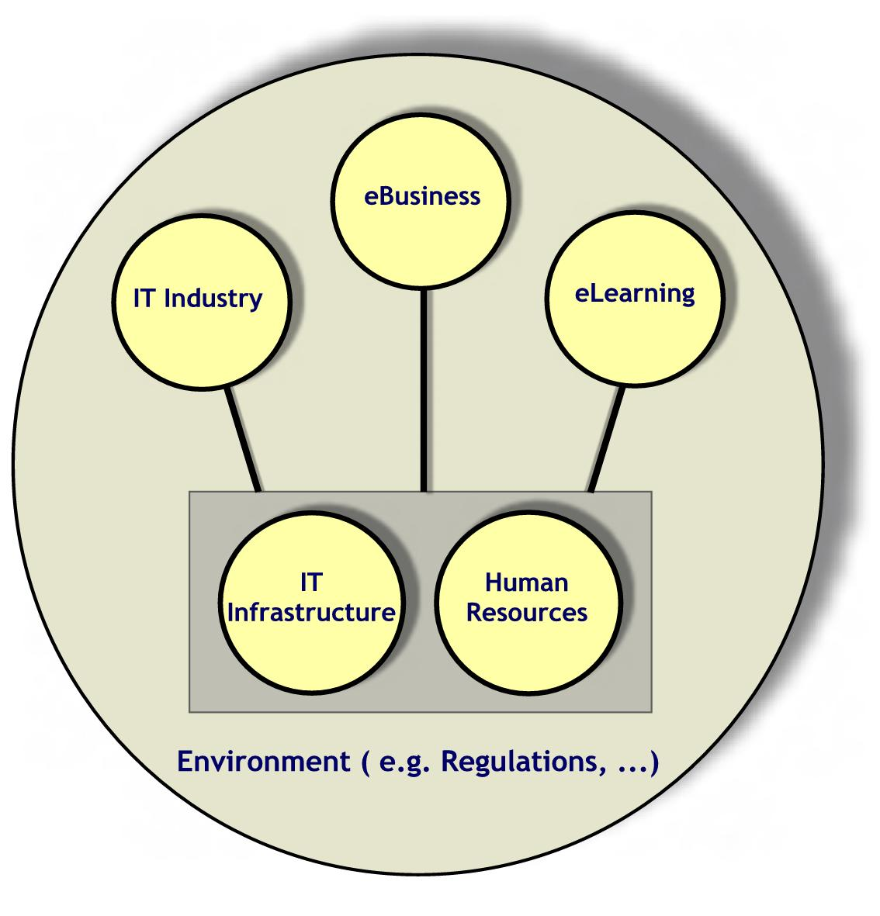
The vision of each of the five strategic thrusts is defined as follows:

IT-Industry: To establish an environment where a vibrant IT industry will be an integral factor of wealth creation primarily through innovation and entrepreneurship, meeting local, regional, and global market demands.

eBusiness: To enable, facilitate, and promote the efficient and effective use of the Internet in the society, government, and, business and economy for development and growth while maintaining local traditions and Islamic values.

IT Infrastructure: To provide fast, easy, secure and affordable access to facilitate a modern internationally linked e-enabled infrastructure.

eLearning: To integrate IT into the Saudi educational system thereby bringing the Kingdom to the forefront of educational technology.

IT Human Resources Development: To have self-sufficiency of a well-trained, competent, qualified, and self-reliant workforce through dynamic educational and training programs, which will produce quality IT graduates of international caliber.

In this plan, key areas are identified, for each strategic thrust; a set of initiatives for each key area is proposed followed by identifying the management of the initiatives and the schedule of their implementation. Prior to the five sections that present plans for the identified strategic thrusts, we propose the management of the plan.

Management of the Plan

The review of the current status of IT in the Kingdom revealed that several obstacles and challenges must be overcome in order to arrive to the ambitious state envisioned. The effort expected and the complexity involved demands the establishment of an efficient and a powerful organization. Due to the nature of IT, in addition to budget commitment and allocation of resources, periodic revisions and follow-up, and most importantly timely execution of all initiatives/recommendations are extremely important.

Therefore, crucial to the success of the plan is its effective management.

In other countries, the role governments play include support for IT projects and investments in Internet infrastructure (as in the USA), encouragement and support for local Internet development and technological innovations (as in Canada), introduction of new Ministries and/or Cabinet or high authority posts for IT (for example, e-Minister and e-Ambassador in the UK), support in terms of regulation easing or finance for start up companies (as in Japan), support for growth of local content on the Internet (as in France and Canada), and lower import duties on IT equipment (as in India).

Table 1 below shows the role of the various steering and implementation bodies in different countries.

Table 1: Steering and Implementation bodies in various countries.
Country | Steering and Implementation Bodies | Role
Australia | • National Office for the Information Economy  • Office for Government Online | Executive Power
Japan | • Inter-ministerial task force lead by the  Prime Minister | Executive Power
Great Britain | • e-Minister  • e-Ambassador | Executive Power
France | • Inter-ministerial groups | Executive Power
Ireland | • Information Society Steering Committee  • Information Society Commission  • Interdepartmental Implementation Group | Executive Power
Philippine | • The National IT Council | Executive Power
Malaysia/  Australia | • The National Information Technology Council | Advisory/Think Tank
Tasmania | • The Information Technology Industry Council | Advisory/Think Tank
Korea | • Ministry of Information and Communications | Executive Power
Singapore | • Infocomm Development Authority | Executive Power
Most of the bodies in the Table 1, report to the highest authority of their country. This is required in order to have a successful implementation of IT strategy and for maximum utilization of IT in improving the economy. For the Kingdom of Saudi Arabia, it is required that a high level IT management body with necessary executive authority be established. The role of this body will include: (1) Planning, (2) Promotion, (3) Execution, (4) Regulation, and finally (5) Overseeing.

For this comprehensive plan that encompasses several key areas, it is important to recognize the interdisciplinary nature of the initiatives and the large number of stakeholders that will be responsible for their execution. It is also important that the higher-level authority will ensure that proper consideration is given to the plans development/revisions, and that its initiatives/recommendations are communicated to respective stakeholders.

Since many of the stakeholders will be at the ministerial level, and there are several ministries involved, two alternatives for establishing such a high-level authority are proposed: (1) Establishment of an independent Commission for IT (ITC) or (2) Creation of a body, which can be annexed to the Higher Economic Council (HEC).

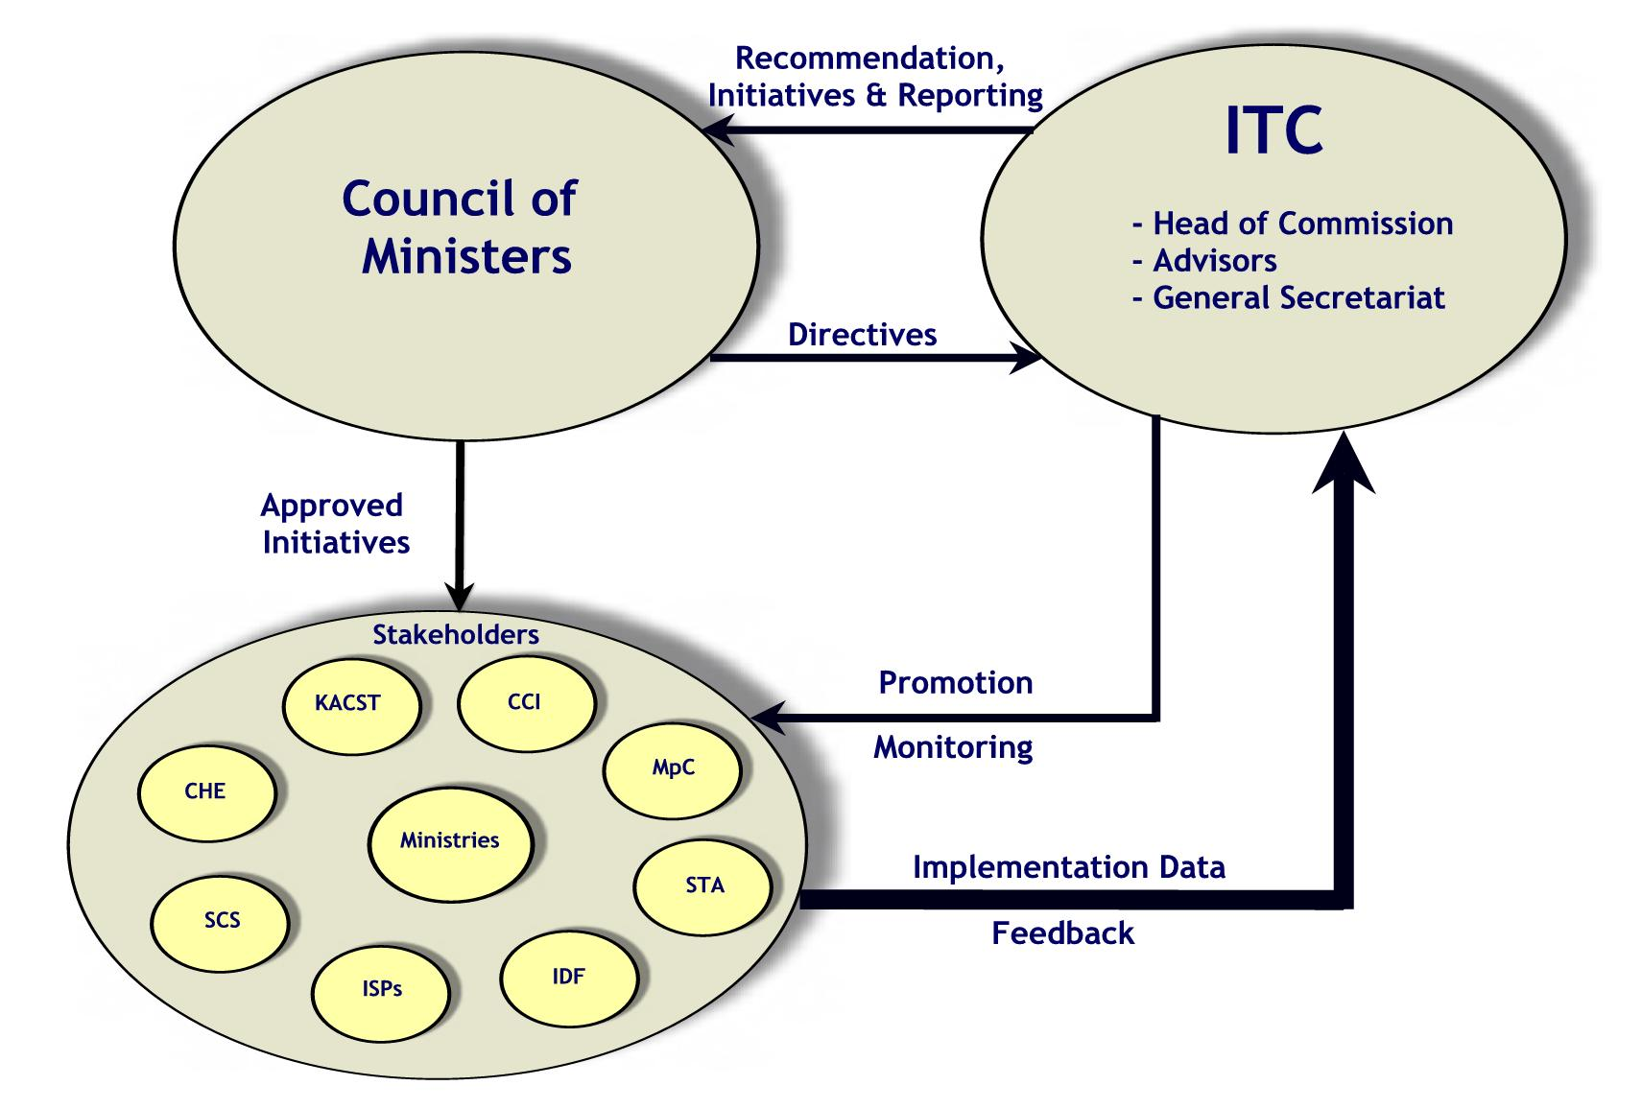

Figure 1: Council of Ministers, ITC and related stakeholders.

Considering our environment, it is proposed that a Commission that reports to the Council of Ministers be established (see Figure 1). The tasks/charges of the commission and its relationship to the other bodies in the Kingdom are detailed below.

Mission and role of ITC: The mission and role of the proposed ITC is the management of the plan’s initiatives, and also its promotion, that will ensure a dynamic and sustainable IT growth in all walks of Saudi society.

Tasks: Below we itemize some of the tasks/charges of the ITC but which are not limited to:

Identifying the national priorities among IT sectors.
Translation of the plan into operational programs.
Monitoring and evaluation of various programs.
Coordination between the different programs.
Promotion of the IT plan at the higher levels as well as the public level.
Continuous assessment/update of IT plan.
Technology assessment and forecasting.

Composition: It is proposed that the membership of the ITC should include visionaries, high caliber IT experts and members from related areas such as Industry, Economy, Education, Law, Business, and Technology.

It is proposed that the Chair of ITC should be at the rank of a Minister with a permanent General Secretary (GS). This Commission will report to the Council of Ministers on the preparation, status and progress of the plan. The General Secretary (GS) of the proposed Commission can organize these plans, oversee regular updates, communicate to the stakeholders, and tabulate feedback for consideration by the Council of Ministers. An important perspective of this theme is that the execution will be done by existing bodies and organizations (such as Ministries). However, funding and other resources are to be approved by the Council of Ministers.

While approval of initiatives and commitment of resources will be done by the Council of Ministers, the ITC will also play the role of identifying sources of funds and initiating new proposals. It will also conduct audits, support studies, and be responsible for the follow-up of IT plans for the Council of Ministers.

The commission, initially, may consist of five sections/groups, one for each area of strategic thrust. The management of proposed initiatives for each key area is discussed in the corresponding sections on strategic thrusts.
4. IT Industry

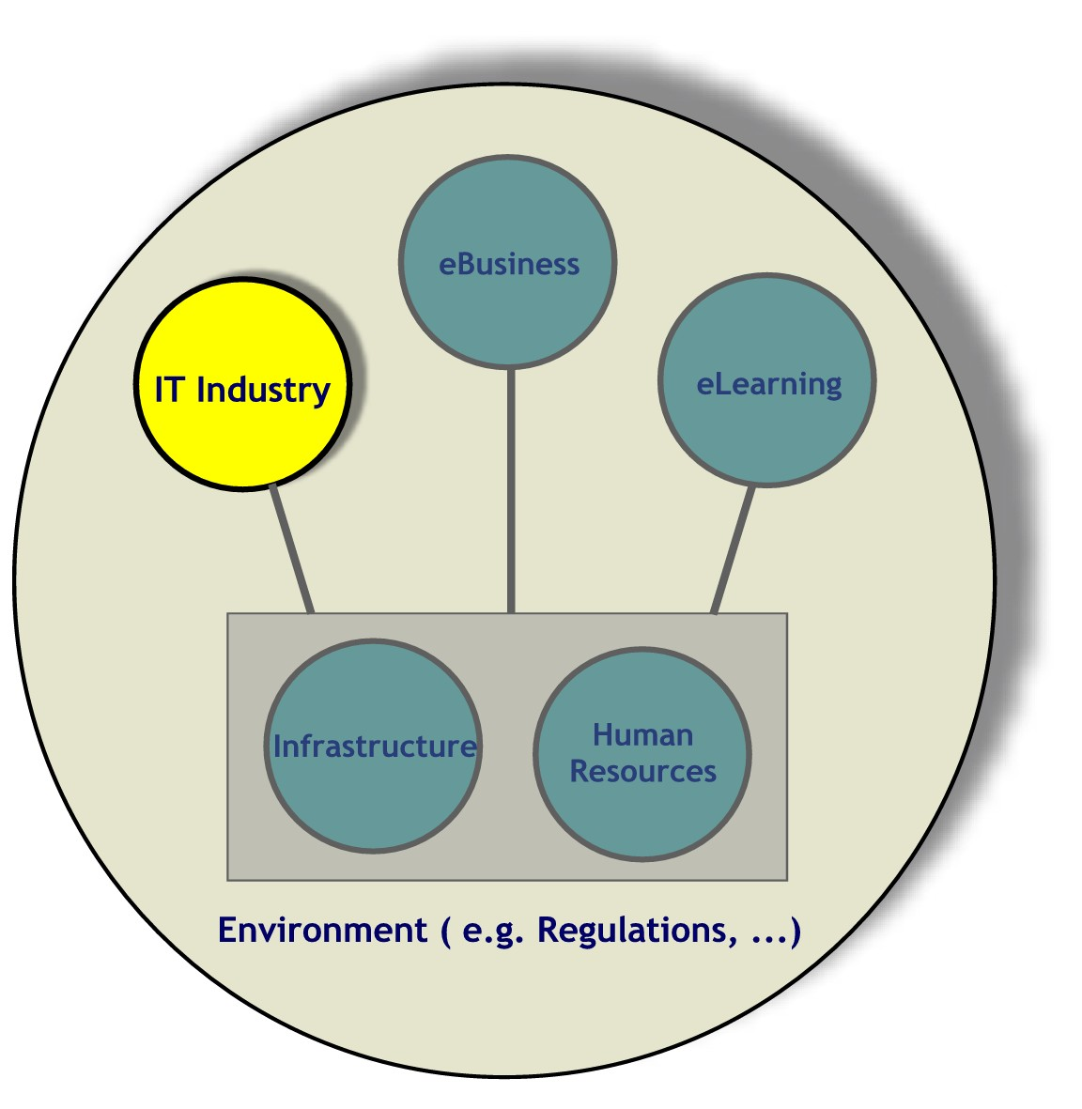
IT industry spans a wide range of products (both hardware and software) and services, and is one of the largest and fastest growing industrial sectors in the world. The major industries that comprise the IT sector are generally acknowledged as including:

Manufacturing
Computer Hardware.
Telecommunication Equipment.
Services
IT Professional Services (including custom software application development and maintenance).
Computer Software (Packaged software products – cross industry & vertical market applications).
Telecommunication services.

The IT industry gives rise to substantial economic and social opportunities since it is one of the main contributors to the rapid development of income and wealth creation in the world (a rate of more than 6%). Moreover, it could reach up to 10% of the income in advanced countries. Software development is a high growth sector of the IT industry and forms a major segment of the vast IT industry market.

It is worth noting India's experience, where in a gloomy year when the economy was fighting with a recessionary environment, political uncertainty and a general lack of direction, the Indian IT industry was an exception to the general economic trend. With a revenue development of 35 percent in US Dollar (USD) terms, the Indian IT industry proved as the savior of sorts for the sluggish economy. The IT services revenue, which grew 50 percent in USD was the driving force behind the spectacular development of the Indian IT industry. It accounted for a share of almost 60 percent of the total revenue.
According to the recent study by Pyramid Research, the total sales of IT hardware, software and support services in Saudi Arabia, Egypt and UAE is poised to cross over 1.4 billion USD in 2001 with a projected estimate of 6 billion USD by 2005.

According to the recent study by Pyramid Research, the total sales of IT hardware, software and support services in Saudi Arabia, Egypt and UAE is poised to cross over 1.5 billion USD in 2001 with a projected estimate of 6 billion USD by 2005. See Figure 2 for more details.

Figure 2: Sales of IT Hardware, Software, and Support services in the Arab Middle East (in Millions)

Growth in the IT industry is driven by various factors. On the supply side, these include the development and introduction of new and improved products through firm-level investments in Research and Development (R&D) and innovation, the ready availability of venture capital funds for investment in IT, the development and rapid growth of new products/services segments, and the general shift towards services. On the demand side, there are rapidly declining costs and prices for IT equipment and the liberalization of the trade and regulatory framework.
Saudi youth are the best to indigenize IT in the Kingdom.

According to the Organization for Economic Cooperation and Development (OECD), software and services dominate the IT market, while data communication equipment is the most dynamic sector. Strong growth in IT markets mirrors and drives the supply side. In information technologies (excluding communications): (i) the software market has shown rapid growth and, together with services, dominates the IT market; ii) single-user systems, mainly PCs and workstations, have grown strongly but the decline of other hardware categories has meant that hardware’s share of the market has fallen; iii) with the rapid growth in the Internet and networks, data communication equipment is likely to continue to be the most dynamic market.
In Saudi Arabia, niche areas in IT Industry need to be identified where IT products can range from providing content on the web, to in-house development of software to meet local and regional needs.
In Saudi Arabia, niche areas in IT industry need to be identified where IT products can range from providing Arabic content on the web, to in-house development of software to meet local and regional needs. A high potential for this is available among the growing number of local entrepreneurs and university graduates who specialize in Computer Sciences, Electrical Engineering, Computer Engineering, and other related areas such as Business Administration and Management Information Systems. The current economic situation of Saudi Arabia also serves as a supporting factor for launching an ambitious IT industry.

4.1 Road Map of the IT Industry Plan

The vision of the IT Industry plan is to create a vibrant IT industry as an integral part of wealth creation in the Kingdom. IT entrepreneurship needs low start-up capital and hence allows smaller players to get started. IT innovation would lead to the highest possible returns through Intellectual Property Rights and Saudi youth are the best to indigenize IT in the Kingdom. Therefore, the strategy adopted to realize the above vision of the IT Industry development plan could be formulated as “An IT industry driven by innovation and entrepreneurship, primarily through meeting the aspiration of the young generation.”
An IT industry driven by innovation and entrepreneurship, primarily through meeting the aspiration of the young generation.

The proposed plan strives to make the Saudi IT Industry the second contributor to GDP after oil by the year 2010. Saudi IT Industry should be able to capture 25% of the total Saudi IT market by year 2005.

There are five major challenges to overcome in order to achieve the above aspirations. These are:

- The sustained development of IT entrepreneurship.

- The high competition in the IT sector from the developed as well as the developing countries.

- Supporting traditional practices of investment in land and infrastructure assets with investment in intellectual assets.

- Maintaining the right balance between economy-of-scale and innovation-of-scale.

- The availability of an infrastructure that can support the IT industry. This is detailed further in the infrastructure section (see Section 6).
IT is one of the most promising fields for transforming the young generation into professionals and entrepreneurs.

The first four challenges lead to the definition of four major key areas of the IT industry plan. It should be emphasized that this should not undermine the importance of infrastructure, which has a direct impact on the success of the plan and is covered in a separate section (see Section 6, IT Infrastructure).
The key areas identified for IT Industry are:
Identifying YIPES can be carried out in higher education institutes, which play a significant role in shaping their technical, professional and entrepreneurship skills.

- IT Entrepreneurship
- IT Industry Development
- Financing & Venture Capital
- Research Development & Innovation

Below we discuss each key area in detail and suggest corresponding initiatives.

4.2 Key Areas for IT Industry

KA-1.1 IT Entrepreneurship
One of the untapped resources of the Kingdom that has not been developed is the capacity for entrepreneurship of young Saudi men and women. Entrepreneurship is central to the creative process, promoting development in the economy, increasing productivity, and creating jobs. Therefore, the following initiatives are identified:
Init-1.1.1: Develop and promote the YIPES program and allow all young entrepreneurs and IT professionals to benefit from its provisions.
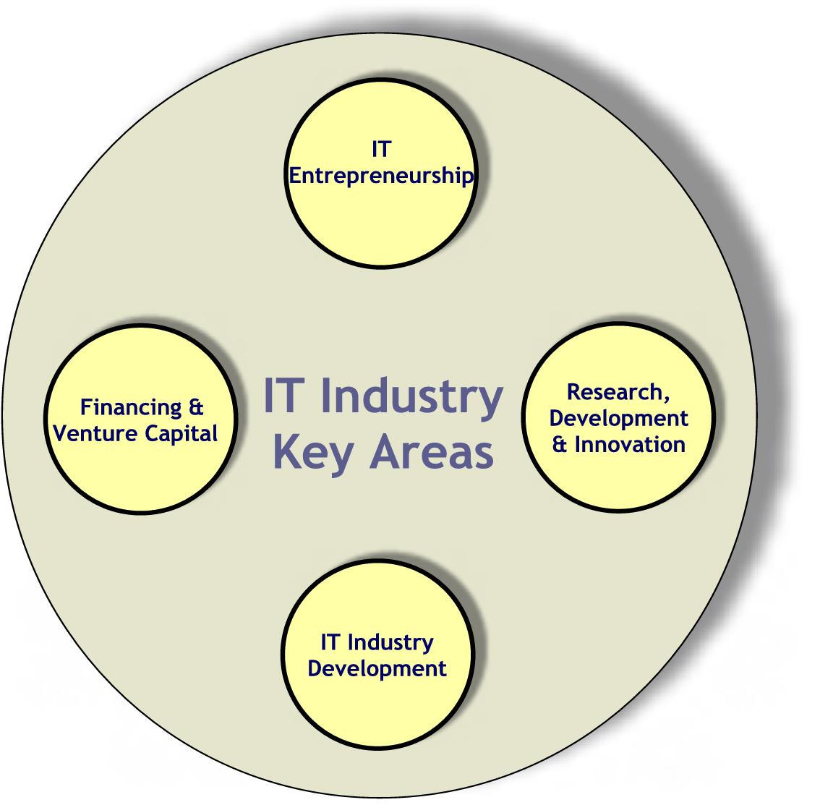
Since IT is one of the most promising fields for transforming the young generation into professionals and entrepreneurs, a program for the development of Young IT Professionals and Entrepreneurs (YIPES) is proposed. The primary objective of this program is to place YIPES in an environment where they are directed towards specific identified niche areas (such as Arabization, Security, etc.,) with a significant market potential for IT.

Identifying YIPES can be carried out in higher education institutes, which play a significant role in shaping their technical, professional and entrepreneurship skills. The role of K-12 stage should also be emphasized. Teaching methods must be adopted earlier on to encourage the students to become innovative.

In this way, YIPES will be directed toward country needs, market demands and international IT trends with hands-on experience in a variety of IT fields. This process will produce a generation of highly-motivated IT experts and businessmen that will lead the country towards a new IT generation bringing it to the forefront of world IT industries.

Responsible Body: Ministry of Higher Education (MoHE)

Init-1.1.2: Setup IT incubators.
IT Incubators provide a full range of scientific, technological and management services to small IT start-up firms, to foster early-stage entry and growth. Generally developed by the private sector, these state-of-the-art incubators offer reduced costs of delivering necessary and advanced public services and the creation of new opportunities for IT partnerships. The incubators would be characterized by broadband Internet connectivity via fiber optic cable, equipped with the required infrastructure, to provide a one-stop shop for the perspective investors in the IT industry. The IT incubators would serve as a technological model for future development, boost the economy and would provide an internationally recognized Saudi IT profile. They also will provide a point of presence for software companies within the Kingdom, such incubators could benefit the YIPES. There are a range of IT incubators emerging around the world (examples include, CMGI Inc. of Boston, Garage.com in Silicon Valley, Idealab.com in Pasadena & Incubasia in Hong Kong).
The IT incubators would serve as a technological model for future development, boost the economy and would provide an internationally recognized Saudi IT profile.

Developing countries such as Malaysia, UAE, Singapore, Jordan, India, etc., boast of an array of IT incubators spread across the country. These have led to the formation of e-Cities or Internet cities. IT Incubators/Parks provide a full range of scientific, technological and management services to small ICT start-up firms, to foster early-stage entry and growth. The parks would serve as a technological model for future development, boost the economy and would provide an internationally recognized IT profile. Within the Kingdom, such parks could benefit from the technology-specialized academic talent available at the universities.
Piracy of intellectual property poses a significant threat to innovation and entrepreneurship. Widespread piracy stifles commercial and academic creativity and inventiveness and discourages the dissemination of products and services protected as intellectual property.

It is recommended that the incubators should be established at three major cities namely, Riyadh, Jeddah and Dammam.

Responsible Body: Private Sector with government support

Init-1.1.3: Enact existing intellectual property laws and re-examine some of their copyright aspects.
The protection of intellectual property is needed to protect IT companies' most valuable assets. Such enactment will encourage individuals and businesses to create new copyrighted works and patented inventions and improve upon existing works and inventions. It will also stimulate the creation and maintenance of indigenous intellectual property industries.

Piracy of intellectual property poses a significant threat to innovation and entrepreneurship. Widespread piracy stifles commercial and academic creativity and inventiveness and discourages the dissemination of products and services protected as intellectual property. For the owner of a copyrighted work, patented invention, or trademarked product or service, the loss is immediate and dramatic. Moreover, the expense and time involved in litigating against pirates further burdens intellectual property owners. This is particularly devastating to small, innovative producers whose products are often most in demand, but who operate with limited revenues.
Enactment of adequate and effective intellectual property laws to protect the rights of owners allows for the vigorous enforcement of those rights.

Enactment of adequate and effective intellectual property laws to protect the rights of owners allows for the vigorous enforcement of those rights. These laws should acknowledge the rights of creators and owners of intellectual property products and services; they should comply with the international standards and set civil and criminal penalties sufficiently high to deter infringement.

Responsible Body: Ministry of Information (MoInfo)

KA-1.2 IT Industry Development
The Kingdom’s seventh Development Plan emphasizes the strategic importance of IT. But it falls short of making IT Industry as a strategic choice for development at par with petrochemical and energy-dependant industries. Perhaps the most important attribute of IT industry is that it does not depend on other traditional industries, and hence the opportunities are open to all countries including the Kingdom to become IT-developed countries. This has prompted the following Initiatives.
Opportunities are open to all countries including the Kingdom to become IT-developed countries.

Init-1.2.1: Recognize IT as an industrial sector.
The IT industry should be recognized as an industrial sector at par with the strategic industrial sectors identified in the long-term perspective of the Kingdom’s development plans. This should open the doors for benefiting from the government financial and non-financial industrial incentives. The government should encourage Saudi companies to form joint ventures with established foreign companies.

For promoting Saudi software packages users should be given fiscal incentives for buying Saudi packages. A special screening mechanism should be devised for identifying the successful and promising packages developed locally. These should be pushed for international acceptance with the consistent support of the government and industry.

Responsible Bodies: Ministry of Planning (MoP) and Ministry of Industry and Electricity (MoIE).

Init-1.2.2: Facilitate the access of SMEs to potential local and international markets.

Small and Medium Enterprises (SMEs) play a critical role in creating opportunities that make the attainment of equitable and sustainable growth possible. They contribute significantly to the national wealth and employment, as intermediate and final producers as well as consumers of goods and services. They are the primary vehicles by which new entrepreneurs provide the economy a continuous supply of ideas, skills and innovation. Strong SME sectors attract and enable foreign investors to establish and expand domestic linkages through joint representation at regional and international exhibitions.

With the help of Ministry of Commerce and other stakeholders, the Chamber of Commerce & Industry can play a significant role in facilitating networking between different enterprises and businesses, promoting the benefits of IT to all sectors of the society, and providing feedback to the government on suitable rules and regulations for the IT business. It can provide strong SME’s presence in major international fares and exhibitions. It can co-ordinate and sponsor the representation of Saudi IT SMEs in these events with the aim of promoting their products and services. This will enhance the ability of SME’s to compete in the global market.
The Chamber of Commerce & Industry can play a significant role in facilitating networking between different enterprises and businesses.

Responsible Body: Chamber of Commerce and Industry (CCI).

Init-1.2.3: Develop a quality certification program for software products and services.
Building a reputation of high quality workforce and products is essential for the success and development of the Saudi IT industry as well as maintaining an edge over its competitors. For this reason sector-specific quality certification for IT products and services should be introduced. With the support from the government, the Saudi Computer Society (SCS) can play a role in developing and running such a program similar to existing ones in other countries such as USA, India and Jordan.

Responsible Body: Saudi Computer Society (SCS).

KA-1.3 Financing and Venture Capital
The Kingdom has well-established and strong financial and investment institutions, including the Industrial Development Fund (IDF) and Public Investment Fund with experience in effectively initiating and supporting a strong industrial base such as the case in the petrochemical industries. Coupled with free market operation, the Saudi environment has the potential for attracting major foreign investment. However, IT Industry is at a disadvantage to benefit from these opportunities since it is not considered as an industrial sector in the Kingdom. Recognizing the IT as an industrial sector by the IDF would be a significant step in the right direction, advocating the Kingdom’s pro-IT policy and opening the channels for funding. IDF should play a proactive part in financing IT projects through dedicated allocation and funds. It is in this direction that the following initiatives are proposed.
There is a need to develop improved ways of assessing risk, particularly for these firms that rely on intellectual property.

Init-1.3.1: Setup a certain percentage of the Industrial Development Fund budget as venture capital for IT projects.
Traditional financial institutions do not embrace intellectual property and other “intangible" assets as a form of adequate security for lending. This orientation coincides with the perceived level of lower risk attached to established businesses. Financial institutions, and in particular the IDF, need to review how their practices respond to businesses whose key assets are in intellectual property, not lands and buildings. There is a need to develop improved ways of assessing risk, particularly for these firms that rely on intellectual property. There is no doubt that the development of a venture capital community for IT in the Kingdom needs to be adopted based on a new way of measuring value-for-money investment. The principal assets of IT firms lie in intellectual property rather than the more traditional "bricks and mortar" assets of land and infrastructure.
The principal assets of IT firms lie in intellectual property rather than the more traditional "bricks and mortar" assets of land and infrastructure.

Moreover, an effective venture capital sector is not only about providing funds, but also about providing entrepreneurs with additional support in terms of management, business development as well as marketing. Such lessons can be learnt from the mechanism and models used around the world especially in countries that have a thriving venture capital investment structure, as the US. Many of the Kingdom's SMEs suffer from a lack of expertise in key areas of business management such as finance, marketing and intellectual property.

Responsible Body: Industrial Development Fund (IDF).

Init-1.3.2: Outsource major government software projects to the private sector.

It must be stressed that any comprehensive IT investment strategy must not only focus on the IT industries themselves, but also on the key supply and demand drivers of IT. The development of the IT sector in the Kingdom depends greatly upon the building of other sectors - such as the financial sector and the public services sector - which have a high dependence on IT as a major business input. These also need to be a central element of the IT investment strategy.
For software development projects requiring expertise that is not locally available, foreign companies can be engaged only if a local partner is involved to ensure the transfer of technology.

Major government software projects should be outsourced to the private sector. Strong preference should be given to local software companies. For software development projects requiring expertise that is not locally available, foreign companies can be engaged only if a local partner is involved to ensure the transfer of technology.

Software companies should also be informed about the long-term needs and requirements of various government departments that want to adopt e-governance. This could be done through delivery of a series of IT industries forums to discuss the government’s IT procurement projects and strategic needs.

Responsible Bodies: Government Organizations.

KA-1.4 Research, Development and Innovation
As indicated in the 7th Development Plan, the government is committed to fostering innovation as part of its strategy to broaden the Kingdom’s industry base. Many governments have realized that it is in the public interest to devote substantial funds to R&D in support of their industries, providing program support for R&D, and sharing the risks and rewards of investing in R&D. Previous experiences of many developed countries, to promote electronic financial transactions, clearly indicate the importance of encouraging diffusion by testing a variety of technological solutions and using them for government business to demonstrate their reliability and dependability. Technology development is primarily led by the private sector. Governments nonetheless have an important policy role in ensuring competition to develop new and improved technologies and solutions and in encouraging interoperability among competing standards.

In the Kingdom, IT research and development needs to establish a strong foundation for a robust IT industrial base. The following are the initiatives proposed in this direction:
Init-1.4.1: Develop an IT focused R&D strategy for the country.
IT companies are increasingly recognizing that conducting R&D is essential to survival, often spending significant percentage of annual revenues on their R&D activities. In general terms, there is a need to articulate a national vision that demonstrates the compatibility of risk, wealth creation and competitiveness with the values of fairness, equity and alternative innovation strategies for the Saudi environment. King Abdulaziz City for Science and technology (KACST) in cooperation with the Ministry of Planning should be required to develop an R&D strategy for the country focusing on high-value added IT products and services for the local and export markets.

Following this, program support for the initiatives identified in this R&D strategy could be developed.

Responsible Bodies: King Abdulaziz City for Science and Technology (KACST) and Ministry of Planning (MoP).

Init-1.4.2: Establish R&D technology parks.
Technology parks are very essential to stimulate research and development for the IT industry. The technology parks should provide workspace, utilities, telecom, and other infrastructure facilities of international standard at low costs. Efficiently functioning technology parks will attract local as well as foreign investment and multinational entrepreneurs.

A number of countries have taken economy of scale further by the concept of 'competing through the building of cooperative networks' by establishing IT clusters. The Cambridge Technology Park, for example, is now well established having been set up more than two decades ago. Many of these IT clusters have been supported by large government budgets.
A number of countries have taken economy of scale further by the concept of ‘competing through the building of cooperative networks' by establishing IT clusters.

Experience of other countries demonstrates that clustering provides benefits by stimulating innovation, increasing productivity, providing access to specialized information, fostering mutually beneficial relationships and building links with public organizations such as training institutions and testing laboratories.

The concept of clustering is not new to the Kingdom. Jubail and Yanbu are testimony to that. They have been very successful in the development of the Kingdom’s petrochemical and other related industries.

R&D technological parks need to be developed in collaboration with the universities in the metropolitan areas to aid in research and development in IT. The government should encourage major multinational companies operating in Saudi Arabia to set up IT R&D laboratories in technological parks.

Responsible Bodies: ITC and Universities.

4.3 Management of IT Industry

Table 2 summarizes the key areas of IT industry and their initiatives, and illustrates the bodies responsible for their implementation. Responsible bodies are also mentioned with the corresponding initiatives.

It is proposed that Ministry of Higher Education be responsible for the YIPES program. Bodies that will be responsible for the other initiatives include the Ministries of Planning, Information, Finance, Commerce, and Industry & Electricity. Other stakeholders include the Chamber of Commerce and Industry, KACST, IDF and the Saudi Computer Society. Private Sector will also play a role, particularly in the setting up of IT incubators. Figure 3 shows the Gantt chart detailing the schedule of the IT industry plan.

Table 2. Key Areas and Initiatives for IT Industry
Key Area | Initiatives | Implementation Responsibility | Time Frame | Source of Funding
KA-1.1  IT Entrepreneurship Capacity | Develop and promote the YIPES program and allow all young entrepreneurs and IT Professionals to benefit from its provisions. | MoHE | By end of 2003 | Government
KA-1.1  IT Entrepreneurship Capacity | Setup IT incubators. | Private Sector with government support | By end of 2003 | Private
KA-1.1  IT Entrepreneurship Capacity | Enact existing intellectual property laws and re-examine some of their copyright aspects. | MoInfo | Immediate | N/A
KA-1.2  IT Industry Development | Recognize IT as an industrial sector. | MoP, MoIE | Immediate | N/A
KA-1.2  IT Industry Development | Facilitate the access of SMEs to potential local and international markets. | CCI | On-going | Private
KA-1.2  IT Industry Development | Develop quality certification program for software products and services. | SCS | By end of 2003 | Private
KA-1.3  Financing and Venture Capital | Setup a certain percentage of the Industrial Development Fund budget as venture capital for IT projects. | IDF | By end of 2002 | Government
KA-1.3  Financing and Venture Capital | Outsource major government software projects to the private sector. | Government Organizations | On-going | N/A
KA-1.4  Research, Development & Innovation | Develop an IT focused R&D strategy for the country. | KACST, MoP | By end of 2002 | Government
KA-1.4  Research, Development & Innovation | Establish R&D technology parks. | ITC, Universities | By end of 2005 | G-P partnership

Figure 3: Gantt chart of Key Areas and Initiatives for IT Industry
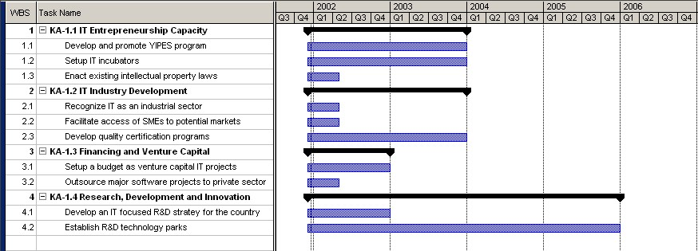

5. eBusiness

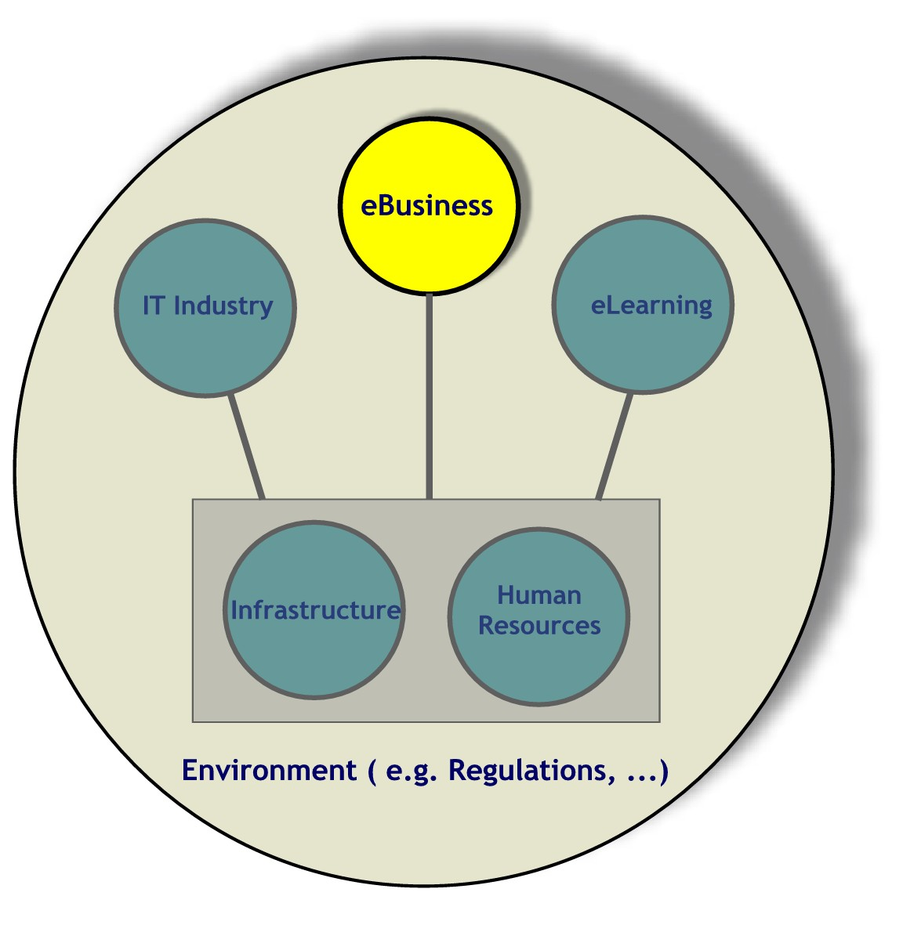
Electronic business (eBusiness) is about enabling organizations to cohesively bring together their processes and the Internet technologies for cost effectiveness, efficiency and better relationships among partners. These partners could be business organizations, customers, suppliers, government departments or citizens. eBusiness concepts and technologies can be applied in various areas of everyday life including, but not limited to, businesses, industry, government and education. However, its pervasive applications are found in commerce, government and service sectors of the economy.

The introduction of the Internet has increasingly changed the way people conduct business. The availability of information, the speed of access to sources of information as well as the links with global markets is revolutionizing people’s way and quality of life in conducting businesses and governance. With developments in Information Technology, more people and governments are increasingly using the Internet to conduct their day-to-day activities. This is becoming essential for all societies in order to be able to interact with the world at large in an efficient and convenient manner as illustrated in Figure 4.

Internet offers enormous opportunities for the government to improve its interactions with the citizen, and its agencies themselves, and makes more effective utilization of its resources. Governments around the world are responding to the information age society. The key forces of change – including globalization, the rise of knowledge-based economies and spread of information technologies – are transforming the relationship between government, business, and society. eGovernment models are revolutionizing how government institutions work and provide quality services that could be delivered to the people.

Therefore, the main thrusts of the eBusiness plan are eCommerce and eGovernment sectors as shown below:

eCommerce: The capability of buying and selling products and information over the Internet and other on-line services by automating business transactions and workflow.

eGovernment: The utilization of Information Technology to provide people with better services by creating stronger and more effective government-to-government, government-to-business and government-to-citizens services and relations.

The increased use of Information Technology in commerce and government services and information is expected to enhance the efficiency and quality of services provided which will create citizens who utilize electronic means (eCitizens) in their day-to-day activities. This will also help ease their global eBusiness reach as shown in Figure 4.
eBusiness offers enormous opportunities for business organizations, government departments, and citizens for improving their inter-relationships, and adds value to their interactive processes.

eBusiness: Seizing the Opportunities

eBusiness offers enormous opportunities for business organizations, government departments, and citizens for improving their inter-relationships, and adds value to their interactive processes. The key benefits of eBusiness are as follows:
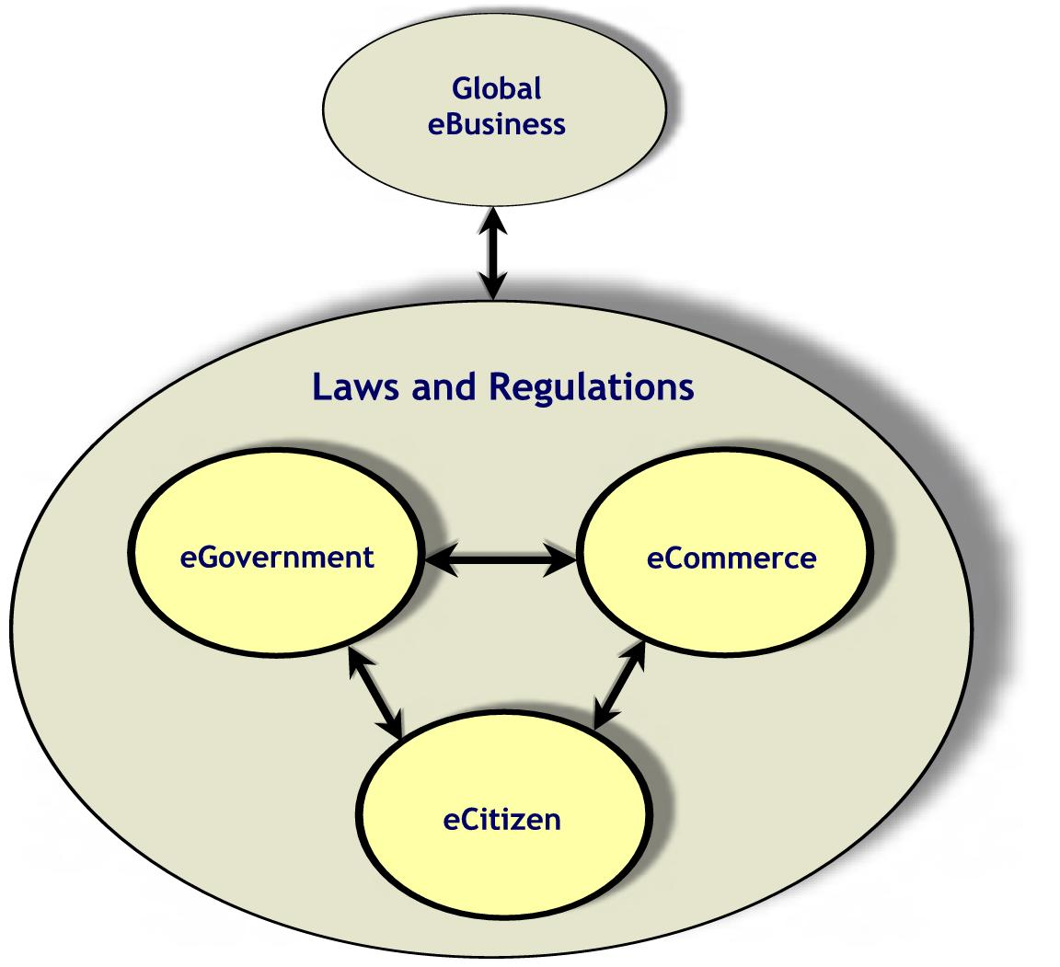
Global Reach: Internet has enabled local business organizations to reach out to global customers and partners for increasing their sales and exploring new markets.

Reduced Cost: eBusiness, especially in business-to-business relationships, has helped organizations to reduce cost of transactions and yet conduct it at a great speed. Internet based procurement has helped companies save 10-25% of the procurement costs.
Figure 4: eBusiness/Society Interaction

Convenience: eBusiness enables consumers and citizens to access information and services at any time from anywhere at their own convenience.

Higher Productivity and Efficiency: eBusiness is helping organizations and administrations reduce cycle times of their services and yet consume fewer resources.

Although every country looks up for such benefits and advantages of eBusiness, not all countries are ready to reap these benefits. Countries differ in creating the right environment for eBusiness. To describe the extent to which a country’s business environment is conducive to Internet-based commercial opportunities, eReadiness model is used. The model tallies score across six categories including connectivity (30%), business environment (20%), eCommerce consumer and business adoption (20%), legal and regulatory environment (15%), supporting eServices (10%), and social and cultural infrastructure (5%).

According to eReadiness rankings released by Economist Intelligence Unit (EIU) in May 2001, countries may be divided into four groups as shown in the Table 3. These groups are described as follows:

eBusiness leaders: These countries already have most of the elements of eReadiness in place, though there are still some concerns about regulatory safeguards.

eBusiness contenders: These countries have both a satisfactory infrastructure and a good business environment but parts of the eBusiness equation are still lacking.

eBusiness followers: These countries form the largest group and have begun to create an environment conducive to eBusiness, but have a great deal of work to do.

eBusiness laggards: These countries risk being left behind, and face major obstacles to eBusiness growth, primarily in the area of connectivity.

Table 3 shows the United States as the most e-ready country listed in the world. Both Egypt and Saudi Arabia who represent the Arab countries are among the eBusiness followers group. It may be noted that Saudi Arabia dropped down from 40th position in 2000 to 44th position in 2001. Adopting initiatives and recommendations in this plan is expected to improve this ranking considerably in the near future.

Saudi eBusiness Environment

A strategic analysis of the Saudi eBusiness environment is summarized in Table 4. The strength of the Saudi eBusiness market lies in the Kingdom being the center of the Islamic World with the largest economy ($168 billion, 2000) in the Arab world with virtually no direct taxes. The rapid Saudi population growth estimated at 3.4% per year is an expanding consumer base and, therefore a driving force for the private sector and eBusiness supported by the high Saudi youth population.

The large Saudi population compared to other Arabian Gulf Countries and the presence of large IT companies based in Saudi Arabia gives Saudi eBusiness an advantage and competitive strength in the region. With more openness towards direct foreign investment, it is inevitable that large foreign investors would also bring and utilize latest technology to conduct their businesses. Local companies are expected to get inspiration and follow suit.

Table 3: Grouping of Countries by eReadiness Ranking
eBusiness Leaders | eBusiness Contenders | eBusiness Followers | eBusiness Laggards
US (8.73)  Australia  UK  Canada  Norway  Sweden  Singapore  Finland  Denmark  Netherlands  Switzerland  Germany  Hong Kong (7.45) | Ireland (7.28)  France  Austria  Taiwan  Japan  Belgium  New Zealand  South Korea  Italy  Israel  Spain  Portugal (6.21) | Greece  Czech Republic  Hungary  Chile  Poland  Argentina  Slovakia  Malaysia  Mexico  South Africa  Brazil  Turkey  Colombia  Philippines  Egypt (3.88)  Peru  Russia  Sri Lanka  Saudi Arabia (3.80)  India  Thailand  Venezuela | Bulgaria (3.38)  China  Ecuador  Iran  Romania  Ukraine  Algeria  Indonesia  Nigeria  Kazakhstan  Vietnam  Azerbaijan  Pakistan (2.66)

The overall business environment of the Kingdom gives eBusiness great potential of success, positioning the Kingdom as a regional leader in eCommerce as well as in utilizing eGovernment towards better and quality services for all citizens. However, the success of eBusiness in Saudi Arabia requires substantial improvements in IT infrastructure with easy and affordable Internet access supported by trained and skilled local IT professionals to meet the demand for human resources (see Sections 6 and 8).
The overall business environment of the Kingdom gives eBusiness great potential of success, positioning the Kingdom as a regional leader in eCommerce as well as in utilizing eGovernment towards better and quality services for all citizens.

The enactment of eBusiness laws and regulations is also a prerequisite for successful eBusiness implementation in the Kingdom.

The rapid implementation of eBusiness and the continuous updates and improvements are necessary steps against the threats of lagging behind regional as well as international competitions resulting from WTOs lower trade barriers.

Table 4: Strategic Analysis of Saudi Arabian eBusiness Environment

Strengths | Threats & Challenges
- Center of the Islamic World.  - The largest Arab economy.  - Free market with minimum taxes.  - High youth population.  - The largest IT market in the region. | - Regional eBusiness initiatives from UAE and Egypt.  - Admission to WTO will lower the legal barriers thus local firms will be exposed to higher international competition.  - Cultural backlash.
Opportunities | Weaknesses
- eCommerce enables access to regional and global marketplaces.  - Internet is an important engine for economic growth.  - Internet helps reduce cost of doing business (e.g., B2B procurement cost).  - With trade barriers coming down, environment for eBusiness is becoming more conducive.  - eGovernment systems enable convenient and responsive services for citizens. | - Lack of local IT professionals.  - Lack of sufficient and affordable facilities for education and training of locals.  - Very high cost of Internet access.  - Telecom operator monopoly.  - Non-existent legal environment for eCommerce transactions.  - Lack of basic infrastructure for secured eCommerce transactions.

5.1 Road Map of the eBusiness Plan

The eBusiness plan envisions harnessing the potential of information technology (IT), particularly the Internet, for good governance, the betterment of the society, and economic development of the Kingdom of Saudi Arabia. Its aims to enable, facilitate, and promote the efficient and effective use of the Internet in the society, government, business and economy while maintaining local traditions and Islamic values.

The following are the main goals of the eBusiness plan:
The rapid implementation of eBusiness and the continuous updates and improvements are necessary steps against the threats of lagging behind regional as well as international competitions resulting from WTOs lower trade barriers.

Make Saudi business and industry more competitive in the new economy.

Provide opportunities for economic development and growth by promoting pervasive use of Internet in all walks of life that will give birth to new businesses, and provide access to new markets.

Enhance the role and ability of Small and Medium Enterprises (SMEs) to participate in global trade and economy.

Make government more efficient and responsive to all citizens by providing easy access to information, and efficient processing of services.

Provide an enabling legal framework for eBusiness.

Develop an internationally linked and efficient eBusiness infrastructure.

Create awareness at various levels among all stakeholders.

In order to meet these goals and promote eBusiness in the Kingdom of Saudi Arabia, six major key areas are identified. These key areas are:

- Internet access.
- eBusiness facilities.
- Awareness & promotion.
- Legal framework.
- eBusiness skills.
- eBusiness organization & management.

Each of the above key areas is discussed in detail as follows.

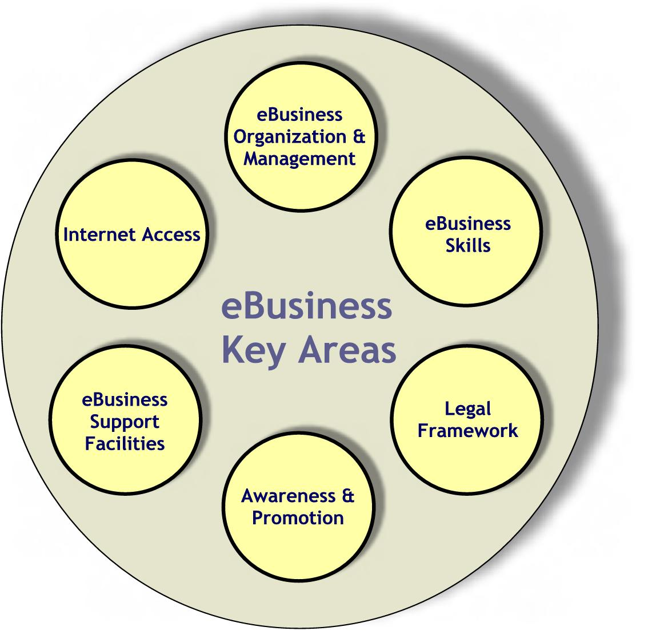
5.2 Key Areas for eBusiness

KA-2.1 Internet Access
Internet connectivity is one of the most important issues in the development and growth of eBusiness in any country. Users connect to the Internet by using a personal computer, a mobile telephone or any other Internet appliance through Internet Service Providers (ISPs). The key resources that determine the quality of Internet access include the efficiency of telecommunication networks, the bandwidth available to the ISPs, and the cost of using such service. Since this is an infrastructure key area, accordingly it enjoys greater focus in that component of the plan (see Section 6).

KA-2.2 eBusiness Facilities
To enable an eBusiness transaction, some basic facilities include, information infrastructure, a certification authority, a payment gateway, and reliable postal addresses. In this regard, the following initiatives are proposed:
Init-2.2.1: Establish a certification authority and Public-Key Infrastructure (PKI) encryption system.

A trusted third party that issues and governs digital certificates is known as certification authority. A good example of such a facility is ComTrust established in the UAE. In the Kingdom, this authority could be a government agency or a private company. Also, a PKI encryption system that provides confidentiality, access control, integrity, authentication, and non-repudiation services for eCommerce services should be set-up. The Ministry of Commerce in collaboration with the Saudi Arabian Monetary Agency (SAMA) should be responsible for implementing this initiative by the end of 2002.

Responsible Bodies: Ministry of Commerce (MoC) and Saudi Arabian Monetary Agency (SAMA).

Init-2.2.2: Implement an e-Payment gateway.
Saudi Arabian Monetary Agency (SAMA) should facilitate an electronic payment facility that connects all banks similar to the Saudi Payment Network (SPAN). This has to be implemented the latest by the year 2002.

Responsible Body: Saudi Arabian Monetary Agency (SAMA).

Init-2.2.3: Establish efficient and reliable postal addresses for residence and business sites.
The speed and efficiency of delivering online ordered goods and services cannot be realized without reliable postal services. Therefore, Saudi business as well as residential sites should have the necessary postal addresses for full utilization of eBusiness all over the Kingdom. This could be based on a Geographic Information System (GIS). The Ministry of PTT in full cooperation with the Ministry of Municipal and Rural Affairs should achieve that, Kingdom wide by the year 2010.

Responsible Bodies: Ministry of Post Telephone and Telegraph (MoPTT) and Ministry of Municipal and Rural Affairs (MoM&RA).
In addition to the above, certain initiatives should be taken to facilitate eGovernment environment in the Kingdom. These initiatives are:
Init-2.2.4: Establish eGovernment portals in all major ministries and departments.
These portals are interactive websites that offer various information and services to citizens and private or public organizations. This should be established for all government organizations by the year 2003.

Responsible Bodies: All Government Organizations.

Init-2.2.5: Transform all necessary documents to eFormat (eGovernment).
The government should, under a well-planned and coordinated program, digitize/translate all of its relevant documents and forms into e-Formats. Priority should be given to documents that will be a must for online processing of services and/or provision of information for use by business and citizens. All government organizations should start this initiative and complete it by the year 2005.

Responsible Bodies: All Government Organizations.

Init.2.2.6: Modernize and Integrate Government Information Infrastructure (GII)
Digital technologies provide the opportunity to easily access and re-use the wealth of information held in the government sector. The Government Information Infrastructure (GII) integrates hardware, software, information and skills that make a vast array of services and information resources available to the people. It can transform the old public sector organizations and provide faster, integrated and more responsive services to all citizens.

There is a need to update and integrate a complete information system that covers the services from different sectors such as Commerce, Education, Health Services, Municipal Services, Labor and Social Services, Civil services, Telecommunications, Transportation, etc., to cater the needs of the society. An integrated information system is needed for fully realizing the benefits of the IT towards achieving e-governance. This will provide the businesses and individuals the opportunity to access and share electronically the information sources and services of the government.

The private sector must have the primary responsibility for the design, deployment, and operation of the GII. However, all the levels of Government will have to play the role of ensuring its effective development and deployment. The government and the private sector should invest to develop this by 2005.

Responsible Body: ITC

Init-2.2.7: Develop a nation-wide directory of government portals, websites, and email addresses.
Accessing government services and information can greatly be facilitated by the existence of a guide to the public in the form of a directory. This directory of portal, web and e-mail addresses should be published and made available to the public and it should also be updated on a regular basis.

Responsible Body: General Secretary of Information Technology Commission (ITC).

KA-2.3 eBusiness Awareness and Promotion
A good number of businesses, government departments and public do not know about the technical aspects and benefits of eBusiness. There is a need to improve this awareness by organizing seminars, training workshops, symposia and conferences on a regular basis. Print and electronic media should be included in promoting basic concepts and benefits of eBusiness. Chamber of Commerce & Industry, Ministry of Higher Education, and Ministry of Commerce should play a lead role in these planned awareness and promotion programs.

Init-2.3.1: Organize public seminars, training workshops, symposia and conferences on eBusiness.
Public awareness of the potential and benefits of eCommerce and eGovernment is essential for the success of eBusiness. This can be achieved through public seminars, training workshops, symposia and conferences. Such activities should be publicized among businesses as well as the public and should be organized regularly.

Responsible Bodies: Chamber of Commerce and Industry (CCI), Ministry of Commerce (MoC), Ministry of Higher Education (MoHE) and Saudi Computer Society (SCS).

Init-2.3.2: Organize seminars, training workshops, and symposia on eGovernment.

Specialized training and awareness workshops and seminars should be organized for all government employees in order to improve their computer skills and raise their awareness of the subject as well. All government organizations should encourage and facilitate for their employees to attend such events with the target of involving at least 10% of their employees every year. This should be conducted on a regular basis.

Responsible Bodies: Institute of Public Administration (IPA), Ministry of Commerce (MoC), government organizations, Saudi Computer Society (SCS), and universities.

KA-2.4 eBusiness Legal Framework
An enabling legal environment is a must for eBusiness transactions to provide protection and enhance confidence of users, providers, and facilitators of information services. For the success of eBusiness the following initiatives should be undertaken:

Init-2.4.1: Pass legislation to ensure privacy and security.
Based on the recommendations of IT and legal experts, the responsible bodies proposed should ensure that laws for privacy and security are in place for eCommerce. Ministry of Commerce should take charge of such initiative. Other legal and enforcement authorities should always be consulted while drafting such laws. This should be implemented by the year 2002.

Responsible Bodies: Ministry of Commerce (MoC) and King Abdulaziz City for Science and Technology (KACST).

Init-2.4.2: Develop government eProcurement laws and regulations.
This will ease business-to-government services and transactions and will allow government employees to browse, search, specify, review, order, monitor delivery, and track purchasing history. The Ministry of Finance and National Economy should take responsibility of facilitating and authorizing such laws by the year 2003.

It is recommended that the United Nations Commission on International Trade Law (UNCITRAL) model be adopted while drafting laws. The legal framework should address the following:

Laws pertaining to authentication, recognition, and retention of electronic records, digital signature, digital IDs, and digital certificates.
Constitution of certifying authorities.
eGovernment specific laws.
eCommerce specific laws.
Protection of privacy, security, confidentiality, and Islamic values.
Prosecution of computer and Internet offences.
Review of existing laws to remove any contradictions that may hamper the implementation of IT Plan.

Responsible Body: Ministry of Finance and National Economy (MoF&NE).

KA-2.5 eBusiness Skills
Human resources development is a critical component of eBusiness plan. eBusiness skills include but are not limited to website development and administration, programming, database development and administration, systems integration, networking, and security.

Training programs should be designed and conducted to develop and/or enhance skills of the on-the job personnel. In addition, eBusiness subjects should be introduced in the curriculum at the university level. Since this is a human resources issue, more details on this initiative are found in the Human Resources section of this plan (see Section 8).

KA-2.6 eBusiness Organization and Management
The eBusiness plan comprises providing opportunities for economic development and growth in the Kingdom by promoting the use of Internet (or IT) in all walks of life that will give birth to new businesses, and provide access to new markets.
The ITC will oversee, monitor and follow up on the implementation of eBusiness initiatives and maintain continuous updates, reviews and improvements. In addition, eGovernment units should be established in all major government organizations. An eBusiness consultant may suffice for relatively small departments. The eGovernment unit/consultant will be responsible for the development, maintenance, updates and management of eGovernment services and information resources. It should, also, facilitate and coordinate eGovernment programs in their concerned department.

Init-2.6.1: Establish eGovernment unit/consultant in all major government organizations.

Responsible Bodies: All government organizations.

5.3 Management of eBusiness

Table 5 provides summary of eBusiness key areas and the associated strategic initiatives under each area. It also identifies responsibility, timeframe for implementation, and source of funding for effective implementation.

For initiatives pertaining to eGovernment, all government organizations will carry the implementation responsibility. For others, several ministries will be involved such as Ministry of Commerce, Ministry of Municipalities and Rural Affairs, Ministry of Higher Education, Ministry of Finance, Ministry of PTT, etc. Other major organizations include the Chamber of Commerce and Industry, Saudi Computer Society, KACST, and the Institute of Public Administration. Once again, the ITC must ensure that the proposed bodies will deliver if the initiatives are approved. The ITC must oversee, monitor and follow-up on the implementation of eBusiness initiatives and maintain continuous updates, reviews and improvements. In addition, for successful implementation, eGovernment units must be established in all major government departments. An eBusiness consultant may suffice for relatively smaller departments. Figure 5 shows the Gantt chart detailing the schedule for the eBusiness plan.

Table 5: Key Areas and Initiatives of eBusiness
Key Area | Initiatives | Implementation Responsibility | Time Frame | Source of Funding
KA-2.1  Internet access | Refer to the IT Infrastructure (Section 6) of this Plan.
KA-2.2  eBusiness facilities | Establish certification authority and PKI encryption system. | MoC, SAMA | By end of 2002 | G-P partnership
KA-2.2  eBusiness facilities | Implement e-Payment gateway. | SAMA | By end of 2002 | G–P partnership
KA-2.2  eBusiness facilities | Establish reliable postal addresses. | MoPTT, MoM&RA | By end of 2010 | G–P partnership
KA-2.2  eBusiness facilities | Establish eGovernment portals. | All Government Organizations | By end of 2003 | Government
KA-2.2  eBusiness facilities | Transform all necessary documents to e-formats. | All Government Organizations | By end of 2005 | G-P partnership
KA-2.2  eBusiness facilities | Modernize/Improve Government Information Infrastructure (GII). | ITC | By end of 2005 | G-P partnership
KA-2.2  eBusiness facilities | Develop a kingdom-wide directory of government portals, websites, and email addresses. | General Secretary ITC | By end of 2005 | Government
KA-2.3  eBusiness awareness and promotion | Organize seminars, training workshops, symposia and conferences for eBusiness. | CCI, MoC, MoHE, SCS | On-going | G-P partnership
KA-2.3  eBusiness awareness and promotion | Organize seminars, training workshops, and symposia for eGovernment. | IPA, MoC, government organizations, SCS, Universities | On-going | Government
KA-2.4  eBusiness legal framework | Pass legislation to ensure privacy and security. | MoC, KACST | By end of 2002 | Government
KA-2.4  eBusiness legal framework | Develop government e-procurement laws and regulations. | MoF&NE | By end of 2003 | Government
KA-2.5  eBusiness Skills | Refer to the Human Resources Development (Section 8) of this Plan.
KA-2.6  eBusiness Organization & Management | Establish eGovernment unit/consultant in all major government organizations. | All Government Organizations | By end of 2002 | Government

Figure 5: Gantt chart of Key Areas and Initiatives for eBusiness.
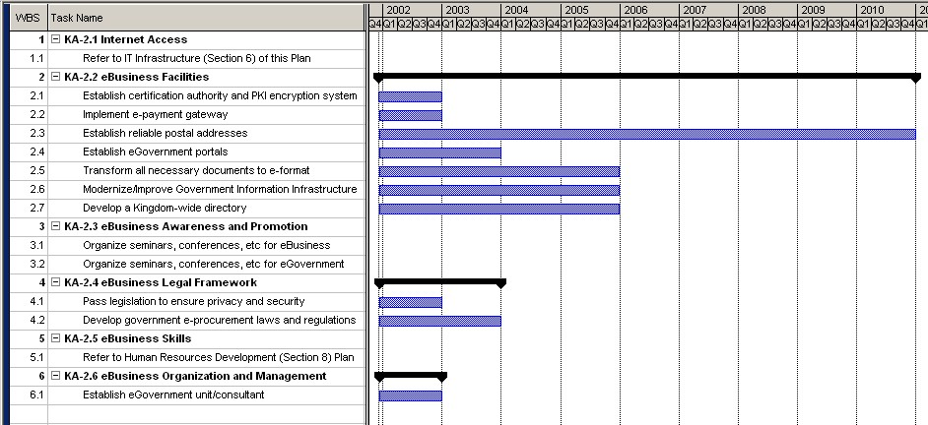

6. IT Infrastructure

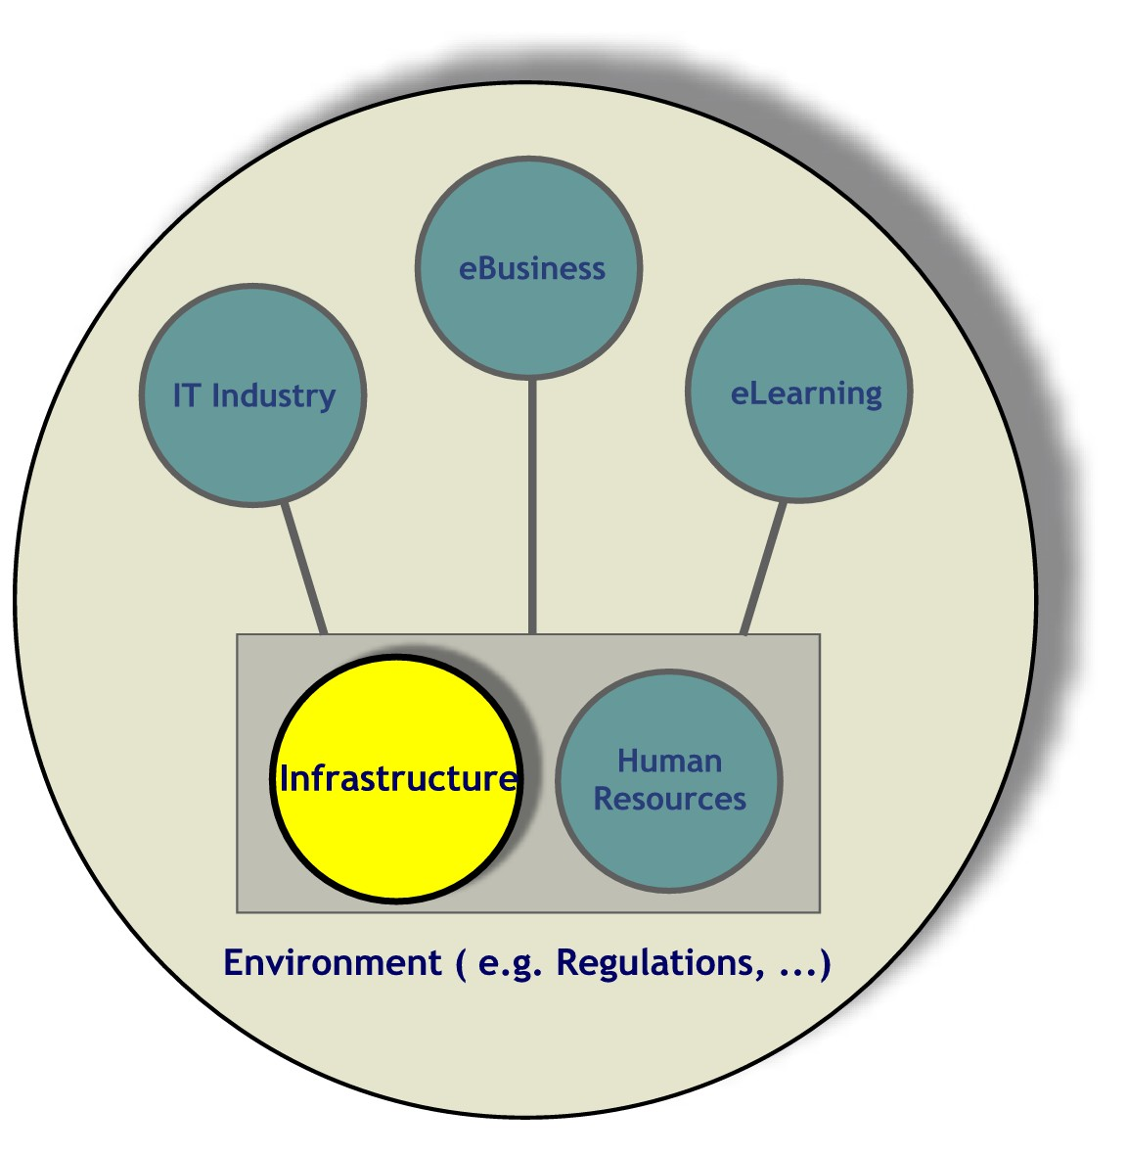
IT infrastructure is the platform that leverages the benefits of the Internet and telecommunication technologies to boost national growth. Prowess in IT infrastructure will help create high-wage jobs, stimulate economic growth, enable new products and services, and promote the Kingdom of Saudi Arabia as a leader in Information Technology. This will revolutionize and initiate IT sector development. Research has shown that economic growth is influenced by the availability of efficient telecommunications and informatics infrastructure. Other studies have extended these correlations to a range of development indicators, such as social development, cost savings for industry, and increased transport efficiency.

Potential demand for a full range of telecommunications services will outstrip the Saudi Telecom Company’s ability to meet that volume, ensuring telecommunication services will continue to expand rapidly in coming years. The full range of IT services are either unavailable or in the development stages, including Digital Subscriber Lines (DSL), video conferencing, wireless Internet access, Very Small Aperture Terminal (VSAT), and high speed broadband data services.
In the next few years a growing share of the Kingdom’s population could become customers or suppliers, not just of globalized industries, but also of any firm or individual who can connect to modern IT infrastructures and benefit from modern logistics of technology-facilitated international trade.

The Internet, by leveraging the potential value of a local loop connection suggests that the economic effects of networking will be far greater in the future. At the micro-level, the Internet is an unprecedented opportunity for firms to reduce costs and increase market coverage (both home and abroad), facilitating the achievement of economies of scale and scope. In the next few years a growing share of the Kingdom’s population could become customers or suppliers, not just of globalized industries, but also of any firm or individual who can connect to modern IT infrastructures and benefit from modern logistics of technology-facilitated international trade.

Some of the important benefits of a fast, efficient and robust IT infrastructure to the Kingdom are discussed below.

Increased Economic Growth and Productivity: IT infrastructure is one of the drivers for economic growth and productivity. According to World Bank, the GDP of a nation is directly related to its IT infrastructure. In today's knowledge based global economy, wherein capital and technology are increasingly mobile, the quality of Saudi Arabian IT infrastructure will help determine whether companies invest locally or overseas.

Job Creation: It is evident from several reports on Asia, America and Europe that high quality IT infrastructure has the potential to create thousands of jobs for skilled and semi-skilled IT professionals. Hence, improving Saudi Arabian IT infrastructure will reduce the unemployment rate.

Technological Leadership: The IT infrastructure will serve as the driver for a wide variety of technologies, such as semiconductors, telecommunications, high-speed networking, advanced displays, software, and human/computer interfaces such as speech recognition, for example. This technology will be used to create exciting new products and services, pushing Saudi Arabia towards leadership in the electronics and information technology sector.

eGovernance: In eGovernance, knowledge is networked for better governance. The widening use of Information and Communication Technology (ICT) is leading to distributed knowledge and power structures. It is reshaping the interaction of citizens with the government. With the emergence of pro-active knowledge societies, options are open to governments to constantly improve to bring in greater efficiency, accountability and transparency in their functioning.

eCommerce: eCommerce can dramatically reduce the time required to market new products. "Time-to-market" is a critical success factor in today's global economy. A fast, reliable, secure and affordable infrastructure plays an important role in establishing and enhancing eCommerce.

Health Care: By using telemedicine, doctors, health centers and other caregivers can consult with specialists around the globe thousands of kilometers away. They can continually upgrade their education and skills, and share medical records and X-rays. The Kingdom can use computer networks to promote health care through the net.

The above are just few of the several examples that exist.

IT Infrastructure statistics/indicators measure access, the stock of communication equipment needed for accessing the Internet and access tariffs to indicate the competence of IT infrastructure in the Kingdom. Some of the major indicators include Internet hosts and servers, Domain Name systems (DNS), IP addresses, autonomous systems, fixed and mobile telephone service lines, broadband access, VSAT access, Internet users, Internet subscribers, number of ISP’s, leased lines, tariffs, and traffic. These indicators generated by network surveys play a role in administering core Internet infrastructure.
Convergence of technologies is facilitated with introduction of broadband access methods to transmit various types of communication signals like telephony, data and video on the same media.
The global trends in the ICT sector indicate proliferation of Internet access, reduction in Internet access charges, and increase in fixed and mobile telephone service lines. Convergence of technologies is facilitated with introduction of broadband and VSAT access methods to transmit various types of communication signals like telephony, data and video on the same media. Global statistics show high number of Internet users and subscribers. The Kingdom of Saudi Arabia has low number of Internet hosts (computers on the Internet) and subscribers when compared to Australia and Japan for example. Increasing importance to secure information and secure access technologies is another concern.

This year, teledensity (number of standard access lines per 100 inhabitants) in Saudi Arabia is 14 (1 channel for every 7 inhabitants). Global trends show countries like Australia, Korea, Canada, UK, USA and UAE have teledensity figures of 40 and above (i.e., approximately 1 channel per every two inhabitants). Of the total number of subscribers in the Kingdom, the percentage of subscribers who are mobile is increasing. Within the Kingdom, the mobile communications sector has been gaining ground in the last couple of years and there is room for further improvement. Globally, broadband services are prominent and in the Kingdom this method of access is enabled and is gaining popularity.

The overall review of the IT Infrastructure in the form of Internet Dimensions (as of September 2001) in the Kingdom is very well represented in Figure 6. The dimensions shown in this Figure represents the framework for analyzing the development and status of the Internet within the Kingdom following general guidelines established by the Global Information Technology Assessment Group (formerly the MOSAIC group). These dimensions are Pervasiveness (number of users per capita), Geographic Dispersion (physical dispersion of infrastructure and access), Sectoral Absorption (connectivity in various social sectors), Sophistication of Use (integration and innovation), Connectivity Infrastructure (capacity and robustness), and Organizational Infrastructure (degree of competition). Each of the six dimensions is given a numeric score, on a scale of 0-4 with 4 being the best. As evident in Figure 6, the Kingdom lags behind countries like Singapore, Malaysia, and Indonesia in most of the dimensions.

Figure 6: Internet dimensions of the Kingdom, Indonesia, Malaysia and Singapore, 2001

6.1 Road Map of the IT Infrastructure Plan

The plan is intended as a strategic road map for IT development and to provide a robust and scalable platform to leverage information technology in the Kingdom, making it the information hub of the region, improving the GDP and empowering its socio-economic development. It is envisioned that the Kingdom will provide fast, easy, secure and affordable access to facilitate a modern internationally linked e-enabled infrastructure.

The strategy pertaining to the IT infrastructure is to provide an action plan with a set of recommendations to improve the IT Infrastructure so that the Kingdom will be at par with the technologically advanced nations. It comprises of documentation of the existing IT infrastructure, its policies and standards, and the consolidation of Kingdom-wide IT requirements to facilitate a modern internationally linked e-enabled infrastructure. The strategic time-bound plan presented here begins with an assessment of the current situation. The approach of the plan is based on a comparison of the Kingdom’s IT Infrastructure with that of the Organization for Economic Cooperation and Development (OECD) countries. The current status and the trends in the OECD countries served as a benchmark in deriving the goals for the IT Infrastructure of the Kingdom. The goals are then translated into a set of recommended actions to improve the current scenario in the Kingdom.
Table 6. Telecom and Internet indicators in OECD countries

Standard access lines per 100 inhabitants | Mobile subscribers per 100 inhabitants | Internet subscribers per 100 inhabitants | DSL per 100 subscribers
52 (year 1999) | 32.4 (year 1999) | 11.4 (year 1999) | 2.4 (year 2000)

The following goals are identified based on OECD average as shown in Table 6:

Increase the percentage of Internet subscribers from 1.2% (2001) to 15% by 2003.

Increase the mobile density (number of mobile subscribers per 100 inhabitants) from 11 in 2001 to 40 by 2003.

Improve broadband access by increasing the number of DSL lines to 10 per 100 subscribers by 2003.

Increase the teledensity (number of telephone lines per 100 inhabitants) from 14 in 2001 to 40 by 2003.

The above-mentioned strategy and goals motivate the focus on the following key areas: (1) Access, (2) Tariff, and (3) Security.

Each of the above key areas is discussed in details as follows.
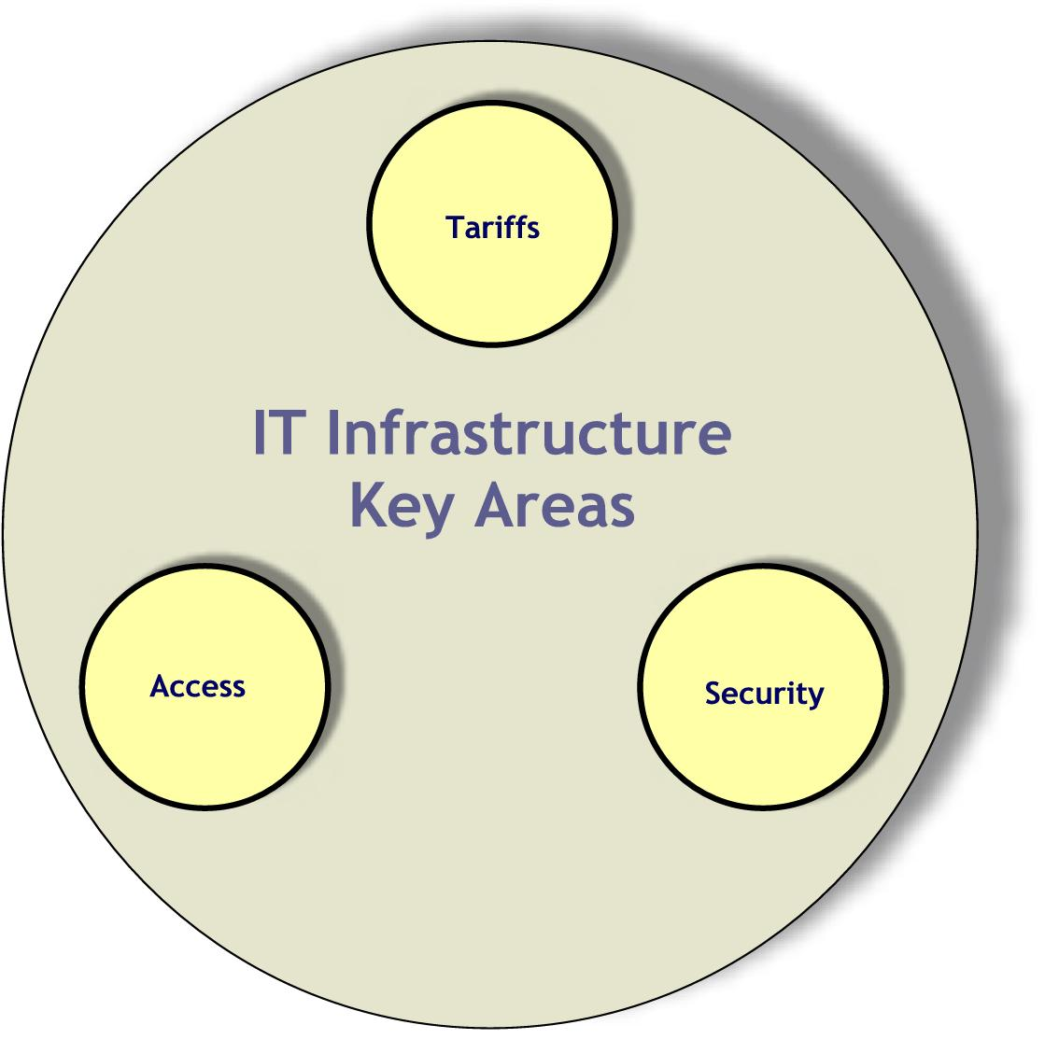
6.2 Key Areas for IT Infrastructure

KA-3.1 Access
The access discipline is the technology that allows end users to be connected to a public network. As such, the access function provides the initial customer interface and experience. Access is truly the "face" of the service provider to the customer and therefore, plays a critical role in determining the customer experience. Equipment in this area includes various types of integrated access technology, digital loop carrier technology, fiber to the premises technology, and wireless access technology. Access to the Public switched Telephone Network (PSTN) has historically been predominantly provided with individual twisted pair copper loops. Growing demand has led to multiplex techniques such as digital loop carrier, E1/T1 (and higher) access, DSL, integrated access (including TDM (Time Division Multiplexing) approaches and packet-oriented approaches such as Asynchronous Transfer Mode (ATM) and fixed wireless access.

Access type and availability is a major indicator of the IT Infrastructure. The access portion of the network also tends to account for a large percentage of total network investment because of diverse customer needs and locations. Access is often viewed as a bottleneck in many contemporary network implementations and its improvement plays a pivotal role in the advancement of information and communication technologies.

The Saudi Telecom Company handles all technical and administrative facilities including the PSTN, mobile communications, and data communications networks. The digitalization of wire-line and wireless communications is complete and the Kingdom proudly boasts of a 100% digital exchange infrastructure and network. The Internet Services Unit (ISU), a department of KACST, is the single entity that is responsible for providing Internet services in the Kingdom of Saudi Arabia, in cooperation with STC and a number of Internet Service Providers (ISPs) from the private sector. There are 30 licensed ISPs in the Kingdom providing their subscribers access to the national and international networks.

Presently the most common telecommunication access method in the Kingdom is the fixed telephone. The number of fixed access lines stood at 3.2 million at the end of second quarter of 2001 (i.e., 15.2% of the population) and is expected to reach around 5 million in 2005. These figures are noteworthy when one takes into account that in 1990, the Kingdom boasted of a million standard access lines. The increase in the size of the PSTNs is a direct result of a double-digit compound annual growth since 1996.

Teledensity in Saudi Arabia started out with about 1 channel for every 12 inhabitants in 1990 and progressed to 1 channel for every 7 inhabitants in 2001 (Figure 7). This shows a great potential for increase in the penetration that is achievable in order for the Kingdom to be comparable to the OECD countries (average: 1 channel for every 2 inhabitants in 1999) and other developing countries around the world. The number of payphones in Saudi Arabia stood at around 70,000 in 2001 and is expected to saturate as the fixed access line and mobile market penetration increases.
Access is often viewed as a bottleneck in many contemporary network implementations and its improvement plays a pivotal role in the advancement of information and communication technologies.

Figure 7: Growth of Teledensity in Saudi Arabia (source: STC, US Census Bureau)

The number of subscribers to mobile services in the Kingdom reached 2.5 million in 2001 and is expected to reach around 6 million by 2003. The mobile communications sector has been remarkable in sustaining a very high annual growth rate in the last couple of years and is expected to maintain and improve it in the coming two years.
Figure 8: Mobile subscribers per 100 inhabitants in the region

Figure 8 shows the number of mobile subscribers per 100 inhabitants in the Kingdom in comparison to the number from other regional countries, for the years 1999 and 2000. There is a great potential to increase the mobile subscribers density. The mobile subscriber density average for the OECD countries stood at 32.4 for the year 1999.

The share of mobile subscribers as the percentage of the total telephone subscribers is increasing at a rapid pace. As the mobile revolution expands in the Kingdom, more operators (other than monopolistic STC) are expected to provide the necessary thrust and numbers to foster a wider access to the network.

Broadband technology allows for fast transmission of large amounts of information, which enables bandwidth hungry technologies, such as full-motion video or CD-quality audio. Broadband services enabled by the STC include DSL, which allows transmission at bandwidths from 144 Kbps to few Mbps. In the coming years, the number of DSL lines in the Kingdom is expected to grow at a rapid pace. According to STC, it is expected that the number of DSL will grow to 100,000 by the end of year 2003.

Leased lines are one of the main building blocks used by businesses to construct networks for eCommerce. STC expects that the number of leased lines will surpass 30,000 lines in the year 2001. VSAT technology represents a cost effective solution for users seeking an independent communications network (through satellite) connecting a large number of geographically dispersed sites. In the Kingdom VSAT access is in nascent stages.

The number of Internet hosts is one of the most commonly used indicators of the growth of the Internet. Total hosts reported by International Telecommunications Union (ITU) in July 2001 for the Kingdom is 3,745. The number of hosts per 10,000 inhabitants in the Kingdom is 1.7 whereas the OECD countries have their average at 8.

The personal computers (PCs) penetration (PCs per 100 inhabitants) in the Kingdom stands at 5, which is very low when compared to other Arab countries such as UAE and Bahrain that boast a penetration rate in the range 10-15.

The number of Internet subscribers (those paying for access to the Internet) rather than users is a precise indicator of access. Until March 2001, the number of Internet subscribers was 275,000. The Kingdom’s user to subscriber ratio for the year 2001 is estimated to be 2.5. A measure of the Internet user market is the Internet coverage - the portion of the population of a country within easy access of the Internet. Coverage in Saudi Arabia is low and stands at 3-4%²⁴. Over 75% of the Internet users are male, and most of them are under the age of 35 years.

The following initiatives are identified to improve the access status in Saudi Arabia and to bring it to the access level in OECD countries.

Init-3.1.1: Open up competition in all telecommunication services sector to expand access.

Competition breeds quality. Increasing competition is the direction for increasing access. Telecommunications deregulation can be a critical component of a government’s plan to promote a low-cost telecom environment, encourage the widespread diffusion of the ICT sector, and enable broader economic and societal benefits from technology integration. For example, the introduction of competition in the provision of access infrastructure in Sri Lanka has resulted in tripling access to communication services with more lines being added to regional areas. The current reach in the Kingdom is expected to expand as newer providers enter the market. This is also expected to improve the quality of service.
Competition breeds quality. Increasing competition is the direction for increasing access.

The current telecommunication network should be seen as a national asset. A license to a second national operator (SNO) should be issued. The SNO should not be required to develop its own infrastructure. It should interconnect with STC on fair terms, and the recently established Saudi Telecom Authority (STA) should regulate these terms. The STA should oversee the provision of the ICT infrastructure and technologies in an equitable manner. The STA should be provided with more power to effectively enforce regulation within a competitive and fair environment and to resolve difficulties as a matter of urgency without compromising the need for a simplified and pro-competitive regulatory framework. Licensing procedures should ensure that a broadly based, local entity enters the competition. The STA is responsible for opening up competition in all telecommunication services by the year 2003 to target a fully integrated and liberalized telecommunications market by 2005.
The current reach in the Kingdom is expected to expand as newer providers enter the market.

Responsible Body: Saudi Telecom Authority (STA).

Init-3.1.2: Issue licenses for different wireless services to provide connectivity, especially to the remote locations in the Kingdom.

The national network operators should be directed to pursue approaches to promote universal Internet access for rural and less-populated areas in the Kingdom so that the benefits pervade throughout the Kingdom. Fixed wireless access is one way to rapidly achieve this. The government should direct the STA to efficiently manage the radio frequency spectrum. Licenses for different wireless services (e.g., VSAT, BWA (Broadband Wireless Access), Wireless Local Loop (WLL) and cellular) have to be introduced by the STA. WLL is expected to provide an economically viable and much needed last-mile connectivity option in rural, less populated areas. Nation-wide access to the Internet is a key area for services such as eGovernance, eCommerce and eLearning. This key area is covered by directing national operators to garner and furnish the necessary infrastructure and services for providing Kingdom-wide connectivity. The STA should immediately start inviting license applications from different operators for different services. Issuing licenses to different national operators shall act as source of revenue generation for the Government.

Responsible Body: Saudi Telecom Authority (STA).

Init-3.1.3: Establish community and edutainment centers.

As e-enabled services such as eLearning, eBusiness, etc. spread through the social spectrum of the Kingdom, the need for public access points is increasing. Municipalities should establish community IT access points as a key means to facilitate timely, broad, affordable and sustainable access to ICT Facilities. Post offices, elementary schools, Internet cafés or community multimedia centers could be possible access points and technology demonstration centers. Moreover, these access points could also offer educational services providing the user with multimedia-based learning facilities, educational aids, advisors and guides, etc. Such services could transform the multipurpose community centers into learning centers. Municipalities are responsible for starting such multipurpose community centers by the year 2003.
Nation-wide access to the Internet is a key area for services such as eGovernance, eCommerce and eLearning.

These access points could be used to access government services and information providing citizens a convenient access especially for those who cannot or do not have an access to the Internet.

Responsible Body: Refer to Human Resources (Section 8) of this plan.

Init-3.1.4: Establish a very high-speed network to link research institutions, universities, and IT parks.
With faster Internet a new concept in computing is emerging - distributed computing over networks. The concept is to facilitate collaboration between geographically dispersed research institutions and university research teams in all scientific disciplines and industrial areas by enabling them to share data and computing infrastructure, working together in real time. IT parks and technological centers maintained by the major global IT companies could add to the knowledge base in the Kingdom. Access to this knowledge easily and in a unified manner is essential to the students, professionals, researchers and the industry. Such easy access is a driver for spreading eLearning services. A Kingdom-wide network grid calls for further development, integration and validation of technology that enables the seamless integration of networks, computers and storage into a unified system. The Ministry of Higher Education (MoHE), in active collaboration with KACST and with the funding from the Government, should establish the high-speed network by the year 2003.

Responsible Bodies: Ministry of Higher Education (MoHE) and King Abdulaziz City for Science and Technology (KACST).

KA-3.2 Tariffs
Accessing information across the Internet makes every user part of IT infrastructure. Cost or tariff of this access is what the end user bears. Therefore tariffs are an important indicator of accessibility, since if people cannot afford the Internet they will not use it. They may also reveal why some countries have a high level of potential Internet access (e.g., high numbers of telephone lines and personal computers) but low user levels. Internet tariff comparisons are complex and further differentiated from access and service providers’ point of view. From a policy viewpoint the most significant Internet tariffs are those associated with dial-up telephone access since this is the most heavily used method of Internet access by individuals at the present time.
There is growing evidence that electronic commerce is growing faster in countries with unmetered Internet access pricing. In fact, some studies pointed out that the Internet economy was being ‘dramatically’ held back by the absence of unmetered Internet access.

Tariffs refer to the prices charged to end users for telecommunication services. Tariffs are an important indicator of accessibility (since affordability is proportional to usage). To access the Internet, a dial-up user needs access, via a PSTN, to their ISP. Dial-up Internet tariffs generally consist of two components:
Tariffs are an important indicator of accessibility, since if people cannot afford the Internet they will not use it.

Telephone line connection charges. These consist of cost of line connection (fixed charge) in addition to the usage charges. Both charges are paid to the telephone company.
Internet access charges (paid to the ISP).

In some countries, a nationwide dialing prefix has been assigned to ISPs; so all calls are treated as local. In some other countries, that traditionally had metered local telephone charges, a subscription-free ISP model had been introduced. In this model, the user only pays the telephone operator that in turn shares the revenue with the ISP.

On the other hand, some telephone operators adopt a flat-rate model (unmetered access) in which they do not charge directly on a usage basis for local calls. This model has been recently more common. Most of the telephone operators in North America are adopting this model. At the beginning of 2000, users in only five OECD countries had the option of unmetered dial-up Internet access. By the beginning of 2001, this option has been extended to 12 countries. There is growing evidence that electronic commerce is growing faster in countries with unmetered Internet access pricing. In fact, some studies pointed out that the Internet economy was being ‘dramatically’ held back by the absence of unmetered Internet access.

Internet tariff comparisons are complex for a number of reasons. First, there are different prices depending on the access infrastructure (e.g., dial-up telephone line, DSL or leased line). Second, there can be a variety of different prices both across and within service providers (e.g., depending on time of day, hours of use). Third, in competitive markets, prices can change rapidly. From a policy viewpoint the most significant Internet tariffs are those associated with dial-up telephone access since this is the most heavily used method of Internet access by individuals at the present time. In Saudi Arabia, current Internet dial-up access prices for 30 hours range from SR 175 ($45) to SR 280 ($75), while it costs only $12 in Malaysia and $25 in Indonesia (source ITU). The relative increase in cost is attributed to the adoption of pricing model that includes both ISP charges and call usage charges. Moreover, the charges of international bandwidth are very high. This is reflected in the monthly charges for a 2 Mbps connection to ISP that costs SR 274,860 ($73,296) per month. The monthly charge for a 2 Mbps connection in Oman, for example, is $25,000. Figure 9 shows Internet dial-up access prices in some OECD countries as of June 2000. Note that the per capita income of these countries varies and should be taken into consideration.

Currently, KACST is offering discounted prices to universities only. STC also provides 30% discounts for universities. In many countries, more discounts are extended to universities as well as other educational institutions.

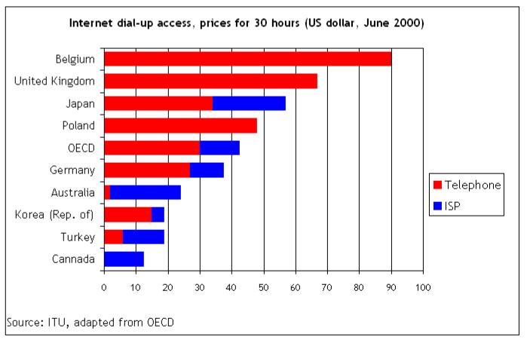
Figure 9: Internet dial-up access prices in other countries

Most countries have accepted the principle of open competition as a tool to address the digital divide. In numerous countries such as Egypt, European nations, South Africa, Singapore and Malaysia among others, deregulating telecommunications has successfully brought down communication prices and made Internet connections more affordable, encouraging people to use technology and foster economic growth. Most countries have realized the importance of creating a competitive telecommunication market. By the beginning of 2001, only two countries out of OECD countries still maintained monopolies in some of their telecommunication markets. On the contrary, Germany had 173 fixed PSTN licenses by mid-2000. Competition can be introduced on different markets: the local market, the long-distance market, the international market and the wireless market.
By the beginning of 2001, only two countries out of OECD countries still maintained monopolies in some of their telecommunication markets.

The major initiatives can be summarized as follows:
Init-3.2.1: Introduce competition in all telecommunication markets.

Competition has to be introduced on all telecommunication markets (local, long-distance, international and wireless). A license to a second national operator (SNO) should be issued. Exclusive licensing must be avoided. The SNO should not be allowed to develop its own infrastructure. It should interconnect with STC on fair terms, and the newly established Saudi Telecom Authority (STA) should regulate these terms. The government should target a fully integrated and liberalized telecommunications market by 2005.

Responsible Body: Saudi Telecom Authority (STA).

Init-3.2.2: Achieve significant reductions in Internet access and data lines tariffs.

Reinforcing competition and providing clear benchmarking at the national level can achieve significant reductions in Internet access and data lines tariffs towards the lowest levels in the world. ISP licensing issues and procedures should be handed over from KACST to STA. Adopting a flat-rate Internet-access model will help in reducing the prices as well as increasing the subscriber base. The STA has to play a key role in this regard.
Adopting a flat-rate Internet-access model will help in reducing the prices as well as increasing the subscriber base. The STA has to play a key role in this regard.

Responsible Bodies: Saudi Telecom Authority (STA) and Internet Service Providers (ISPs).

Init-3.2.3: Consolidate ISP’s to maximize return on investment.

Consolidation of ISPs is necessary to maximize their return on investment, to leverage the economies of scale and to provide a solid service. The role of KACST on ISP’s should only be limited to auditing.

Responsible Body: Saudi Telecom Authority (STA).

Init-3.2.4: Introduce special Internet access rates for educational institutions.
More discounted prices for educational institutions should be provided.

Responsible Body: Saudi Telecom Authority (STA).

KA-3.3 Security
Security and reliability pose a major concern for a modern e-Enabled IT infrastructure. The Internet provides a means to access an ever-increasing volume of secure data. As incidents of cyber-crime increase, more sophisticated technologies and research is needed to counter them. These technologies could be based on hardware, software, or firmware. The Kingdom needs to implement a stringent security policy to protect against cyber-crime. To promote a healthy environment for eBusiness, there is a need for a secure and reliable infrastructure.
The Kingdom needs to implement a stringent security policy to protect against cyber-crime.

The Internet provides a means to access an ever-increasing volume of data. Also, the Internet is becoming a cost-effective channel to do business with customers and partners. However, against the extremely promising backdrop of explosive growth are mounting concerns over the security health of our Internet infrastructure. The community and tools for illegal access are getting well organized and sophisticated. There is a constant supply of stories of how computer hackers succeed in defacing prominent websites or bringing down well-known eCommerce portals, as well as reports of the alarming number of security holes in popular software and increasing theft of credit card information (leading to billions of dollars losses) and other confidential information from the databases of online portals. Hence, security does pose a major concern for a modern eEnabled IT infrastructure and has become a critical issue all over the globe.

Attackers and intruders can be anywhere on the earth and deploy collaborating agents to attack any site on the Internet. As incidents of cyber-crime increase, more sophisticated technologies and research is needed to counter them. These technologies could be based on hardware, software, or firmware. All these technologies transmit encrypted messages between the client and the server. Weak encryption servers are the ones that use encryption, which is less than 40 bits. Such servers are hackable by intelligent hackers. Strong encryption servers are supposed to contain high-level encryption algorithms (greater than 40 bits), which are not hackable, to date. Netcraft conducted a survey on the number of secure servers (weak and strong) in 166 countries of the world. The survey shows that the Kingdom of Saudi Arabia stands at 87th position in the strong encryption group. Table 7 gives the summary of this survey of the secure servers in some of the countries in the world.
Table 7. Secure servers in some of the countries
Country | Strong Encryption | Weak Encryption
USA | 68919 | 9207
Germany | 3784 | 1372
Japan | 3588 | 1565
Australia | 2010 | 1412
South Africa | 304 | 217
Singapore | 271 | 254
Israel | 191 | 110
UAE | 25 | 6
Lebanon | 11 | 8
Bahrain | 9 | 2
Saudi Arabia | 7 | 4
Egypt | 5 | 6
Kuwait | 3 | 1
Qatar | 3 | 0
Jordan | 2 | 0
Morocco | 2 | 3
Oman | 1 | 1

KACST is studying to put in place a public key infrastructure (PKI) encryption system that will enable secure Kingdom-wide eCommerce transactions. Saudi Arabian Monetary Agency (SAMA) is piloting an online payment system for business-to-business (B2B) eCommerce based on the widely used SWIFT technology. Furthermore, it has recently launched a new electronic securities trading system that will deliver straight-through processing of payment and share transfers. Ministry of Commerce is planning to come up with the rules and regulations to govern eCommerce in the Kingdom. STC has already established a certification authority (CA) for authentication with their external clients as well as for their internal operations.
To promote a healthy environment for eBusiness, eLearning and eGovernment there is a need for a national level security policy mechanism to counter cyber-crime and a body/team to respond to security threats/breaches.

To promote a healthy environment for eBusiness, eLearning and eGovernment there is a need for a national level security policy mechanism to counter cyber-crime and a body/team to respond to security threats/breaches. Currently, Kingdom of Saudi Arabia does not have these and so special attention has to be taken to develop it so that a healthy environment for eCommerce, eLearning and eGovernment could be created in the Kingdom. Hence, this area has been recognized as another key area of this plan.

Init-3.3.1: Develop a national information security policy.

An information security policy is a kind of “social contract”, needed to protect the community from unintended externalities resulting from individual behavior - as well as to protect and preserve the privacy of each individual. The primary purpose of an information security policy is to decide how the Kingdom is going to protect itself against illegal intrusion. The purpose of this policy is threefold:

To protect corporate and individual privacy which could result in avoiding substantial harm, embarrassment, inconvenience, or unfairness to them.
To secure the network for the purpose intended.
To support the effective use of network by minimizing the down time.

The Kingdom needs to implement a stringent security policy to protect against cyber-crime. The policy will generally have the following sub-policies:

Program policy
Computer security policy
Issue specific policy
System-specific policy

These sub-policies set the overall approach to information security. The rules define what is and what is not allowed. The rules may be supplemented with procedures and other guidance.

These policies have to be developed by KACST by the end of year 2002 with the collaboration/assistance from Internet Service Providers (ISPs) of the Kingdom. The government should provide the source of funding for the development of this policy. For information policy to be effective, the policy maker must understand the tradeoffs being made. The policy must also be in synchronization with other related policy issues. Technical professionals should provide the information they need to explain information policy issues to policy makers. It provides a construct for linking high-level policy to detailed technical decisions.

Responsible Body: King Abdulaziz City for Science and Technology (KACST).

Init-3.3.2: Develop a mechanism to counter cyber-crime.
The significant growth in computer and telecommunications technologies brings with it new challenges: global networks require new legal and technical mechanisms that allow for a timely and effective national law enforcement response to computer-related crimes. Saudi Arabia does not have any law relating directly to cyber-crime. The mechanism has to be developed in order to enhance abilities to locate, identify, and prosecute criminals; cooperate with (at the international level) and assist one another in the collection of evidence; and continue to develop training for law enforcement personnel to fight high technology and computer-related crime. This could be done in one or more of the following ways:

Review our legal systems to ensure they appropriately criminalize abuses of telecommunications and computer systems and promote the investigation of high-tech crimes.

Consider issues raised by high-tech crimes, where relevant, when negotiating mutual assistance agreements or arrangements.

Continue to examine and develop workable solutions regarding: the preservation of evidence prior to the execution of a request for mutual assistance; trans-border searches; and computer searches of data where the location of that data is unknown.

Develop expedited procedures for obtaining traffic data from the concerned authority.

Work jointly with industry to ensure that new technologies facilitate our effort to combat high-tech crime by preserving and collecting critical evidence.

Such a mechanism has to be developed by the Ministry of Interior in collaboration with public and private sectors by the end of year 2002. Tracing the overseas cyber-criminal could involve similar ministries of other countries; hence an unprecedented level of international cooperation has to be developed. The government should provide the source of funding for the development of this mechanism.

Responsible Body: Ministry of Interior (MoInt).

Init-3.3.3: Establish Computer Emergency Response Teams.
Our responsibility is not only to react to the activities of organized criminal groups, but also to anticipate and prevent their growth. With the advancement of information and communication technologies, hackers are also getting more and more sophisticated. A national level team, called Computer Emergency Response Team (CERT) has to be formed in order to deal with computer security incidents and their prevention. This CERT should make a prompt rapid reaction to such incidents and should primarily aim for:

Reducing the probability of successful attack.
Reducing the direct costs of security to Saudi organizations.
Lowering the risk of consequential damage.

This CERT should also:

Provide technical assistance and coordinate responses to security compromises.
Identify trends in intruder activity.
Work with other security experts to identify solutions to security problems.
Disseminate information to the broad community.
Issues advisories based on the circumstances surrounding actual attacks and intrusions.
Analyzes product vulnerabilities, publishes technical documents, and presents training courses.

The CERT should be formed by KACST in collaboration with the public and private sector by the end of year 2002. It should be funded initially by the government and should work in coordination with similar groups at the international level, such as FIRST (Forum of Incident Response and Security Teams) in USA. In the future CERT can become an autonomous body with some income from value added services such as research, training and education.

Responsible Body: King Abdulaziz City for Science and Technology (KACST).

6.3 Management of IT Infrastructure

Table 8 summarizes the key areas of IT infrastructure and their initiatives, and illustrates the bodies responsible for their implementation.

The STA (Saudi Telecom Authority) has a major role to play in matters pertaining to telecommunication services, networking of schools and research institutions, and Internet access. Other issues such as mechanism to counter cyber-crime are to be handled by the Ministry of Interior. KACST again has a major role to play in matters such as a nation-wide security policy, and the establishment of Computer Emergency Response Teams. Figure 10 shows the Gantt chart detailing schedule of the IT Infrastructure plan.

Table 8: Key Areas and Initiatives for IT Infrastructure
Key Areas | Initiatives | Implementation Responsibility | Time Frame | Source of Funding
KA-3.1  Access | Open up competition in all telecommunication services sector to expand access. | STA | By end of 2003 | N/A
KA-3.1  Access | Issue licenses for different wireless services to provide connectivity, especially to the remote locations in the Kingdom. | STA | Immediate | N/A
KA-3.1  Access | Establish community and edutainment centers. | Refer to Human Resources Development section of this plan
KA-3.1  Access | Establish a very high-speed network to link research institutions, universities and IT parks. | MoHE, KACST | By end of 2003 | Government
KA-3.2  Tariffs | Introduce competition in all telecommunication markets. | STA | By end of 2003 | N/A
KA-3.2  Tariffs | Achieve significant reductions in Internet access and data line tariffs. | STA & ISP’s | Immediate | N/A
KA-3.2  Tariffs | Consolidate ISP’s to maximize their return on investment. | STA | By end of 2002 | N/A
KA-3.2  Tariffs | Introduce special Internet access rates for educational institutions. | STA | By end of 2002 | G-P partnership
KA-3.3  Security | Develop a national information security policy. | KACST | By end of 2002 | Government
KA-3.3  Security | Develop a mechanism to counter cyber-crime. | MoInt | By end of 2002 | Government
KA-3.3  Security | Establish Computer Emergency Response Teams. | KACST | By end of 2002 | G-P partnership

Figure 10: Gantt chart of Key Areas and Initiatives for IT Infrastructure
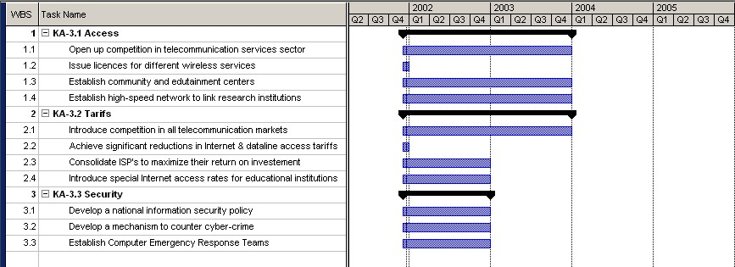

7. eLearning

The emergence of the Internet as a prime communication medium presents a significant opportunity for improving all aspects of the educational systems. The current education systems, which mainly depend on conventional instructor-led classroom teaching, are bound to witness major changes in the years to come similar to those seen in other important areas such as business, communication, media, and entertainment.

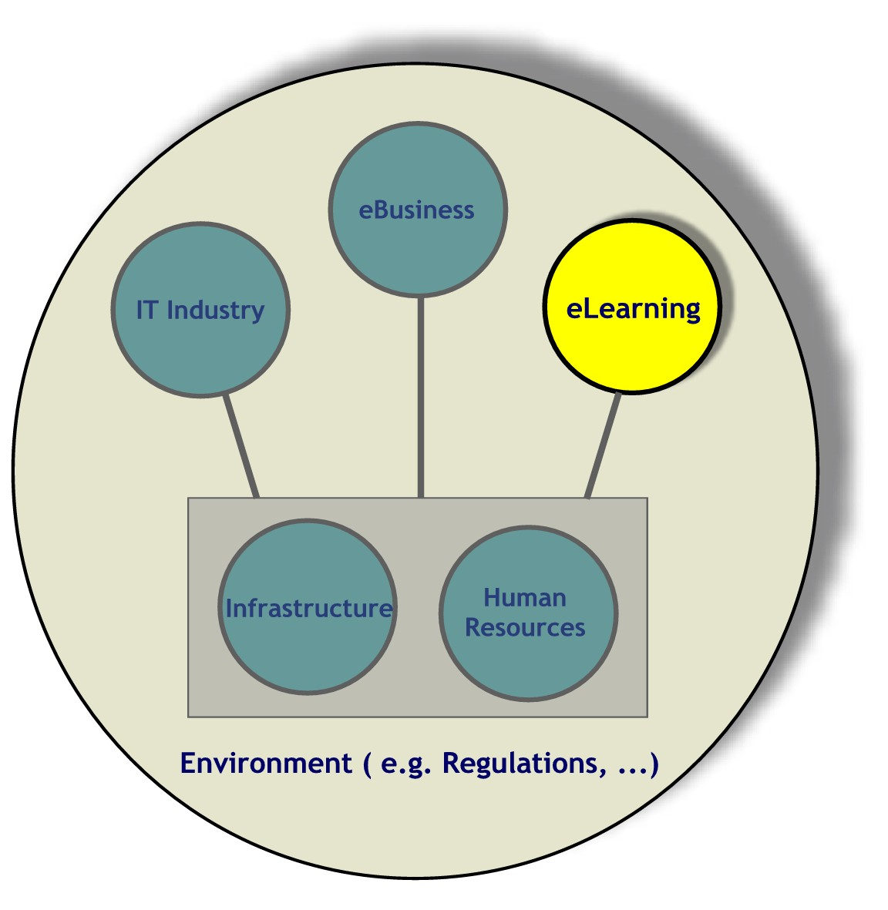
The ease of communication offered by the Internet can be utilized to empower people’s education at all levels. Such a technology will cause future education systems to be more learner-centered rather than instructor-based, and hence the term “eLearning” (rather than “eEducation”) has been widely adopted. eLearning refers to an electronically empowered learning system. The system uses technology-enabled delivery methods of study material to a community of learners who need not necessarily be in the same physical location. In general, eLearning is any form of learning that utilizes a computer network for delivery, interaction, or facilitation of the educational material. The term eLearning groups together education, training and structured information delivery using computer networks. The network could be the Internet, a school or college local area network (LAN), or even a corporate wide area network (WAN).

Depending on the level of education (e.g. university, high school, etc.,), an eLearning model suitable to that level of education is adopted. Three major models are commonly used. The first is the synchronous model where class is broadcast in real-time to the learners, where the instructor and the learners need not be located in the same geographical location. The second is the asynchronous model, where the educational material is posted on the web and learners can access it on demand at different times and from a distance. The third model uses the electronic course material posted on the web as supporting material to conventional class instruction. Variations of these eLearning models are also possible.

eLearning enhances the quality of student understanding through the use of a interactive and lively learning approach with multimedia, graphics, simulations, videos, etc. Compared to conventional Instructor-Led Classroom (ILC) education, eLearning resulted in about 30% greater learning in up to 40% less time. Furthermore, performance of computer-based training (CBT) learners on examinations was found to be higher by about 26% to 37% on the average. Likewise, long-term retention was also found to be an average of 15% higher for CBT.

Such results clearly show that eLearning can be used effectively at various school levels from Kindergarten to high school (K-12) as well as for university undergraduate and graduate level programs. Furthermore, eLearning is quite effective for lifelong learning or non-degree education, e.g. online seminars or scientific conferences.

eLearning has already been introduced in many other countries across the globe. Several countries or consortium of countries, have established a growing eLearning environment at various levels or have formulated plans for enhancing conventional education systems through eLearning.

First used in US schools, eLearning at the K-12 level is currently being adopted or tested in many parts of the world. Internet access in US public schools has increased from 35% in 1994 to 95% in 1999, while the connectivity of instructional rooms has increased from 3% to 63%. By fall 2000, almost all public schools in the United States had access to the Internet: 98% were connected. In the US alone, educational trends include home schooling, which has an annual growth of 15% ($1.3 billion market).

In Europe, the eEurope initiative has been launched to fully benefit from advances in IT for generations to come. Special attention is given to education where member states have committed themselves to put all schools online by 2002. A prime objective in the eEurope initiative is what they termed “European youth into the digital age” whose prime aim is to turn digital literacy into a basic competence for all young Europeans. The emphasis is on mastering the Internet and multimedia resources; using these new resources to learn and acquire new skills; and acquiring key skills such as collaborative working, creativity, adaptability, intercultural communication and problem-solving.

In China a fast-paced plan to provide eLearning to primary and secondary schools has been announced, which envisions providing broadband access networks interconnecting 800,000 Chinese schools.

Allover the world, higher education institutes have been pursuing eLearning more ambitiously. Quite a few institutions offer eLearning as a variant of distance learning, which is a preferred option for maximizing enrollment at a reasonable cost. Those institutions have carried out projects individually or collectively to realize eLearning by developing electronic course content and acquiring good connectivity to the Internet. In May, Beijing University launched a web-based education portal that will serve one million college students. Over 30 of Australia's leading higher education institutions are currently providing distance learning through Open Learning Australia program. In Canada, several universities are participating in a similar program through the Open Learning Agency. In UK, several universities are finalizing a program through Higher Education Funding Council for England (HEFCE) to establish a virtual university to electronically offer programs to students overseas. In the US a large number of universities started initiative to offer distance-learning opportunities on their own such as the university of Texas at Austin, while others are establishing consortiums of universities to offer joint programs such as California Virtual Campus, Connecticut State Universities, and Illinois Virtual Campus.
Higher education institutes have been pursuing eLearning more ambitiously. Quite few institutions adopt offering eLearning at distance, as distance learning is considered to be a preferred option for maximizing enrollment at a reasonable cost.

Need and Benefit to Saudi Arabia

The quality of K-12 education in Saudi Arabia needs major improvement. Remote areas suffer from lack of teachers in some subjects.

With over 50% of the Kingdom’s population under the age of 20 and one of the highest birth rates in the world, Saudi Arabian higher education institutions have been facing a growing demand for enrollment. The capacity growth rate of existing Saudi universities does not match the current growth rate in enrollment demand. This has resulted in overcrowded classrooms with a consequent reduction in the quality of learning. Even with such a compromise in quality, higher education institutes can accommodate only a fraction of high school graduates. Moreover, many students have to change their hometowns or drive long distance everyday in order to study at universities or colleges.

eLearning captures the attention of many governments and education institutions around the world for two major reasons. The first, it provides a very powerful model that enhances the quality of education by being centered around the learner and utilizing the computer for multimedia-rich course material. The second reason is that it provides an attractive solution of accommodating increasing demand for higher education. Those two reasons were in contradiction before the use of eLearning as a distance learning approach.

In the Saudi K-12 education, an ambitious project has been initiated under the auspices of HRH Prince Abdullah Bin Abdulaziz to build a national Schools’ network. This project, known as the Watani Project, announced in 2000 and aims to connect all Saudi Schools and Educational Directorate Districts by means of a wide area network covering the entire Kingdom of Saudi Arabia and local area networks within every educational directorate and school. The project has plans to establish a service portal to include all subjects’ curricula, educational references, electronic books, and other services for students. The proposed eLearning plan can help further crystallize and enhance objectives and goals projected in the Watani project as well as put it in the context of an overall countrywide IT plan.

The plan proposed here calls for initiating an effective eLearning system in Saudi Arabia at all levels to improve the quality of education, reach to students at a distance, increase the capacity of higher education institutions, and solve problems specific to girls’ education, students with special circumstances, and working professionals seeking higher education.

7.1 Roadmap of the eLearning Plan

The eLearning system has slightly different missions as far as the level of education is concerned. On the one hand, the mission of the K-12 eLearning system is to improve the population literacy level and provide a wider access to quality, cost-effective education to all population segments regardless of location or gender. On the other hand, the mission of the higher-education eLearning system is to improve quality, increase enrollment, and expand access to postsecondary educational opportunities by providing a means for individuals to learn, independent of time and place and to earn higher education degrees and other credentials that are credible to both academic institutions and employers.

With the implementation of the eLearning system, it is expected that Saudi Arabia will be in the forefront in providing easy access to affordable, high-quality, education that will give skills and knowledge through the use of technology to overcome barriers of time and distance.

Guided by the above-mentioned vision, the followings are the main goals of the eLearning plan:

- Enhance the quality of education while maintaining the same level of operational cost.
- Provide wider access to knowledge for students with special circumstances, e.g., girls, the handicapped, the gifted, and senior citizens.
- Promote new effective trends in education by making it substantially learner-centered at learner-pace.
- Enable universities to increase enrollment capacities in the most cost-effective way possible.
- Assert the regional technological/educational leadership of Saudi Arabia.

The abovementioned strategy and goals motivate the focus on the following key areas: (1) eLearning organization and management, (2) digital content, (3) content delivery, (4) eLearning infrastructure, (5) assessment and quality assurance, and (6) training & awareness.
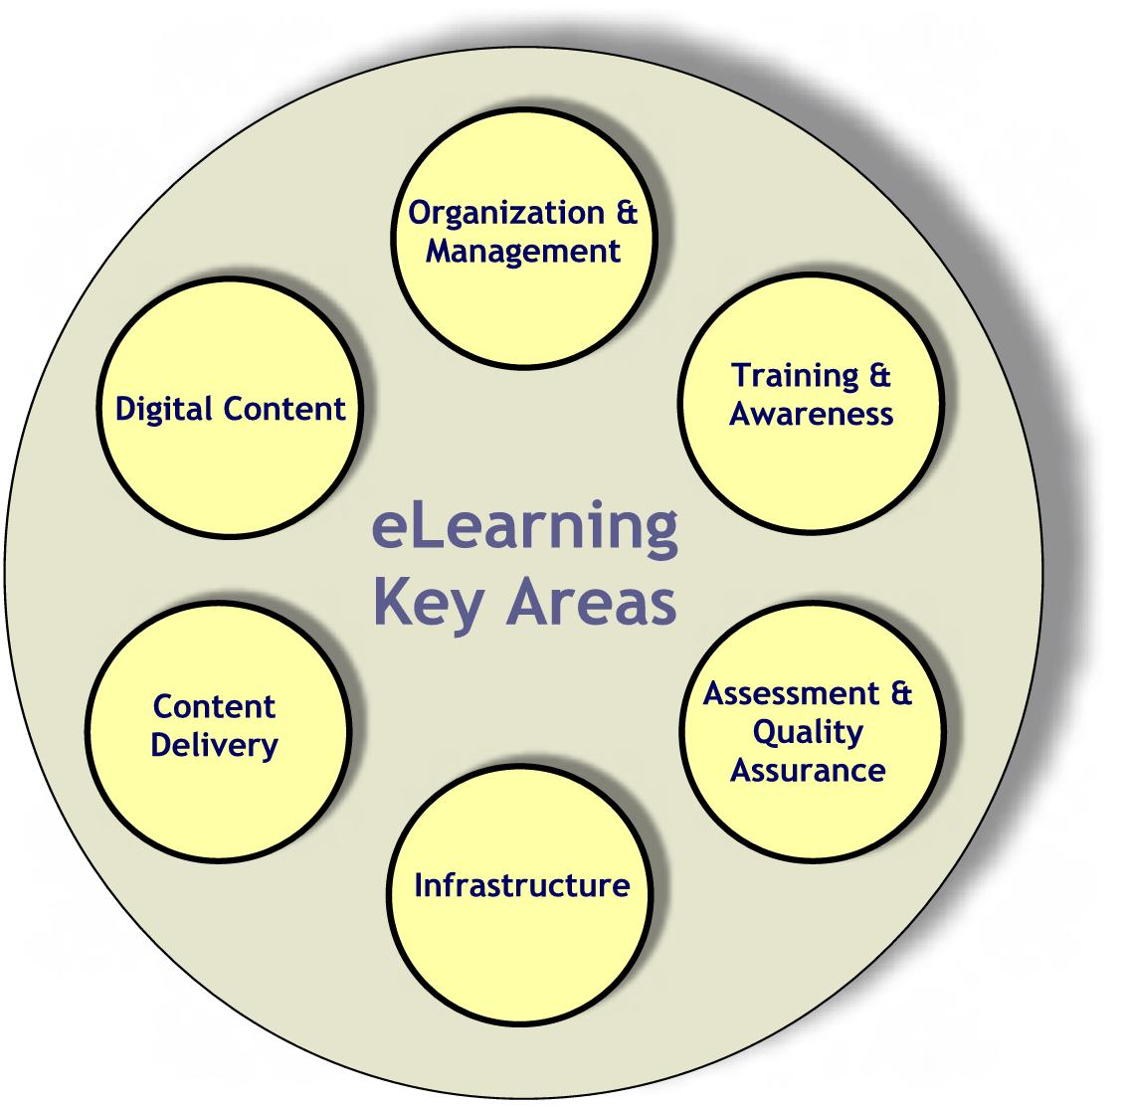
Each of the above key areas is discussed in details as follows

7.2 Key Areas and Initiatives for eLearning

KA-4.1 eLearning Organization and Management
To ensure a smooth transition from the current classical education system to the revolutionary technology-enabled education, an efficient organization and management scheme has to be in place. Two major initiatives are proposed for this key area:

Init.4.1.1: Setup the organization structure for eLearning in the Kingdom.
For the management and execution of the Kingdom-wide eLearning plan, the establishment of an NEB (National eLearning Board) is proposed. The NEB will report to ITC, which will coordinate eLearning initiatives with other IT initiatives. ITC will also ensure that NEB has the necessary authority and resources to successfully complete its tasks. The NEB is to promote, plan, and manage the eLearning systems at both levels: the K-12 and the higher education. These tasks are to be accomplished though two different entities discussed below: eLC and DECC.
The mission of the DECC is to increase awareness, expand access, assure quality, and improve cost-effectiveness of certificate and degree programs.

Within NEB, an eLearning Center (eLC) responsible for K-12 should be jointly formed through consultation with the Ministry of Education (MoE) and the General Presidency of Girls Education (GPGE). It should include representatives of all concerned organizations at various levels/types of education, e.g., elementary, intermediate, secondary, etc. eLC is an umbrella organization with four subordinate departments; an Electronic Content Development Department (eCDD), an Education Portal Department (EPD), an Information Technology Training Department (ITTD), and an eLearning Assessment Department (eAD). The role of eLC is to support digital content development, content delivery, training, and assessment.

As for the higher education, the NEB should have a Distance Education Coordinating Committee (DECC). The mission of the DECC should be to increase awareness, expand access, assure quality, and improve cost-effectiveness of certificate and degree programs. These distance education programs are offered by Saudi institutions of higher education through nationwide coordination of resources and services to competitively serve the needs of society. The DECC also deals with issues related to accreditation, common course catalogue, technology support systems, finances and expansion strategies. The DECC should have representatives of the higher education institutions participating in delivering distance education.

To maximize coordination of nation-wide resources and services, the costs of the development of distance education content should be shared among those universities delivering similar programs. Each of these universities then would use this content in delivering a given course or program. Electronic courses material are to be developed by individual participating universities in a coordinated manner, such that there is no course repetition, and all universities share one repository of electronic courses material. This coordinated nationwide online course/program delivery will require forming a Saudi Distance Education Consortium (SDEC) of well-established Saudi higher education institutions with support and guidance from the DECC of the NEB.

Responsible Body: Council of Ministers based on recommendation by ITC

Init.AT-4.1.2: Define and adopt a comprehensive set of policies and regulations for eLearning.
Necessary policies and regulations related to system security, user access privileges, legal and ethical code of using the technology, etc., should be formulated. It is also of great importance to propose legislations concerning copyright protection of authored digital content and criteria for accrediting and recognizing degrees obtained through an eLearning program.

Since eLearning at the higher education level is expected to be offered as a distance learning option, the set of policies and regulations should include the principles of good practice. These principles should be developed as a minimum standard for campuses serving students through distance education. The principles should include statements on curriculum, instruction, institutional commitment, evaluation, and assessment. These principles are meant to ensure that appropriate technical support, learning resources and student services are available. The policies and regulations should also ensure that distance learners are able to remotely conduct administrative and academic activities similar to regular university students. Examples of such activities are admission, registration, academic counseling and advising, and acquisition of text, related books, and learning resources for registered courses.

It is expected to have slight differences between the policies and regulations applicable to the K-12 level and those applicable to the higher education level. As for the K-12 eLearning system, the team responsible for formulating the policies and regulations is expected to include legal experts, child psychologists and representatives of MoHE, MoE, NEB, GPGE, school administrators, school teachers, the national portal site director, the eLC director, etc. As for higher education, the team should have representatives of the participating universities, MoHE, MoE, and NEB.

Responsible Body: National Education Board (NEB)

KA-4.2 Digital Content
This key area is concerned with the development of effective educational electronic course material and references. It is also concerned with the selection, design and implementation of electronic course materials. Digital content is the multimedia-rich material that encourages students to seek and manipulate information in a collaborative, creative, and engaging ways that make eLearning possible. It includes video on demand, CD-ROMs, web sites, email, online eLearning management systems, computer simulations, streamed discussions, data files, databases, and audio. Not only should content of all student courses be developed, but also a well designed digital library should be prepared with other supporting digital reference material, e.g. eBooks, eMagazines, eJournals, etc. Digital content should be developed according to a set of well thought-of standards and regulations for digital content authoring, using state-of-the-art course content development software. Training should be provided to prospective digital content authors. Course content should be updated regularly. The initiatives proposed for this key area are:

Init.AT-4.2.1: Develop digital content for all subjects.
Digital content for subjects in K-12 curricula must be developed by the end of 2005. For higher education, it is recommended that the Saudi Distance Education Consortium starts offering complete programs in selected areas by the end of 2004.

Responsible Body: National Education Board (NEB)

Init.AT-4.2.2: Develop a national digital library of e-Reference material.
This work is an ongoing process that should be conducted in parallel with upgrading of the digital content material based on the feedback received from the eLearning assessment process.

Responsible Body: National Education Board (NEB)

KA-4.3 Content Delivery
The content delivery method depends upon the adopted eLearning model. Digital content may be delivered by the instructor as a supporting material in a conventional instructor-led class. In this case, the instructor explains the lesson with the help of multimedia and other technology tools. Basic course information is distributed via the web including a class web page, syllabus, assignments, solutions, review material, etc. Alternatively, content may be delivered asynchronously, with possible student-instructor interaction through email and/or web-based teleconferencing. In the asynchronous delivery systems, a student can access the course website and may receive the lectures, notes, and other supporting material on-line in an “interactive” way. Content delivery can also be synchronous, where lectures are delivered in real-time through interactive technologies to an audience, which may not necessarily be in the same geographical location.

For K-12, we propose to use the digital content (available on an educational portal) to support conventional classroom instruction. The instructor in this model provides the students with supplementary electronic/multimedia learning material through the Internet. Classrooms should, accordingly, be equipped with sufficient number of Internet-connected PCs in addition to projection equipment. For students to get the full benefits of this learning model, not only should the digital instructional material be made accessible to them at school, but it should be accessible at home or any other location at an affordable cost.

For higher education, the emphasis is on distance learning. Accordingly, the asynchronous model is the best candidate. In general, distance learning can follow three distinct approaches:

Self-paced: Asynchronous, individual learning, where students are not expected to proceed through the course with a group. There is no semester concept, so students can begin a course of study any month of the year; this system is referred to as ‘rolling enrollment’.
Term-based: Classes with fixed beginning and end dates, usually taken with a group. Each online class is primarily a group forum of students who will progress through the program together, and where students put their work and ideas before classmates for comment. Private communication between individual students is also possible. Each group is assigned a student advisor and a full-time faculty member who acts as an academic mentor.
Short-Training: Classes completed in one week or less with fixed beginning and end dates or self-paced. The self-paced model is used for topic-on-demand non-credit courses.

In all of these forms, students may have access to a tutor assigned to them for inquiries and assistance. Face-to-face tutorials may also be organized through a network of regional study centers. Students may also participate in interactive seminars and regular chat line discussions of relevant topics.

The initiatives proposed for this key area are:

Init.4.3.1: Establish national Education Portals.
Two centralized portal sites: one for K-12 and another for higher education are needed. These sites are needed to serve as a gateway for various educational levels materials. All electronic content material should be accessible through this portal. Work on portal development should start by the end of the second quarter of the first year. It should attain its final form by the end of the year 2005. This education portal should be made publicly accessible. Other portals, specific to instructors, should also be developed. Such portals should include subject support material, e.g. solutions to exercises and exams, instructor guide, instructors frequently asked questions, technical help, etc. Creative financing can be employed through allowing some private sector advertisements to appear on the portals.
The ratio of Internet-connected PCs to students in all public schools should be improved to 1 to 5 by the year 2010. This improves the digital literacy of students and instructors as well as helps integrate technology into classrooms and laboratories.

Responsible Body: National Education Board (NEB)

Init.4.3.2: Improve the ratio of Internet-connected PCs to students in all public schools.
The ratio of Internet-connected PCs to students in all public schools should be improved to 1 to 5 by the year 2010. This improves the digital literacy of students and instructors as well as helps integrate technology into classrooms and laboratories. This initiative is government funded and supervised by the NEB.

Responsible Body: National Education Board (NEB)

Init.AT-4.3.3: Devise a cost-effective scheme to fund/support student/instructor acquisition of educational technology.
A cost-effective scheme should be devised to fund/support student/instructor acquisition of educational technology. Financing of such a scheme may require promoting new creative models of purchasing or leasing. This scheme should also address possible means for financing/subsidizing of private school Internet connectivity cost. This initiative should also exploit new inexpensive technologies to expand access at lower costs. These technologies include handheld devices, such as personal digital assistants (PDAs) and graphic calculators, as well as devices that make it easier to connect to the Internet, such as through TV sets or other Internet appliances. The responsibility of this initiative lies with NEB and is government funded.
A cost-effective scheme should be devised to fund/support student/instructor acquisition of educational technology. Financing of such a scheme may require promoting new creative models of purchasing or leasing.

Responsible Body: National Education Board (NEB)

Init.AT-4.3.3: Provide affordable Internet access for all.
Provide affordable, easy and high speed Internet access to all by the year 2005. In this proposed tariff model, a person is only charged for the price of the phone line connection, but no fees are paid to Internet Service Providers (ISPs). Several countries, e.g. Egypt and India, are currently adopting such an Internet access model. Creative financing may also be used to fund such an initiative, e.g. by allowing certain business advertisements (TV model).

Responsible Body: Please refer to the IT Infrastructure plan (Section 6).

KA-4.4 eLearning Infrastructure
A strong infrastructure needs to be established to provide efficient and effective access to education material and services.
Keeping in mind the interactive and multimedia-rich content of most courses, a strong infrastructure needs to be established to provide efficient and effective access to education material and services. The initiatives proposed for this key area are:

Init.4.4.1: Establish high performance national backbone network and powerful servers for hosting educational portals.
Establish a high performance national backbone network and powerful servers for hosting education portals and install powerful servers to host the national education portal and its mirror sites.

Responsible Body: Please refer to the IT Infrastructure plan (Section 6).

Init.4.4.2: Provide Internet connectivity to all schools and higher education institutions.

Connect all public schools to the Internet by the year 2010 through at least an E1 connection of 2Mbps per school. Provide an Internet2 connection to higher education institutions to meet the bandwidth demand. NEB will be responsible for executing this initiative and the government should provide the needed funds.

Responsible Body: National Education Board (NEB)

KA-4.5 Assessment and Quality Assurance
As a new paradigm, all aspects and products of the eLearning system need to be assessed and should be assured to be of high quality. This includes assessment and quality assurance of the digital content material, the portal service, the effectiveness of the delivery method, and the infrastructure performance. This is in addition to assessment and monitoring of learners’ progress and their level of achievement in a manner that is effective and consistent with the adopted content delivery technique and underlying infrastructure.

Pilot projects, in selected schools and a university, should be launched for the purpose of collecting some initial assessment results. Such results of the assessment should be, then, utilized by all parties involved to further strengthen the gains of eLearning and overcome or minimize its shortcomings. The assessment strategy should compare performance of students in pilot schools/university to that of students in other schools/university.
An effective assessment model for the eLearning system and a mechanism for applying this model must be devised. Lessons learned from pilot experiments should be used to revise or adapt the overall eLearning plan.

Assessment is a continuous process for quality assurance of the education process. The initiatives proposed for this key area are:

Init.4.5.1: Devise an effective assessment and quality assurance model for eLearning and a mechanism for applying this model.
An effective assessment model for the eLearning system and a mechanism for applying this model must be devised. Lessons learned from pilot experiments should be used to revise or adapt the overall eLearning plan.

The assessment model should identify the areas to be assessed in the system, the ways the assessment process to be conducted, the mechanism of applying the assessment procedure, ways to identify the points of strengths and weaknesses and methods to feedback such information into the system to further strengthen the strong aspects as well as correct or avoid any negative aspects of that system. Most aspects of eLearning may be evaluated through student assessment, instructor assessment and administrator assessment.

One of the most important considerations in deploying the distance learning system is to assure students and academic community, as well as employers that all courses and programs offered over the Internet system are of high quality. Similarly, for K-12, parents and higher educational institutions should also be assured of the same. Standards have to be developed for all programs with quality assurance mechanisms to ensure adherence.

Responsible Body: National Education Board (NEB)

Init.4.5.2: Launch Pilot Projects.

With over 22,000 public schools in the country, the transition process has to be undertaken in a gradual well-controlled manner. This calls for a pilot eLearning plan to be devised and implemented in at least 40 candidate boys and girls schools with proper milestones to assess the implementation process and modify the overall plan as dictated by such assessment before the full launching of the eLearning system. The schools should be selected based on some criteria, e.g., geographical location, student population, and different level schools (elementary, intermediate, or secondary), etc.

Similarly, as an initial step towards effective, efficient, and high quality distance learning, it is recommended to start offering electronic courses and distance programs through a single well-established university. This selected university should be supported to transform its operations utilizing the potential of IT.

The NEB should, through a special Task Force, devise and supervise a pilot eLearning plan at K-12 as well as higher education.

Responsible Body: National Education Board (NEB)

KA-4.6 Training & Awareness
Instructors and administrators are essential key players for the success of an eLearning system. Training for both is essential for effective integration of technology into classroom education. The initiatives proposed for this key area are:

Init.4.6.1: Provide training to instructors and administrators.
Train all K-12 instructors and school administrators by the end of 2010. A responsible party for such training should be established. This party should establish a long-term technology training plan and proficiency standards for all instructors and administrators. Funds required for the training are government provided. The plan should help instructors & administrators integrate technology into classrooms and school administration by the end of 2010, and should start by training instructors of the selected pilot schools. There should be training workshops. Instructors should be provided with tools, incentives, and on-going professional development to technology integration into classrooms. Online technical and instructional support should also be available over the Internet
For effective K-12 eLearning, modify curricula of colleges of education to include eLearning and IT proficiency skills by the end of 2005.

For higher education, faculty and students should be provided with training on the effective use of eLearning tools.

Responsible Body: National Education Board (NEB)

Init.4.6.2: Introduce eLearning and IT skills in teachers training colleges and colleges of education.
For effective K-12 eLearning, modify curricula of colleges of education to include eLearning and IT proficiency skills by the end of 2005. New instructor and administrator licensure and certification programs should require proficiency in integrating technology into the curriculum. Hiring standards for instructors and administrators should include technology integration proficiency as a desirable skill, and it should be made mandatory by the end of 2010.

Responsible Body: National Education Board (NEB)

Init.4.6.3: Launch an eLearning awareness campaign.
Launch an eLearning awareness campaign to promote eLearning advantages and effects on enhancing the future of the country economically, technically, etc. The campaign should alleviate typical social resistance to and fear of change particularly among school instructors and administrators. The campaign should be the concerted responsibility of both NEB and the Ministry of Information. Such campaign should be government funded.

Responsible Bodies: National Education Board (NEB) and Ministry of Information (MoInfo).

7.3 Management of eLearning

Table 9 summarizes the eLearning key areas and their initiatives for eLearning. Figure 11 shows a Gantt chart detailing an eLearning plan schedule for Saudi Arabia.

Table 9: Key Areas and Initiatives for eLearning.
Key Area | Initiatives | Implementation Responsibility | Time Frame | Source of Funding
KA-4.1  Organization & Management | Setup the organization structure for eLearning in the Kingdom. | Council of Ministers based on recommendation by ITC | By the 1st quarter of 2002 | Government
KA-4.1  Organization & Management | Define and adopt a comprehensive set of policies and regulations for eLearning. | NEB | By the 2nd quarter of 2003 | Government
KA-4.2  Digital Content | Develop digital contents for all subjects. | NEB | By the end of 2005 | Government
KA-4.2  Digital Content | Establish a national digital library with e-Reference material. | NEB | From 2006- End of 2010 | Government
KA-4.3  Content Delivery | Establish national Education Portals. | NEB | By the end of 2005 | G-P Partnership
KA-4.3  Content Delivery | Improve the ratio of Internet-connected PCs to students in all public schools. | NEB | By the end of 2010 | Government
KA-4.3  Content Delivery | Devise a cost-effective scheme to fund/support student/instructor acquisition of educational technology. | NEB | By the end of 2005 | Government
KA-4.3  Content Delivery | Provide affordable Internet access to all. | Refer to the IT Infrastructure Section of this Plan
KA-4.4  eLearning Infrastructure | Establish high performance national backbone network and powerful servers for hosting education portals. | Refer to the IT Infrastructure Section of this Plan
KA-4.4  eLearning Infrastructure | Provide Internet connectivity to all schools and higher education institutions. | NEB | By end of 2010 | G-P Partnership
KA-4.5  Assessment and Quality Assurance | Devise an effective assessment and quality assurance model for eLearning and a mechanism for applying this model. | NEB | By mid of 2005 | Government
KA-4.5  Assessment and Quality Assurance | Launch Pilot Projects. | NEB | By mid of 2002 | Government
KA-4.6  Training & Awareness | Provide training to instructors and administrators. | NEB | By end of 2010 | Government
KA-4.6  Training & Awareness | Introduce eLearning and IT skills in teachers training colleges & colleges of education. | NEB | By end of 2005 | Government
KA-4.6  Training & Awareness | Launch an eLearning awareness campaign. | NEB & MoInfo | By end of 2003 | Government

Figure 11: Gantt chart of Key Areas and Initiatives for eLearning

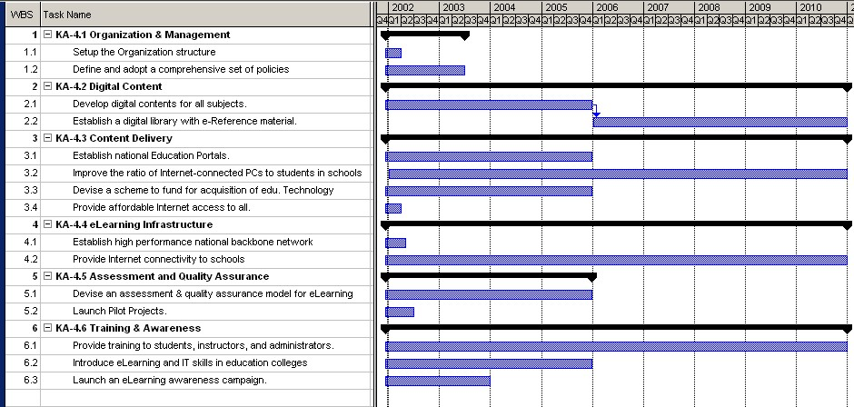

8. IT Human Resources Development

The world has entered into the twenty-first century with IT apparently prevailing in every aspect of life. It is expected that the success or failure of a society in the global context will mainly depend upon its ability to adapt to the new IT-bound competition standards. IT workforce, a vital component for the information era, poses serious challenges for the nations. Almost all countries of the world (developed as well as developing) are experiencing shortages in IT workforce. Only effective planning can help to meet the global challenge.
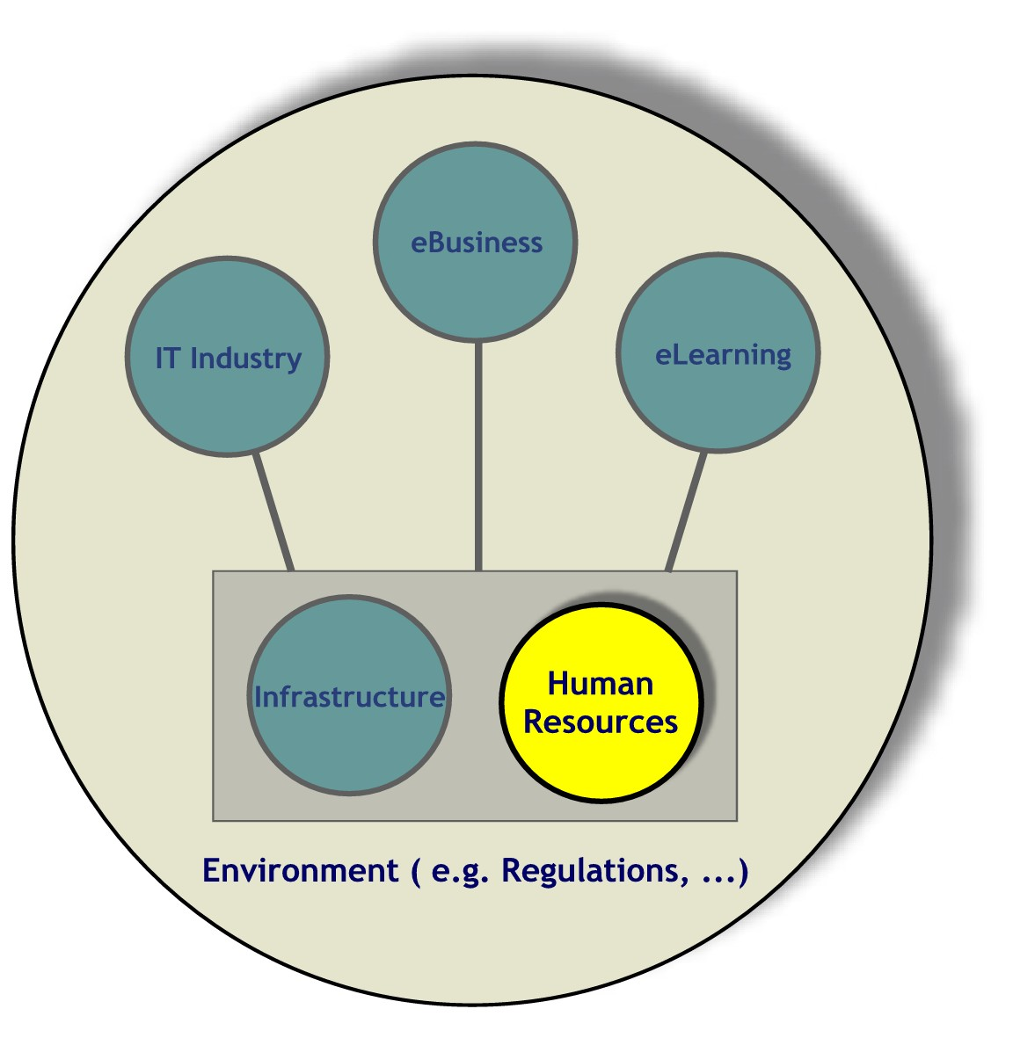
The history of IT, which is concentrated in the second half of the twentieth century, is short for an industry’s growth but large enough to witness the rapid changes in the development of the technology and its related occupations and skills. Many occupations like computer operators and data-entry workers grew and then declined. Ultimately some became obsolete due to the advances in the ease and extent of use of computers. New job titles like network administrator, or Webmaster emerged with the advances in the computer communications and the worldwide web.
A well-thought planning process and commitment are the most needed ingredients to develop and retain a reasonable level of IT workforce in the Kingdom.
In North America, the shortage of qualified IT workers is a matter of considerable concern. The Information Technology Association of America found that nearly 10% of IT positions in the USA were unfilled in the year 1998. Canadian researchers also reported a shortage of 20,000 IT professionals in 1998, which is expected to grow to nearly half a million by 2010.

The tight IT labor market is not unique to North America. A recent study by Microsoft Corporation found that Western Europe has a current shortage of 850,000 IT sector jobs with the shortage expected to grow to 1.7 million by 2003. Germany alone is reported to have a shortage of between 75,000 to 80,000 IT professionals and other European Union countries report shortages of varying severity.
With highly skilled and technically well-trained workforce, Saudi Arabia can become an IT-producing country rather than a consuming one.

The success of a nation today will highly depend upon the education, training, productivity, and competitiveness of its IT workforce. A well-thought planning process and commitment are the most needed ingredients to develop and retain a reasonable level of IT workforce in the Kingdom. The importance of human resources in the development of the Kingdom is very much reflected in the national development plans. There has been a steady increase in the share of expenditure on human resources development in the previous five consecutive national development plans: SR 115 Billion (18.4%) of the total expenditure in the third plan, SR 115.1 Billion (33%) during the fourth plan, SR 164.6 Billion (33%) during the fifth plan, SR 222.2 Billion (53.8%) in the sixth plan, and currently it is SR 276.9 Billion (56.7%) in the seventh development plan. This reflects the unique position given to human resources development among the themes of the Seventh Development Plan. With highly skilled and technically well-trained workforce, Saudi Arabia can become an IT-producing country rather than a consuming one. This will help diversify as well as improve the national income of the Kingdom and achieve regional leadership in IT.

Various studies pertaining to the status of IT workforce in the Kingdom have been carried out since late eighties. The most noticeable activity was a forum conducted in March 1989 under the title “Enhancing the Efficiency of Computer Applications in the Governmental Entities”. The Ministry of Finance organized the forum. The basic findings of that forum indicated the following:

The most essential problem is the absence of coordination among entities and the lack of a national computing strategy.

The second problem is the human resources availability, employment vacancies and the low level of computer training.

The third problem is the rigid technical and financial government procedures.

Similar findings are also documented in the proceedings of the National Computer Conferences (NCC), most notably the 12th NCC. A prominent study in this regard is the one carried out as a research project funded by the King Abdulaziz City for Science and Technology to study the assimilation of Information Technology (IT) in the Saudi government sector. The study indicated the shortage of IT human resources and the alarming low level of computer training at the time of the study. As part of our effort to assess the current IT human resources status, a similar survey has been conducted during the development of this plan. The survey clearly reveals the severity of the human resources issue in the IT public sector of the Kingdom. The IT human resources issue maintains its status as the most challenging factor in the surveyed organizations. None of the interviewed IT managers considered the level of their IT human resources capabilities and skills (quality & quantity) to be sufficient. In fact 42% of interviewed IT managers considered the level of their IT human resources far below the minimal required. Although the level of IT training has improved slightly in 2001, more work needs to be done to reach acceptable levels of IT training. The latest survey is in agreement with the 1994 study on the need to adopt a national IT human resources development strategy that coordinates national IT programs and directs Saudi education institutions to satisfy IT human resources requirements.
Keeping in view the global as well as the local situation of IT workforce, we believe that it is imperative to develop a strategy for the human resources in the national IT plan. We also believe that the human resources strategy should envision and enable an IT conscious society in Saudi Arabia.

Keeping in view the global as well as the local status of the IT workforce, it is imperative to develop a strategy for human resources in the national IT plan. The human resources strategy should envision and enable an IT conscious society in Saudi Arabia. The strategy should aim at raising the IT awareness level of the people to one that enables them to use IT vigorously in all aspects of life. It is a silent assumption for the information age that the public in general will be able to use IT pervasively for all their needs in the society. Definitely the success of various IT sectors like IT industry, eCommerce, eGovernment, and eLearning, will depend heavily on the use of IT by the general public. We believe that the initiatives of this IT plan will promote the use of IT in the Saudi society-at-large.

8.1 Road Map of the IT Human Resources Plan

Saudi IT human resources strategy aspires to have self-sufficiency and self-reliance in a well-qualified, well-trained, and competent IT workforce for all IT needs of the Kingdom. To achieve the set forth vision, the approach of the plan is to classify the society into various categories based on the needed levels of knowledge for various roles to be played by the individuals in the information age. The classification also aims at identifying the key areas to launch various initiatives in an attempt to provide opportunities to the society-at-large to acquire the required levels of knowledge to become an information society.
The classification presented here is meant to illustrate the wide spectrum of IT deployment in the society and help in developing a well focused IT plan addressing the whole spectrum of the society. The IT workforce constitutes a subset of the whole IT society.

IT Providers: This class of individuals contains all people related to providing IT from software to hardware. These individuals work closely with IT and they are targeted towards engineering tasks to provide technologies, software, and services to the user groups. This class can further be divided into three subclasses: providers of software solutions, providers of hardware solutions, and providers of special services.

IT Users: This category contains most of the individuals that will be directly or indirectly using IT. They can be further subdivided into public service providers, special interest users, and general interest users.

IT Experts: Expertise in different disciplines is required to fill the gap between providers and users. This expertise falls into two categories: IT-direct expertise and IT-indirect expertise. In IT-direct expertise, experts on subjects such as capacity planning and training are needed to work closely with the technologies and to function as a point of reference and consultations whenever needed. IT-indirect expertise is needed for legal as well as regulatory matters and to serve as a mediator between the existing logistics and regulations and those which need to be implemented when IT is put in place.

The following are the main goals of the IT Human Resources Development plan:
Double the number of IT graduates and diploma holders by the year 2005.
Increase the number of government employees with IT skills to 50% of the total by the year 2005.
Achieve IT literacy at high school level by the year 2005.

To attain these goals, the three key areas for human resources development plan have been identified. They are:

- Education
- Training
- IT HRD Supportive Environment

Each key area and the initiatives to achieve the vision for IT human resources in the Kingdom are discussed in the following paragraphs.

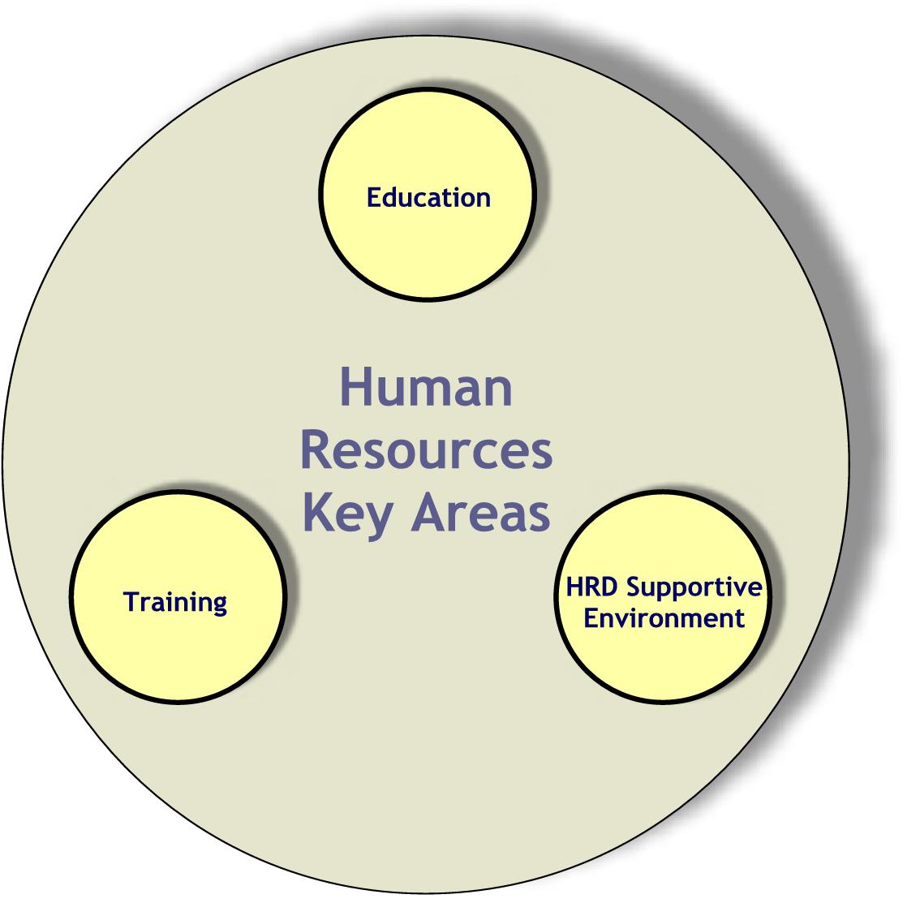
8.2 Key Areas for IT Human Resources Development

KA-5.1 Education
In its effort to catch up with the advances taking place in IT, the Kingdom of Saudi Arabia should spare no effort to encourage and prepare young people to endorse IT education and careers. This should include exhibiting an appropriate image of IT technical profession; providing attractive and accurate information about IT technical work to young students and their parents; and strengthening the Math, Science, and English language education for K-12 students.
A major shift in the underlying objectives of the pre-university education in Saudi schools has to occur in which creative thinking and innovations become a major thrust in the educational process. Two major challenges to the Saudi pre-university education systems are therefore identified. The first challenge is to graduate students with solid foundation and fluency in Math, Sciences, and the English language. The second major challenge is instilling students with the ability for creative thinking and innovation. Success in meeting these two challenges is inevitable in the sequel of providing young Saudi students with adequate means to make informed decisions about future careers in IT.
The Kingdom of Saudi Arabia should spare no effort to encourage and prepare young people to endorse IT education and careers.

Alongside with appropriate education, a concerted effort and media campaign are needed in order to provide Saudi students, and their parents, with appropriate exposure to the wide variety of careers and people in the IT professions. It is also very important to provide Saudi females with opportunity to pursue technical IT roles, as scientists and technologists. A joint national campaign involving the government and the private sector is needed in supporting and developing national information and advertising programs to communicate the portfolio of skills needed to thrive in the new world economy.
Two major challenges to the Saudi pre-university education systems are therefore identified. The first challenge is to graduate students with solid foundation and fluency in Math, Sciences, and the English language. The second major challenge is graduating students with instilled ability of creative thinking and innovation.

It is recognized worldwide that majority of young students form opinions about careers before they graduate from high school. Middle school can therefore be a key decision making point in their educational life. The prime time to influence students’ opinions about their future career is in the seventh to the ninth grade. It is important to provide students at that age with information about the wide range of interesting and rewarding IT technology careers together with the education and skills needed to pursue them. It is essential to make IT an integral part of the Saudi educational system. The following initiatives are suggested in order to help Saudi students acquire a leading edge in IT. These initiatives address the whole spectrum of the education system and can be launched in the form of various programs. Some of the programs are directed towards K-12 education, some for technical and vocational education, and others for university education. The main objective of the initiatives is to develop a solid base for the IT-society through K-12 education, graduate competent IT providers through various college level programs, and produce high quality experts through training programs.
It is essential to make IT an integral part of the Saudi educational system.

Init.5.1.1: Introduce/Update computer and IT related programs at the K-12 education system.

A program to introduce IT technology in teaching specific high school subjects is proposed. This program is meant to help students comprehend difficult subjects such as Math and Science via non-conventional means. It is also meant to introduce students to IT technology. Another program to introduce IT specialized subjects in schools is also proposed. It should help students to get acquainted with IT and its applications.

A special IT-specific program for gifted young male and female students should also be instituted. This special program is directed towards identifying gifted Saudi students and to prepare them to pursue IT careers. An annual nation-wide competition in “Creative Projects in IT” for high school students is an example element in this program.

Responsible Bodies: Ministry of Education (MoE), General Presidency of Girls Education (GPGE) and General Establishment of Technical Education and Vocational Training (GETE&VT).

Init-5.1.2: Introduce/Update IT programs at the post-secondary school education level, and increase the capacity of existing institutions.

In order to increase and broaden the IT technical profession base with highly skilled IT professionals, the following programs are proposed.

Introduce new IT diploma and associate degree programs and enhance the current ones.
Introduce IT technology in current undergraduate level university programs.
Introduce new BS degree programs in different IT fields and enhance the current ones.
Introduce new Master programs in different IT specializations and enhance the current ones.
Introduce post-graduate, one-year diploma IT programs coordinated with international IT training leaders.
Establish new IT specialized technical institutes and community colleges.
Establish Information Technology Colleges at universities.

It should be emphasized that community/technical colleges could play an important role in extending and enriching the IT workforce. It is generally expected that community/technical colleges can respond more quickly to the rapid changes taking place in the IT markets as compared to universities.
It is conceivable to establish a professional entity in the Kingdom to oversee the issues of model curricula and accreditation.
It is crucial to have model curricula and accreditation systems in order to guarantee the quality and the standard of the formal IT education. Some internationally recognized professional societies such the Association of Computing Machinery (ACM) and the Institute of Electronics and Electrical Engineers (IEEE) have track record in the area of model curricula. Also the Computer Science Accreditation Board (CSAB) and the Accreditation Board for Engineering and Technology (ABET) have track record in IT programs accreditation. It is conceivable to establish a professional entity in the Kingdom to oversee the issues of model curricula and accreditation.

It is interesting to observe that a major objective of the current Seventh National Development Plan of the Kingdom emphasized the issue of producing young people who are not only well versed in using up-to-date technology but are also creative in applying such technology. The proposed educational programs are in harmony with the seventh national plan of the Kingdom. On the same issue of creativity and innovation, it is worth mentioning that organizations such as that of “King Abdulaziz and his companions’ foundation for the gifted students” and national programs such as that of “Watani” have been established with the intent of identifying gifted students and helping them to flourish and innovate.
In order to accommodate program updates and larger enrollments, capacity, resources and funding of the existing institutes need to be increased.

In order to accommodate program updates and larger enrollments, capacity, resources and funding of the existing institutes need to be increased.

A section of this plan on eLearning (Section 7) spells the key areas and initiatives that are necessary for developing digital content and content delivery in K-12 and university education.

Responsible Bodies: Ministry of Higher Education (MoHE), General Presidency of Girls Education (GPGE) and General Establishment of Technical Education and Vocational Training (GETE&VT).

KA-5.2 Training
IT training refers to any activity aimed at improving the performance of the IT worker or preparing an individual to join the IT workforce. Training can be formal or informal. Formal training requires attending specialized training programs while informal training can be just learning by doing under the supervision of an expert. In either form, training is oriented toward acquiring new skills. Due to the nature of IT and the pace at which advances are taking place, IT workers must continually learn and update their skills, as technology changes every day.

It is observed in the Middle Eastern culture (Saudi employers are no exception) that employers do not pay much attention to training. Employers give priority to an employee who has a combination of formal education, formal training, and work experience relevant to the job he is hired for. The principle of hire-and-train seems to be totally neglected in our work culture. With the growing need of IT workers and given the observed shortage of IT workers in the job market, a change has to take place. IT training has to be looked at as an integral part of the hiring process. Training provides mutual benefits for both the employers and the workers. It enables employers to have alternatives in hiring new workers, thus relieving the tightness in the IT labor market. It increases both the efficiency of the workers as well as their loyalty. Through training, workers on the other hand, can stay current in their skills. The anticipated problem is that well-trained IT workers will always be in demand and therefore are expected to leave their work place. This point may discourage employers from providing support for ongoing training. It is recommended that workers share the responsibility of training by committing themselves for a minimum period of time to their companies and/or by being willing to spend some of their own time on training efforts.
Training is a shared responsibility among the government, the private sector, and individual workers.

Before introducing the initiatives for training Saudi IT workforce, it should be stressed that training is a shared responsibility among the government, the private sector, and individual workers. The government cannot and should not be solely responsible for the nation-wide training programs. We see the responsibility of the government in training its employees. However, the individual workers have responsibility for maintaining their IT skills up-to-date in the face of the rapidly changing technology. Individual IT workers should be keen enough to negotiate release time for training and professional development whenever possible with their employers. Government policymakers and managers should be ready to allow employees to have such release time for professional development. A reward system should be developed that would encourage individual employees to take advantage of any skill development programs. Individual IT workers should also be keen to participate in professional societies and tap the skill development programs usually offered by such societies. The private sector should contribute financially to the establishment of the proposed high-tech community centers.
The government is to provide land and help the private sector to establish specialized training, edutainment, and community centers in a number of communities in the Kingdom.

In view of the vital role played by training in IT assimilation, the following initiatives are proposed:
Init-5.2.1: Establish edutainment and IT Community centers in major cities.

Community technology centers are places, which are available for the public to get access to computers and computer-related technology, such as the Internet to achieve their own personal goals and objectives. These centers are an integral part of the communities they serve. For technologies such as IT and multimedia, such centers can serve as edutainment centers too. These technologies are easy to pick up and master, as they are designed with the objective of being easier for users to learn and use .

The major difference between commercial leisure time programs and technology centers is in the relationship they assume between education and entertainment. With little cleverness one can create an experience that is completely educational and entertaining.

The government is to provide land in prime locations and help the private sector to establish specialized training, edutainment, and community centers in a number of communities in the Kingdom. In these centers, financed and operated by the private sector, not only can young males and females receive training at a reasonable cost, but also other citizens can benefit from the advantages of access and entertainment. This self-financing endeavor will not only help meet some of the training needs of the Kingdom but will also enrich the IT industry.
In these centers, financed and operated by the private sector, not only can young males and females receive training at a reasonable cost, but also other citizens can benefit from the advantages of access and entertainment.

Responsible Body: Ministry of Municipality and Rural Affairs (MoM&RA).

Init-5.2.2: Deploy training programs for government employees.
These training programs should improve the public service sector by having trained employees to use IT in their profession. They should also help retain the trust of the public in the government information systems. The following means and requirements are suggested for providing these programs.

- Establish specialized government training centers in different government units. These units should be responsible for holding regular training sessions to government employees to develop and/or improve their skills in using IT in providing public service.

- Sign collaborative training agreements with qualified training houses with contribution from the private sector.

Responsible Bodies: All Government Organizations.

Init-5.2.3: Deploy coordinated training programs through certification with internationally reputed companies.

Industry certification is a rapidly growing verifier of skills for IT worker around the globe. An estimated 2.4 Million certificates had been awarded worldwide to about 1.6 million individuals. In its general form, industry certification requires certain level of experience in addition to successful completion of a number of examinations. Large IT companies such as Microsoft, Cisco, Oracle, and Sun Microsystems award the most widely organized and acceptable certification programs. Certification holders from such highly reputable companies receive extensive training as well. Certifying organizations offer a series of certificates for those individuals who can attain progressive advanced skills. The apparent advantage of such certified professionals is that employers can hire them with a certain level of assurance of minimal competency. Industry training certification programs are becoming popular around the world and in nearby countries. For example, it was recently announced that Microsoft in alliance with an Egyptian IT company called “Raya” have established the first training academy in Egypt to grant IT certificates and training programs to individuals joining the IT workforce in a number of areas such as Information Management, and IT skill development. It is highly recommended that IT policymakers in Saudi Arabia should vigorously seek alliance programs with highly reputable companies through which nation-wide certificate based training programs are deployed in the Kingdom. It is anticipated that such alliance programs will play a major role in feeding the IT industry in Saudi Arabia with a highly trained IT workforce.
It is highly recommended that IT policymakers in Saudi Arabia should seek vigorously alliance programs with highly reputable companies through which nation-wide certificate based training programs are deployed in the Kingdom.

These coordinated training programs are expected to increase the training opportunities for young Saudis to allow them to join the IT workforce. They should also increase the number of internationally qualified IT workers. Therefore, certification-training programs from highly reputable companies should be deployed in the kingdom. A framework through which such certificates gain wide recognition in employment should be established. Moreover, a rewarding system for employees who earn such certificates while on the job should be introduced.

Responsible Bodies: All educational and training institutions.

KA-5.3 HRD Supportive Environment
Strategies to achieve a competitive IT employment framework have to focus on both short-term and long-term relationships between the employer and the employees. In countries like Saudi Arabia, where the IT industry is in developing stages, it is needed to retain the current IT professionals along with new recruitments. It is thus useful to tailor the HR practices to achieve not only short-term productivity but also long-term productivity and retention.

To address these issues, the following initiatives are proposed:

Init-5.3.1: Review all policies and regulations that affect the IT workforce, and create a more conducive legal environment for the IT industry.

Policies and regulations that can affect IT workforce in Saudi Arabia are numerous. The Ministry of Labor, Ministry of Interior, and Ministry of civil service are only a few in a larger list of government bodies that legislate such policies and regulations. No substantial differentiation between IT and non-IT workforce can be traced. Regulations must be eased to hire IT experts from abroad. Special facilities should be given to such IT employees. Mobility, ease in changing jobs, ease of regulations in granting visas, flexibility in terms of exit/re-entry, and other legal matters can help solve the short-term shortage problem of IT workforce. Saudi Arabia needs not only to amend the regulations but also to adopt a new set of regulations to help recruit and retain highly experienced IT employees.

Responsible Body: Information Technology Commission (ITC).

Init-5.3.2: Build and maintain a national database on IT workforce.

In cooperation with the Ministry of Labor, Ministry of Interior, and other concerned public and private organizations, the Manpower Council needs to launch a program to develop and maintain a national database on IT workforce in the Kingdom. All the relevant data should be collected and populated into a well-designed database system. Such database should be kept up-to-date and it should provide a formal and reliable base for planning and policy making.

The database can help research studies on: (1) the market needs and trends, (2) the number of job market entrants and their qualification, and (3) historical data analysis and future projections. The findings of the studies can be used to review and update the educational and training programs in the Kingdom.

Responsible Body: Manpower Council (MpC).

Init-5.3.3: Fund national research studies and projects on IT workforce.
Shortages of IT workforce are a worldwide felt phenomenon but the real situations differ from country to country. Research studies and programs in the area of human resources provide a solid basis for planning to achieve the desired national objectives. Only specialized well-focused research studies and projects at the national level can highlight these issues and provide an in-depth analysis of the situation. The Manpower Council and KACST should fund studies and surveys on the IT workforce, IT employment and business opportunities, and the dimensions of a favorable environment for IT workforce.

Responsible Bodies: Information Technology Commission (ITC), King Abdulaziz City for Science and Technology (KACST), Manpower Council (MpC), and Human Resources Fund (HRF).

8.3 Management of IT Human Resources Development

Table 10 summarizes the key areas of IT Human Resources Development and their initiatives, and illustrates the bodies responsible for their implementation. All Ministries and bodies concerned with education, such as MoHE, GPGE, GETE&VT are involved in the update of curricula and training programs. Another major body is the Manpower Council, which will be responsible for building and maintaining a database of IT workforce, partially funding research on HR for IT. The Human Resources Fund can also help in funding of HR for IT research.

Through NEB, the Information Technology Commission (ITC) shall oversee IT related reform in the Saudi K-12 and higher education and coordinate the efforts of MoE, GPGE, GETE&VT, and MoHE to implement the relevant initiatives. The ITC should be responsible to identify, prioritize, and seek funding approval from the Council of Ministers. KACST can also adopt national projects and fund them on a priority basis. The advisory board of ITC can be responsible to study the relevant legal system and propose changes. It is essential to coordinate with all concerned parties such Ministry of Labor, Ministry of Interior, Ministry of Civil Services and other government bodies.

All initiatives are to be funded in part by the government; some can be funded on a public-private partnership basis, and some by the private sector. Figure 12 shows the Gantt chart detailing schedule of the IT HRD plan.

Table 10: Key Areas and Initiatives for Human Resources
Key Area | Initiative | Implementation Responsibility | Time Frame | Source of Funding
KA-5.1  Education | Introduce/Update computer and IT related programs at the K-12 education system. | MoE, GPGE, and GETE&VT | By end of 2002 | Government and G–P partnership
KA-5.1  Education | Introduce/Update IT programs at the post-secondary school education level, and increase the capacity of existing institutions. | MoHE, GETE&VT, and GPGE. | By end of 2003 | Government and G–P partnership
KA-5.2  Training | Establish edutainment and IT Community centers in major cities. | MoM&RA | By end of 2003 | G-P Partnership
KA-5.2  Training | Deploy training programs for government employees. | All government organizations | By end of 2002 | Government
KA-5.2  Training | Deploy coordinated training programs through certification with internationally reputed companies. | All educational and training institutions | By end of 2002 | Government, and G-P partnership
KA-5.3  HRD Supportive Environment | Review all policies and regulations that affect IT workforce, and create more conducive legal environment IT industry. | ITC | By end of 2002 | Government
KA-5.3  HRD Supportive Environment | Build and maintain a national database on IT workforce. | MpC | By end of 2003 | Government
KA-5.3  HRD Supportive Environment | Fund national research studies and projects on IT workforce. | ITC, KACST, MpC, HRF. | By end of 2003 | Government

Figure 12: Gantt chart of Key Areas and Initiatives for Human Resources

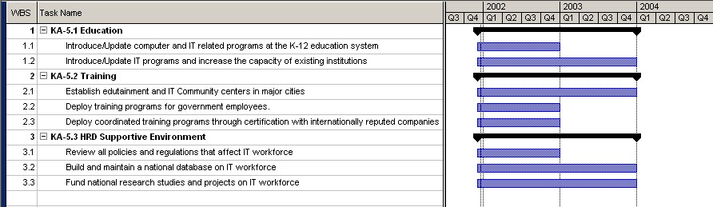

9. Concluding Remarks

The objective of the plan is to identify key areas and propose initiatives that will take Saudi Arabia to a state at par with other highly developed countries. The initiatives proposed target a Kingdom-wide information society, which, in addition to enhancing quality of life and improving services, will also result in tapping the high potential available in young citizens, building a strong IT-based industry which will not only contribute to diversification of economy but also will provide a channel for innovation and entrepreneurship.

Success Factors & Management of the Plan: The critical factors that would ensure the success of this national strategic plan include:

- Leadership, ownership, commitment and involvement of concerned organization(s) for effective implementation of the plan.
- Awareness, rationality, foresightedness, capability, and motivation at all levels among all stakeholders.
- An effective change management strategy for sustained involvement and acceptance by beneficiaries of the plan.
- Necessary infrastructure and human resources for implementation.
- Arabic support for wider acceptance and use of the Internet resources.
- An enabling and comprehensive legal environment for the various key areas.
- Encouragement by government for adoption of IT in all walks of life, in particular, government organizations.
- An effective management and control system for all programs.

The plan has cited a number of challenges, offered suggestions for removal of obstacles, proposed projects, and listed areas where policies and regulations need to be revisited. In a world where change is the only constant entity, it is expected to have new sets of challenges and obstacles. A major source of change is the rapid unforeseen developments in technology and market settings. Therefore, the plan must be revised annually in order to continually accommodate these changes.

Prioritization: This plan proposes several ambitious initiatives. In case of constraints due to funding, prioritization may be in place. In such case some initiatives can be put on hold temporarily or can be scaled down. Without more information on the available resources and management well, setting the priorities is an impractical task.

Leverage efforts with cooperating countries: It is important that we do not "re-invent the wheel". The proposed initiatives may find common ground with other GCC and Islamic countries. Since much needs to be done, cooperation with other GCC countries may be considered. There may be areas where we can leverage efforts that have already started or are further ahead. One key area of such cooperation would be the production of digital content in Arabic, especially for eLearning. Another would be to have one central certification authority (PKI) for all GCC members. The basic premise is that there is a lot to do to catch up with the developed world – we should aggressively look for ways to divide this work rather than have each nation of the GCC do it on its own.

Participating in the Open-Source Movement: The IT Plan may benefit from participating in and encouraging the Open Source community. This is one of the fastest ways to jumpstart local talent to become more than just consumers of technology. It also allows one not to be held hostage by a handful of companies or export restrictions of high performance computing to "Tier 3 countries". Germany, for example, is moving most of its government IT infrastructure on open source software platforms.

Glossary

ATM Asynchronous Transfer Mode
BWA Broadband Wireless Access
CCI Chamber of Commerce and Industry
DECC Distance Education Coordinating Committee
DSL Digital Subscribers Line
eAD eLearning Assessment Department
eCDD Electronic Content Development Department
eLC eLearning Center
EPD Education Portal Department
GDP Gross Domestic Product
GETE&VT General Establishment of Technical Education & Vocational Training
GII Government Information Infrastructure
GIS Geographic Information System
GPGE General Presidency for Girls Education
HRF Human Resources Fund
IDF Industrial Development Fund
IPA Institute of Public Administration
ISP Internet Service Provider
ITC Information Technology Council
ITTD Information Technology Training Department
KACST King Abdulaziz City for Science and Technology
MoC Ministry of Commerce
MoE Ministry of Education
MoF Ministry of Finance
MoF&NE Ministry of Finance and National Economy
MoHE Ministry of Higher Education
MoInfo Ministry of Information
MoInt Ministry of Interior
MoL Ministry of Labor
MoIE Ministry of Industries and Electricity
MoM&RA Ministry of Municipal and Rural Affairs
MoP Ministry of Planning
MoPTT Ministry of Post, Telephone & Telegraph
MpC Manpower Council
NEB National eLearning Board
OECD Organization for Economic Cooperation and Development
PKI Public Key Infrastructure
PSTN Public Switched Telephone Network
SAMA Saudi Arabian Monetary Agency
SCS Saudi Computer Society
SME Small and Medium Enterprises
STA Saudi Telecom Authority
STC Saudi Telecom Company
TDM Time Division Multiplexing
VSAT Very Small Aperture Terminal
WLL Wireless Local Loop
YIPES Young IT Professionals and Entrepreneurs

Nielsen/Netrating Q1, 2000 Global Internet trends report
Ajeeb.com Research Unit.
McConnell International Report 2001
Ministry of Finance and National Economy estimate for 2002
Icon Group International, 2000
Sofres, T. N., “eLearning in USA & Canada Benchmark”, Survey Research, commissioned by SkillSoft, April 19, 2001
Barron T., “E-Learning's Global Migration”, Learning Circuits, Sept. 2000, http://www.learningcircuits.org/sep2000/barron.html
Internet2 is a consortium being led by over 180 universities working in partnership with industry and government to develop and deploy advanced network applications and technologies, accelerating the creation of tomorrow's Internet
The Global IT Workforce, Special Issue of the Communications of the ACM, Volume 44, Number 7, July 2001
http://www.irlgov.ie/tec/cait/conference/media/carinacronsioe.ppt
http://www.insightview.com/saudi-comp
The Organization for Economic Cooperation and Development (OECD), 2000
Pyramid Research 2000
Goldman Sachs eBusiness Survey, 2000.
The Economist Intelligence Unit (EIU) 2001
Grouping of Countries by eReadiness. Source: The Economist Intelligent Unit, 2001.
Saudi American Bank Report, 2001
Icon Group International 2000.
Ranking is based on a country’s score out of 10. Source: The Economist Intelligent Unit, 2001
Source: ITU
STC Data 2001
ITU 2000
Saudi Network Information Center
Paul Budde Communication Report, March 2001
See Durlacher study on UK.
“Effectiveness of Computer-Based Training and PLATO software” 1994, http://www.plato.com/papers/pdf/training.pdf
Sofres, T. N., “eLearning in USA & Canada Benchmark”, Survey Research, commissioned by SkillSoft, April 19, 2001
Barron T., “E-Learning's Global Migration”, Learning Circuits, Sept. 2000, http://www.learningcircuits.org/sep2000/barron.html
Cattagni A., Farris E., and Westat, “Internet Access in U.S. Public Schools and Classrooms: 1994 – 2000”, National Center for Education Statistics, U.S. Department of Education, Office of Educational Research and Improvement, http://nces.ed.gov/pubs2001/2001071.pdf
Trends Report 2001, “Redefining Education: The Economic Engine: Education and Training”, http://www.trendsreport.net/education/2.html
Learnframe, “Facts, Figures and Forces Behind eLearning”, August 2000, http://www.learnframe.com/aboutelearning/elearningfacts.pdf
“An Information Society For AI, “l Communication on a Commission Initiative for the Special European Council of Lisbon, 23 and 24 March 2000
“Open Learning Australia,” Australia, http://www.ola.edu.au/
“Open Learning Agency,”Canada, http://www.ola.bc.ca/
“The e-University Project,” Higher Education Funding Council for England (HEFCE), December 2000; http://www.wfc.ac.uk/education/hefcw/pub00/w0015he.html#anna.
“The e-University Initiative,” University of Texas at Austin, December 2000; http://www.utexas.edu/e-University/.
“California Virtual Campus,” California, U. S. A., http://www.cvc.edu.
“OnlineCSU, the virtual classroom of the four Connecticut State Universities (CSU),” Connecticut, http://onlinecsu.ctstateu.edu/
“Illinois Virtual Campus”, Chicago, U. S. A., www.ivc.illinois.edu
http://www.watani.org.sa/new/English/A/A1.htm
The CEO Forum on Education and Technology, “The Power of Digital Learning: Integrating Digital Content”, School Technology and Readiness Report – Year 3; Washington, D.C. http://www.ceoforum.org/downloads/report3.pdf
http://www.planning.gov.sa/PLANNING/
Abdul-Gader, A and Alangari, K. (1994), Information Technology Assimilation in the Government Sector: An Empirical Study, final report of KACST funded project, King Abdulaziz City for Science and Technology. Riyadh
Alangari et. Al., “The Status of Information Technology in the Saudi Public Sector: Year 2001”
An excellent pioneering project is Ta’aheel program which is an optional IT training and technical certification (by Cisco, Microsoft, and other companies) for high school students. The project is managed by the Saudi Computer Society for the Center of Educational Development in the Ministry of Education.
Community Technology Centers Network, http://www.ctcnet.org/
Community Technology Centers, http://www.ombwatch.org/ctc/
“Children’s entertainment and edutainment centers”, http://www.whitehutchinson.com/leisure/edutainmentctr.shtml
Alan J. Friedman, “Are Science Centers and Theme Parks Merging?” http://www.informallearning.com/archive/1997-0708-a.htm
Arab News, Sept. 14, 2001

