COE 561, Term 091

Digital System Design and Synthesis

HW# 4 Solution

Due date: Tuesday, Jan. 19

Consider a technology library containing the following cells:

Cell | Area Cost
INV(x1) = x1’ | 1
NAND2(x1, x2) = (x1 x2)’ | 2
NAND3(x1, x2, x3) = (x1 x2 x3)’ | 3
NOR2(x1, x2) = (x1 + x2)’ | 2
AOI21(x1, x2, x3) = ((x1 x2) + x3)’ | 3
OAI21(x1, x2, x3) = ((x1+x2) x3)’ | 3
AOI22(x1, x2, x3, x4) = (x1 x2 + x3 x4)’ | 4
OAI22(x1, x2, x3, x4) = ((x1+x2) (x3+x4))’ | 4

Show the pattern trees of the library cells using NAND2 and INV as base functions. Assume that symmetric representations do not need to be stored.

Using the dynamic programming approach, map the circuit given below using the given library into the minimum area cost solution. Inputs are {a, b, c, d, e, f, g, s} and output is {t}.

Using the given library, use the SIS command read_libray q1.lib to read the library. Then, map the circuit to the library using the sis command map –s –m 0. Compare your solution to the solution obtained in (iii) and comment on any differences. You can save the mapped circuit using the sis command write_blif –n.

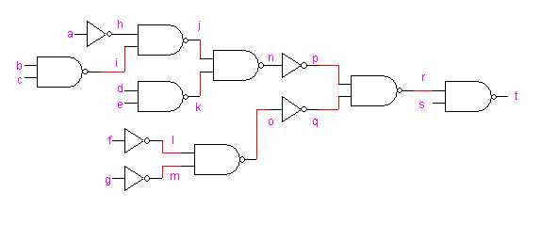

Assuming Boolean matching, determine the number of ROBDD’s that need to be stored in the cell library for each of the following cells. Justify your answer.

f = a ⊕ b ⊕ c

f = a b + a c + b c

f = a b + a’ b’ + a c + b c

