COE 561, Term 091
Digital System Design and Synthesis
HW# 3 Solution

Due date: Tuesday, Dec. 29

Consider the following function:

X = ACE + BCE + AC’D’ + BC’D’ + DE + F

Compute all the kernels of X using the recursive kernel computation algorithm. Show all the steps.

Compute all the kernels of X based on matrix representation. Compare your answer to the result obtained in (i).

Find a quick factor of X by using the first level-0 kernel found. Assume that input variables are sorted in lexicographic order. Determine the number of literals obtained. Compare your solution with the result obtained by running the sis commands factor –q x; print_factor; print_stats –f.

Consider the following function:

X=AC+BC+AD+BD+A’B’C’+A’B’D’+AEF+BEF+AE’F’+BE’F’+A’B’EF’+A’B’E’F

Compute all double-cube divisors of X along with their bases and their weights. Show only double-cube divisors that have non-empty bases.

Apply the fast extraction algorithm based on extracting double-cube divisors along with complements or single-cube divisors with two-literals. Show all steps of the algorithm. Determine the number of literals saved. Compare your solution with the result obtained by running the sis commands fx.

Consider the logic network defined by the following expressions:

X = AB’ + A’B;
Y = XC + A B;
Z =Y +A';

Inputs are {A, B, C} and output is {Z}.

Compute the SDC set for node X.

Compute the ODC set for node Y.

Simplify the function of Y using both its ODC and SDC of node X.

Compute the ODC set for node X based on the optimized network on (iii).

Simplify the function of X using its ODC.

Apply the sis command full_simplify and compare the solution obtained with your obtained solution based in (iv).

Consider the logic network defined by the following expressions:

e=a b d

f =c d

g = e + f

h = a d

i =a’ b’ d’

j = h + i

k= b d

l =j + k

x =g + l

Inputs are {a, b, c, d} and output is {x}. Assume that the delay of a gate is related to the number of its inputs. Also, assume that the input data-ready times are zero except for input d, which is equal to 2.

Draw the logic network graph and compute the data ready times and slacks for all vertices in the network.

Determine the maximum propagation delay and the topological critical path.

Suggest an implementation of the function x to reduce the delay of the circuit. What is the maximum propagation delay after the modified implementation?

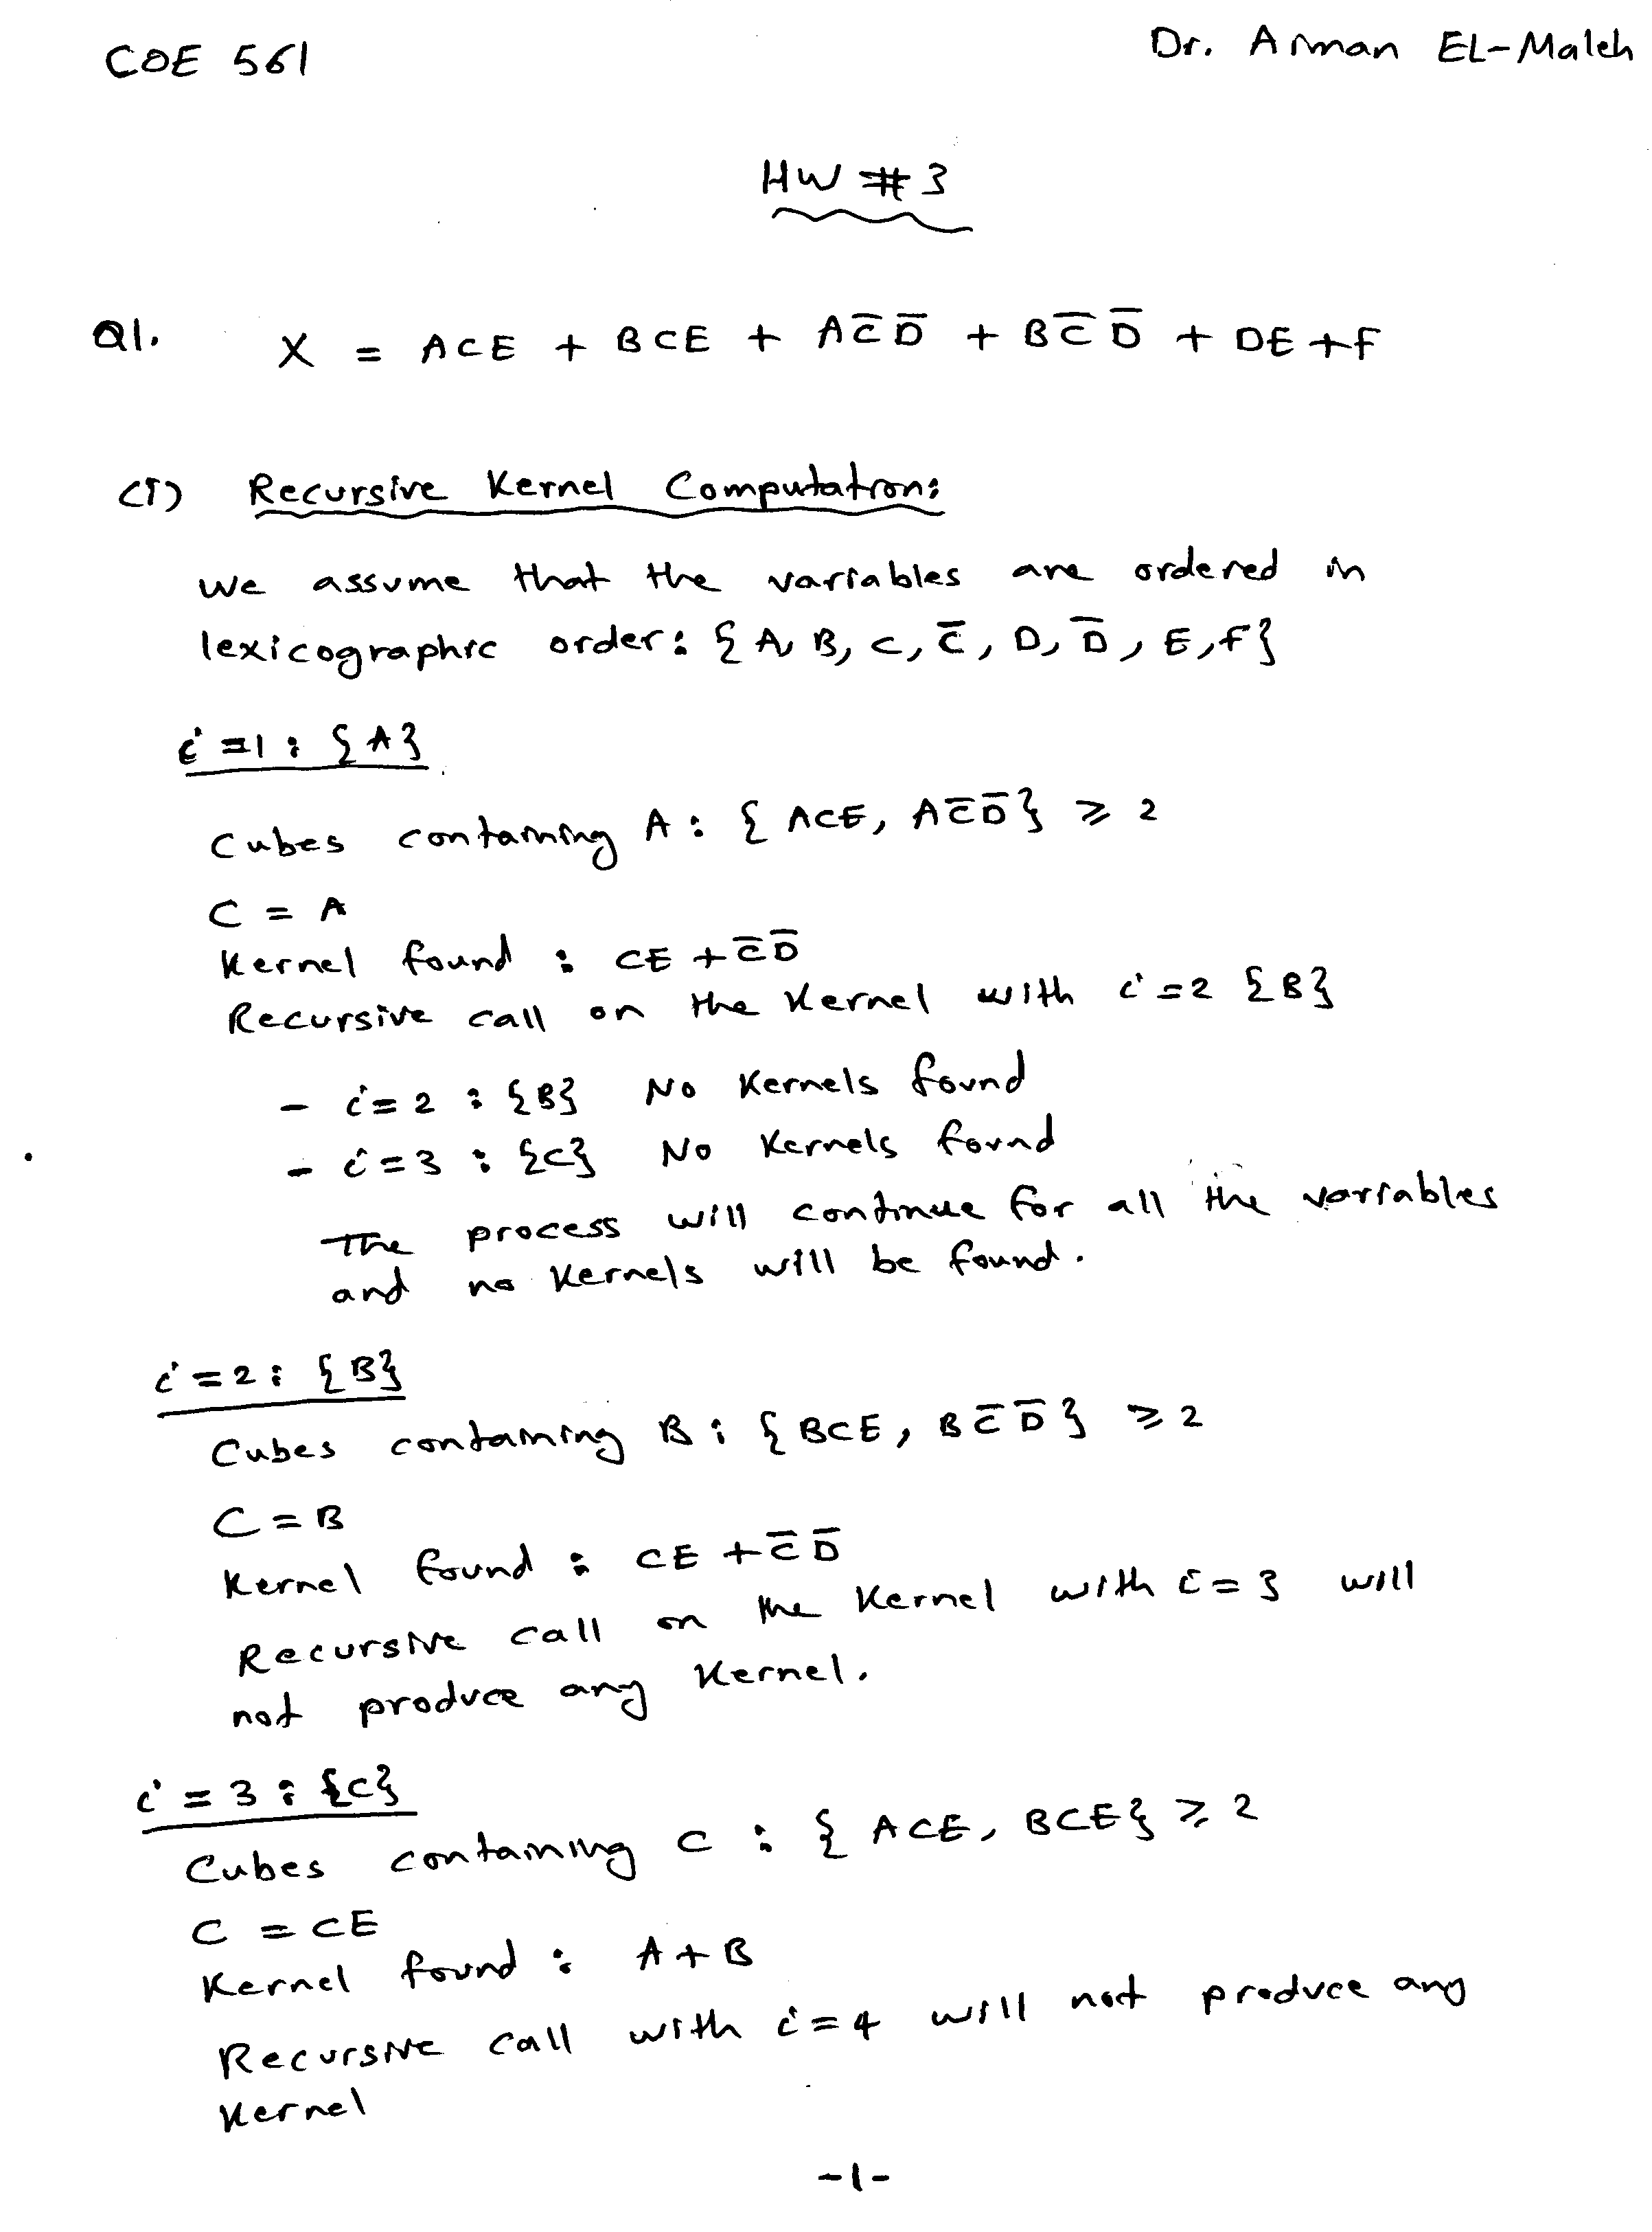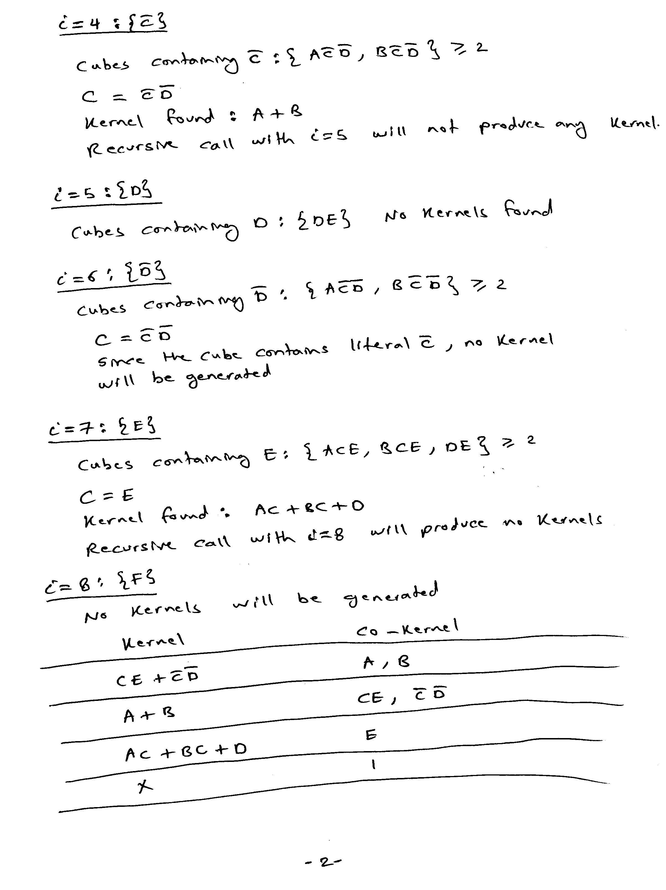
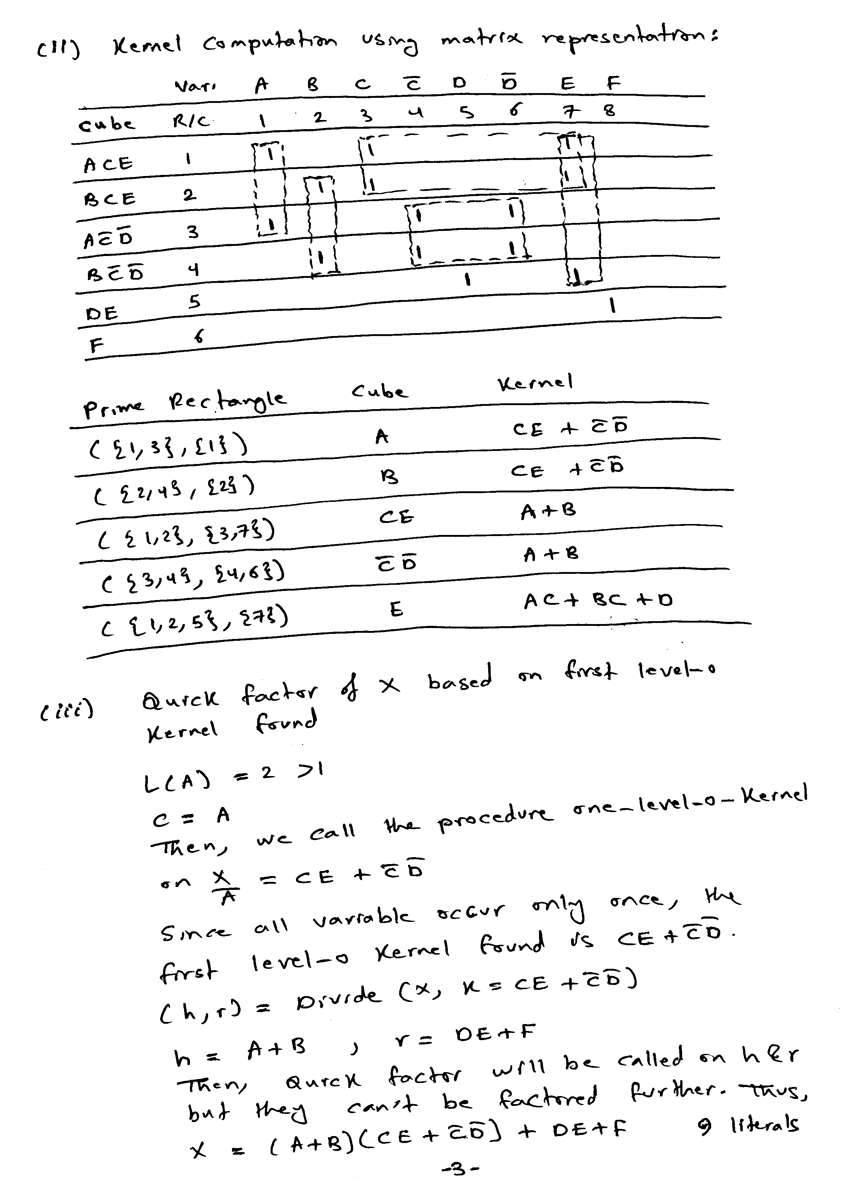
SIS produces the same quick factor as shown below:

sis> read_eqn hw3q1.eqn
sis> print
{X} = A C E + A C' D' + B C E + B C' D' + D E + F
sis> factor -q X; print_factor; print_stats -f
{X} = (C E + C' D') (B + A) + D E + F
hw3q1.eqn pi= 6 po= 1 node= 1 latch= 0 lits(sop)= 15 lits(ff)= 9
sis>
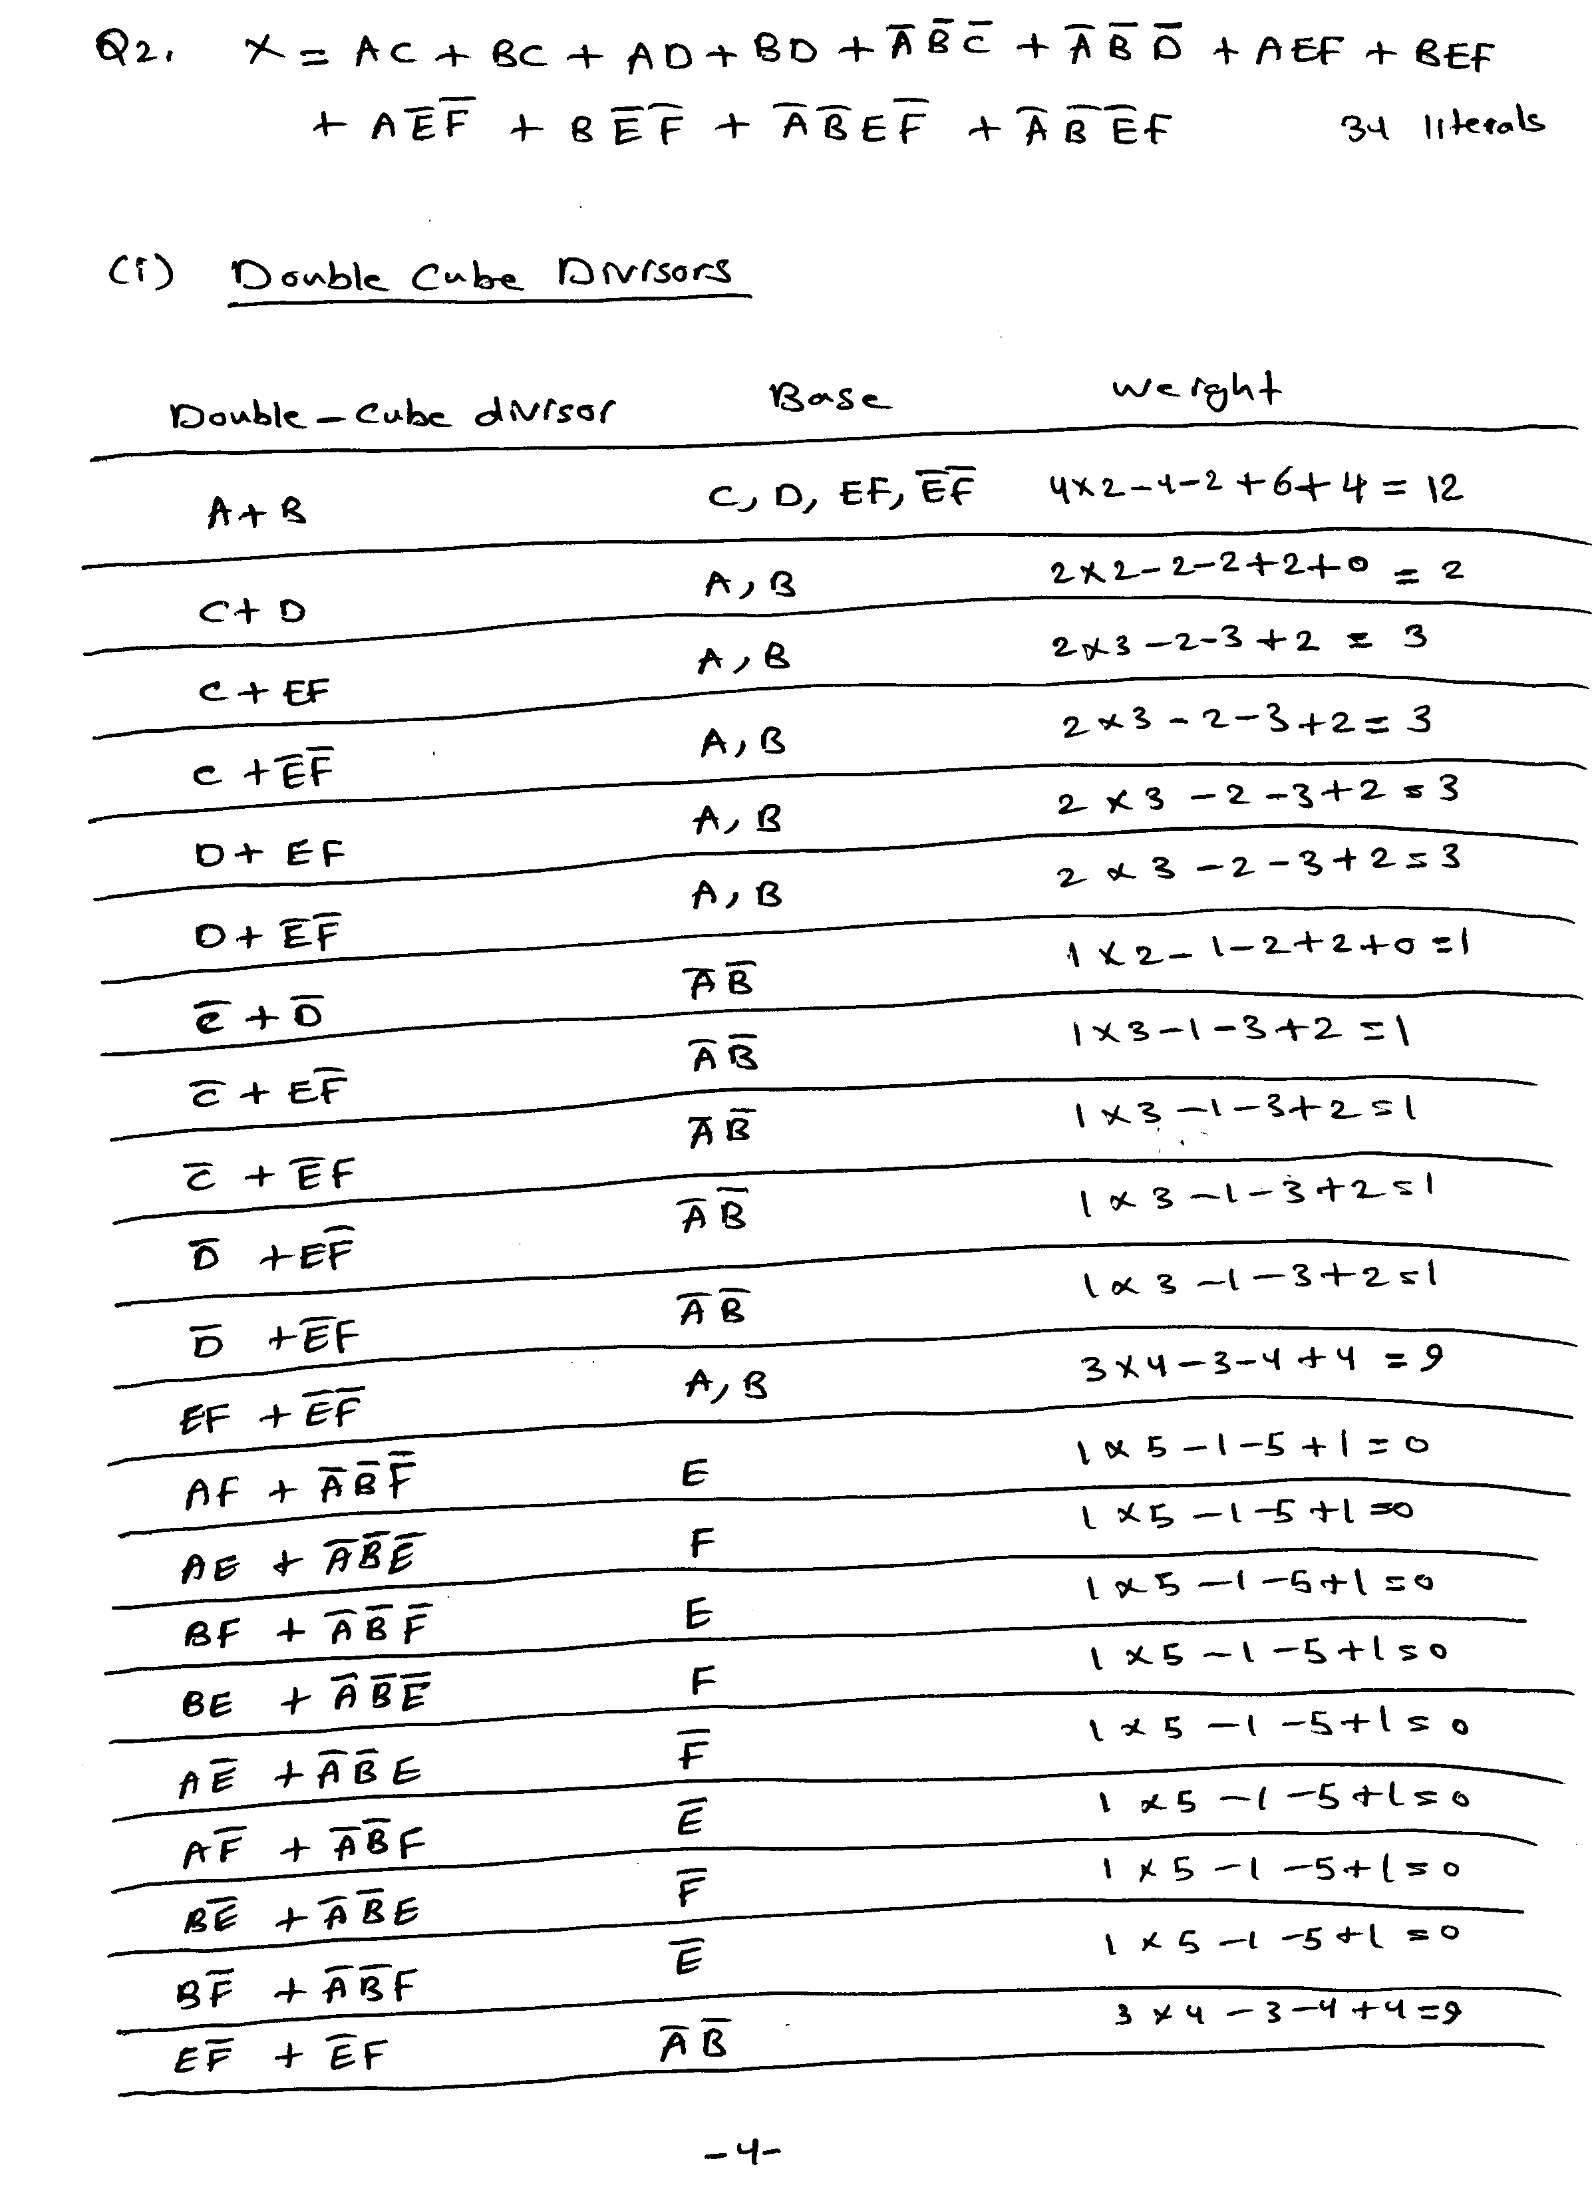
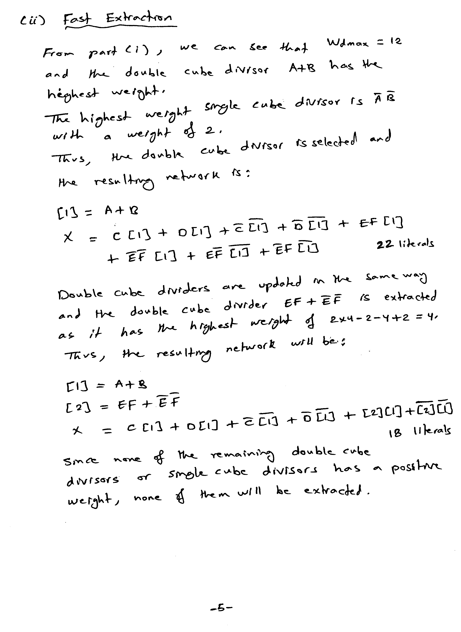
SIS has resulted in the same extracted network as shown below:

sis> read_eqn hw3q2.eqn
sis> print
{X} = A C + A D + A E F + A E' F' + A' B' C' + A' B' D' + A' B' E F' + A' B
' E' F + B C + B D + B E F + B E' F'
sis> print_stats
hw3q2.eqn pi= 6 po= 1 node= 1 latch= 0 lits(sop)= 34 lits(ff)= 16
sis> fx
sis> print
{X} = C [1] + C' [1]' + D [1] + D' [1]' + [1] [2] + [1]' [2]'
[1] = A + B
[2] = E F + E' F'
sis> print_stats
hw3q2.eqn pi= 6 po= 1 node= 3 latch= 0 lits(sop)= 18 lits(ff)= 14
sis>
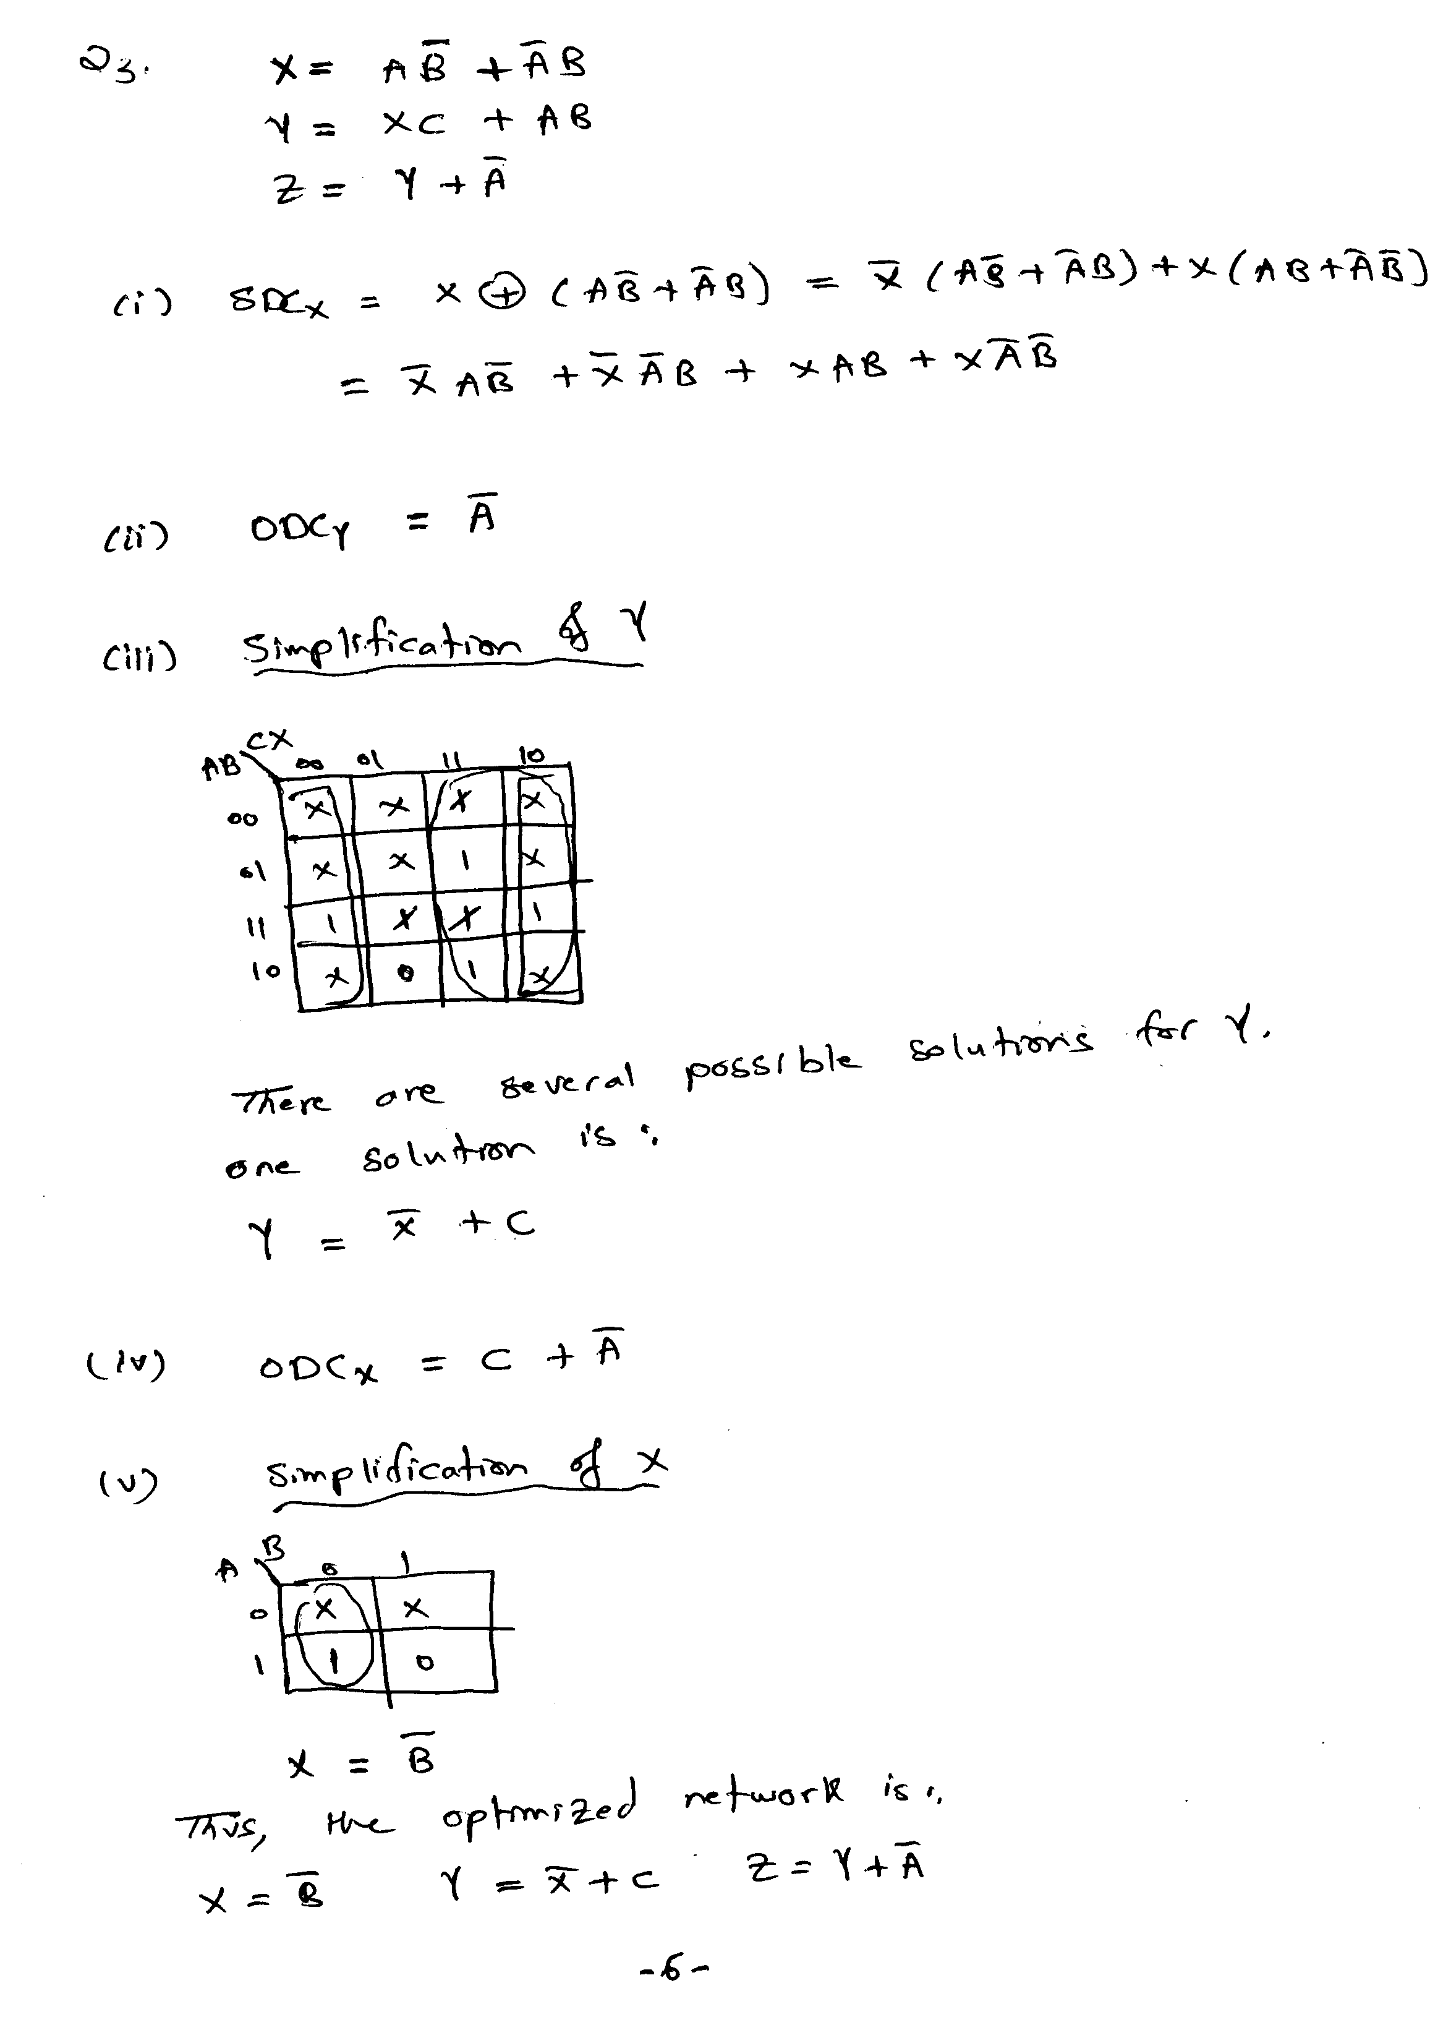
SIS has resulted in the same simplified network as shown below:

sis> read_eqn hw3q3.eqn
sis> print
{Z} = A' + Y
X = A B' + A' B
Y = A B + C X
sis> print_stats
hw3q3.eqn pi= 3 po= 1 node= 3 latch= 0 lits(sop)= 10 lits(ff)= 10
sis> full_simplify
sis> print
{Z} = A' + Y
X = B'
Y = C + X'
sis> print_stats
hw3q3.eqn pi= 3 po= 1 node= 3 latch= 0 lits(sop)= 5 lits(ff)= 5
sis>
