COE 561, Term 111

Digital System Design and Synthesis

HW# 2 Solution

Consider the function F(A,B,C,D) with the following ON-set and DC-set:

F^{ON}= ∑m(0, 2, 3, 4, 5, 7, 8, 10, 12, 13, 15)

F^{DC}= ∑m(1, 11)

Apply the EXPAND procedure on the given cover using Espresso heuristics and show the obtained expanded cover. Compare your solution with the result obtained by ESPRESSO tool.

Consider the function F(A, B, C, D) with ON-SET=Σm(0, 4, 5, 7, 8, 12, 13, 15) and DC-SET=Σm(1, 3, 9, 14).

A cover of the function is given by F = C’ + BD. Reduce the cube C’ using Theorem 7.4.1.

Use Corollary 7.4.1 to check if the implicant BD is an essential prime implicant.

Consider the following cover of a function F(A,B,C,D)

Determine the relatively essential set of cubes, E^{r}.

Determine the totally redundant, R^{t}, and partially redundant, R^{p}, sets of cubes.

Find a subset of R^{p} that, together with E^{r}, covers the function by solving a covering problem.

Compare your solution with the result obtained by ESPRESSO tool.

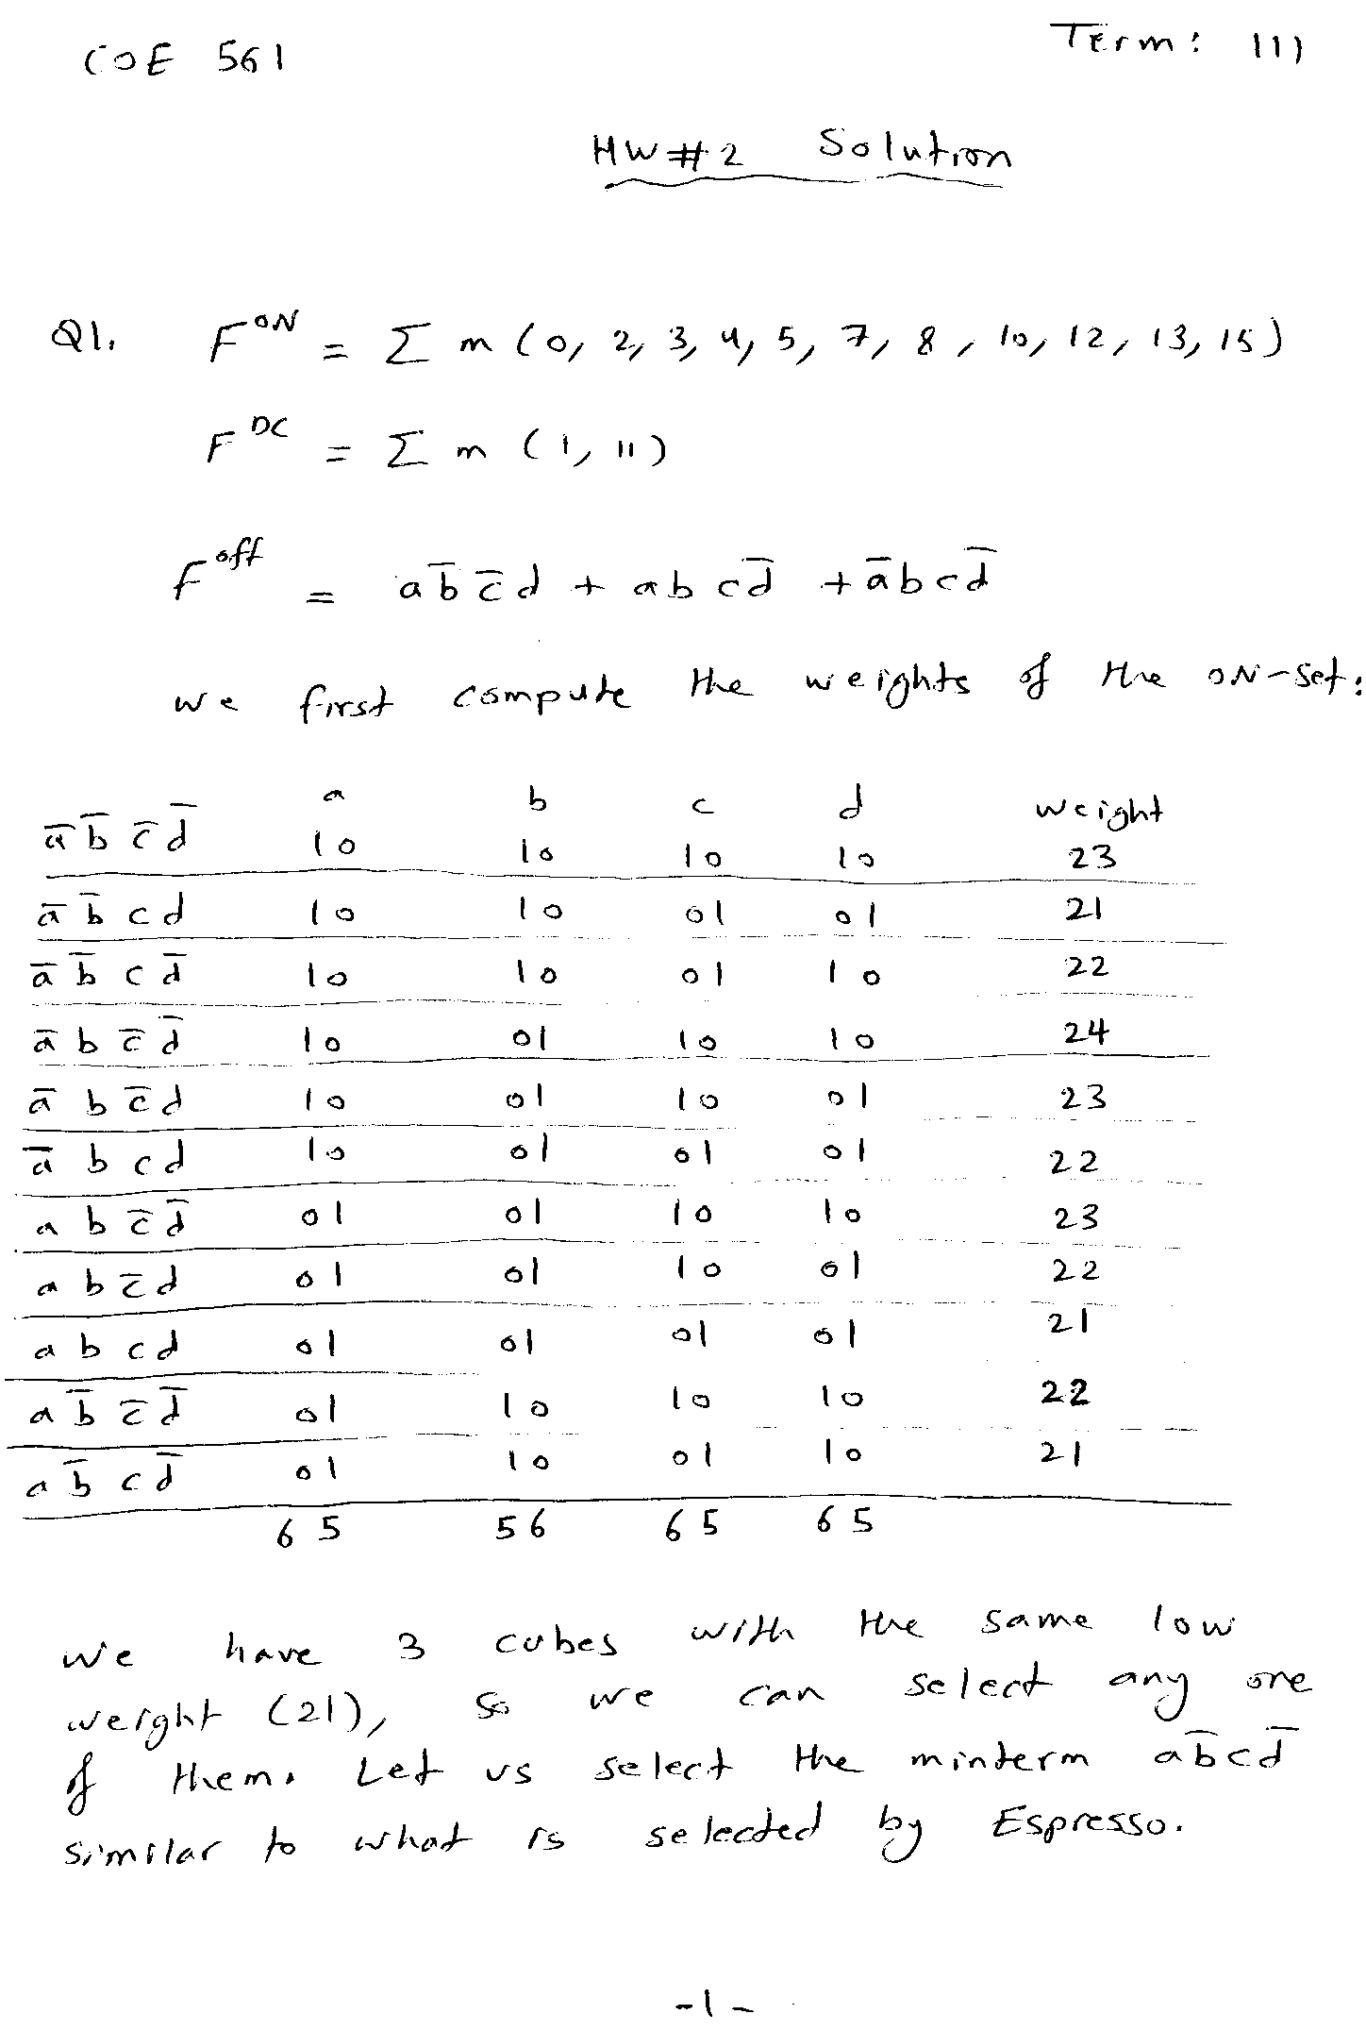
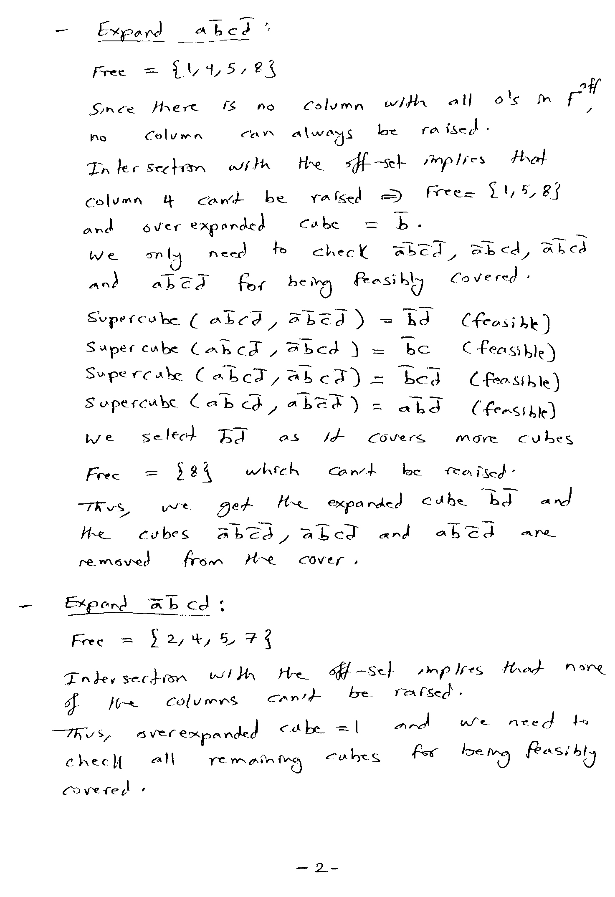
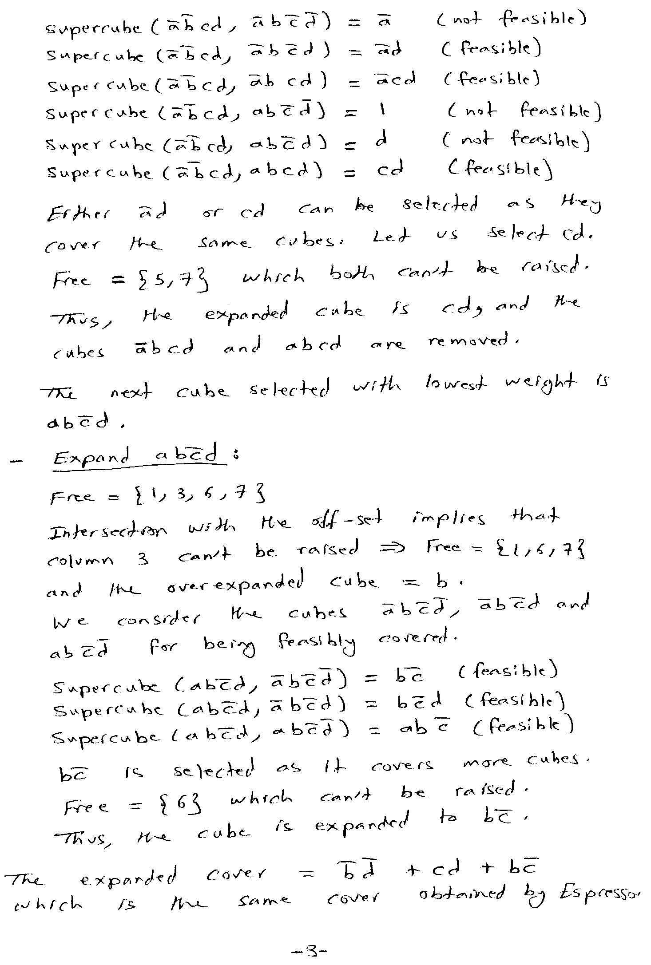
# espresso -d -t -Dexpand hw2q1.pla
# UC Berkeley, Espresso Version #2.3, Release date 01/31/88
.olb y
# READ Time was 0.00 sec, cost is c=11(11) in=44 out=11 tot=55
# COMPL Time was 0.00 sec, cost is c=2(2) in=7 out=2 tot=9
# PLA is hw2q1.pla with 4 inputs and 1 outputs
# ON-set cost is c=11(11) in=44 out=11 tot=55
# OFF-set cost is c=2(2) in=7 out=2 tot=9
# DC-set cost is c=2(2) in=8 out=2 tot=10
EXPAND: 1010 1 (covered 3)
EXPAND: 0011 1 (covered 2)
EXPAND: 1101 1 (covered 3)
# EXPAND Time was 0.00 sec, cost is c=3(0) in=6 out=3 tot=9
# READ 1 call(s) for 0.00 sec ( 0.0%)
# COMPL 1 call(s) for 0.00 sec ( 0.0%)
# EXPAND 1 call(s) for 0.00 sec ( 0.0%)
# expand Time was 0.00 sec, cost is c=3(0) in=6 out=3 tot=9
.i 4
.o 1
.ilb a b c d
.p 3
-0-0 1
--11 1
-10- 1
.e
# WRITE Time was 0.00 sec, cost is c=3(0) in=6 out=3 tot=9

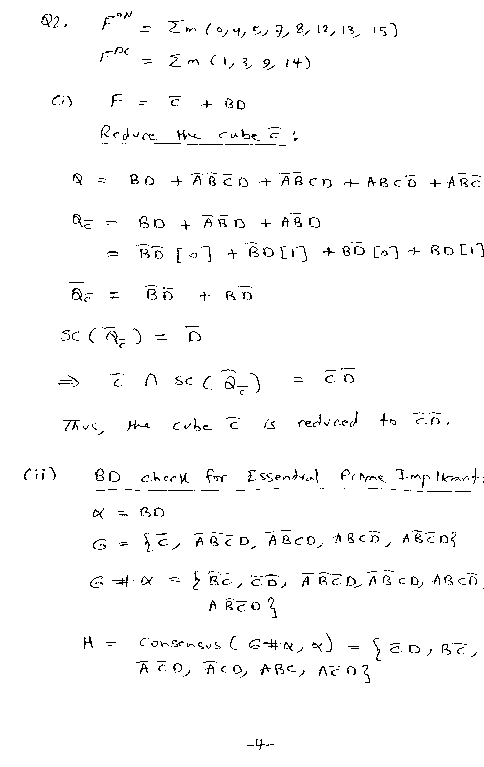
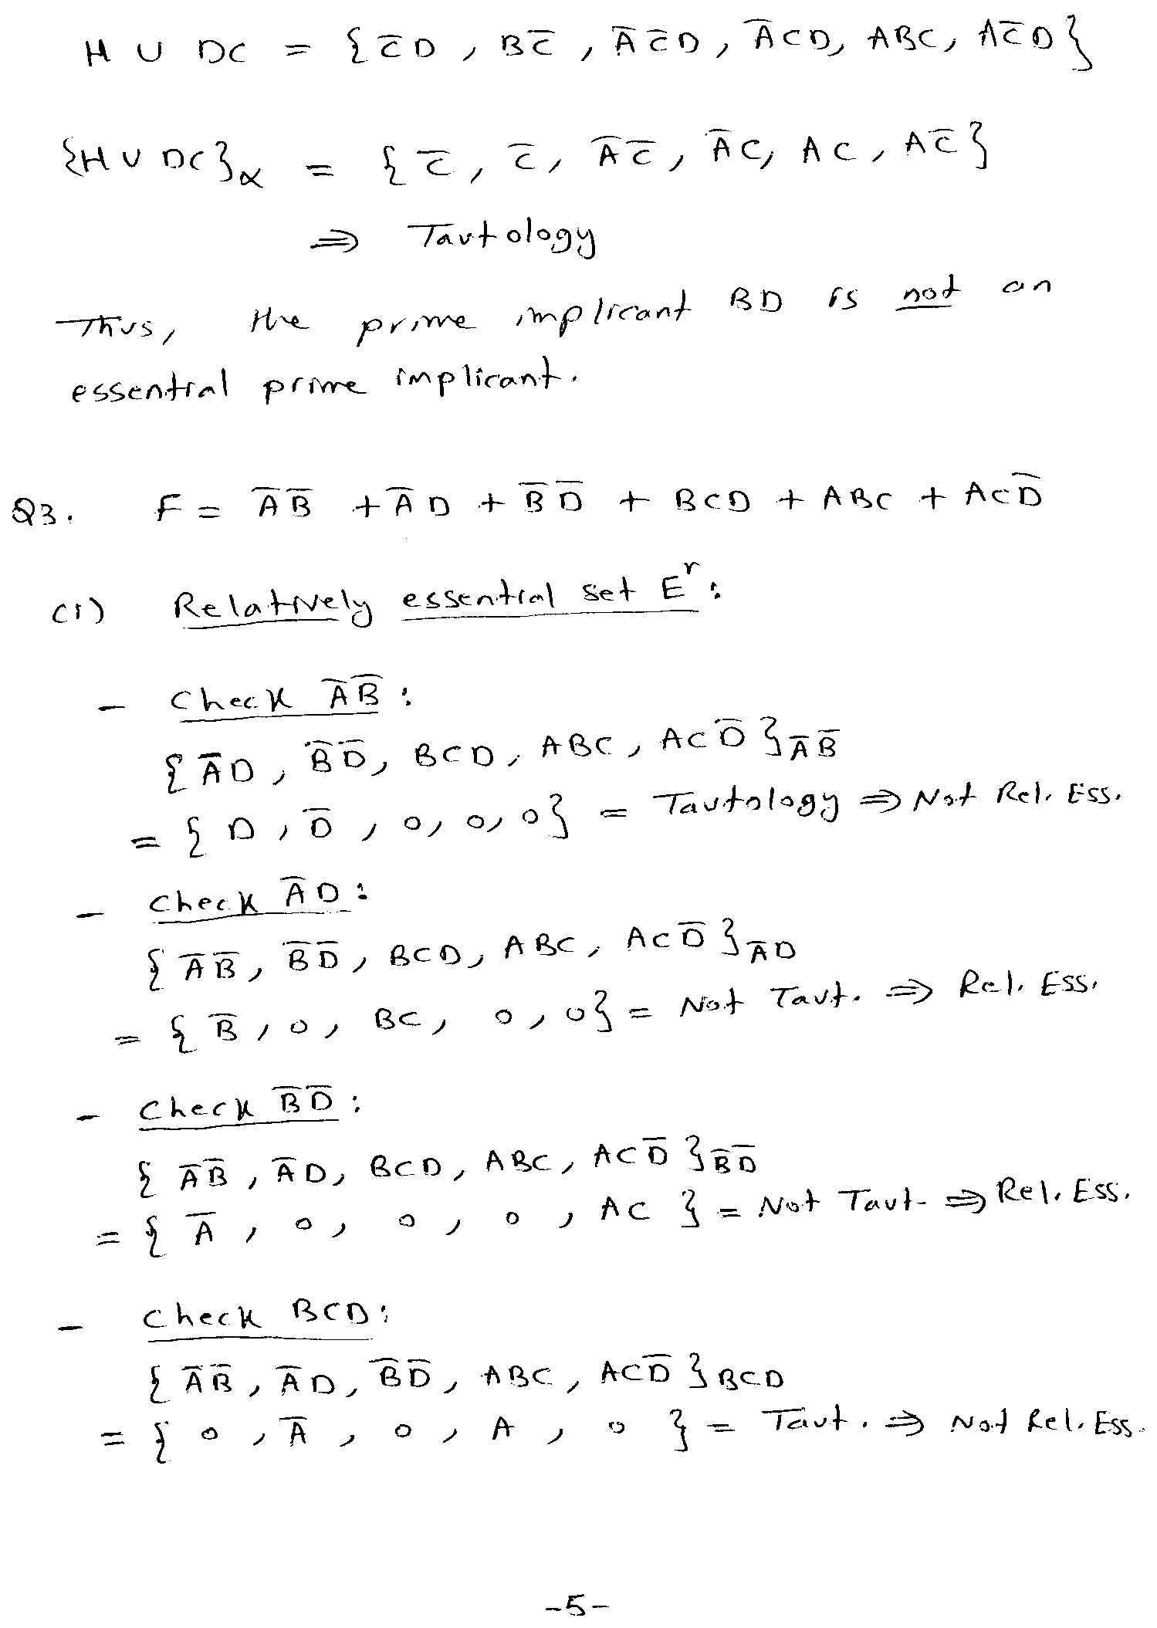
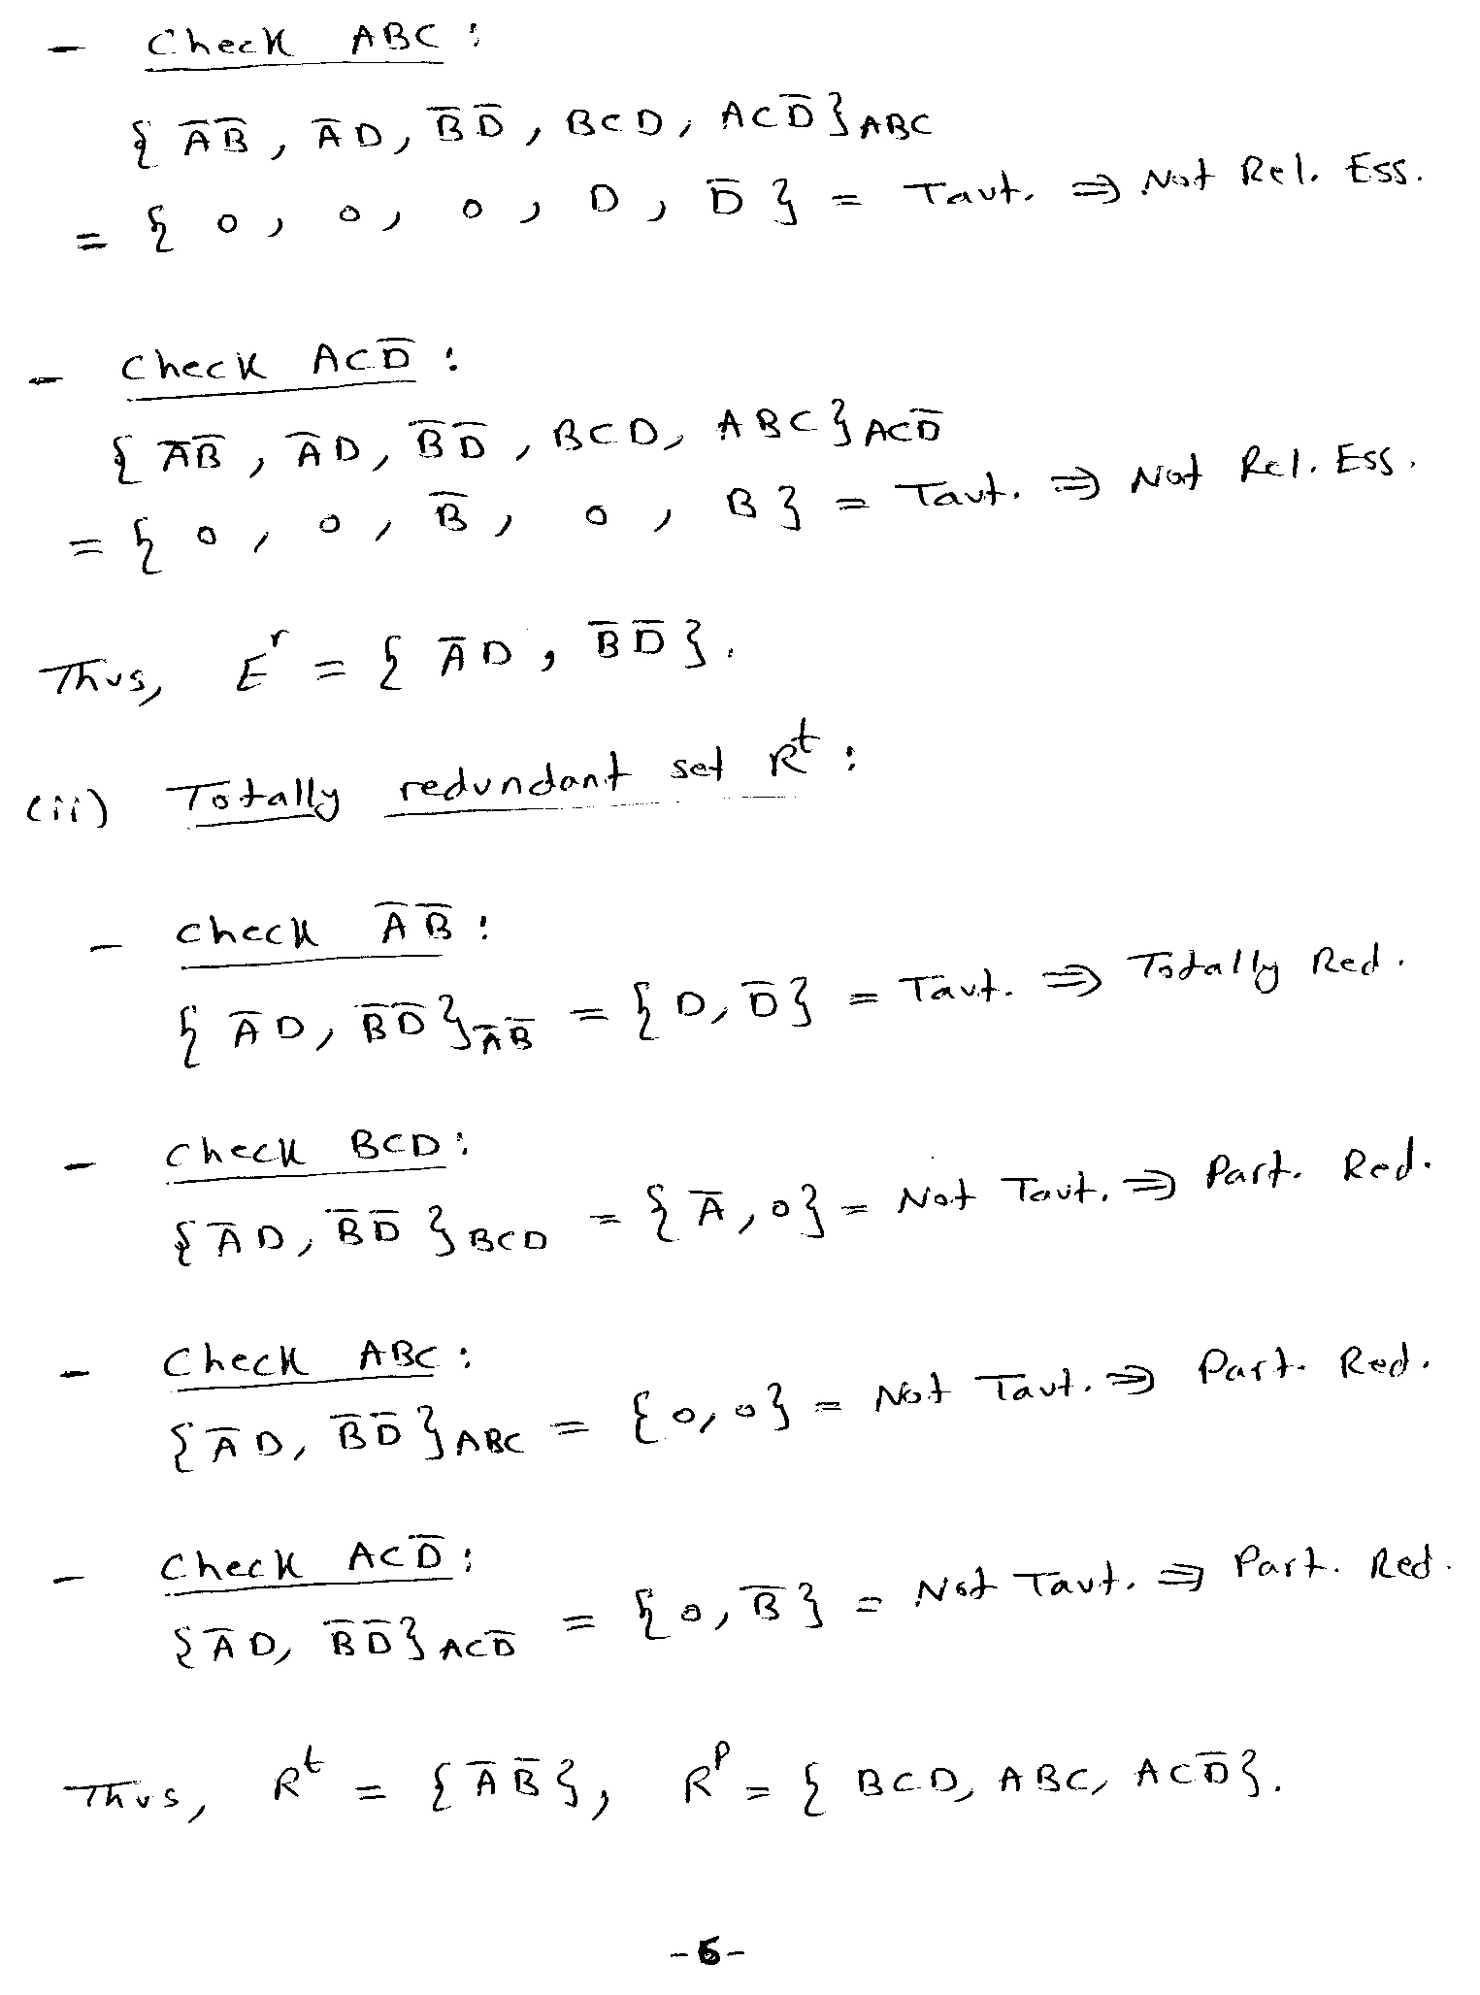
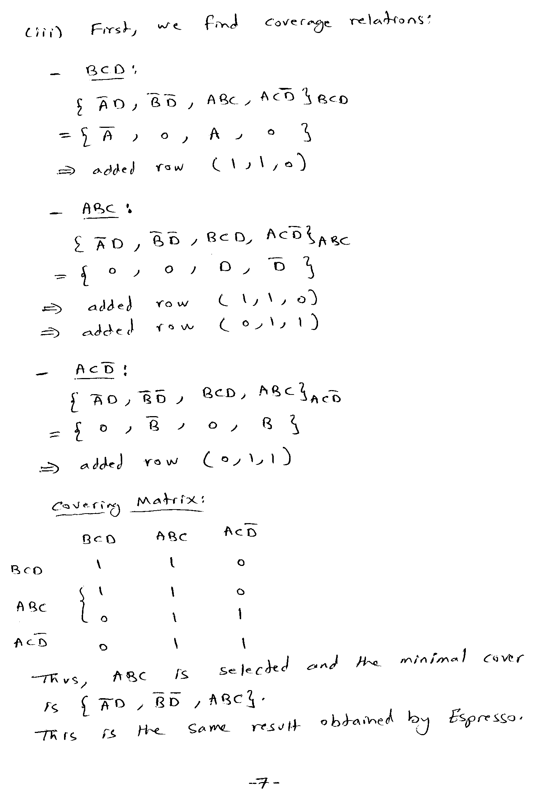
# espresso -Dirred -t -d hw2q3.pla
# UC Berkeley, Espresso Version #2.3, Release date 01/31/88
.olb y
# READ Time was 0.00 sec, cost is c=6(6) in=15 out=6 tot=21
# COMPL Time was 0.00 sec, cost is c=0(0) in=0 out=0 tot=0
# PLA is hw2q3.pla with 4 inputs and 1 outputs
# ON-set cost is c=6(6) in=15 out=6 tot=21
# OFF-set cost is c=0(0) in=0 out=0 tot=0
# DC-set cost is c=0(0) in=0 out=0 tot=0
# IRRED: F=6 E=2 R=4 Rt=1 Rp=3 Rc=1 Final=3 Bound=0
# IRRED Time was 0.00 sec, cost is c=3(3) in=7 out=3 tot=10
# READ 1 call(s) for 0.00 sec ( 0.0%)
# COMPL 1 call(s) for 0.00 sec ( 0.0%)
# IRRED 1 call(s) for 0.00 sec ( 0.0%)
# irred Time was 0.00 sec, cost is c=3(3) in=7 out=3 tot=10
.i 4
.o 1
.ilb a b c d
.p 3
0--1 1
-0-0 1
111- 1
.e
# WRITE Time was 0.00 sec, cost is c=3(3) in=7 out=3 tot=10

